**JAX Colony Management System**



**USER GUIDE**

**Release 6.1**



**JAX Colony Management System** **(JCMS)**

**User Guide**

**JCMS Release 6.1**

Prepared by:

Beth Sundberg, Scientific Software Engineer

Charles Donnelly, Scientific Software Engineer

Michael McFarland, Scientific Software Engineer

Abigail Ames, Scientific Software Engineer

Dave Springer, Scientific Software Engineer

Kavitha Rama, Scientific Software Engineer

Peter Blauth, Software QA Engineer

Rick Palazola, Scientific Software Engineer

Michael Amato, Scientific Software Engineer

Computational Sciences

The Jackson Laboratory

The development and distribution of this software is made possible by generous grants from

The National Institute for General Medical Sciences (NIGMS)

[Grant number: 2R01GM072863-05A1]

The National Cancer Institute (NCI) [Grant number: P30 CA034196-20]

and

The Howard Hughes Medical Institute

**Document modification history**

|  |  |  |  |
| --- | --- | --- | --- |
| ***Revision number*** | ***Date*** | ***Who*** | ***Comments*** |
| ***1*** | 10/14/05 | bas | Document started |
| ***10*** | 11/19/07 | dsj | Add sample tracking |
| ***11*** | 11/23/07 | aames | Add sample tracking guide |
| ***13*** | 9/18/08 | mmm | Added colony report and MLV |
| ***14*** | 9/19/08 | BAS | Added experimental data import, updated experimental data section, cage cards |
| ***15*** | 12/10/08 | BAS | Added plug dates |
| ***16*** | 10/23/09 | aames | Release 3.4.0 updates |
| ***17*** | 1/12/10 | BAS | Release 4.0.0 updates |
| ***18*** | 6/4/10 | BAS | Release 4.1.0 updates |
| ***19*** | 6/3/11 | BAS | Release 4.2.0 updates |
| ***20*** | 9/ 7 – 14 /11 | RPP | Release 4.3.0 Add Sample updates |
| ***21*** | 10/3/11 | BAS | Release 4.3.0 updates |
| ***22*** | 11/16/11 | BAS | Release 4.4.0 updates |
| ***23*** | 6/13/12 | BAS | Release 4.5.0 updates |
| ***24*** | 9/10/12 | BAS | Release 4.6.0 updates |
| ***25*** | 2/20/13 | BAS | Release 4.7.0 updates |
| ***26*** | 3/19/13 | BAS | Release 4.8.x updates |
| ***27*** | 5/3/13 | BAS | Release 5.0.0 updates |
| ***28*** | 5/10/13 | MKA | Release 5.0.0 installation information |
| ***29*** | 7/5/13 | BAS | Release 5.1.0 updates |
| ***30*** | 9/23/13 | BAS | Release 6.0.0 updates |
| ***31*** | 10/9/13 | BAS | Release 6.1.0 updates |
| ***32*** | 2/26/14 | BAS | Release 6.1.2 updates |

**About this document**

This User Guide is now available from the JCMS Colony Management System Web site (colonymanagement.jax.org) as a separate download from the installation files for those who only need a copy of the documentation.

**Document Purpose**

This document provides a user manual for the JAX Colony Management System (JCMS) database, primarily focusing on the Microsoft Access user interface.

**Related Documents**

JCMS_ReleaseNotes.pdf

ReadMe.pdf

**Audience**

Users and Database Administrator.

**Table of Contents**

1 Overview 12

1.1 What is JCMS? 12

1.2 Types of Information Collected by JCMS 14

2 Getting Started 15

2.1 Quick Start 15

2.1.1 Administrator 15

2.1.2 Regular Users: Owners and Secretaries 15

2.2 Installation 15

2.2.1 System Requirements 15

2.2.2 Download the JCMS Files 16

2.2.3 ReadMe Files 17

2.3 Configuration 18

2.3.1 Required Configuration Steps 18

2.3.2 MS Access 2007 Configuration 18

2.3.3 MS Access 2010 Configuration 21

2.3.4 Removing Security Alerts and Warnings 22

2.3.5 Configure some Database Options 23

2.3.6 Creating a Multi-User Environment 23

2.3.7 Moving JCMS to a New Location 24

2.3.8 Re-linking the Tables 24

2.3.9 System.mdw File 26

2.3.10 Installing a Multi-User Client 26

2.3.11 Backing up 27

2.3.12 Installing the Bar Code 128 Font 27

2.3.13 Configuration Issues and Answers to Common Problems 28

3 Administrator Setup 30

3.1 Owner and Secretary Accounts 30

3.1.1 Rule 1: Every User of JCMS Must Have a Logon to MS Access. 30

3.1.2 Rule 2: Each logon name that JCMS uses must be defined as either an owner (of mice) or a secretary. 30

3.2 Changing the Forms Used by Secretaries and Owners 32

3.3 Initializing Controlled Value (CV) Tables 32

3.3.1 Simple Controlled Value Tables 32

3.3.2 Strain Table 35

3.3.3 Mouse Line Viability 37

3.3.4 Ear Tag Ranges 38

3.3.5 Approved Strains for Matings 39

3.3.6 Life Status 40

3.3.7 Gene, Gene Class, and Allele Tables 40

3.3.8 Rooms, Health Level, and Pens 43

3.3.9 Mouse Use Types 43

3.4 Setup Variables Table (DbSetup) for Customizing the Installation 43

3.5 Cage Card Setup 47

3.5.1 Printing Cage Cards 47

3.5.2 Blank Cage Cards 48

3.5.3 JCMS-Provided Cage Card Formats 48

3.5.4 Creating Custom Cage Cards 60

3.5.5 User-designed Cage Cards 60

3.6 Setting up an Experimental Plan 61

4 User Setup 61

4.1 Logging On and Passwords 61

5 Basics on Using JCMS 62

5.1 What are Owners and Secretaries? 62

5.2 Changing Passwords 62

5.3 Button Bars 63

5.4 Using the Forms 64

5.4.1 Special Features of Some Forms 65

5.5 Navigation Buttons 65

5.6 Session Reports 65

5.7 Printing 65

5.8 Statistics 66

6 Mice 66

6.1 Mouse IDs 66

6.1.1 Automatically Incrementing Mouse IDs 66

6.1.2 Base Mouse Numbers 67

6.2 Adding Mice 67

6.3 Editing Mice 69

6.3.1 Changing the ID of a Mouse 69

6.4 Importing or Bulk Adding Mice 70

6.5 Adding Pups 71

6.6 Changing Life Status or Diet of a Group of Mice 73

6.7 Changing Life Status using the Handheld Forms 73

6.8 Change Life Status of an Individual Mouse using Handheld 73

7 Pens and Cage Cards 75

7.1 Manage Pen Configuration Form 75

7.2 Rooms and Health Level 77

7.3 Adding Pens 77

7.3.1 Pen Info Form 78

7.3.2 Add Pen Form 78

7.4 Editing and Retiring Pens 79

7.5 Moving Mice between Pens 79

7.6 Moving Mice Using Handheld 80

7.7 Printing Blank Cage Cards 80

7.8 Retiring Pens Automatically 80

7.9 Bulk Retire Pens 81

7.10 Correcting Pen Status and Date Errors 81

7.11 Cage Use Reports 82

7.11.1 Cage Use Report 82

7.11.2 Cage Use Summary 83

8 Matings 85

8.1.1 Automatic Litter Number Generation 85

8.2 Technical Matings 85

8.3 Which Mating Forms to Use? 86

8.4 Approved Mating Strains 86

8.5 Designing a New Mating 87

8.6 Activating a Mating 88

8.7 Add a Natural Mating 89

8.8 Add a Technical Mating 90

8.9 Edit a Mating 92

8.10 Design Matings to be Retired 92

8.11 Retire a Mating 93

8.12 Working with Matings using a Handheld 94

8.13 Automatic Retiring of Matings 94

9 Litters 95

9.1 Automatic Litter Number Generation 95

9.1.1 Turning Automatic Litter Numbering On or Off 95

9.1.2 Setting the Number of Litter Numbers that are Generated for Each Mating 95

9.2 Which Litter Forms to Use? 95

9.3 Adding Litters 96

9.4 Wean Report 96

9.5 Editing Litters 97

9.6 Wean Litters 98

9.7 Adding Litters with Pups at Weaning 98

9.8 Weaning Mice using a Handheld 100

10 Embryo Litters 101

10.1 Add Embryo Litter w/Samples 101

10.2 Edit Embryo Litter 103

11 Plug Dates and Pregnancy Checking 104

11.1 Add Plug Date 104

11.2 Edit Plug Date 105

11.2.1 Automatically mark plug dates as obsolete 105

11.3 Plug Date and Pregnancy Check Work Reports 106

11.3.1 Plug Date / Pregnancy Stage Report 107

11.3.2 Plug Check Work Report 107

11.3.3 Pregnancy Check Work Report 108

11.3.4 Plug Date History 108

12 Breeding Performance Reports 109

12.1 Full Breeding Performance Report 110

12.2 Summary Breeding Performance Report 111

12.3 Breeding Performance Report Tabular Spreadsheet 112

12.4 Breeding Performance Report Litter Detail Pivot Table 112

12.5 Breeding Performance Report Litter Summary Pivot Chart 113

12.6 Breeding Performance Report Mating Count Pivot Chart 113

12.7 How to Use the Dynamic Features of a Pivot Table or Chart 114

12.7.1 Changing the Chart Type 114

12.7.2 Showing Only Some of the Criteria 114

12.7.3 Adjusting the Axis Scale 115

12.7.4 Switch from Pivot Chart to Pivot Table 116

12.7.5 Viewing Values for Portions of a Pivot Chart or Table 116

13 Genotyping 117

13.1 How Does Genotyping Work? 117

13.2 Adding a Genotype to a Mouse or Sample 117

13.2.1 Mouse-Genotype Documents 118

13.3 Editing a Genotype 119

13.4 Adding a Genotype to a Group of Mice 120

13.5 Genotype String Format 120

13.6 Genotype Work Report 121

14 Genotype Loader 122

14.1 Import genotypes from a comma separated value (CSV) file 122

14.1.1 Input File Format 123

14.1.2 Alleles 125

14.1.3 Import File Integrity Checks 125

14.1.4 Select the type of Import 126

14.1.5 Verification 127

14.1.6 Genotype Load Report 129

15 Scheduling Procedures (Uses) 130

15.1 How do Mouse Uses Work? 130

15.2 Adding a Use to a Mouse 130

15.3 Mouse Use Work Report 131

15.4 Editing a Mouse Use 132

15.5 Adding or Editing a Mouse Use for a Group of Mice 133

16 Calendar 135

16.1 Edit a Mouse Use Shown on the Calendar 137

16.2 Mouse Use Details Form 138

16.3 Print a Calendar Report 139

16.3.1 Suggestions for speeding up the calendar form 139

17 Documents 140

17.1 Document Storage 140

17.2 Adding (Uploading) Documents 140

17.3 Selecting Documents to Associate 142

17.4 Edit Document 143

17.5 Bulk Add Document Associations 144

18 Queries 145

18.1 Colony Summary Report 145

18.2 What are Queries used for? – or How to Search the Database 145

18.2.1 Basics on using the Query Forms 146

18.2.2 How to Select Query Criteria 147

18.2.3 Like Criteria for Mouse ID 148

18.2.4 Mouse Age 148

18.2.5 Filtering Strains or Stock #’s 149

18.3 Mouse Query 149

18.3.1 Query by Genotype (QGT) 149

18.3.2 Interpreting the Genotype Output 150

18.3.3 Restricting Genotypes in the Query Output 150

18.3.4 Listing Documents Associated with Genotypes 150

18.3.5 Listing Other Associated Documents 151

18.3.6 Query by Mouse Use 151

18.4 Mating Query 153

18.5 Experimental Data Query 154

18.5.1 Documents Associated with Experimental Data 155

18.6 Sample Query 155

18.7 Microsoft Query 155

19 Experimental Plans 156

19.1 How to use an Experimental Plan 157

19.2 How to Create Experimental Data without using an Experimental Plan 158

19.3 Setting up Test Types (Data Descriptions) 159

19.4 Editing a Test Type 160

19.5 Setting up Default Data for Experiments 160

19.6 Editing Default Data 161

19.7 Adding an Experimental Plan 161

19.8 Adding an Experimental Test 162

19.9 Editing an Experimental Test 163

19.10 Selecting Mice for an Experimental Plan 163

19.11 Adding Mice to a Plan using the Mouse Complex Query Form 164

19.11.1 Example of the report format: 165

19.11.2 Error message: “XX mice were selected by the query, more than can be held in the Query Results box.” 165

19.12 Managing an Experimental Plan 166

19.12.1 Choosing Mice for Experimental Tests 166

19.12.2 Removing Mice from an Experimental Plan 167

19.12.3 Editing Experimental Plan Fields 167

19.12.4 Deleting an Experimental Plan 168

19.12.5 Deleting an Experimental Test 168

19.13 Adding or Editing Experimental Data for a Mouse 169

19.14 Editing Experimental Data 170

19.15 Adding Experimental Data to Several Mice at Once 171

19.16 Experiment Work Report for Scheduling Procedures 171

19.16.1 Connector/ODBC Window Pops-up When Using the Experiment Work Report 173

19.16.2 Setup Variables Used by the Experiment Work Report 174

19.17 Experimental Plan Query 174

19.18 Importing Experimental Data 174

19.18.1 Input File Format 175

19.18.2 Create a Test Type 176

19.18.3 User Interface 177

19.18.4 Troubleshooting Notes 183

20 Samples 184

20.1 Set up Controlled Vocabulary for Sample Tracking 185

20.2 Pooled Samples 188

20.3 Add Samples 189

20.4 Edit Samples 191

20.5 Bulk Change Samples 192

20.6 Query Samples 193

20.6.1 Searching for sample genotypes 194

20.7 Browse Sample Storage Locations 195

20.8 Print Sample Labels 196

21 FAQ’s (Frequently Asked Questions) 197

21.1.1 JCMS starts up and shows the database, but no welcome window appears. 197

21.1.2 Every time I add, edit, or delete a record in JCMS I’m prompted with a dialog box. 197

21.1.3 What to do about an “end/debug” error message 197

21.1.4 Error messages when editing date fields 197

21.1.5 Error message: “user Admin does not have permission to use this form” 197

21.1.6 Error message about “could not find file” 198

21.1.7 A note about session boxes 198

21.1.8 List boxes of mice information are scrambled! 198

21.1.9 Warning message about not saving a record. 198

21.1.10 The database keeps telling me it is “Read only” 198

21.1.11 The Connector/ODBC Window is Popping Up 198

21.1.12 Other FAQs 199

22 Technical Guide 199

22.1 Security 199

22.2 Changing Security Access to Forms 200

22.3 Data Integrity 200

22.4 Back up the Database 200

22.5 The dbInfo Table 200

22.6 Access to the Primary Data Tables 200

22.6.1 Editing Records in Datasheet View 200

22.7 Temporary Tables 201

22.8 Temporary Queries 201

22.9 Screen Resolution 201

22.10 Printer Notes 201

23 Appendix 1: Automated TGS Genotype Loader Submissions 203

23.1 Adding a TGS Genotype Request 203

23.2 Editing a TGS Genotype Submission Request 207

23.3 Importing TGS Genotyping Results 208

**Table of Figures and Tables**

Figure 1‑1 Database Overview Diagram 14

Figure 2‑1 File browser 17

Figure 2‑2 Setting full control 17

Figure 2‑3 Logon Password 18

Figure 2‑4 Link to the database source 19

Figure 2‑6 JCMS Welcome Window 20

Figure 2‑5 Link Tables dialog box 20

Figure 2‑7 MS Access 2010 Users and Permissions dialog boxes 21

Figure 2‑8 MS Access 2010 Linked Table Manager 21

Figure 2‑9 Access 2007 Trust Center 22

Figure 2‑10 Access 2007 Confirm Options 23

Figure 2‑11 Access 2007 configure record-level locking 23

Figure 2‑12 JCMS Failed to start up correctly. 24

Figure 2‑13 Office 2007 Linked Table Manager 25

Figure 2‑15 Sample of a bar code for the pen ID number 27

Figure 2‑14 JCMS client shortcut 27

Figure 2‑16 Error: release numbers don’t match 28

Figure 3‑1 Dialog Box: Personal ID 30

Figure 3‑2 Form: Administrator Buttons 31

Figure 3‑3 Form: Owner and Secretary Accounts 31

Figure 3‑4 Form: Edit Form Privileges 32

Figure 3‑5 Sample Simple CV Table 33

Figure 3‑6 Forms: Default Strain Types and Generations 34

Figure 3‑7 Form: Add or Edit Strains 35

Figure 3‑8 Open Mouse Line Viability Report 37

Figure 3‑9 Example mouse line viability report 38

Figure 3‑10 Ear tag ranges 39

Figure 3‑11 Add Approved Strain Form 40

Figure 3‑12 Form: Add or Edit Gene 41

Figure 3‑13 Form: Add or Delete an Allele 42

Figure 3‑14 Add or delete mouse use types 43

Table 3‑1 JCMS Setup Variables 47

Figure 3‑15 Form: Print blank cage cards 48

Figure 3‑16 OS_2PWeanCageCard 49

Figure 3‑17 TS_1PWeanCageCard or TS_1PWeanCageCardWithBarCode 49

Figure 3‑18 CC_JCMS_WeanCageCardUsingPenNames 52

Figure 3‑19 TS_MatingCAgeCard or TS_MatingCageCardStyle1With BarCode 53

Figure 3‑20 TS_MatingCageCardStyle2With BarCode 53

Figure 3‑21 OS_MatingCageCard 53

Figure 3‑22 MW_MatingCageCardLandscape 53

Figure 3‑23 CC_JCMS_MatingCageCardUsingPenNames 53

Figure 3‑24 TS_DetailCageCard 57

Figure 3‑25 TS_DetailCageCardWithBarCode 57

Figure 3‑27 MW_DetailCageCardLandscape 57

Figure 3‑26 (left) CC_JCMS_DetailCageCardUsingPenNames 57

Figure 3‑28 Office 2007 reports list shown using F11 key 60

Figure 4‑1 User Logon Screen 61

Figure 5‑1 Dialog Box: Change Password 63

Figure 5‑2 Main Button Bar 63

Figure 5‑4 Example of regular form buttons 64

Figure 5‑3 Example of a text box 64

Figure 6‑1 Add Mouse Form 67

Figure 6‑2 Add mouse form after a successful submit 68

Figure 6‑3 Change Mouse ID Form 69

Figure 6‑4 Edit Mouse With Browser Functions 70

Figure 6‑5 Bulk Add Mice Form 71

Figure 6‑6 Add Pup from Litter Form 72

Figure 6‑7 Form: Bulk Change Life Status or Diet 73

Figure 6‑8 Individual Mouse Change Life Status Handheld Form 74

Figure 6‑9 Bulk Exit Handheld Form 74

Figure 7‑1 Manage Pen Configuration Form 75

Figure 7‑2 Administrator Forms for Managing Room and Health Level 77

Figure 7‑3 Pen Info Form 78

Figure 7‑4 Add Pen Form 78

Figure 7‑5 Edit Pen Form 79

Figure 7‑6 Move Mouse Form 79

Figure 7‑7 Handheld Move Mice Form 80

Figure 7‑9 Edit Pen Status/Location Form 81

Figure 7‑8 Pen Maintenance Form 81

Figure 7‑10 Cage Use Report 82

Figure 7‑11 Cage Use Summary Report 83

Figure 7‑12 Cage Use Summary (bottom) vs. Cage Use Report (top) 83

Figure 8‑1 Mating to Weaning Diagram 85

Figure 8‑2 Add Approved Strains Form 86

Figure 8‑3 Design Mating Form 87

Figure 8‑4 Activate Mating Form 88

Figure 8‑5 Add Mating Form 89

Figure 8‑6 Add Ovary Transfer Mating 90

Figure 8‑7 Add Embryo Transfer Mating 91

Figure 8‑8 Add In vitro Fertilization Mating 91

Figure 8‑9 Design Retire Matings Form 92

Figure 8‑10 Retire Matings Form 93

Figure 8‑11 Handheld Form: Pair Mating 94

Figure 9‑1 Add Litter Form 96

Figure 9‑2 Wean Work Report 96

Figure 9‑3 Edit Litter Form 97

Figure 9‑4 Add Litter w/Pups Form 98

Figure 9‑6 Handheld Forms: Weaning and Add litter and mice 100

Figure 10‑1 Add Embryo Litter with Sample records 101

Figure 10‑2 Edit Embryo Litter form 103

Figure 11‑1 Add Plug Date Form 104

Figure 11‑2 Edit Plug Date Form 105

Figure 11‑3 Confirm plug date expiration 106

Figure 11‑4 Form: Request plug date or pregnancy reports 106

Figure 11‑5 Sample plug date / pregnancy stage report 107

Figure 11‑6 Sample tabular spreadsheet format plug date / pregnancy stage report 107

Figure 11‑7 Plug Check Report 107

Figure 11‑8 Sample pregnancy check work report 108

Figure 12‑1 Select the Breeding Performance Report 109

Figure 12‑2 Form: Request a breeding performance report 109

Figure 12‑3 Detail section of the report 110

Figure 12‑4 Strain total section of the report 111

Figure 12‑5 Owner and grand total section of the report for all strains 111

Figure 12‑6 Summary shown for one strain 111

Figure 12‑7 Tabular spreadsheet format 112

Figure 12‑8 Litter detail pivot table 112

Figure 12‑9 Litter summary pivot chart 113

Figure 12‑10 Mating counts by week 113

Figure 12‑11 Chart changed to 3-D and only one owner 114

Figure 12‑12 Changed "drill buttons" 115

Figure 12‑13 Properties dialog box 115

Figure 12‑15 Hover over a column with the mouse to see the values 116

Figure 12‑14 View button 116

Figure 13‑1 Form: Add Genotype 117

Figure 13‑2 Add genotype documents 118

Figure 13‑3 Form: Edit Genotype 119

Figure 13‑4 Form: Bulk Add Genotype 120

Table 13‑1 Examples of genotype strings 121

Figure 13‑5 Request a genotype work report 121

Figure 13‑6 Genotype Work Report 121

Figure 14‑1 Form: The main button bar with the "Import Genotype" button visible 122

Figure 14‑2 Spreadsheet: the input file as seen in MS Excel 124

Table 14‑1 The mapping of the input fields to the data tables 124

Table 14‑2 Genotype loader allele representations 125

Table 14‑3 Genotype loader error messages 125

Figure 14‑3 Select import type dialog box 126

Figure 14‑4 The file open dialog 127

Figure 14‑5 The user notification screen during validation 127

Figure 14‑6 The user notification after validation 128

Figure 14‑7 The user notification after import 128

Figure 14‑8 Genotype Load Report 129

Figure 15‑1 Form: Add Use 130

Figure 15‑2 Adding a use based on a plug date 131

Figure 15‑3 Request mouse use work report 132

Figure 15‑4 Form: Edit Use 132

Figure 15‑5 Bulk Add or Edit Use Form 133

Figure 15‑6 Warning about making a change to the "done" field 134

Figure 16‑2 Form: Request mouse use calendar 135

Figure 16‑1 Open the calendar 135

Figure 16‑3 Example of a mouse use calendar 136

Figure 16‑4 Single day format 137

Figure 16‑5 Opening the edit mouse uses form 137

Figure 16‑6 Mouse use details form 138

Figure 16‑7 Example of a calendar printout 139

Figure 17‑1 Possible data file setup for documents 140

Figure 17‑2 Add document form 140

Figure 17‑3 File browser 141

Figure 17‑4 Upload New button 141

Figure 17‑5 Associate Documents form 142

Figure 17‑6 Associate Existing button 142

Figure 17‑7 Edit Document form 143

Figure 17‑8 Bulk Add Document Associations form 144

Figure 17‑9 Experimental plan category 144

Figure 18‑1 Colony Summary Report 145

Figure 18‑2 Mouse Query Form 146

Figure 18‑3 Datasheet: Mouse Query Results 146

Figure 18‑4 Query: Do you want to save changes to Form? 147

Figure 18‑5 Query Form: List Box Criteria 147

Figure 18‑6 Query Form: Range Criteria 147

Figure 18‑7 Query Form: Check Box Criteria 147

Figure 18‑8 Query Form: Like Criteria 148

Figure 18‑9 Mouse age result choice 148

Figure 18‑11 Query Form: Genotype 149

Figure 18‑10 Strain or Stock # Filter 149

Figure 18‑12 Query Datasheet: Restricted Genotype Output 150

Figure 18‑13 Requesting documents in the query output 150

Figure 18‑14 Query Form: Mouse Use 151

Figure 18‑15 Query Datasheet: Mouse Uses 151

Figure 18‑16 Mouse query - use term error message 152

Figure 18‑17 Query Mating Form 153

Figure 18‑18 Mating type selection 153

Figure 18‑19 Query Datasheet: Mating 153

Figure 18‑20 Query Experiment Form 154

Figure 18‑21 Experiment Query Datasheet 155

Figure 19‑1 Diagram: Experimental Plan Tables 156

Figure 19‑2 Diagram: Experimental Plan 157

Figure 19‑3 Form: Add Test Type 159

Figure 19‑4 Form: Add Test Type Defaults 160

Figure 19‑5 Form: Add Experimental Plan 161

Figure 19‑6 Form: Add Experimental Test 162

Figure 19‑7 Form: Bulk Add Mice from Query 164

Figure 19‑8 Report: Add Mice to Plan 165

Figure 19‑9 Form: Manage Experimental Plan 166

Figure 19‑10 Report: Edit/Mange Experimental Plan 167

Figure 19‑11 Form: Add Experimental Data 169

Figure 19‑12 Form: Bulk Add Experimental Data 171

Figure 19‑13 Request Experiment Work Report 172

Figure 19‑14 Experiment Work To Do Report Based on the Mouse Age Range 173

Figure 19‑15 Experiment Work Report Spreadsheet 173

Figure 19‑16 Connector/ODBC window 174

Table 19‑1 MySQL setup variables 174

Figure 19‑17 Process for importing experimental data from a user file 175

Figure 19‑18 Create a test type to match the input fields 176

Figure 19‑19 Import Exp Data button 177

Figure 19‑20 Import Experimental Data with no experimental plan 177

Figure 19‑21 Validate input 178

Figure 19‑22 Sample validation report 179

Figure 19‑23 Maximum number of validation errors 179

Figure 19‑24 Import Experimental Data using an Experimental Test 180

Figure 19‑25 Data validation failure 181

Figure 19‑26 Allow experimental data to be imported to an experimental test without preselecting the mice 181

Figure 19‑27 Enabled load data button 182

Figure 19‑28 Final load report 182

Figure 19‑29 Changing the experimental test status 183

Figure 20‑1 Simple controlled vocabulary buttons for sample tracking 185

Figure 20‑2 Example of editing simple controlled vocabulary 185

Figure 20‑3 Complex controlled vocabulary buttons for sample tracking 186

Figure 20‑4 Manage sample types screen 186

Figure 20‑5 Manage preservation vocabularies screen 187

Figure 20‑6 Manage sample locations screen 187

Figure 20‑7 Dummy strain for a pooled sample 188

Figure 20‑8 Add Sample form 189

Figure 20‑9 Edit Sample Form 191

Figure 20‑10 Bulk Sample Update Form 192

Figure 20‑11 Query Samples Form 193

Figure 20‑12 Sample genotype criteria 194

Figure 20‑13 Sample genotype results in multiple columns 194

Figure 20‑14 Genotype results when no gene criteria 195

Figure 20‑15 Browse Sample Storage Locations Form 195

Figure 20‑16 Print Sample Labels 196

Figure 21‑1 Could Not Find File Error 198

Figure 21‑2 Error: You can't save this record at this time 198

Figure 22‑1 Administrator - Owner - Secretary Security Relationship 199

Figure 23‑1 The Add Genotyping Request button 203

Figure 23‑2 Select mice whose IDs begin with “A1” 204

Figure 23‑3 Setting the plate ID 204

Figure 23‑4 A well plate with samples from seven mice of two strains 205

Figure 23‑5 The genotyping request ID field 205

Figure 23‑6 To seal the plate select “Sealed” 206

Figure 23‑7 The Submit button 206

Figure 23‑8 Notification of a successful submission. 206

Figure 23‑9 To edit an existing genotyping request 207

Figure 23‑10 Select a request to be edited. 207

Figure 23‑11 Import Genotype data 208

Figure 23‑12 Select the format 208

Figure 23‑13 To import the results from the selected file. 209

# Overview

## What is JCMS?

The Jackson Laboratory’s Colony Management System (JCMS) is a multi-user relational database for managing mouse colonies in a research environment. It was developed in response to increased demand within The Jackson Laboratory for a system that would execute the core functionality of colony management from an intuitive, easy-to-use interface.

Since its initial release in 1998 it has been widely used within The Jackson Laboratory and adopted by a number of outside institutions. Some of the salient features that JCMS offers are:

* Tracking individual mice
  + Genotype
  + Uses and status
  + Pedigrees
  + Breeding performance
* Mating records
* Litter records
* Animal cage/pen management
  + Preformatted or user-designed cage cards with optional bar codes
* Experiment setup and tracking
  + Schedule mice
  + User designed metadata
* Track biological samples relating to mice, matings, or litters
* Bulk data entry
* Sophisticated query capabilities
* Data export to Excel
* Hard copy reports
* Handheld computer support
* User configurable

JCMS has an underlying data model that is independent of any specific database management system technology. The software engineers of Computational Sciences worked closely with the scientific research staff to derive a data model that was comprehensive yet flexible enough to fully satisfy the requirements of multiple research labs.

## Types of Information Collected by JCMS

Gene

Litter

Mating

Experimental

Plans

**Mouse**

Strain

Genotype

Cage

**Sire**

**Dam 1**

**Dam 2**

Uses

Sample

Storage

Figure ‑ Database Overview Diagram

The above diagram shows the main types of information stored by the JCMS database. The mouse is the central entity. A mouse will have a specific strain and multiple genotypes associated with it. Each mouse is also associated with its current cage (pen). Two or three mice are set up in a mating (breeding pair or trio). Each mating can be tracked individually from pre-design to retirement based on a particular laboratory’s workflow. Matings have their own strain, which may be different from the strains of the sire and dams. Each mating produces one or more litters. The litters of pups will become individual mice in the database at weaning/tagging. An embryo litter will produce biological samples. Technical matings involving samples (embryo, egg, sperm, or ovary), host dam, and sire may be recorded. These can produce samples or pups.

Two methods are provided for keeping track of experimental workflow (procedures, tests, routine activities, etc.) that may be scheduled. 1. The simple method is called **Mouse uses** and provides a method of assigning various “uses”, proposed dates, and simple data results to individual mice. 2. The more comprehensive method is called **Experimental plans**. This section of JCMS provides a method of defining experimental plans. Each plan contains various user-designed experimental tests, user-designed data fields, default data values, and scheduling information. Individual mice can have experimental data results associated with them and can be scheduled for various experimental tests and various experimental plans. See the section on Experimental Plans for a more comprehensive diagram and description.

Biological samples that are related to mice, matings, and litters may be entered. Users may also define their own types of samples. See the section on Sample Tracking for more information.

# Getting Started

## Quick Start

BEFORE BEGINNING, YOU MUST (1) Create a password for user ‘Admin’, (2) Create the user ‘mtsadmin’, and make it a member of the Admins group.

JCMS defines a security hierarchy with three levels of permission: Administrator, Owner, and Secretary. All users of JCMS are assigned into one of these groups. The Administrator (mtsadmin) has the overall responsibility for the database. Owners are usually the people who are maintaining the colony, including any breeding activities, and/or are performing experiments, which may include creating and storing biological samples. An owner has direct responsibility for groups of mice, matings, samples, and/or for experimental plans and data. An owner may have limited access to perform activities only with the mice, samples, experiments, that they “own”. Secretaries are users that have more limited security access to the database and normally are restricted to entering data, executing queries, and viewing reports.

### Administrator

One individual must be assigned to be the database Administrator (mtsadmin). The Administrator will be responsible for the installation and setup of the database and for creating other user accounts. The Administrator has full access to all data. The Administrator is not expected to be an IT professional, so they may need assistance from their IT department to do a networked installation.

The Administrator must complete the Installation and Administrator Setup sections of this manual before other users may begin. The other users are divided into two groups: Owners and Secretaries.

### Regular Users: Owners and Secretaries

Users have restrictions within the database depending on their security level. The Administrator (see above) has full access to the data and forms. Owners have access only to forms at the “owner” or “secretary” security level. These include the ability to enter and edit the mice, matings, samples, experimental plans, and experimental data that they “own”.

A secretary is a user who has only limited security access to the database and is restricted to forms at the “secretary” level. Secretaries usually do not have the authority to make changes to data. This type of user may request reports and run queries. A secretary is assigned to specific owners and may only enter data or make changes to mice, matings, etc. that belong to those owners.

It is possible for a user to be both an owner of their own mice and to act as the “secretary” for one or more other owners.

To get started, first the Administrator will provide a new user with either an owner or secretary logon. Then begin with the User Setup and Basics on Using JCMS sections.

## Installation

### System Requirements

* Single user
  + PC computer with Microsoft Office 2007 or 2010; a version that includes an English language Microsoft Access.
  + MySQL 5.5
  + Disk space requirements are minimal; 100 MB should be plenty to get started.
  + Memory requirements are minimal; however, large amounts of RAM will boost performance when JCMS has large amounts of data in it.
  + Bar Code 128 from Elfring Fonts Inc. www.barcodingfonts.com is required only if using the optional bar codes on cage cards or for sample labels.
* Multi-user
  + Either a client or file server computer with Microsoft Office 2007 or 2010; a version that includes an English language Microsoft Access.
  + A file server computer running MySQL 5.5
  + A network environment set up so that all client computers can access the file server.
  + PC computers, Macintosh computers, wireless handheld computers, and UNIX/LINUX computers may act as clients if supported by the network software.
  + It is recommended that network thin client software such as Citrix® Metaframe Client/Server be used if computers other than PCs are used.
  + Disk space requirements are minimal; 100 MB should be plenty to get started.
  + Memory requirements are minimal; however, large amounts of RAM will boost performance when JCMS has large amounts of data in it.
  + Bar Code 128 with a site license from Elfring Fonts Inc. www.barcodingfonts.com is required only if using the optional bar codes on cage cards or for sample labels.

### Download the JCMS Files

Download from the Jackson Laboratory JCMS Web site (colonymanagement.jax.org) the Windows installer file **JCMSInstaller.msi** and place it on the desktop. Double click the file to run it. It will ask you to specify an installation folder. The default is C:\Program Files\The Jackson Laboratory, but a different folder may be used for the installation. At the same level as the installation folder, the subfolders \data and \docs are created (see diagram).

docs folder ----------- Installation folder ------------------ data folder

|

|

JCMS.mdb

The following files are included in the folder named *docs*:

* ReadMe.pdf
* JCMS_UserGuide.pdf
* JCMS_UserGuide.docx
* JCMS_ReleaseNotes.pdf
* JCMSInstall-Upgrade-guide.pdf
* License.txt

The data folder is used to hold the user files (referred to as documents) that are associated with the mice, mouse genotypes, samples, and/or experimental data in JCMS. JCMS does not incorporate the documents into its database. It moves a copy of the original file into this special “data” folder and maintains a link to the file in the JCMS database. You must change the JCMS_DATA_FILE_DIRECTORY setup variable to match the path of the data directory.

#### **Windows 7 and MS Access 2010**

It is necessary to set the folder permissions in Windows 7 to allow the user "Full" access to the installation folder, otherwise everything opens in read-only mode and you can't complete the setup.

Using a file browser, right click the installation folder name and select “Properties”.

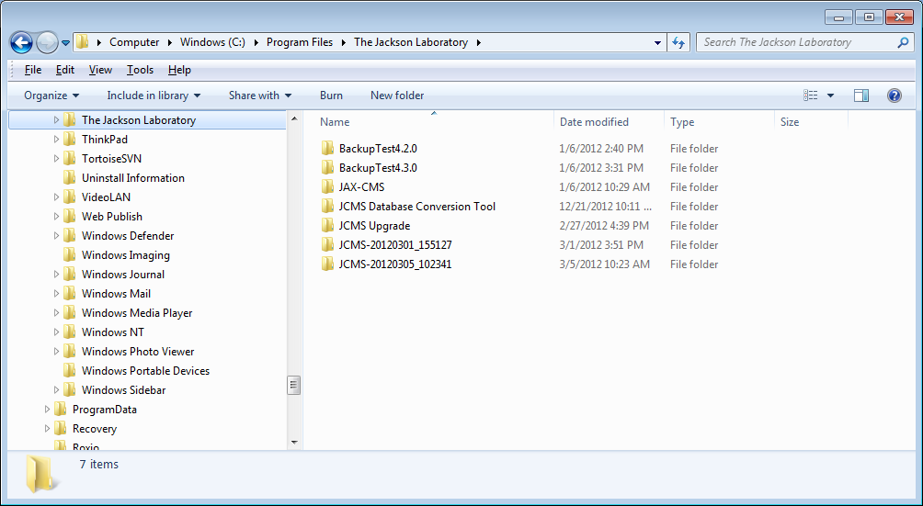

Figure ‑ File browser

If on the Security tab, the user does not have “full control” click the Edit button to change it.

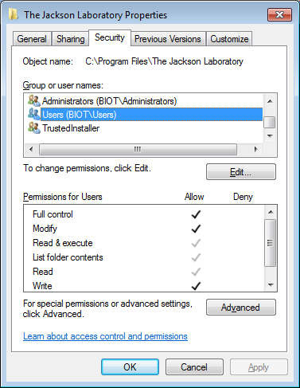

Figure ‑ Setting full control

Microsoft has moved the location of some of the features on the ribbon. The new locations are described in the MS Access 2010 configuration section below.

### ReadMe Files

We suggest you first read the files **ReadMe.pdf**, **JCMS_ReleaseNotes.pdf**, and online JCMS discussion forum for updated information. These should contain up-to-date information on changes not included in this documentation. We recommend you become a member of the JCMS discussion forums at: <http://community.jax.org/jcms_discussion_forum/default.aspx>. This is a place where JCMS users can post questions and answers plus review answers to previous questions. To receive notices of upgrades and other important user information we recommend also subscribing to the JCMS mailing list by sending an email to: [jaxcms-subscribe@lists.jax.org](mailto:jaxcms-subscribe@lists.jax.org). No subject or email body is required.

## Configuration

### Required Configuration Steps

BEFORE BEGINNING, YOU MUST (1) Create a password for user ‘Admin’, (2) Create the user ‘mtsadmin’ and make it a member of the Admins group.

Solutions to some minor problems that may occur are given at the end of this section (see the configuration issues section 2.3.13.) A new installation of JCMS will need special logon passwords created (system.mdw). The directions below are specific to different versions of MS Access. If the version of MS Access in use has password protection already set up, skip down to the *Setup the Administrator User* step.

### MS Access 2007 Configuration

**(1) Initialize Using Passwords for MS Access (Admin)**

* Open the JCMS interface by double clicking on the desktop shortcut.
* Select the “Database Tools” tab.
* Select “Users and Permissions” from the ribbon.
* 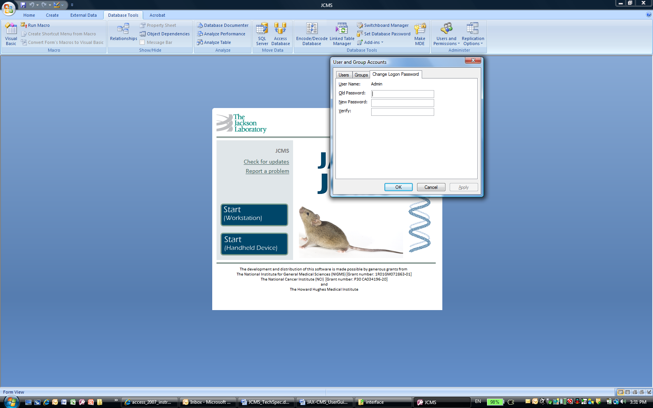Select “User and Group Accounts”.
* Select “Change Logon Password” tab.
* Old password <blank>.
* New password “Admin” (or your choice).
* Verify (repeat your choice).
* Select “OK”.

**(2) Setup the Administrator User (mtsadmin)**

* Select the “Database Tools” tab.
* Select “Users and Permissions” from the ribbon.
* Select “User and Group Accounts”.
* Select “Users” tab.
* Select “New” button.
* Put “mtsadmin” in the Name field.
* Enter any random value in the Personal ID field.
* Select “OK”.
* Use the “Add>>” button to set user mtsadmin as a member of the *Admins* and *Users* groups.

Figure ‑ Logon Password

* Close MS Access.
* Restart JCMS and logon as mtsadmin. Leave the password blank.
* Now give mtsadmin a password using the same procedure as described above to give the Admin user a password. This is not required, but it is very strongly encouraged.

**(3) Link the Database Tables (Only necessary if linking failed during install)**

* On the toolbar, select the “External Data” tab.
* Select “ODBC Database” in the Import section of the ribbon.
* Select “Link to the data source by creating a linked table” radio button (DO NOT IMPORT the tables).
* Click on the “Machine Data Source” tab and click “New”
* Select either User Data Source or System Data Source and click “Next >”
* Select “MySQL ODBC 3.51” Driver from the driver list, click “Next” followed by “Finish”
* Fill out the information in the form. Data Source Name and Description are up to you, TCP/IP Server is the name of the machine with MySQL on it and Username/Password is your MySQL username/password ().
* Select the DSN you created from the list of datasources and click OK.
* The “Link Tables” window opens ().
* Select “Select all”.
* Select “OK”.
* Close *JCMS.mdb* and re-open it. The welcome window should appear as shown below with the proper release number (). The installation is now ready to be used.

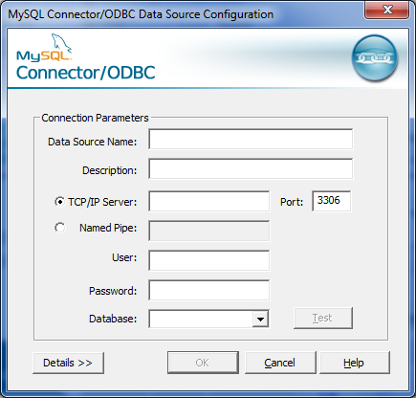

Figure ‑ Link to the database source

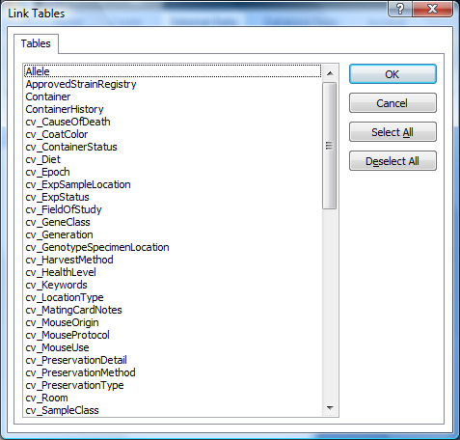

Figure ‑ Link Tables dialog box



Figure ‑ JCMS Welcome Window

### MS Access 2010 Configuration

The steps are the same as indicated above for Access 2007. However, the some of the features have been moved.

**Users and Permissions**

Use the red File tab to find the Users and Permissions tool.

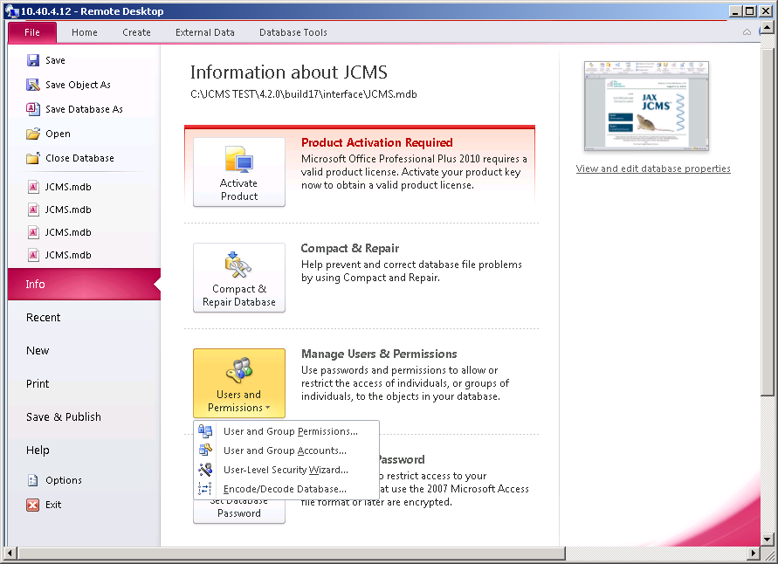

Figure ‑ MS Access 2010 Users and Permissions dialog boxes

**Linked Table Manager**

Use the External Data tab to find the Linked Table Manager.

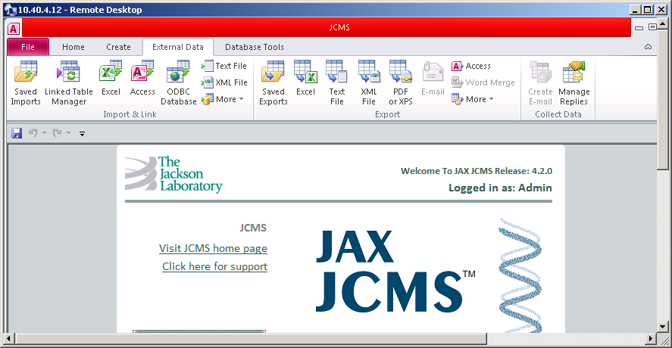

Figure ‑ MS Access 2010 Linked Table Manager

**Deleting Tables that are not linked**

In MS Access 2010, certain configuration changes may require logging on as Admin, for example, if tables need to be deleted because they were imported instead of linked. Only the Admin logon can perform this function. However, remember that the Admin user logon is not able to open the regular JCMS forms.

### Removing Security Alerts and Warnings

In Access 2007, **you may see a security alert.**  
  


The folder location of JCMS must be added to the “trusted locations” as follows.

* Select the Office button (top left of window).
* Select the Access Options button.
* 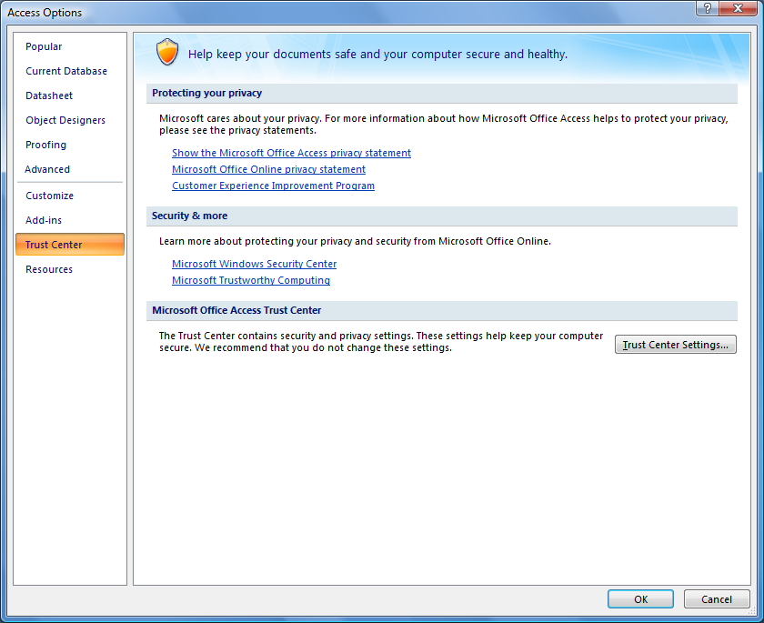Select “Trust Center” and then the “Trust Center Settings” button.

Figure ‑ Access 2007 Trust Center

* Select “Trusted Locations”.
* Check “Allow Trusted Locations on my network”.
* Select “Add new location”.
* Browse to the folder containing JCMS.
* Check “Subfolders of this location are also trusted”.
* Select “OK” to save.

### Configure some Database Options

* 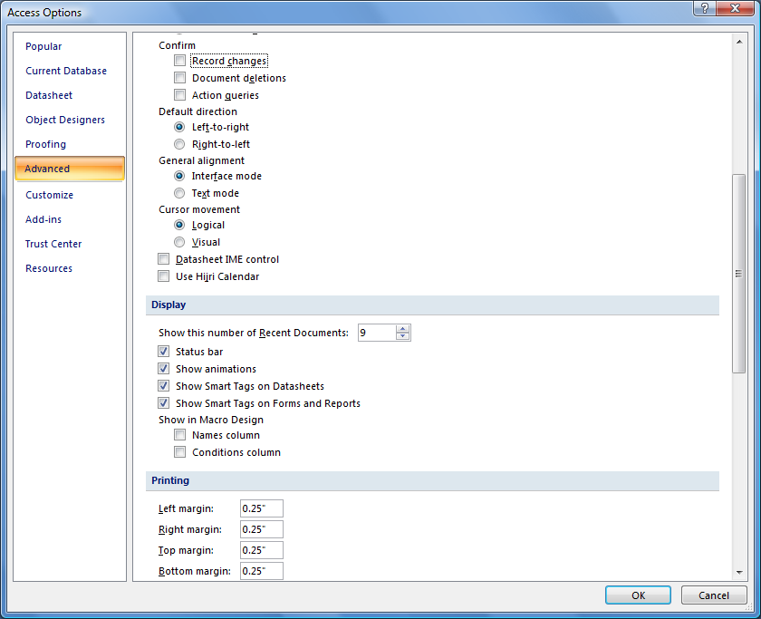In Access 2007, click the Office button, select the Access Options button, and then the Advanced section on the left. Scroll down to the Confirm choices. Make sure the Confirm options are all un-checked as in .
* Scroll further down the Advanced dialog to find the “open databases by using record level locking” and make sure it is not checked ().

Figure ‑ Access 2007 Confirm Options

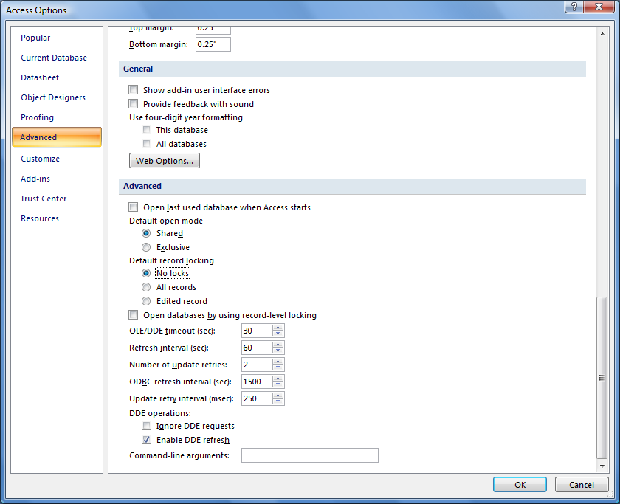

Figure ‑ Access 2007 configure record-level locking

### Creating a Multi-User Environment

JCMS is designed to be used by many people simultaneously (multi-user). To implement this, the database is placed on a computer (server) that all users may access. A copy of the interface may be placed on each user’s computer (client) and the tables are then linked to the database.

However, we recommend that both the MySQL data source and JCMS.mdb (interface) files sit on one central machine (server). Each user’s computer (client) will have a shortcut on the desktop that invokes the JCMS.mdb file through a share folder over the network. That way you don’t have multiple copies of the JCMS.mdb file to maintain. The “best” way to access share folders from clients is by using Uniform Naming Convention (UNC) instead of direct paths with drive letters. Thus if your server machine is named *goofy* and the share folder is named *JCMS_Share* then the UNC would be

\\goofy\JCMS_Share

Often creating a multi-user environment involves moving an existing installation of JCMS onto a server. Therefore, the instructions for moving are included below. These may be skipped if the original installation is on the server and the goal is to create client shortcuts.

### Moving JCMS to a New Location

**Access-MySQL**

1. Install MySQL on the new computer.
2. Dump the MySQL JCMS database on the old machine and move the dump file onto the new machine.
3. Open a terminal and navigate to the directory containing the dump file.
4. In the terminal type in “mysql -uroot -p < dumpFileName.sql” where dumpFileName.sql is the name of the dump file you moved onto the new machine.
5. Relink the tables following the instructions in Configuration Section 2.3.
6. For support please visit our Forums at: http://community.jax.org/jcms_discussion_forum/default.aspx

The standard installation location for the JCMS.mdb file is

C:\Program Files\The Jackson Laboratory\JAX-CMS\interface

If it is installed somewhere else, that’s okay; just adjust the paths accordingly.

### Re-linking the Tables

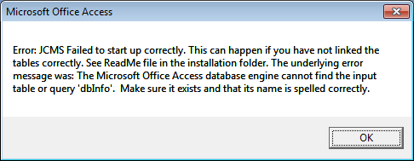

Figure ‑ JCMS Failed to start up correctly.

The message in Figure 2‑12 is displayed when the MySQL database is moved to a new location. Tell JCMS where to find the moved tables by re-linking them.

**Office 2007**

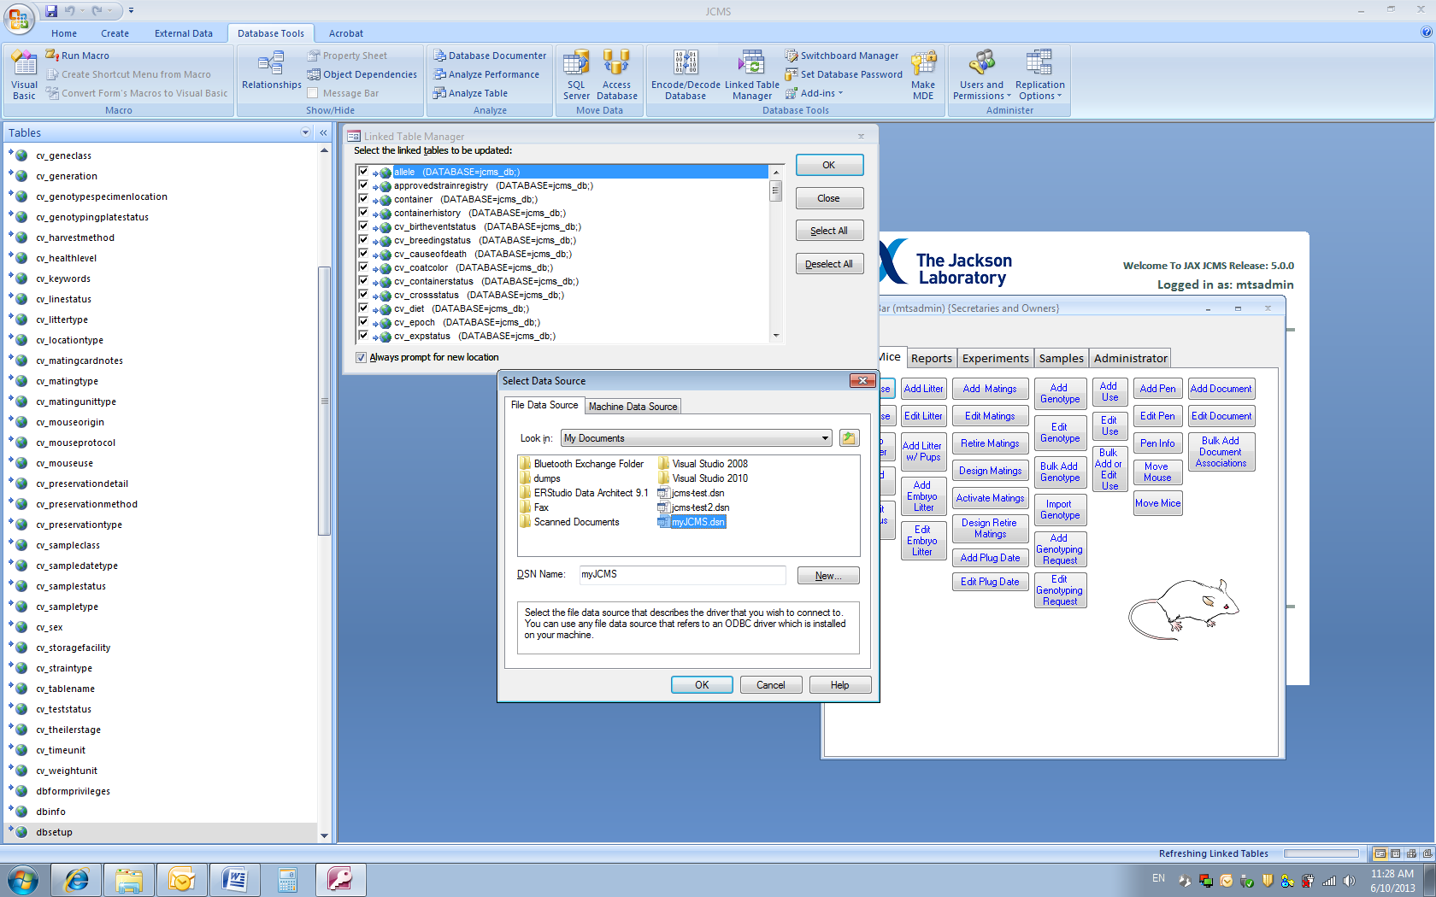

Figure ‑ Office 2007 Linked Table Manager

* Select the “Database Tools” tab
* Select “Linked Table Manager” on the Database Tools ribbon.
* In the Linked Table Manager dialog box, click the “Select All” button.
* Check “Always prompt for new location”
* Select “OK”
* Browse to the new location of the data source; Select “Open”. If using a UNC such as \\goofy\JCMS_Share it may be necessary to type the path.
* Select “OK” and the “Close”

**Office 2010**

In Office 2010 use the External Data tab to find the Linked Table Manager and follow the steps above.

### System.mdw File

When the Administrator creates new users in MS Access, this information is stored in a “workgroup” file called **system.mdw** on the local computer (client). Every time a client computer is added, the Administrator has to set up mtsadmin and the users again in the system.mdw file on the new client machine. MS Access does provide a method of avoiding repeating this setup. The database must use a special workgroup file instead of the default system.mdw. We recommend naming this file JCMS.mdw. This file is set up once on the file server and contains all the users’ MS Access logons. The Administrator can set up a new user from any machine and only has to do it once.

Locate the system.mdw file currently in use, copy it into the JCMS installation folder, and rename it.

Hint: To locate the system.mdw file, use advanced search options to search system folders, hidden files, and subfolders. It can typically be found in:

Windows XP: C:\Documents and settings\<your user name>\Application Data\Microsoft\Access

Vista and Windows 7: C:\Users\<your user name>\AppData\Roaming\Microsoft\Access

### Installing a Multi-User Client

Let’s assume that a copy of the system.mdw file has been put it into the JCMS installation folder and renamed JCMS.mdw. Of course, the mdw file can be put anywhere and named anything you like.

When MS Access is started, it must “know” to use the special workgroup file. There are several ways of implementing this depending on the version of MS Access and if other MS Access applications are in use.

Assuming everything is installed in the standard spot and JCMS_Share is the shared folder, then the next thing to do is create a shortcut for JCMS.mdb that uses the JCMS.mdw workgroup file. This is easy, first create the shortcut (we'll assume you can do that). Open the shortcut properties by right clicking the mouse on the shortcut and select properties. Now just edit the shortcut properties so that the target string in the shortcut will look like this

Target = "C:\Program Files\Microsoft Office\OFFICE12\MSACCESS.EXE" "\\goofy\JCMS_Share\JCMS.mdb" /wrkgrp "\\goofy\JCMS_Share\JCMS.mdw"

Now just put a copy of the shortcut on any client's desktop.

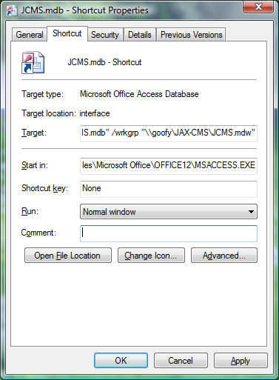

Figure ‑ JCMS client shortcut

Notes:

* The client machine must have MS Access installed on it.

### Backing up

Make sure to have a reliable and routine back up strategy in order to avoid loss of data. See section 22.4 for suggestions.

### Installing the Bar Code 128 Font

JCMS offers optional bar codes on cage cards or for sample labels. To use this feature, Bar Code 128 with a site license from Elfring Fonts Inc. (www.barcodingfonts.com) will need to be installed on any clients that print cage cards, sample labels, or read bar codes. Follow the manufacturer’s installation instructions.

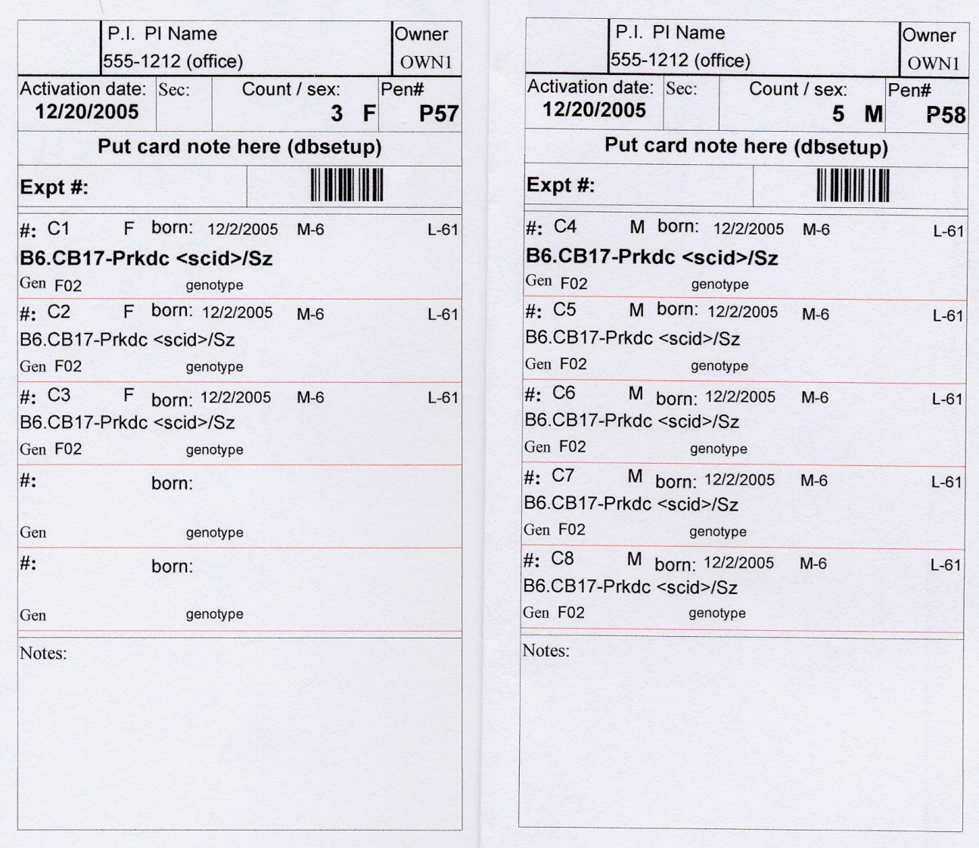

Figure ‑ Sample of a bar code for the pen ID number

### Configuration Issues and Answers to Common Problems

#### **File MSCOMCT2.OCX is missing**

#### **File MSCOMCTL.OCX is missing**

#### **File MSFLXGRD.OCX is missing**

#### **Error messages about DTPicker**

Some versions of MS Access may not have a necessary Windows file installed. The JCMS installer should have installed these files for you. To add the controls to a client machine, look on the JCMS website (<http://colonymanagement.jax.org/support-2/jcms-user-tips/>.) User Tip #4 has a link to download a special installer called JCMS_Controls_v4.1.msi. Run this on all clients with this problem.

#### **When JCMS is started it states the release numbers do not match.**

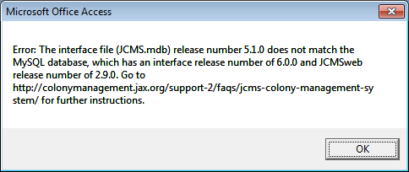

Figure ‑ Error: release numbers don’t match

#### This message indicates that the linked database tables are for a different version of JCMS. There are several possible causes, which include opening an old version of the JCMS access interface, opening a new version of the access interface that needs to have the tables relinked, or that upgrading JCMSweb has upgraded the tables and now an upgraded version of the Access interface is needed. The link to the online [FAQ](http://colonymanagement.jax.org/support-2/faqs/jcms-colony-management-system/) page will provide the most up-to-date instructions.

#### To relink the tables in Access 2007 use the Database Tools tab. The Linked Table Manager is in the Database Tools section of the ribbon. In Access 2010 the Linked Table Manager is found on the External Data tab, Import & Link section.

#### **The MS Access menu bar has virtually no options on it**.

* MS Access has an option that allows menus (such as the tools menu) to be displayed or not. If the menu bar shows only the bare minimum of buttons, then enable full-menus as follows:
  + Close JCMS (if it isn’t already)
  + Start JCMS and hold down the shift key as it is starting up. A full set of menu options should now appear.
  + Go to the Tools/Startup menu option and check the box that says *allow full menus.*

#### **The Welcome window is not displayed**

If all tables have been linked or re-linked and no error messages are displayed at startup it is possible that the startup form needs to be reset.

* Select the “Office button”
* Select “Access Options” button
* Select “Current Database”

In the application options “Display Form” field enter “MTS Welcome”. Select “OK” to save. Close MS Access and start the application again.

#### **I need to delete the tables and the delete button is grayed out**

In MS Access 2010, certain configuration changes may require logging on as Admin, for example, if tables need to be deleted because they were imported instead of linked, that only Admin can perform this function. However, remember that the Admin user is not able to open the regular JCMS forms.

#### **Didn’t find your question here?**

Also check the FAQs in section 21, the online [JCMS Discussion Forum](http://community.jax.org/jcms_discussion_forum/default.aspx), and the online colony management website [FAQs](http://colonymanagement.jax.org/support-2/faqs/jcms-colony-management-system/).

# Administrator Setup

JCMS uses the logon name **mtsadmin** as the database Administrator. Anyone accessing JCMS as mtsadmin can perform Administrator functions in JCMS.

## Owner and Secretary Accounts

JCMS uses a very simple user account system. There are two rules to know.

1. Every user of JCMS must have a logon to MS Access.
2. Each logon name that JCMS uses must be defined as either an owner (of mice) or a secretary. The logon name and the JCMS owner/secretary names must be identical. To add owners and secretaries you must be logged on as mtsadmin.

### Rule 1: Every User of JCMS Must Have a Logon to MS Access.

An Administrator (user *Admin* or *mtsadmin*) can set up new MS Access logon accounts for starting MS Access. Setting up new MS Access accounts is not a JCMS function; it is an MS Access function. JCMS uses the logon name of the user to determine if the user is an owner, secretary, or Administrator (mtsadmin.)

#### **How to Add a New User Logon.**

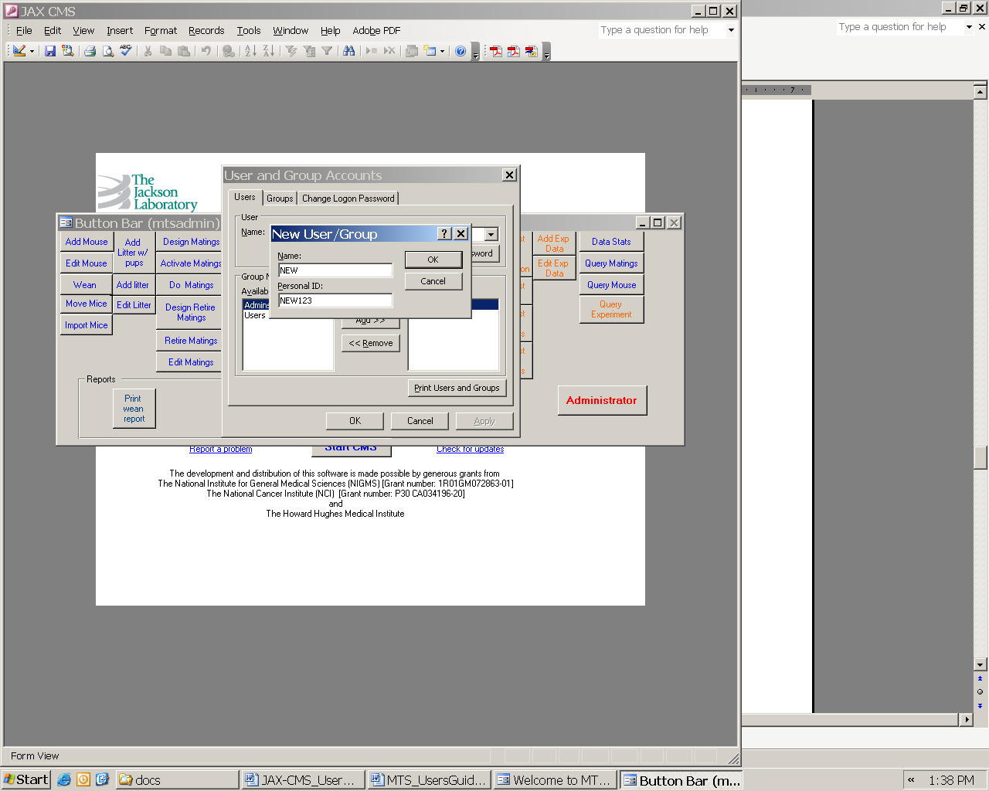

With MS Access running, select the Database Tools tab. In the Administer section of the ribbon select Users and Permissions, and then select User and Group Accounts.

Figure ‑ Dialog Box: Personal ID

Select the Users tab and then the “New” button. Note: the Personal ID (PID) is not used by JCMS at this point. It is recommended to use the logon name also for the personal ID and add numbers as necessary to make it long enough. Keep all logon names short with no spaces, commas, semicolons, or quotes in them; this is especially important for mouse owners since owner logon IDs are stored with each mouse. Do not make owners and secretaries part of the Admins group; they are part of the Users group by default. Users can later set their own passwords by logging on MS Access and setting the password from this same menu. When a user is first added, his/her password is blank.

### Rule 2: Each logon name that JCMS uses must be defined as either an owner (of mice) or a secretary.

This rule applies to owners and secretaries. User mtsadmin is neither an owner nor a secretary. The Administrator needs to tell JCMS if the user is an owner or a secretary or both. Owners own mice, matings, experimental plans, experimental data, and samples. Secretaries are associated with one or more owners and have limited edit access to their associated owner’s data. NOTE: Owners can be secretaries of other owners and thus have limited editing capability for other owners.

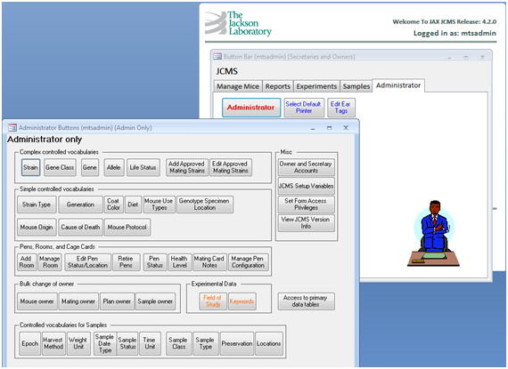

Figure ‑ Form: Administrator Buttons

To set up a user (other than mtsadmin) as an owner or secretary, open JCMS. Open the Administrator button bar from the Administrator tab and select the button labeled *Owner and Secretary Accounts*. From this account maintenance form owners and secretaries can be added or deleted (see example below.)

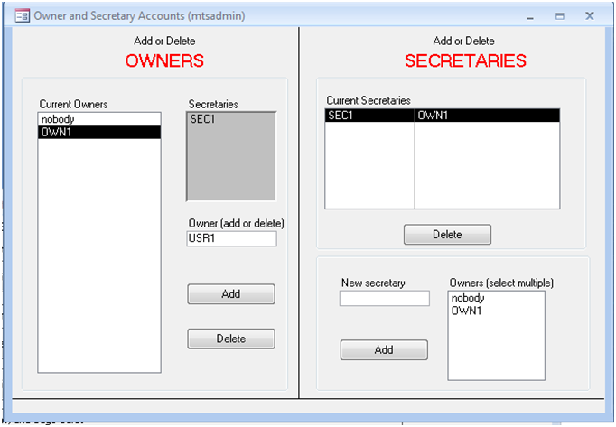

Figure ‑ Form: Owner and Secretary Accounts

NOTE: the names entered in this form must agree exactly with the names used for logging on to JCMS. NOTE also, do not delete owners that have mice in JCMS as their mice will no longer be accessible (unless you add the owner back using this form). Bulk changes of the owner of mice, matings, samples, and experimental plans may be done using the buttons provided on the Administrator button bar.

## Changing the Forms Used by Secretaries and Owners

JCMS allows the Administrator to configure access to the forms in the interface by the type of user. For example, secretary users may be set up to only use certain add forms and none of the edit forms. Note that some forms are required by JCMS to be available to all users or only to the Administrator.

To change the access or “privilege” level for one or more forms, use the Set Form Access Privileges button on the Administrator button bar.

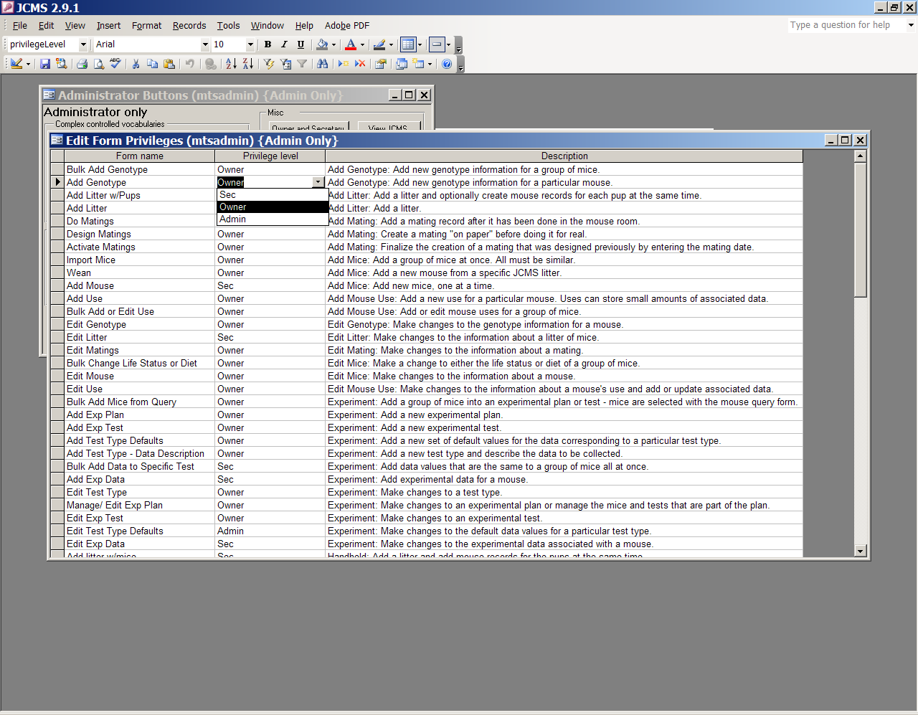

Figure ‑ Form: Edit Form Privileges

All forms listed may have the access privilege level changed to secretary (Sec), owner (Owner), or Administrator (Admin). The Administrator may use any form; owner level forms are restricted to only owners or the Administrator; secretary level forms may be used by secretaries, owners, and the Administrator. Any change made to the access privilege level for a form will NOT take effect immediately. You must quit and restart JCMS for the change to be implemented.

## Initializing Controlled Value (CV) Tables

Before any mice can be added into the database, values for certain required fields must be established. These values are kept in a set of tables referred to as the controlled value or CV tables. A few of the very simplest controlled vocabularies are stored in the user interface forms instead of in tables and cannot be changed (for example, sex can only be “m”, “f”, or “-“).

Controlled vocabularies are changed from the **Administrator** button bar (see Figure 3‑2) and may only be changed by the mtsadmin user.

### Simple Controlled Value Tables

The **Strain Type, Generation, Coat Color, Diet, Genotype Specimen Location, Mating Card Notes, Mouse Origin, Cause of Death, Mouse Protocol, Field of Study,** and **Keywords** buttons each open a table for adding or deleting choices from the lists. These lists of choices appear in pull-down menus on many forms. These simple CV terms should be kept minimal in length since they are copied into the database records.

The following list shows all JCMS simple controlled vocabulary tables.

* Generation: valid mouse generation terms (e.g. F1)
* Diet: list of diets (e.g. 4%)
* Coat Color: list of valid coat color names
* Genotype Specimen Location: specifies where genotype samples are located (e.g. a freezer number)
* Cause Of Death: terms that a user can select to specify why a mouse died
* Mating Card Notes: some mating cards allow notes to be printed on them
* Mouse Origin: list of terms that specify where mice can originate, including the local colony. Every mouse has an origin. When mice are brought in from other institutions, they too should be listed in this table.
* Strain Type: Used in the strain table to specify the type of strain (e.g. congenic)
* Mouse Protocol: Some institutions need to link mice to protocol numbers
* Field of Study: Used to associate experimental plans with each other
* Keywords: Used to describe an experimental plan and may include keywords used for publication of the results

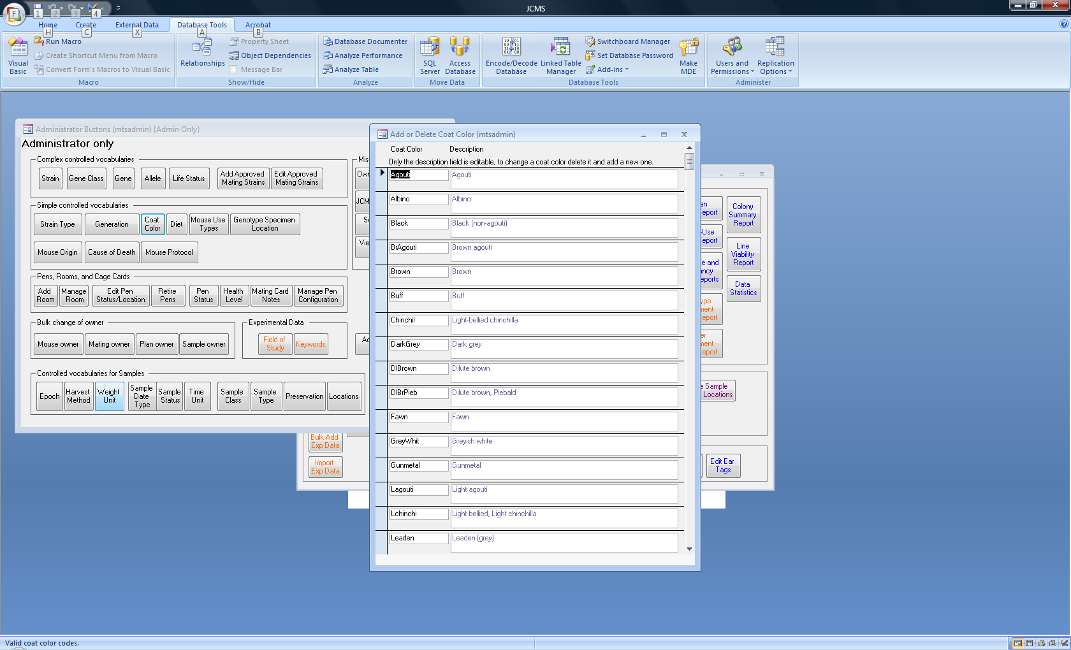

Figure ‑ Sample Simple CV Table

A value in the simple controlled vocabulary tables cannot be changed, instead add or delete a value. Thus, to change a value in one of the tables, delete it, and then add the value back with the change. Deleting a choice will not remove it from any data records where it has already been used within the database; the choice is simply removed from the list of current possible choices.

IMPORTANT NOTE: think carefully before deleting (or changing) a controlled vocabulary value if it has already been used. Controlled vocabularies may be used in queries, and thus the ability to find records based on a CV term may be lost if the term is deleted. This could result in a loss of what is known in database terminology as referential integrity, a mortal sin in relational database systems. This means that some data items will reference no longer existing data objects (the deleted CV term) resulting in undefined consequences.

**To add a choice** to a table, scroll to the bottom of the list. Type the new choice into the blank space at the bottom.

**To delete a choice** from the table, click on the box at the left side of the row in the table. The whole row will be highlighted. Press the delete key. A dialog box will ask for confirmation that the record should be deleted.

Some of the CV tables have two fields, the choice and a description. This description field may be edited.

DATA CONSTRAINTS on CV terms: CV terms **cannot** contain single or double quote characters, commas or semicolons. Thus, “Fred’s chair” would be illegal because of the “ and ’ symbols.

Some CV tables also come with pre-set values that may be deleted or added to.

Figure ‑ Forms: Default Strain Types and Generations

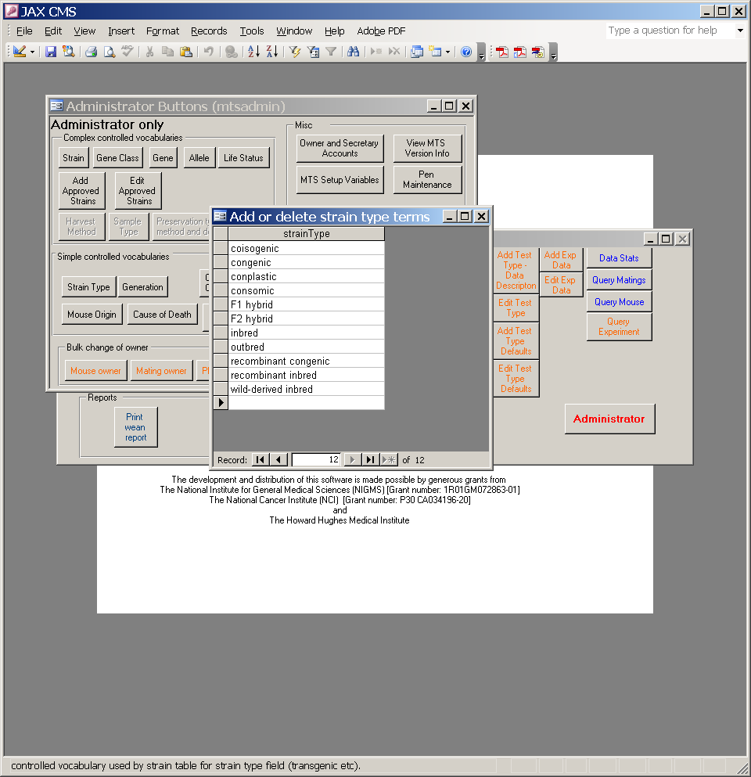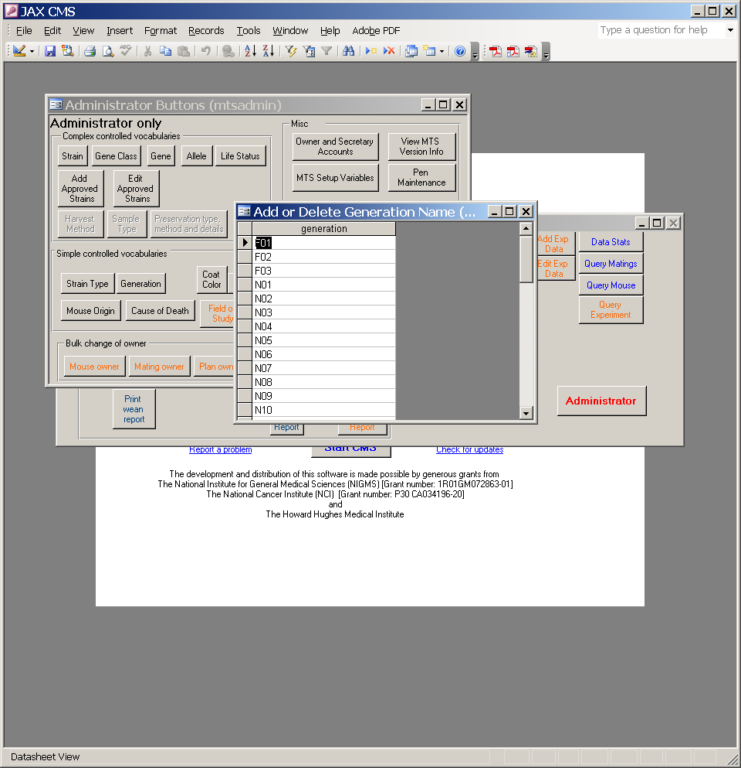

Generations go up to N30.

The **Strain, Gene Class, Gene, Allele, and Life Status buttons** open forms that are more complicated than those used for maintaining the simple CV tables described above. These are described in more detail below. **Owner and Secretary Accounts** are described above. Other sections are dedicated to the Pen, Room, and Cage Card terms and the Samples terms.

### Strain Table

Strain names often use unusual characters to delimit fields in the strain name. Some characters may confuse some of the JCMS displays. It is best to avoid using the following characters in the strain names: double quote (“), single quote (‘), and comma (,).

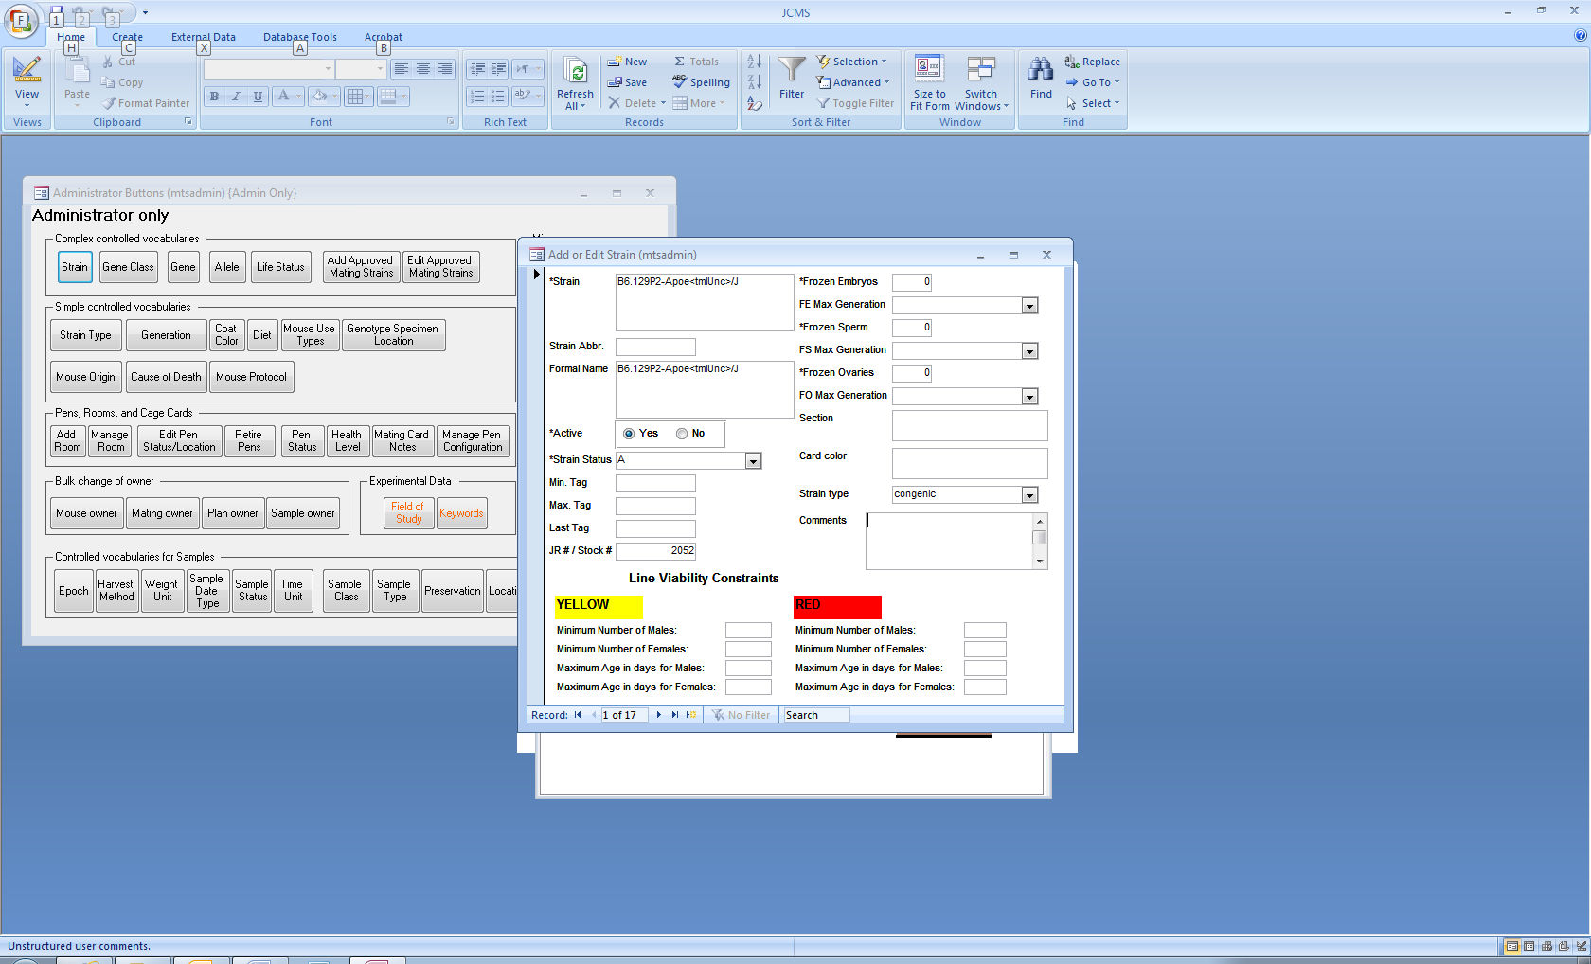

Figure ‑ Form: Add or Edit Strains

There are three “name” fields in each strain record: Strain, Abbreviation, and Formal Name. Currently, JCMS only uses the “Strain” field. The other two fields can have information added to them for reference purposes, but it will not be used anywhere in the JCMS system.

By default, a strain is active. Set *active* to “No” if a strain is no longer in use. Some of the add forms have an option to display only active strains as choices. A strain may be changed back to active when it is in use again. Note that the *strain status* of A (active), F (frozen), D (discarded), and C (see comments) is not used to limit the strains displayed as choices.

Use the navigation buttons to move from one strain to another. The strains are listed in alphabetical order. Or click in the strain field and use the find icon (it looks like binoculars) to search for a particular strain. If the exact strain is not known, use the “Match start of field” option.

To **add a strain**, click on**\*** or move to the last record. Only the strain name and status are required. The strain will not be added unless values are entered into those fields. Adding will occur when you navigate to another existing record or press **\*** to move to a new record.

To **edit a strain,** type in the field and change it. If a mistake is made, undo using the standard undo icon. Note that pressing the ESC key acts the same as the undo icon.

You cannot **delete a strain** from the database unless it is not associated with any matings or mice. If the strain name is incorrect, edit the name. Everywhere in the database where this strain is used, the name will change.

The strain name field contains the name that will appear for all the mice or litters. The strain abbreviation is the shorthand that may be used to refer to this strain within a user group. The formal name is the one assigned by the nomenclature committee. JR # stands for Jackson Laboratory Resource number. Stock # and JR # is the same field. This field may also be called JRnum. Users may enter their own stock # when not using Jackson Laboratory strains or leave the number as 0 if not using a numbering system. This number is always associated with a particular mouse strain. The strain nomenclature may change over time, but the Stock # will remain the same. The Stock # may be useful in the future to look up nomenclature changes to the strain name. Additional data is stored about whether or not frozen embryos, sperm, and ovaries are available.

#### Strain table fields

* Strain: name of strain as it will appear on JCMS forms and reports
* Formal Name: formal name of the strain assigned by the nomenclature committee
* Strain Abbr.: a short string abbreviation for the strain name for use in lab only
* Active: indicates if this strain is available to use (yes/no)
* Strain status: a controlled vocabulary that specifies how the strain is currently maintained (e.g., frozen, on shelf, etc.)
* Min tag, Max tag, Last tag: specifies ear tag numbers as discussed below
* JR # / Stock # / JRnum: the Jackson Laboratory Resource Number or user’s stock number
* Frozen Embryo: number of frozen embryos
* FE Max Gen: maximum generation stored as frozen embryo
* Frozen Sperm: quantity of frozen sperm
* FS Max Gen: maximum generation stored as frozen sperm
* Frozen ovaries: number of frozen ovaries
* FO Max Gen: maximum generation stored as frozen ovaries
* Section: section number in the mouse room where this strain is kept
* Card color: color of cage cards used for this strain (displayed on several forms from which cage cards are printed)
* Strain type: from Strain Type controlled vocabulary table, a term that specifies this strain type such as “congenic”
* Comments: free form text
* For *Line Viability Constraints* values, see the next section: **Mouse Line Viability**.

### Mouse Line Viability

The mouse line viability function provides the colony manager the ability to configure warning levels when the breeders in her colony are:

* approaching a critical age threshold or
* when the numbers of potential breeders have fallen below certain thresholds.

Thresholds are set at the strain level. Therefore the configuration is done by the super user, *mtsadmin*, within the Strain controlled vocabulary function.

The **Strain** configuration function is accessible from the **Administrator** button bar.

There are two levels of thresholds: yellow (warning) and red (dire).

To bring up the report, click on the **Line Viability Report** button on the reports tab.

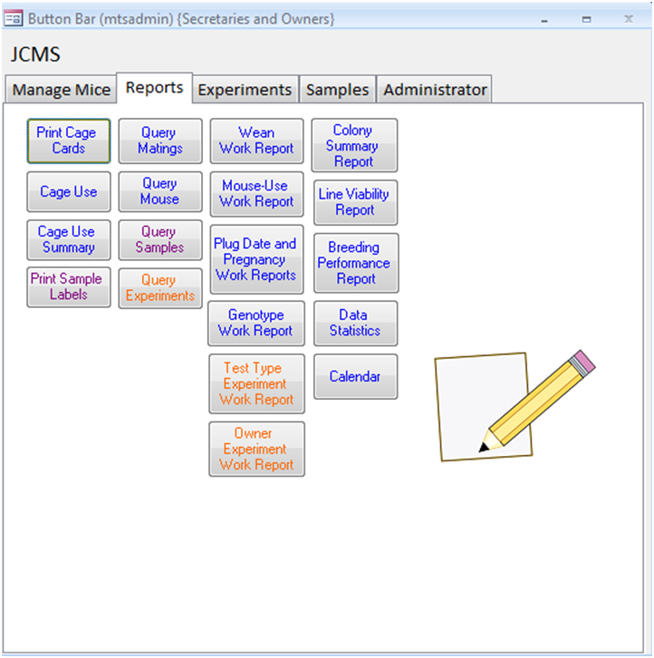

Figure 3‑8 Open Mouse Line Viability Report

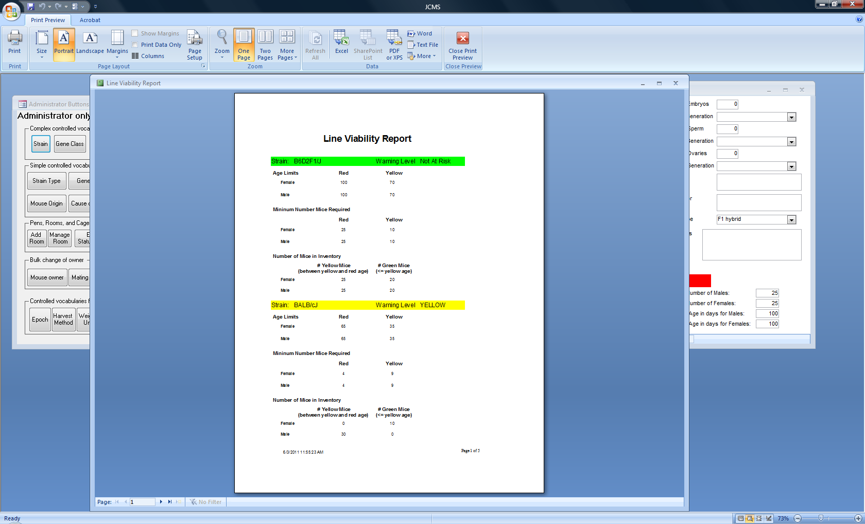

Figure ‑ Example mouse line viability report

### Ear Tag Ranges

If the pups from a particular strain are all given ear tags from a pre-set group of tags, then the ear tag ranges can be used to keep track of which ear tags are used as a function of strain. This range is called the **minimum tag** and **maximum tag**. The **last tag** field is used to record the highest tag number from that range that is currently in use.

To update the ear tag range, use the **Edit Ear Tags button** on the Administrator tab. To find the correct strain, use the navigation buttons or click in the strain field and use the find icon (it looks like binoculars). If you do not know the exact strain, use the “Match start of field” option.

If a range has been completely used, either blank it out (if no new range has been assigned) or enter the new range, replacing the old one.

All fields in the strain table, with the exception of the strain, stock #, section, and color fields are simply for user tracking purposes. The four fields that JCMS uses may be printed on cage cards, or will show up in pull down lists.

There are two places where ear tag ranges may be entered. To eliminate this redundancy, it is proposed to eliminate the Edit Ear Tag ranges form. If this form is important to you, please send a message to jaxcms@lists.jax.org as soon as possible.

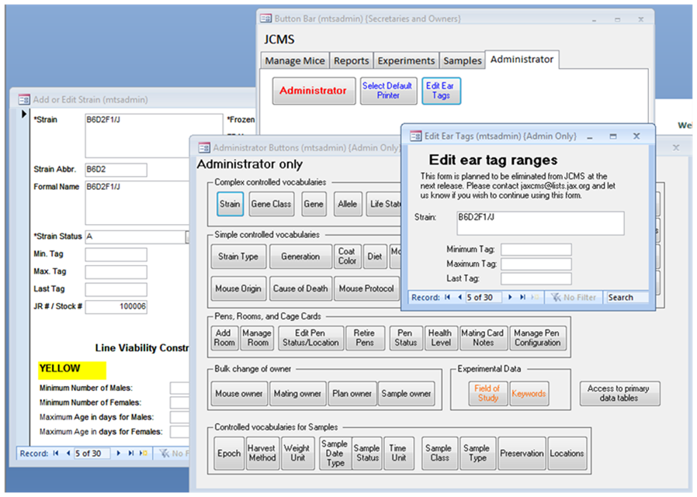

A

B1

B2

Method A: use the edit ear tags button (A) on the Administrator tab.

Figure 3‑10 Ear tag ranges

Method B: use the Administrator button (B1) on the Administrator tab and then the Strain button (B2) to open the Edit strain form.

### Approved Strains for Matings

The JCMS Administrator has the ability to create a table of approved litter strains to limit the mating forms to pre-approved strains. This will establish better breeding control and prevent inadvertent errors. If necessary, the user is able to override the restriction. To implement using approved strains, the Administrator must change JCMS_ENFORCE_APPROVED_MATINGS in the setup variables to “True”.

An approved litter strain field is a function of the dam strain and the sire strain. A sire strain and dam strain combination is **not** unique. That is, a sire and dam strain combination may result in multiple litter strains. The special case of when the sire and dam strains are the same will result in that strain always being ‘approved’ and need not be entered in the database. Click the **Add combination** button to create a new approved strain.

The **New combination w/ reversed parent strains** button tells the software to reverse the dam and sire strains and create a new record in the database, that is, switch the dam and sire strains but produce the same litter strain. This must be done to make that combination also valid.

The **Swap dam/sire** button is a convenience that will reverse the strains listed in the Dam Strain and Sire Strain boxes.

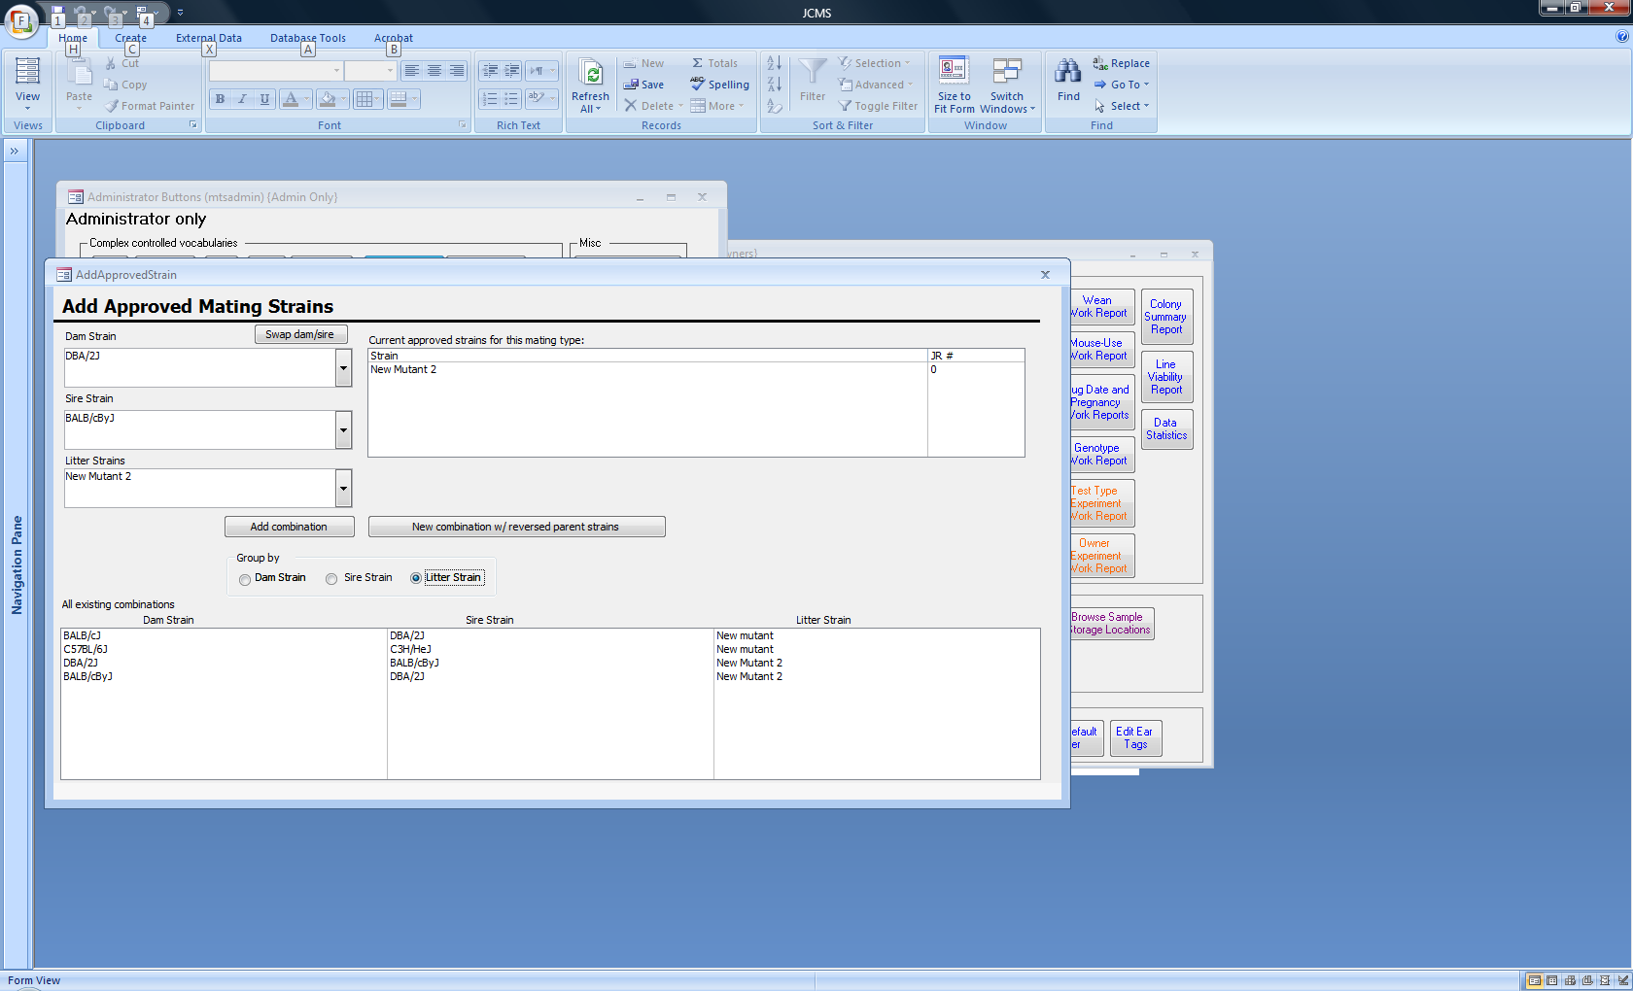

Figure ‑ Add Approved Strain Form

Approved strainrecords can be active or inactive. Inactive records are ignored as candidates for litter strains. They are kept in the database for documentation purposes and possible future use.

Use the **Edit Approved Strains** button to make combinations inactive or to delete combinations.

### Life Status

The life status controlled vocabulary has three fields. The first field is the lifeStatus field. Use one or two letter entries to specify a life status. The second field gives a description of the life status so users will know which one to select from pull-down menus. The third field, “exitStatus” is a Boolean (true or false) field that specifies if the associated life status implies that the mouse has exited the colony. JCMS uses this Boolean value to enforce rules about whether or not a cause of death or an exit date may be entered. JCMS will prevent entering an exit date if the mouse life status is not an exit status.

The Life Status controlled vocabulary table must include the following pre-set terms in order for JCMS to work correctly.

|  |  |  |
| --- | --- | --- |
| Vocabulary term | Description | Exit status? |
| A | Alive | no |
| K | Killed | yes |
| D | Dead | yes |
| M | Missing | yes |
| S | Shipped | yes |

### Gene, Gene Class, and Allele Tables

In the database, alleles are associated with specific genes or gene classes. The JCMS forms that display alleles that may be associated with a gene use both criteria (association to the gene and association to the gene class) to come up with a list of alleles that may be associated with a given gene.

Any mouse or sample may have several genotypes. Each genotype consists of a gene and the two alleles that were found for that gene.

#### **Genes**

In order to set up a genotype for a mouse or sample, **first the gene must be entered** into the database.

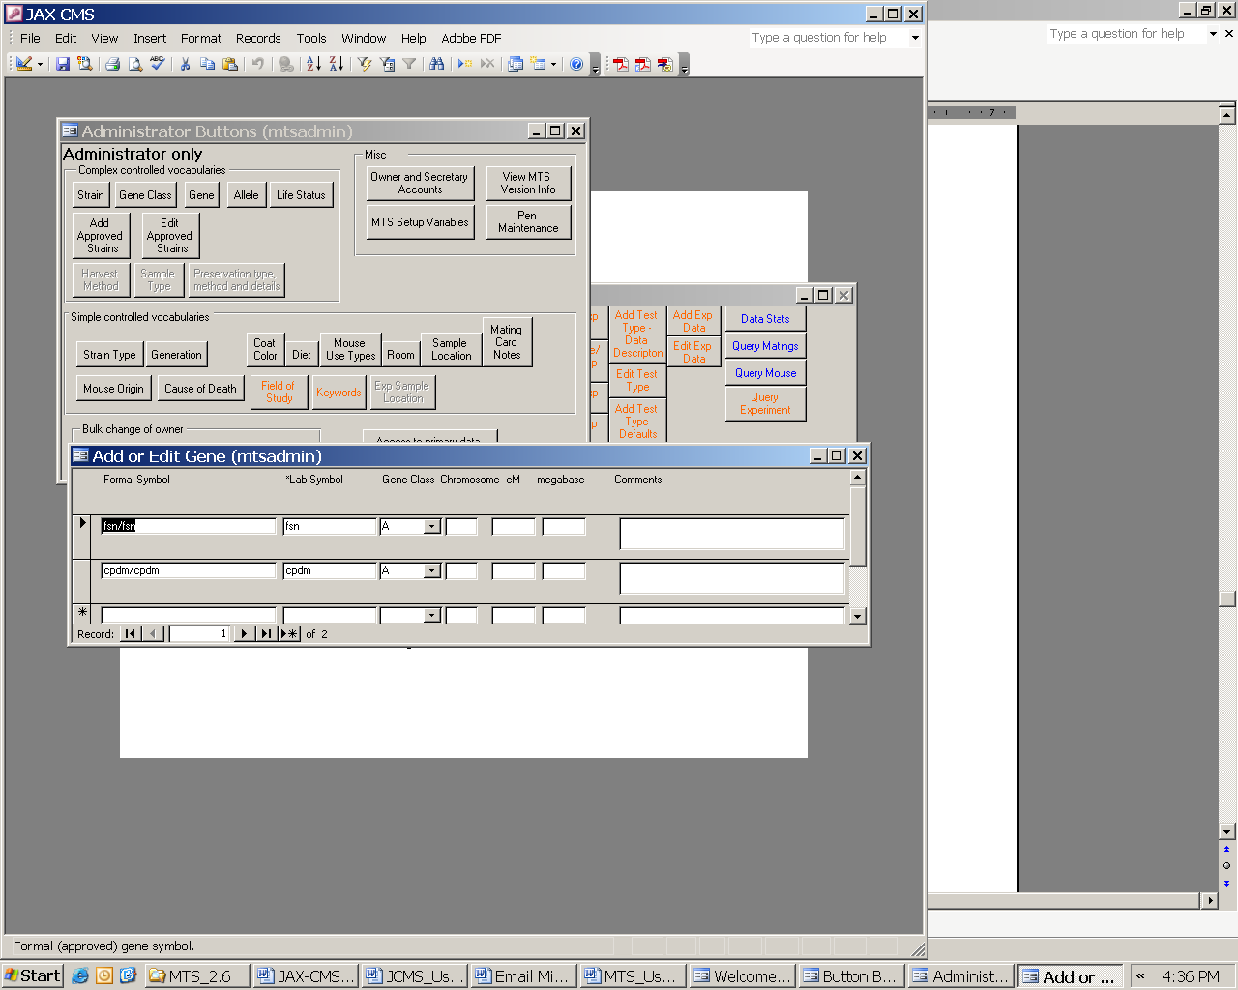

Figure ‑ Form: Add or Edit Gene

The gene table will be shown as a form. Genes may only be added or edited, not deleted. The field called “Lab symbol” is the gene name that will be used when setting up alleles and genotypes. Gene class is optional. Certain gene classes have been preset. Any new gene classes should be added before the gene is added.

To **add a gene**, scroll to the bottom of the list on the form and enter the new gene into the empty bottom row or use the navigation buttons to move to a new record. The formal symbol and lab symbol are required and the gene will not be added unless values are entered in them. Adding will occur after clicking in a field that is not part of this row.

To **edit a gene,** type in the field that should be changed. If a mistake is made, pressing the ESC key once will revert that field back to the original value. Pressing the ESC key twice in a row will revert the whole record back to the original values.

**A gene cannot be** **deleted** from the database. If the gene name is incorrect, edit the name. Everywhere in the database where this gene is used, the name will change.

#### **Gene classes**

Gene classes are stored as a controlled vocabulary in a controlled vocabulary table. As with all controlled vocabularies, do not delete or change a gene class term unless no records in the database use that term.

The following Gene Class values are preset. These terms may be used to further describe a specific gene. Note that if alleles are assigned to a gene class, all genes in that class are able to have that allele.

| *Class name* | *Comments* |
| --- | --- |
| E | endogenous |
| MKO | multi allele knock out |
| MTG | multi allele transgene |
| TG | transgene |
| KO | knock out |
| KI | knock in |
| Floxed | tissue specific knock out |
| CTK | Combination transgene + KO |
|  |  |

#### **Alleles**

Once a gene is added, the list of possible alleles for this gene must be entered into the allele table. Click on the **allele button** on the Administrator button bar to open the add or delete allele form. Alleles may be associated with either a specific *gene* or a particular *gene class*. If an allele is associated with a gene class it will also be associated with all genes of that class. The user can select which association to use by clicking the appropriate radio button in the “Associate allele with” group box.

To associate an allele with a gene, enter the lab gene symbol and the list of alleles already available for this gene will appear. To add another allele to the list, type it into the new allele field and click the submit button. To remove an allele from the list, check the delete box, type the name of the allele to delete into the “new allele” box, and press the submit button (or double click the allele name in the list box and the name of the allele will appear in the “new allele” box).

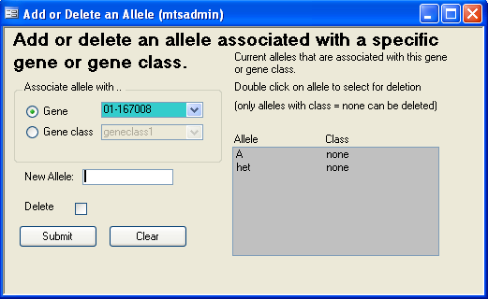

Figure ‑ Form: Add or Delete an Allele

#### **Generic alleles**

To save time entering alleles, it is possible to create generic alleles that are available for a whole gene class. These alleles will be automatically available as a choice for any gene that is associated with this gene class.

To associate an allele with a gene class, click on the “Gene class” radio button and perform the same operations as described above.

NOTE: Allele names cannot be edited and an allele that is associated with a gene class cannot be deleted.

NOTE: Since each genotype record links to a record in the gene table, changes to a gene name will be reflected in the genotype records that “point” to the gene. Allele names, on the other hand, are stored directly in each genotype record (not pointed to by a genotype record). If there ever is a need to search for mice based on specific alleles, then those alleles must still exist in the Allele table. Otherwise they will not be found. Therefore, those allele terms should not be deleted, even if no longer in use.

After the gene and alleles have been entered, this gene can be used for any mouse or sample.

### Rooms, Health Level, and Pens

See section 7 on Pens and Cage Cards for details on setting up room names, health levels, and pens. Section 3.5 Cage Card Setup explains the details of the different cage cards that are provided and how to create custom cards.

### Mouse Use Types

Mouse use types consist of a list of terms that specify a mouse use (e.g. clinical exam). These terms are used in the Mouse Usage table and by the add and edit mouse use forms, add plug date form, and the mouse use calendar.

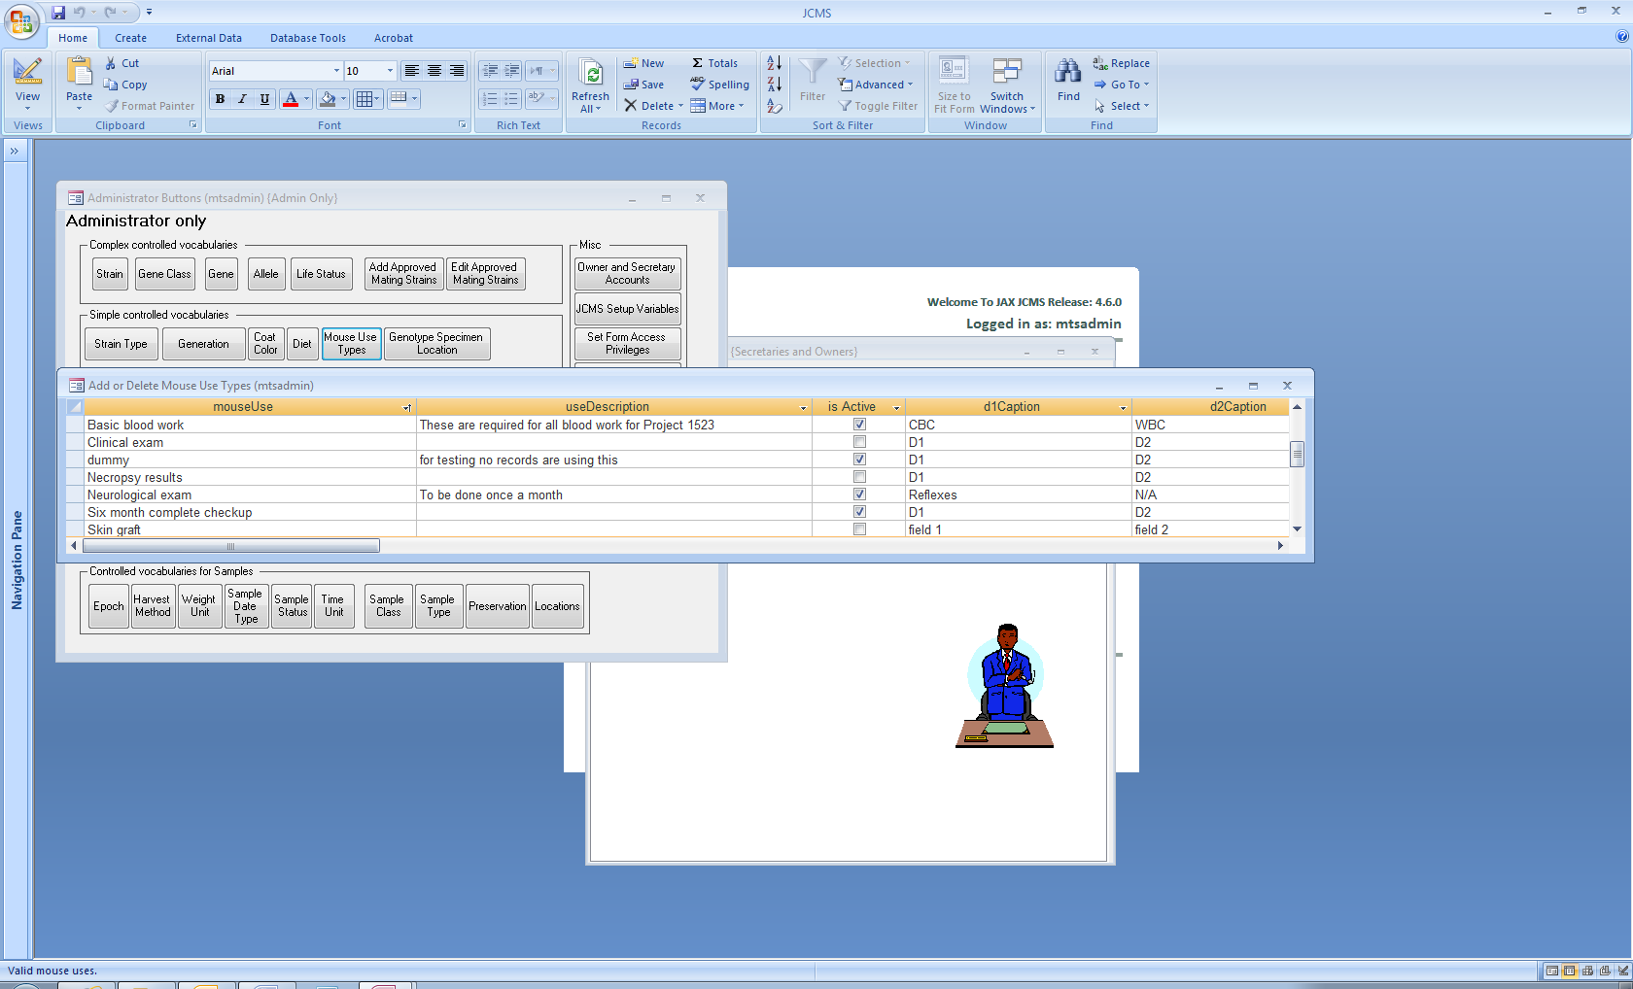

Figure ‑ Add or delete mouse use types

On the Administrator button bar, click the Mouse Use Types button. An existing mouse use term may not be edited. It may be deleted if it is not in use by any mice. All the other fields on the form may be edited.

When a mouse use is no longer needed, set it to no longer be active (uncheck “is Active”). Mouse use terms that are not active will not be shown on the drop-down list of choices to use for a term when adding. It will still be a choice for reporting and editing so older data can be found.

Captions to use for the D1, D2, … D10 data fields can be entered for the mouse use term. Any data field with no caption (i.e. possibly not needed) will automatically be set to D1, D2, …D10. The caption may not be blank. The captions can be edited.

## Setup Variables Table (DbSetup) for Customizing the Installation

JCMS has a setup variables table that allows easy customization of each installation. The Administrator (mtsadmin) can change configuration variables from the **JCMS Setup Variables** button on the Administrator button bar. **Some of these variables should be initialized; those are marked below in bold print.** The others may be left at the default and changed later once the users are more familiar with the database. See section 3.5.4 on creating custom cage cards for a list and examples of the standard cage card choices. Section 7.1 Manage Pen Configuration explains the form interface used to change the settings of the setup variables used for pens, rooms, and cage cards.

| **JCMS Setup Variable name** | | | | | | | | | | **Value** | **Description** |
| --- | --- | --- | --- | --- | --- | --- | --- | --- | --- | --- | --- |
| JCMS_ACTIVATE_MATINGS_INCREMENT | | | | | | | | | | false | true or false; if true the mating ID is automatically incremented after activating a mating. May be overridden on the form. |
| JCMS_ADD_AT_WEAN_INCREMENT | | | | | | | | | | false | true or false; if true the mouse ID is automatically incremented after adding a mouse at weaning. May be overridden on the form. |
| JCMS_ADD_GENOTYPE_INCREMENT | | | | | | | | | | false | true or false; if true the mouse ID is automatically incremented after adding a genotype. May be overridden on the form. |
| JCMS_ADD_LITTER_INCREMENT | | | | | | | | | | false | true or false; if true the litter ID is automatically incremented after adding a litter. May be overridden on the form. |
| JCMS_ADD_LITTER_PUPS_INCREMENT | | | | | | | | | | false | true or false; if true the litter ID is automatically incremented after adding a litter with pups. May be overridden on the form. |
| JCMS_ADD_MOUSE_INCREMENT | | | | | | | | | | false | true or false; if true the mouse ID is automatically incremented after adding a mouse. May be overridden on the form. |
| JCMS_ADD_MOUSE_USE_INCREMENT | | | | | | | | | | false | true or false; if true the mouse ID is automatically incremented after adding a mouse use. May be overridden on the form. |
| JCMS_ALLELE_CONF_HIGH | | | | | | | | | |  | Character(s) displayed/printed as part of a genotype to indicate high confidence in an allele. May be blank. |
| JCMS_ALLELE_CONF_LOW | | | | | | | | | | ? | Character(s) displayed/printed as part of a genotype to indicate low confidence in an allele. May be blank. Ex: use ? To display Abc +?/+? For low confidence in both alleles. |
| JCMS_ALLELE_GENE_SEPARATORS | | | | | | | | | |  | Specify separators to display around the alleles. Ex: specify [] to get Abc[+/+] or leave blank for Abc +/+ |
| JCMS_ALLOW_USERDEFINED_GENERATIONS | | | | | | | | | | false | true or false; If true user may add generations to the Generations table on the fly. |
| JCMS_ALLOW_USERDEFINED_STRAINS | | | | | | | | | | false | true or false; If true user may add strains to the Strains table (via the Strains form) on the fly. |
| JCMS_AUTOINCREMENT_GENERATION | | | | | | | | | | false | true or false; If true the generation for a litter will be automatically incremented when creating matings. May be overridden on the form. |
| JCMS_AUTO_RETIRE_MATINGS | | | | | | | | | | true | true or false; If true automatically retire a mating when the sire and dam(s) all have an exit life status. |
| JCMS_AUTO_RETIRE_PENS | | | | | | | | | | false | Automatically retire a pen when it becomes empty or all occupants are not alive. |
| JCMS_BILL_PARTIAL_FIRST_DAY | | | | | | | | | | false | A pen is counted for billing on the day it is created or moved into a room. |
| JCMS_BILL_PARTIAL_LAST_DAY | | | | | | | | | | false | A pen is counted for billing on the day it is retired or moved out of a room. |
| JCMS_CREATE_PEN_INCREMENT | | | | | | | | | | false | true or false; if true the pen ID is automatically incremented when adding new pens. |
| JCMS_DATABASE_DBMS | | | | | | | | | | MSAccess | Name of the database management system. Valid values are MSAccess or MySQL. Required for MySQL to function properly. |
| **JCMS_DATA_FILE_DIRECTORY** | | | | | | | | | |  | The root directory where JCMS documents (files for images, Excel, Word, etc.) are stored |
| JCMS_DAYS_TO_GENOTYPE | | | | | | | | | | 14 | The number of days from the birth date to when the pups should be genotyped. |
| JCMS_DEFAULT_CONTAINER_STATUS | | | | | | | | | | active | Specify the default value for pen status; must match a value in the pen status table. |
| JCMS_DEFAULT_EXIT_TERM | | | | | | | | | | E | Specify the default term used when exiting mice from the colony, usually E or K; must match a value in the life status table. May be overridden on forms. |
| JCMS_DESIGN_RETIRE_MATINGS_INCREMENT | | | | | | | | | | false | true or false; if true the mating ID is automatically incremented when using the design retire mating form. May be overridden on the form. |
| JCMS_EDIT_LITTER_INCREMENT | | | | | | | | | | false | true or false; if true the litter ID is automatically incremented after editing a litter. May be overridden on the form. |
| JCMS_EDIT_MOUSE_INCREMENT | | | | | | | | | | false | true or false; if true the mouse ID is automatically incremented after editing a mouse. May be overridden on the form. |
| JCMS_EDIT_MOUSE_USE_INCREMENT | | | | | | | | | | false | true or false; if true the mouse ID is automatically incremented after editing a use. May be overridden on the form. |
| JCMS_ENABLE_GENOTYPE_IMPORT | | | | | | | | | | true | true or false; must be set to true to allow importing genotypes. |
| JCMS_ENFORCE_APPROVED_MATINGS | | | | | | | | | | false | true or false; if true then user is only allowed to set litter strain to pre-approved strains. May be overridden on the form. |
| JCMS_ENFORCE_PASSWORD_CHANGE | | | | | | | | | | false | Tells application whether to remind user whether to change password after password change period has elapsed (used by JCMSWeb) |
| JCMS_EXT_WEAN_TIME | | | | | | | | | | 28 | the number of days from the birth date to when a litter should be weaned - used for late weanings/"long" wean time. |
| JCMS_FEMALES_FIRST | | | | | | | | | | true | true or false; if true females are the first to be assigned mouse IDs when adding mice with a bulk add. |
| JCMS_GENERATION_INCREMENT_RIGHTMOST | | | | | | | | | | true | true or false; if true, increment the rightmost numeric portion of the generation; if false the leftmost. |
| JCMS_GESTATION_PERIOD | | | | | | | | | | 21 | The length of gestation (pregnancy) is used to determine when plug dates expire. |
| JCMS_IMPORT_EXP_DATA_ALLOW_MULTIPLE | | | | | | | | | | false | If importing with NO experimental plan, allow more than one record for a test type/mouse combination. |
| JCMS_IMPORT_EXP_DATA_MICE_MUST_BE_PRESELECTED | | | | | | | | | | true | true or false; if false, any mouse IDs not pre-selected will be automatically added to the plan and test. |
| JCMS_JAXLAB_INSTALLATION | | | | | | | | | | false | Is this a Jackson Laboratory installation. |
| JCMS_JAX_ACCOUNT_NUMBER | | | | | | | 12.210.3163.56048 | | | | The value to submit in every export-to-TGS file as the  “JAX Account #”. |
| JCMS_LITTERID_INCREMENT_RIGHTMOST | | | | | | | | | | true | true or false; if true, increment the rightmost numeric portion of the litter ID; if false the leftmost. |
| JCMS_LOOP_LITTER_NUMBERS | | | | | | | | | | true | true or false; if true the litter numbers recycle after 10 litters, appending a character to the number. |
| JCMS_MAX_IMPORT_EXP_DATA_ERRORS | | | | | | | | | | 10 | Import Experimental data; when this number of errors is reached, verification stops and a report is printed. |
| JCMS_MOUSEID_INCREMENT_RIGHTMOST | | | | | | | | | | true | true or false; if true, increment the rightmost numeric portion of the mouse ID; if false the leftmost. |
| JCMS_MTS_IMPORT_PATH | | | | | | | | | | C:\ | The file path to default to for non-TGS imports via the ‘Import Genotype’ button. |
| JCMS_MySQL_DATABASE_NAME | | | | | | | | | | jcms_db | The name of your MySQL database. |
| JCMS_MYSQL_DRIVER | | | {MySQL ODBC 3.51 Driver} | | | | | | | | The name of your MySQL driver. |
| JCMS_MYSQL_SERVER | | | | | | | | | | localhost | The name of your MySQL server. |
| JCMS_MYSQL_USER_ID | | | | | | | | | | root | The name of your MySQL user ID. |
| JCMS_PASSWORD_CHANGE_PERIOD | | | | | | | | | | 90 | The number of days between a user changing and being reminded to change their password (used by JCMSWeb) |
| JCMS_PEN_NAMES_INCREMENT_RIGHTMOST | | | | | | | | | | true | true or false; if true, increment the rightmost numeric portion of the pen name; if false the leftmost. |
| JCMS_PRINT_EXITED_MICE_ON_CAGE_CARDS | | | | | | | | | | true | true or false; if true, mice with an exit status such as dead, euthanized, missing, shipped, etc. will print on cage cards. |
| JCMS_RETIRE_MATINGS_INCREMENT | | | | | | | | | | false | true or false; if true the mating ID is automatically incremented after retiring a mating. May be overridden on the form. |
| JCMS_SAMPLE_LABEL_REPORT | | | | | | | | PrintSampleLabels | | | The name of the report used to print sample labels from the Print Sample Label form |
| JCMS_SORT_BY_PEN_NAME | | | | | | | | | | False | Causes lists with pen ID and pen name to sort alphabetically by pen name instead of pen ID. |
| JCMS_STANDARD_WEAN_TIME | | | | | | | | | | 18 | the number of days from the birth date to when a litter should normally be weaned. |
| JCMS_STRAINNAME_FIRST | | | | | | | | | | true | true or false, if true the strain name will appear first (to the left of the JR number) in all the dropdown lists. |
| JCMS_TGS_REQUEST_FILENAME | | | | | | | | | komp2typ.txt | | The filename to store the file being submitted to TGS. Note this value should not be overridden; TGS expects this filename verbatim. |
| JCMS_TGS_REQUEST_PATH | | \\jax\jax\cs\private\appdev\src\komp\DEV | | | | | | | | | The file path to store the file being submitted to TGS. Note this should not include the actual filename or a trailing slash. |
| JCMS_TGS_RESPONSE_PATH | | \\jax\jax\cs\private\appdev\src\komp\DEV\outbox | | | | | | | | | The file path to look for response files from TGS. |
| JCMS_USING_HEALTH_LEVEL | | | | | | | | | | true | true or false; if false, the room health level will not be displayed on most forms |
| JCMS_USING_PEN_COMMENTS | | | | | | | | | | true | true or false; if false, the pen comment field will not be displayed on most forms |
| JCMS_USING_PEN_NAMES | | | | | | | | | | true | true or false; if false, pen names will not be displayed on most forms |
| JCMS_WARN_DUPLICATE_PEN_NAME | | | | | | | | | | false | true or false; if false warn if a duplicate pen name is used. |
| JCMS_WARN_LITTER_NOT_UPDATED | | | | | | | | | | true | true or false, if true, add mice at weaning will warn if litter record was not updated. |
| JCMS_WRITE_FAILED_TRANSACTIONS | | | | | | | | | | false | true or false; used by the Add Sample form for debugging, should be set to false. |
| MTS_1PEN_WEAN_CAGE_CARD | | | | | | TS_1PWeanCageCard | | | | | The name of the cage card report for 1-pen wean cage cards. |
| MTS_2PEN_WEAN_CAGE_CARD | | | | | | OS_2PWeanCageCard | | | | | The name of the cage card report for 2-pen wean cage cards. |
| MTS_AUTOINCR_DAMS_SIRES | | | | | | | | | | false | true or false, if true the dams and sire are automatically incremented on the handheld trio/pair mating form. May be overridden on the form. |
| MTS_AUTO_COLOR | | | | | | | | | | true | true or false; if true, then many forms get all data entry fields colored after user hits submit. Color is cleared after user visits the field. |
| MTS_AUTO_LITTER_NUMS | | | | | | | | | | on | on or off; if on litter numbers are automatically generated for matings. |
| **MTS_CAGE_CARD_DETAIL_NOTE** | | | | | Put card note here (dbsetup) | | | | | | A note that will be printed on all Detail cage cards. |
| MTS_DEFAULT_AUTO_INCREMENT | | | | | | | | | | off | on or off; if on then auto increment is the default on forms with functions that do not have a specific auto increment setup variable. |
| **MTS_DEFAULT_COD** | | | | | | | | | |  | Specify the default cause of death; must match a value in the cv_CauseOfDeath table. |
| MTS_DEFAULT_HEALTH_LEVEL | | | | | | | | | | 2 | Specify the default room health level; must match a value in the Health Level table. |
| **MTS_DEFAULT_MOUSE_ORIGIN** | | | | | | | | | |  | Specify the default mouse origin; must match a value in the cv_MouseOrigin table. |
| **MTS_DEFAULT_MOUSE_ROOM** | | | | | | | | | |  | Specify the default mouse room; must match a value in the Room table. |
| MTS_DEFAULT_PRINTCARDS | | | | | | | | | | true | true or false; if true the print cage card option on the handheld trio/pair mating form is set on. May be overridden on the form. |
| MTS_DEFAULT_USE_BASEMOUSE_ID | | | | | | | | | | false | true or false; if true indicates using a base mouse id on the handheld add litter form. May be overridden on the form. |
| MTS_DETAIL_CAGE_CARD | | | | | | | TS_DetailCageCard | | | | The name of the cage card report for detail cage cards. |
| MTS_DOB_ROLLBACK_OFFSET | | | | | | | | | | 7 | Subtract this number of days from today's date to get the date of birth. |
| MTS_HELP_EMAIL | mailto:jaxcms@lists.jax.org?subject=Support issue | | | | | | | | | | Specify an email address that users can send JCMS support questions to. Used as the link for "Report a problem" on the JCMS welcome window. |
| MTS_IMPORT_MAX_WARNING | | | | | | | | | | 20 | Users will be warned if they try to import more than this number of mice at once (only effects bulk imports of mice). |
| MTS_INSTALLATION_NAME | | | | | | | | | | JCMS | Name of this JCMS installation (anything you want to call it). |
| MTS_LITTER_ID_PREFIX | | | | | | | | | | L | A short string of characters that are prefixed on litter IDs generated by JCMS (not all litter IDs are generated by JCMS). |
| MTS_MAIN_BUTTON_BAR | | | | MainButtonBarJCMS | | | | | | | Name of the main button bar form displayed when user hits start workstation from welcome window. |
| MTS_MATING_CAGE_CARD | | | | OS_MatingCageCard | | | | | | | The name of the cage card report for mating cage cards. |
| MTS_MATING_CAGE_CARD2 | | | | TS_MatingCageCardStyle2WithBarCode | | | | | | | The name of the cage card report for mating cage cards style 2; handheld only, print cage card form. |
| MTS_MATING_ID_PREFIX | | | | | | | | | | M | A short string of characters that are prefixed on mating IDs when printed on some cage cards. |
| MTS_MAX_MICE_PER_PEN | | | | | | | | | | 10 | Maximum number of live mice in any pen. |
| MTS_MOUSE_ID_PREFIX | | | | | | | | | | A | A short string of characters that are prefixed on mouse IDs generated by JCMS (not all mouse IDs are generated by JCMS). |
| MTS_NUM_AUTO_LITTER_NUMS | | | | | | | | | | 10 | This variable sets the number of litter numbers that are assigned to a mating. It should be set to a value bigger than the max number of litters you ever expect. Suggested values are 10 or 100. |
| MTS_PEN_ID_PREFIX | | | | | | | | | | P | A short string of characters that are prefixed on pen IDs when printed on some cage cards. |
| **MTS_PI_NAME** | | | | | | | | | | PI Name | Name of lab PI who owns colonies tracked by JCMS, printed on some cage cards. |
| **MTS_PI_PHONE** | | | | | | | | | | 555-1212 (office) | Phone numbers, printed on mating card |
| MTS_RELAXED_PEN_NUMS | | | | | | | | | | true | true or false; if false, then it is required that a cage card is printed for all pens. |
| MTS_THRESHOLD_MICE_BATCH_OPERATION | | | | | | | | | | 50 | This variable will trigger a warning from the handheld wean and exit form when the number of affected mice exceeds this value. |

Table ‑ JCMS Setup Variables

## Cage Card Setup

Cage cards are designed to print on a standard index card. The exact cage cards used will vary depending on the setup. Different cage card formats may be selected from the setup variables option on the Administrator’s button bar. Enter into the JCMS Setup Variable value the exact name of the cage card report. When cage cards are printed from data entry forms, relevant information (such as mouse ID, strain, etc.) is printed directly on the card.

### Printing Cage Cards

The cage cards use the default printer and default paper location. Many modern printers will use the sheet feeder as the default whenever there is paper in the sheet feeder. To print cage cards, open the sheet feeder and load the cards into the envelope feeder part of it. Also set the printer to use as straight a paper path as possible. Many printers have an option for sending sheets out the back if it is open or have a toggle switch to change the path. The cage cards are designed to print either centered or to the far left on the paper. Adjust the envelope feeder to place the cards in the proper location. If the cage cards do not print out correctly, adjust the margins from the File/Page Setup menu (Access 2007: Print dialog box, Setup button). To solve problems with printing, see the printer notes in the Technical Guide section of this document.

Note that some wean cage cards are designed to print for one pen and some for two pens. The two-pen option is useful for side-by-side shoebox type pens.

A JCMS setup variable, JCMS_PRINT_EXITED_MICE_ON_CAGE_CARDS, allows configuring whether or not mice that are not in the colony print on cage cards. The default value is true, but if changed to false, mice with a status indicating that they have exited the colony (i.e. “Dead,” “Missing,” “Shipped”) will be excluded from the cage card.

### Blank Cage Cards

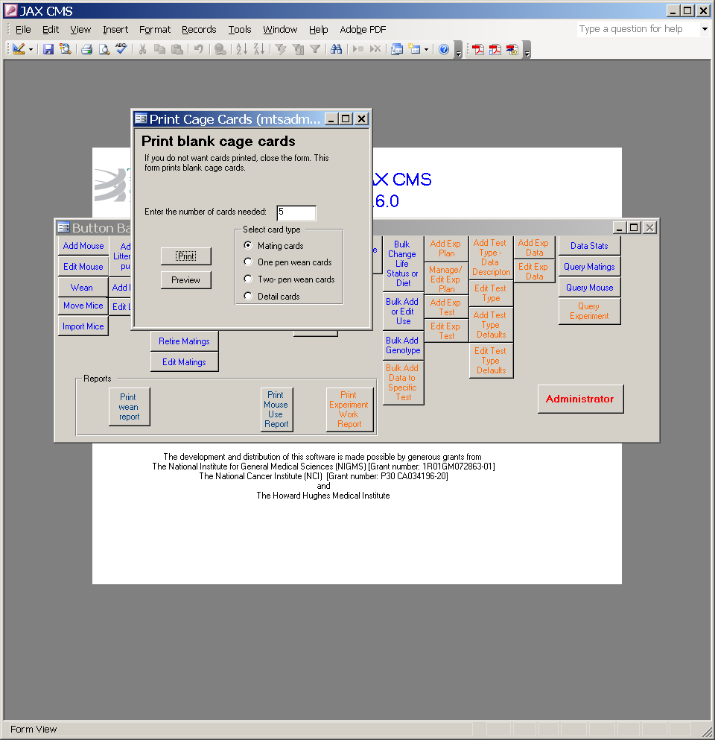Periodically, blank cage cards can be printed to use in the mouse room for newly weaned mice or mice obtained from other sources. Use the **Print Cage Cards button** on the reports tab to open the Print Cage Cards form. Enter the number of cards needed. Any of the four cage card types may be printed as blank cards. JCMS will generate unique pen ID numbers for each card.

Figure ‑ Form: Print blank cage cards

### JCMS-Provided Cage Card Formats

JCMS defines four types of cage cards:

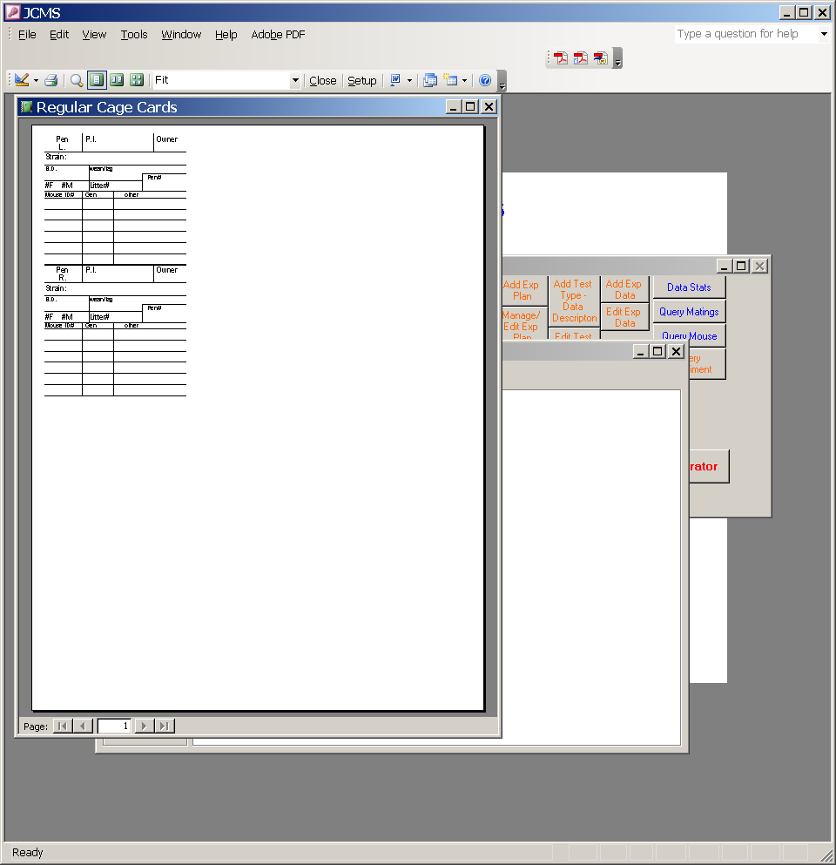

1. Mating cage card
2. One-pen wean cage card
3. Two-pen wean cage card
4. Detail cage card

#### **Two-pen Wean Cards** (setup variable MTS_2PEN_WEAN_CAGE_CARD)

Two-pen wean cards can only be printed as blank cage cards. The PI phone and PI name information will be shown on the card using the values specified in the setup variables called MTS_PI_NAME and MTS_PI_PHONE (these values are set via the Administrator tool bar*, JCMS Setup Variables* button).

* Two-pen wean cards can be printed from the Print Cage Cards Form.

This card format prints on the upper left corner of the page. Make sure the envelope feeder on the printer is set to print to the far left side.

Figure ‑ OS_2PWeanCageCard

| ***Field name*** | ***Description*** | ***Data source*** |
| --- | --- | --- |
| ***PINameR*** | Name of PI responsible for the right cage | Setup variable (MTS_PI_NAME) |
| ***PINameL*** | Name of PI responsible for the left cage | Setup variable (MTS_PI_NAME) |
| ***PIPhoneR*** | A short string of text with PI contact information for right pen | Setup variable (MTS_PI_PHONE) |
| ***PIPhoneL*** | A short string of text with PI contact information for left pen | Setup variable (MTS_PI_PHONE) |
| ***PenIDR*** | Right pen ID | generated unique by JCMS or user can generate |
| ***PenIDL*** | Left pen ID | generated unique by JCMS or user can generate |

#### **One-pen Wean Cards** (setup variableMTS_1PEN_WEAN_CAGE_CARD)

One-pen wean cards can be printed as blank wean cards or with mouse IDs and other pertinent information on them. One-pen wean cards can be printed from the following JCMS forms:

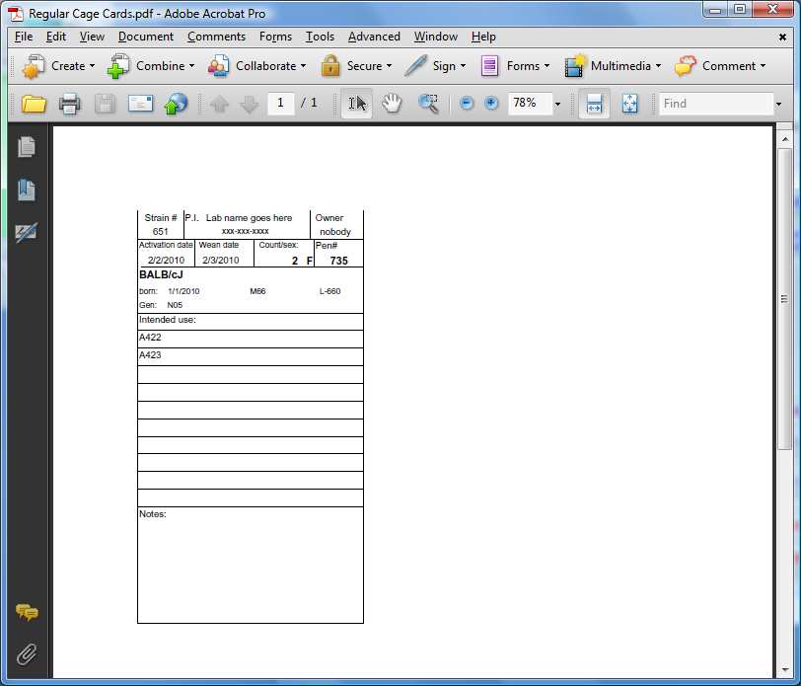

* Print Cage Cards
* Pen Info
* Add Pen
* Edit Pen
* Move Mice
* Add Litter With Pups
* Handheld Print Cage Cards
* Edit Pen Status/Location

Figure ‑ TS_1PWeanCageCard or TS_1PWeanCageCardWithBarCode

These two card formats will print centered – make sure the envelope feeder sends the cards through the center of the print path.

| ***Field name*** | ***Description*** | ***Data source*** |
| --- | --- | --- |
| ***StrainNum*** | Strain number | Strain table |
| ***PIPhone*** | A short string of text with PI contact information | Setup variable (MTS_PI_PHONE) |
| ***Owner*** | Owner ID | mouse owner |
| ***activationDate*** | Pen activation date | Container history table |
| ***weanDate*** | Date mice were weaned or blank if mice imported from external colony | litter table |
| ***PenID*** | A unique pen number | JCMS generated or user specified |
| ***countSex*** | A string with number of mice and sex e.g. “10 M”, would specify ten males | JCMS generated |
| ***birthDate*** | Date of birth of mice | litter table |
| ***MatingID*** | Mating number that produced this litter | mating table |
| ***LitterID*** | Litter number for the litter | litter table |
| ***IntendedUse*** | From CV pull down list | mouseUse |
| ***generation*** | Litter generation | litter table |
| ***M1ID*** | Mouse 1 ID (from litter) | mouse table |
| ***M2ID*** | Mouse 2 ID (from litter) | mouse table |
| ***M3ID*** | Mouse 3 ID (from litter) | mouse table |
| ***M4ID*** | Mouse 4 ID (from litter) | mouse table |
| ***M5ID*** | Mouse 5 ID (from litter) | mouse table |
| ***M6ID*** | Mouse 6 ID (from litter) | mouse table |
| ***M7ID*** | Mouse 7 ID (from litter) | mouse table |
| ***M8ID*** | Mouse 8 ID (from litter) | mouse table |
| ***M9ID*** | Mouse 9 ID (from litter) | mouse table |
| ***M10ID*** | Mouse 10 ID (from litter) | mouse table |
| ***penIDBC*** | Pen ID in barcode format. Must be of the font Code 128AB | User specified |
| ***matingIDBC*** | Mating ID in barcode format. Must be of the font Code 128AB | User specified |

#### **One pen wean card for designing new cards**

The report named TS_1PWeanCageCardwithXtraFields may be used for designing a new cage card; it uses the fields and format above. The following fields are added.

| ***Field name*** | ***Description*** | ***Data source*** |
| --- | --- | --- |
| ***protocol1*** | Protocol for mouse 1 | Mouse table |
| ***protocol2*** | Protocol for mouse 2 | Mouse table |
| ***protocol3*** | Protocol for mouse 3 | Mouse table |
| ***protocol4*** | Protocol for mouse 4 | Mouse table |
| ***protocol5*** | Protocol for mouse 5 | Mouse table |
| ***protocol6*** | Protocol for mouse 6 | Mouse table |
| ***protocol7*** | Protocol for mouse 7 | Mouse table |
| ***protocol8*** | Protocol for mouse 8 | Mouse table |
| ***protocol9*** | Protocol for mouse 9 | Mouse table |
| ***protocol10*** | Protocol for mouse 10 | Mouse table |
| ***coatColor1*** | Coat color for mouse 1 | Mouse table |
| ***coatColor2*** | Coat color for mouse 2 | Mouse table |
| ***coatColor3*** | Coat color for mouse 3 | Mouse table |
| ***coatColor4*** | Coat color for mouse 4 | Mouse table |
| ***coatColor5*** | Coat color for mouse 5 | Mouse table |
| ***coatColor6*** | Coat color for mouse 6 | Mouse table |
| ***coatColor7*** | Coat color for mouse 7 | Mouse table |
| ***coatColor8*** | Coat color for mouse 8 | Mouse table |
| ***coatColor9*** | Coat color for mouse 9 | Mouse table |
| ***coatColor10*** | Coat color for mouse 10 | Mouse table |
| ***comment1*** | Comment for mouse 1 | Mouse table |
| ***comment2*** | Comment for mouse 2 | Mouse table |
| ***comment3*** | Comment for mouse 3 | Mouse table |
| ***comment4*** | Comment for mouse 4 | Mouse table |
| ***comment5*** | Comment for mouse 5 | Mouse table |
| ***comment6*** | Comment for mouse 6 | Mouse table |
| ***comment7*** | Comment for mouse 7 | Mouse table |
| ***comment8*** | Comment for mouse 8 | Mouse table |
| ***comment9*** | Comment for mouse 9 | Mouse table |
| ***comment10*** | Comment for mouse 10 | Mouse table |
| ***room*** | Room name | Room table |
| ***penName*** | Name of the pen | Container table |
| ***penComment*** | Comment for pen | Container table |
| ***statusDate*** | Date when pen status or room changed | ContainerHistory table |
| ***statusDateWithTime*** | Same as status date only includes the exact time of the change | ContainerHistory table |
| ***penStatus*** | Current status of pen (active, retired, proposed, etc.) | Container History table |
| ***Dam1-ID*** | Mouse ID of dam1 (from mating) | Mouse table |
| ***Dam2-ID*** | Mouse ID of dam2 (from mating) | Mouse table |
| ***Sire-ID*** | Mouse ID of sire (from mating) | Mouse table |
| ***Dam1-Strain*** | Strain of dam1 (from mating) | Strain table |
| ***Dam2-Strain*** | Strain of dam2 (from mating) | Strain table |
| ***Sire-Strain*** | Strain of sire (from mating) | Strain table |
| ***Dam1-Genotype*** | Genotype of dam1 (from mating) | Genotype table |
| ***Dam2-Genotype*** | Genotype of dam2 (from mating) | Genotype table |
| ***Sire-Genotype*** | Genotype of sire (from mating) | Genotype table |
| ***PlanID*** | Experimental plan ID | ExpPlan table (Only one plan ID for one of the mice is displayed when there are multiple possibilities) |
| ***PlanName*** | Experimental plan name | ExpPlan table |
| ***M1NewTag*** | Replacement tag for mouse 1 | Mouse table |
| ***M2NewTag*** | Replacement tag for mouse 2 | Mouse table |
| ***M3NewTag*** | Replacement tag for mouse 3 | Mouse table |
| ***M4NewTag*** | Replacement tag for mouse 4 | Mouse table |
| ***M5NewTag*** | Replacement tag for mouse 5 | Mouse table |
| ***M6NewTag*** | Replacement tag for mouse 6 | Mouse table |
| ***M7NewTag*** | Replacement tag for mouse 7 | Mouse table |
| ***M8NewTag*** | Replacement tag for mouse 8 | Mouse table |
| ***M9NewTag*** | Replacement tag for mouse 9 | Mouse table |
| ***M10NewTag*** | Replacement tag for mouse 10 | Mouse table |

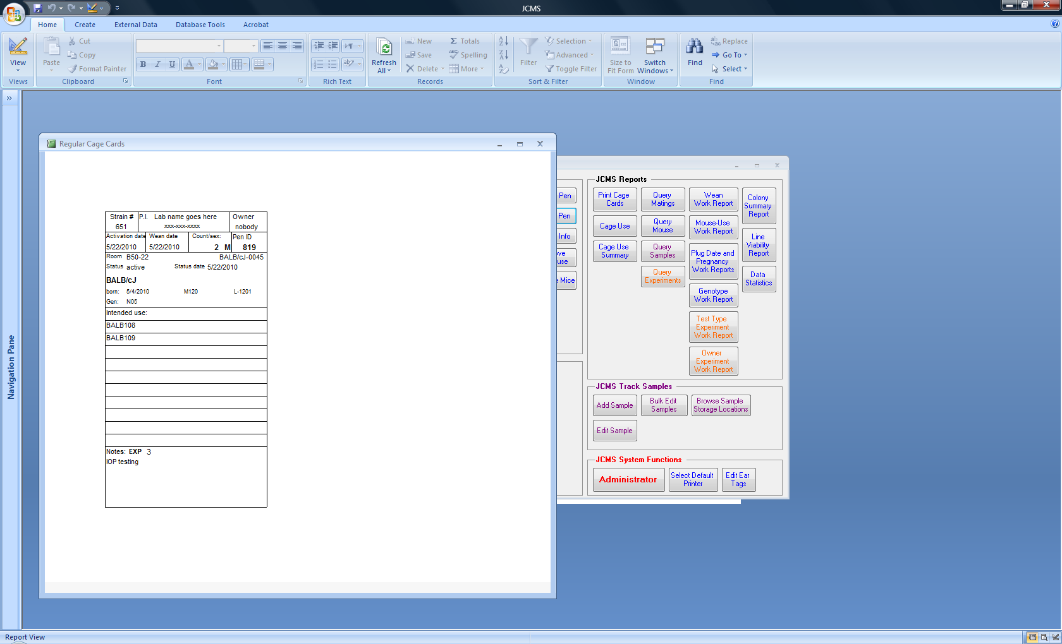

Figure ‑ CC_JCMS_WeanCageCardUsingPenNames

#### **Mating Cards** (setup variable MTS_MATING_CAGE_CARD or MTS_MATING_CAGE_CARD2)

Figure ‑ TS_MatingCAgeCard or TS_MatingCageCardStyle1With BarCode

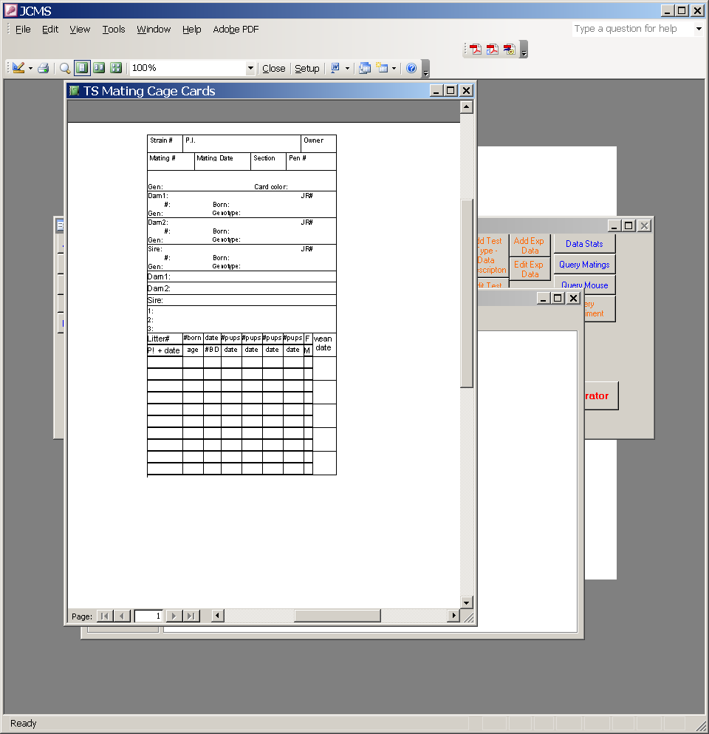

Figure ‑ TS_MatingCageCardStyle2With BarCode

Figure ‑ OS_MatingCageCard

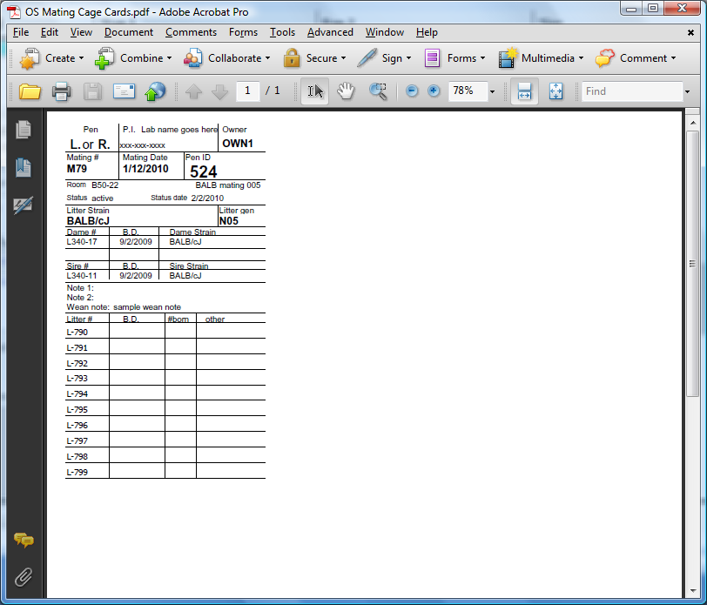

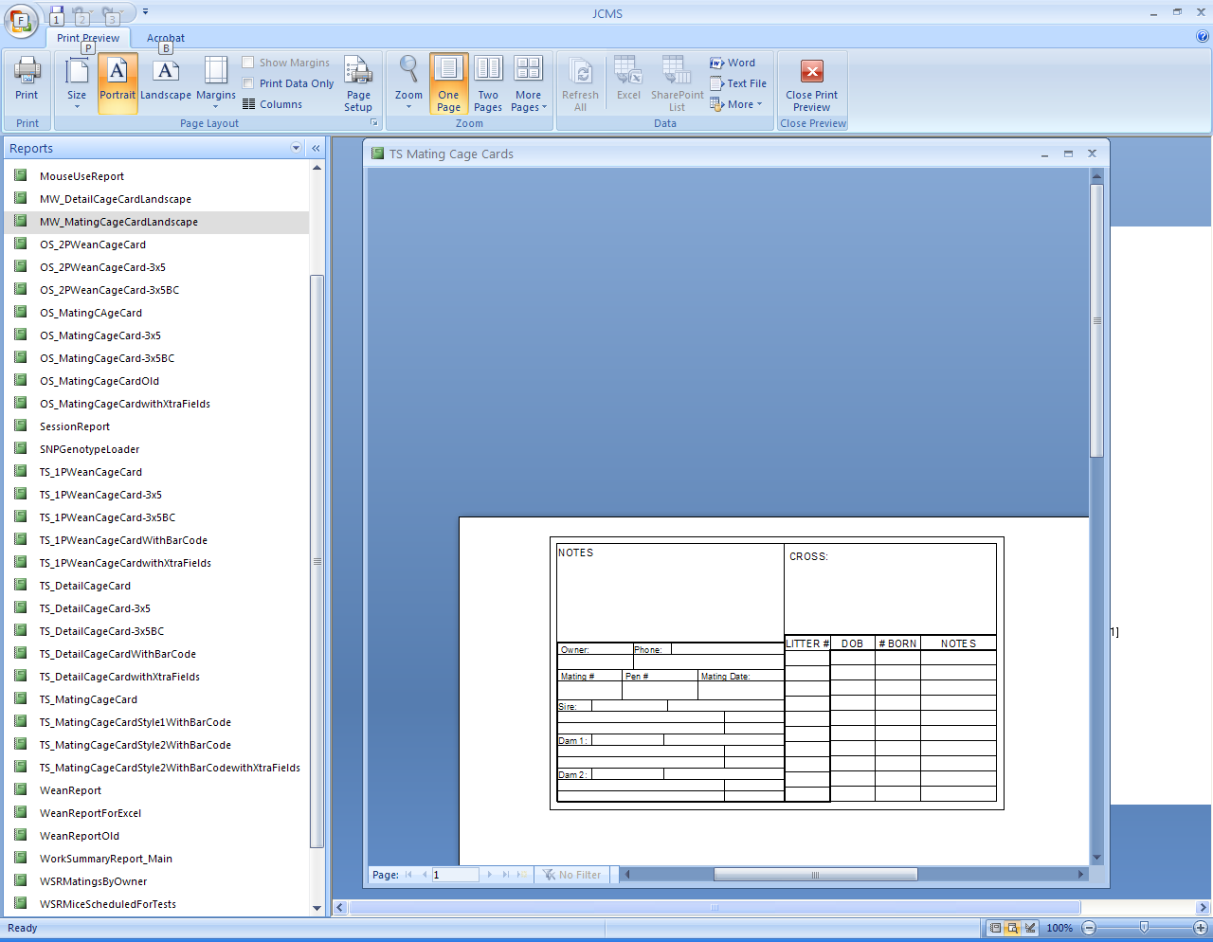

Figure ‑ MW_MatingCageCardLandscape

Figure ‑ CC_JCMS_MatingCageCardUsingPenNames

Mating cards may be printed from the following set of forms:

* Design Matings
* Activate Matings
* Edit Matings
* Add Matings
* Move Mice
* Print Cage Cards
* Handheld Print Cage Cards

The OS and CC Mating Cage Card format prints in the upper left corner of the page. The MW landscape card prints on the left of the page with a one inch left margin. The TS card formats will print centered at the top of the page. Make sure the envelope feeder sends the cards through the correct print path.

| ***Field name*** | ***Description*** | ***Data source*** | ***OS_***  ***Visible?*** | ***TS_***  ***Visible?*** | ***CC_ Visible?*** | ***MW Visible?*** |
| --- | --- | --- | --- | --- | --- | --- |
| ***PIName*** | Name of responsible PI | Setup variable (MTS_PI_NAME) | y | y | y | n |
| ***PIPhone*** | Contact phone for PI | Setup variable MTS_PI_PHONE | y | y | y | y |
| ***owner*** | Mating owner | mating table | y | y | y | y |
| ***matingID*** | Mating number | mating table | y | y | y | y |
| ***matingDate*** | Mating date | mating table | y | y | y | y |
| ***StrainSection*** | Strain section in mouse room | strain table | n | y | n | n |
| ***PenID*** | Pen number | (one mouse) Container table | y | y | y | y |
| ***LitterStrain*** | Strain of pups | mating table | y | y | y | y |
| ***litterGeneration*** | Generation of pups | mating table | y | y | y | y |
| ***CardColor*** | Color of cage card | strain table | n | y | y | n |
| ***dam1ID*** | Mouse ID for dam 1 | mouse table | y | y | y | y |
| ***dam2ID*** | Mouse ID for dam 2 | mouse table | y | y | y | y |
| ***sireID*** | Mouse ID for sire | mouse table | y | y | y | y |
| ***dam1BirthDate*** | Birth date of dam1 | mouse table | y | y | y | y |
| ***dam2BirthDate*** | Birth date of dam2 | mouse table | y | y | y | y |
| ***sireBirthDate*** | Birth date of sire | mouse table | y | y | y | y |
| ***dam1Strain*** | Strain of dam1 | mouse table | y | y | y | y |
| ***dam2Strain*** | Strain of dam2 | mouse table | y | y | y | y |
| ***sireStrain*** | Strain of sire | mouse table | y | y | y | y |
| ***dam1Genotype*** | Genotype of dam1 | genotype table | n | y | n | y |
| ***dam2Genotype*** | Genotype of dam 2 | genotype table | n | y | n | y |
| ***sireGenotype*** | Genotype of sire | genotype table | n | y | n | y |
| ***dam1JRNum*** | JR number of dam 1 strain | strain table | n | y | n | n |
| ***dam2JRNum*** | JR number of dam 2 strain | strain table | n | y | n | n |
| ***sireJRNum*** | JR number of sire strain | strain table | n | y | n | n |
| ***dam1MatingID*** | Mating dam1 came from | mating table via litter | n | y | n | n |
| ***dam2MatingID*** | Mating dam2 came from | mating table via litter | n | y | n | n |
| ***sireMatingID*** | Mating sire came from | mating table via litter | n | y | n | n |
| ***dam1LitterID*** | Litter dam1 came from | litter table | n | y | n | n |
| ***dam2LitterID*** | Litter dam2 came from | litter table | n | y | n | n |
| ***sireLitterID*** | Litter sire came from | litter table | n | y | n | n |
| ***dam1Gen*** | Generation of dam1 | mouse table | n | y | n | n |
| ***dam2Gen*** | Generation of dam2 | mouse table | n | y | n | n |
| ***sireGen*** | Generation of sire | mouse table | n | y | n | y |
| ***matingNote1*** | A note about the mating | user selected from pick list on form | y | y | y | n |
| ***matingNote2*** | Additional mating notes | user selected from pick list on form | y | y | y | n |
| ***weanNote*** | Additional mating notes | mating table, wean note field | n | y | y | n |
| ***penIDBC*** | Pen ID in barcode format. Must be of the font Code 128AB | User specified | n | y | n | n |
| ***matingIDBC*** | Mating ID in barcode format. Must be of the font Code 128AB | User specified | n | n | n | n |
| ***litter1ID*** | Auto generated litter IDs | JCMS generated (optional) | y | y | y | y |
| ***litter2ID*** | Auto generated litter IDs | JCMS generated (optional) | y | y | y | y |
| ***litter3ID*** | Auto generated litter IDs | JCMS generated (optional) | y | y | y | y |
| ***litter4ID*** | Auto generated litter IDs | JCMS generated (optional) | y | y | y | y |
| ***litter5ID*** | Auto generated litter IDs | JCMS generated (optional) | y | y | y | y |
| ***litter6ID*** | Auto generated litter IDs | JCMS generated (optional) | y | y | y | y |
| ***litter7ID*** | Auto generated litter IDs | JCMS generated (optional) | y | y | y | y |
| ***litter8ID*** | Auto generated litter IDs | JCMS generated (optional) | y | y | y | y |
| ***litter9ID*** | Auto generated litter IDs | JCMS generated (optional) | y | y | y | y |
| ***litter10ID*** | Auto generated litter IDs | JCMS generated (optional) | y | y | y | y |
| ***protocol*** | Protocol for dam1 | Mouse table | n | n | n | n |
| ***room*** | Room | Room table | n | n | y | n |
| ***matingComment*** | Comment | Mating table | n | n | n | n |
| ***penName*** | Name of pen | Container table | n | n | y | n |
| ***penStatus*** | Current status | Container History table | n | n | y | n |
| ***statusDate*** | Date pen status or room changed | Container History table | n | n | y | n |
| ***statusDateWithTime*** | Same as above only including time | Container History table | n | n | n | n |
| ***penComment*** | Misc. information | Container table | n | n | n | n |
| ***PlanID*** | Experimental plan ID | ExpPlan table (Only one plan ID for one of the mice is displayed when there are multiple possibilities) | n | n | y | n |
| ***PlanName*** | Experimental plan name | ExpPlan table | n | n | y | n |
| ***dam1NewTag*** | Replacement tag for dam1 | Mouse table | n | n | n | n |
| ***dam2NewTag*** | Replacement tag for dam2 | Mouse table | n | n | n | n |
| ***SireNewTag*** | Replacement tag for sire | Mouse table | n | n | n | n |

Two reports are available to use for designing new cage cards in these formats. They are named TS_MatingCageCardStyle2WithBarCodewithXtraFields and OS_MatingCageCardwithXtraFields. The following fields are visible on both: protocol, room, statusDateWithTime, penComment, matingComment, PlanID, PlanName, dam1NewTag, dam2NewTag, and sireNewTag. Note they are located outside the normal boundaries for an index-sized card. Some of these fields are also on the MW_MatingCageCardLandscape report, but they are not visible. Make a copy of this report before changing it.

#### **Detail Cards** (setup variable MTS_DETAIL_CAGE_CARD)

Figure ‑ TS_DetailCageCard

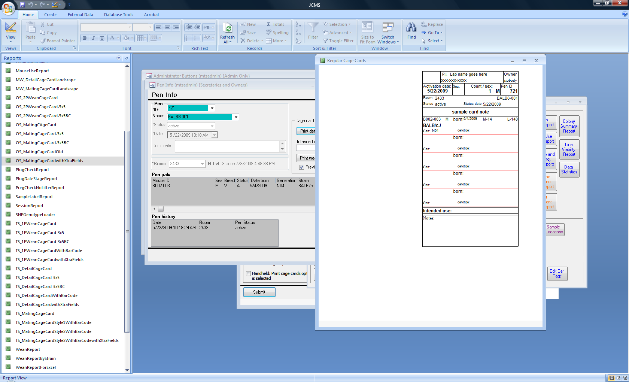

Figure ‑ TS_DetailCageCardWithBarCode

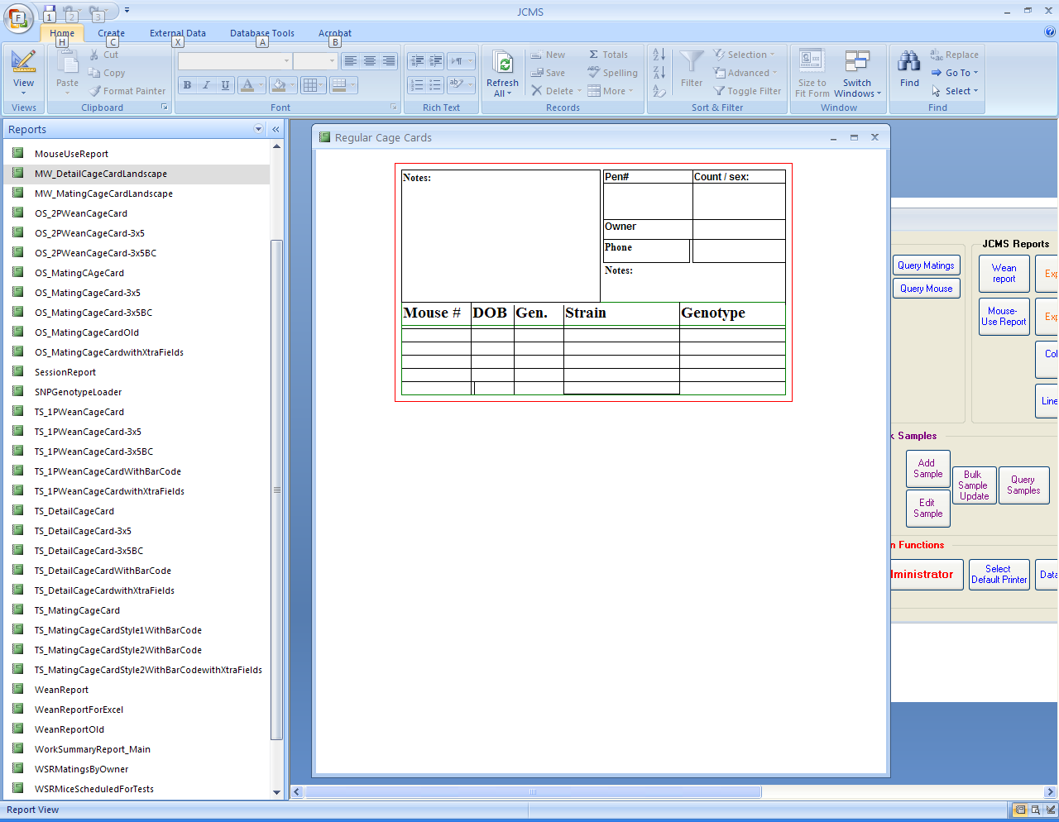

Figure ‑ MW_DetailCageCardLandscape

Figure ‑ (left) CC_JCMS_DetailCageCardUsingPenNames

Detail cards can be printed from the following forms:

* Pen Info
* Add Pen
* Edit Pen
* Bulk Add Mice
* Move Mouse
* Move Mice
* Print Cage Cards
* Handheld Print Cage Cards
* Edit Pen Status/Location

The “TS” and “CC” card formats will print centered – make sure the envelope feeder sends the cards through the center of the print path. The landscape “MW” card prints with a one inch margin, left side.

| ***Field name*** | ***Description*** | ***Data source*** |
| --- | --- | --- |
| ***PIName*** | Name of responsible PI | Setup variable (MTS_PI_NAME) |
| ***PIPhone*** | Phone number of responsible PI | Setup variable (MTS_PI_PHONE) |
| ***Owner*** | Owner of mice in pen | Mouse table (one mouse) |
| ***ActivationDate*** | Date pen was activated | Container History table |
| ***Section*** | Strain section | strain table |
| ***countSex*** | String of text with count and sex of mice on it (e.g. 4 M) | Generated by JCMS when mouse information is retrieved. |
| ***PenID*** | Pen number | Container table, from one mouse |
| ***penIDBC*** | Pen ID in barcode format. Must be of the font Code 128AB | User specified |
| ***matingIDBC*** | Mating ID in barcode format. Must be of the font Code 128AB | User specified |
| ***Note*** | A cage card note | Setup variable (MTS_CAGE_CARD_DETAIL_NOTE) |
| ***M1ID*** | Mouse 1 ID number | mouse table |
| ***M1Sex*** | Mouse 1 Sex | mouse table |
| ***M1Born*** | Mouse 1 DOB | mouse table |
| ***M1MID*** | Mouse 1 is a product of Mating ID | mating table |
| ***M11LID*** | Mouse 1’s litter ID | litter table |
| ***M1Strain*** | Mouse 1’s strain | mouse table |
| ***M1Generation*** | Mouse 1’s generation | mouse table |
| ***M1GenoType*** | Mouse 1’s genotype | genotype table |
|  |  |  |
| ***M2ID*** | Mouse 2 ID number | mouse table |
| ***M2Sex*** | Mouse 2 Sex | mouse table |
| ***M2Born*** | Mouse 2 DOB | mouse table |
| ***M2MID*** | Mouse 2 is a product of Mating ID | mating table |
| ***M2LID*** | Mouse 2’s litter ID | litter table |
| ***M2Strain*** | Mouse 2’s strain | mouse table |
| ***M2Generation*** | Mouse 2’s generation | mouse table |
| ***M2GenoType*** | Mouse 2’s genotype | genotype table |
|  |  |  |
| ***M3ID*** | Mouse 3 ID number | mouse table |
| ***M3Sex*** | Mouse 3 Sex | mouse table |
| ***M3Born*** | Mouse 3 DOB | mouse table |
| ***M3MID*** | Mouse 3 is a product of Mating ID | mating table |
| ***M3LID*** | Mouse 3’s litter ID | litter table |
| ***M3Strain*** | Mouse 3’s strain | mouse table |
| ***M3Generation*** | Mouse 3’s generation | mouse table |
| ***M3GenoType*** | Mouse 3’s genotype | genotype table |
|  |  |  |
| ***M4ID*** | Mouse 4 ID number | mouse table |
| ***M4Sex*** | Mouse 4 Sex | mouse table |
| ***M4Born*** | Mouse 4 DOB | mouse table |
| ***M4MID*** | Mouse 4 is a product of Mating ID | mating table |
| ***M4LID*** | Mouse 4’s litter ID | litter table |
| ***M4Strain*** | Mouse 4’s strain | mouse table |
| ***M4Generation*** | Mouse 4’s generation | mouse table |
| ***M4GenoType*** | Mouse 4’s genotype | genotype table |
|  |  |  |
| ***M5ID*** | Mouse 5 ID number | mouse table |
| ***M5Sex*** | Mouse 5 Sex | mouse table |
| ***M5Born*** | Mouse 5 DOB | mouse table |
| ***M5MID*** | Mouse 5 is a product of Mating ID | mating table |
| ***M5LID*** | Mouse 5’s litter ID | litter table |
| ***M5Strain*** | Mouse 5’s strain | mouse table |
| ***M5Generation*** | Mouse 5’s generation | mouse table |
| ***M5GenoType*** | Mouse 5’s genotype | genotype table |

#### **Detail card for designing new cards**

The report named TS_DetailCageCardwithXtraFields may be used for designing a new cage card. It uses the fields and formats shown above. The following fields are added. Some of these fields are also on the MW_DetailCageCardLandscape report, but they are not visible. Make a copy of this report before changing it. Up to 10 mice may be placed on a detail card. Fields for M6ID, M7ID up to M10ID are not provided. The user must create these. Be careful to follow the naming convention for the field name that is illustrated in these two tables.

| ***Field name*** | ***Description*** | ***Data source*** |
| --- | --- | --- |
| ***protocol1*** | Protocol for mouse 1 | Mouse table |
| ***protocol2*** | Protocol for mouse 2 | Mouse table |
| ***protocol3*** | Protocol for mouse 3 | Mouse table |
| ***protocol4*** | Protocol for mouse 4 | Mouse table |
| ***protocol5*** | Protocol for mouse 5 | Mouse table |
| ***coatColor1*** | Coat color for mouse 1 | Mouse table |
| ***coatColor2*** | Coat color for mouse 2 | Mouse table |
| ***coatColor3*** | Coat color for mouse 3 | Mouse table |
| ***coatColor4*** | Coat color for mouse 4 | Mouse table |
| ***coatColor5*** | Coat color for mouse 5 | Mouse table |
| ***comment1*** | Comment for mouse 1 | Mouse table |
| ***comment2*** | Comment for mouse 2 | Mouse table |
| ***comment3*** | Comment for mouse 3 | Mouse table |
| ***comment4*** | Comment for mouse 4 | Mouse table |
| ***comment5*** | Comment for mouse 5 | Mouse table |
| ***room*** | Room name | Room table |
| ***weanDate1*** | Wean date for mouse 1 | Litter table |
| ***weanDate2*** | Wean date for mouse 2 | Litter table |
| ***weanDate3*** | Wean date for mouse 3 | Litter table |
| ***weanDate4*** | Wean date for mouse 4 | Litter table |
| ***weanDate5*** | Wean date for mouse 5 | Litter table |
| ***penName*** | Name of the pen | Container table |
| ***penComment*** | Comment for pen | Container table |
| ***statusDate*** | Date when pen status or room changed | ContainerHistory table |
| ***statusDateWithTime*** | Same as status date only includes the exact time of the change | ContainerHistory table |
| ***penStatus*** | Current status of pen (active, retired, proposed, etc.) | Container History table |
| ***PlanID*** | Experimental plan ID | ExpPlan table (Only one plan ID for one of the mice is displayed when there are multiple possibilities) |
| ***PlanName*** | Experimental plan name | ExpPlan table |
| ***M1NewTag*** | Mouse 1’s Replacement tag | mouse table |
| ***M2NewTag*** | Mouse 2’s Replacement tag | mouse table |
| ***M3NewTag*** | Mouse 3’s Replacement tag | mouse table |
| ***M4NewTag*** | Mouse 4’s Replacement tag | mouse table |
| ***M5NewTag*** | Mouse 5’s Replacement tag | mouse table |

### Creating Custom Cage Cards

JCMS is configured to allow new cage card designs to be easily created using the MS Access report design tools. An easy to follow tutorial may be found online (check out the v4.6 tutorial package found in the [JCMS Tutorials](http://colonymanagement.jax.org/tutorials-2/jcms-hands-on-tutorials/)).

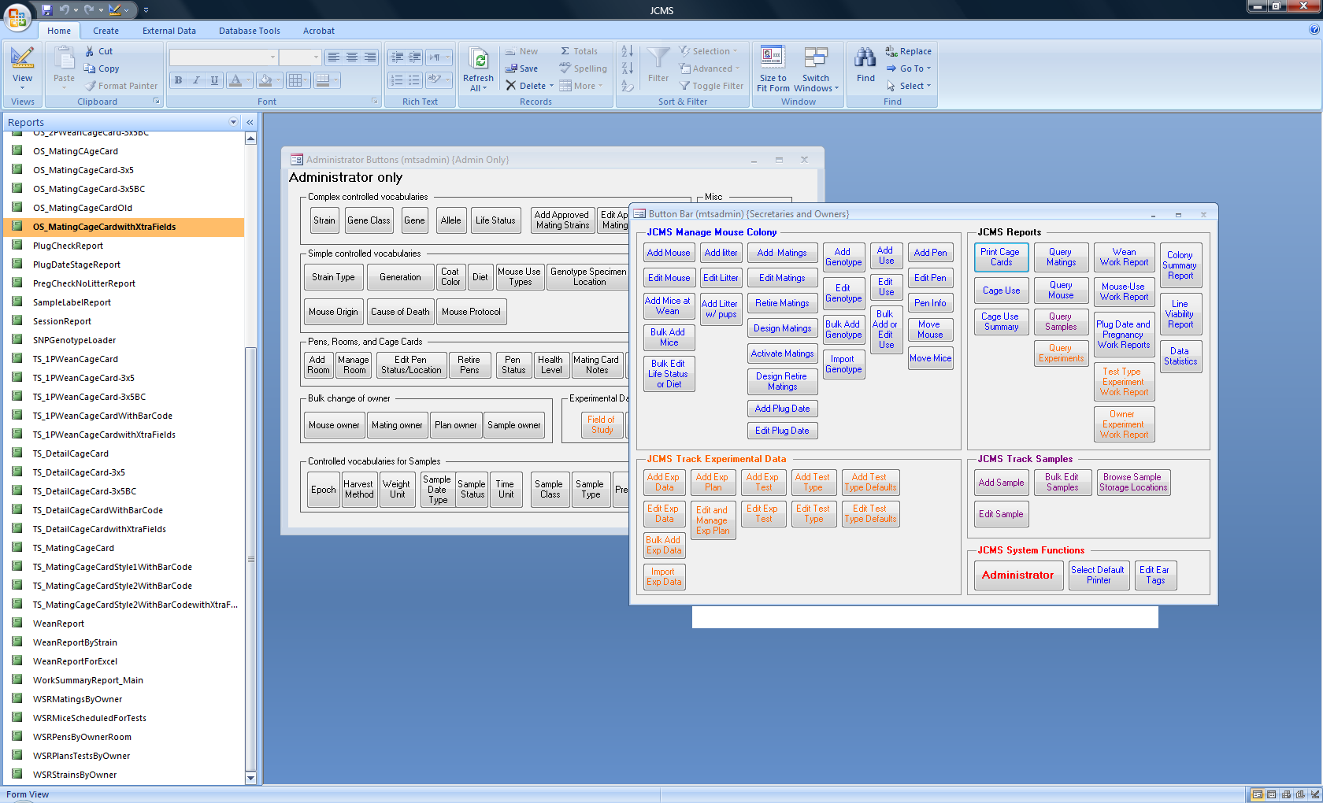When JCMS prints a cage card, it writes information from the database into text fields on the card. If a text box is put on a card and given a name that JCMS knows about, then JCMS will write the associated information into that text box when the card is printed. For example, the field PIName is a text box on each cage card where JCMS prints the PI name (as specified in the setup variables).

Make a backup copy of JCMS interface before making changes (Copy the interface JCMS.mdb file and save as {backup name}). To view the card designs in JCMS, logon as mtsadmin, press F11, and select the reports tab. To create a new card, simply draw the card wanted and add the fields (as specified in the tables above) that should appear on the card. Use the tables above as references showing what fields can be put on the card. JCMS is installed with a number of cards pre-configured for your use. To create a custom card, it may prove easiest to start with a card similar to the one wanted. Save a copy of the report format for this card under a new name. To make changes, open the report in “design view.” Now edit this new report format. Place the new report name into the setup variable value for the particular type of cage card. Four cage cards have been created specifically for use to help create new cage cards. These contain all possible fields. These reports have a name ending “withXtraFields”.

Figure ‑ Office 2007 reports list shown using F11 key

### User-designed Cage Cards

A separate JCMS cage card database, containing designs from the user community may be downloaded at the [colonymanagement.jax.org](http://colonymanagement.jax.org/support-2/faqs/jcms-colony-management-system/info-about-cage-cards-and-how-to-design-your-own/) FAQs page.

**Instructions for importing a cage card report (Access 2007):**

* Download the JCMS Cage Card database from the JCMS website. Save.
* Open existing JCMS database (as user mtsadmin).
* Select External Data tab from the ribbon.
* Select Access Import icon.
* Select Import bullet.
* Select Browse button and navigate to the JCMS CageCard database.
* Highlight JCMS_CageCards-1.mdb and select Open.
* Back to Get External Data window, select OK.
* Import Objects window opens. Select Reports tab.
* Choose Select All or highlight desired cage cards to import. Select OK.

**How to activate Cage Cards:**

* From the Administrator tab, select Administrator. Open JCMS Setup Variables.
* Scroll to MTS_1PEN_WEAN_CAGE_CARD. Type in the desired cage card name in the JCMS Setup Variable Value field.
* Scroll to MTS_2PEN_WEAN_CAGE_CARD. Type in the desired cage card name in the JCMS Setup Variable Value field.
* Scroll to MTS_DETAIL_CAGE_CARD. Type in the desired cage card name in the JCMS Setup Variable Value field.
* Scroll to MTS_MATING_CAGE_CARD. Type in the desired cage card name in the JCMS Setup Variable Value field.
* Close Setup Variables form.

## Setting up an Experimental Plan

In order to use the Experiments section of JCMS, the following CV tables must also have terms entered into them: **field of study** and **keywords**. Controlled vocabularies are changed from the **Administrator** button bar and may only be changed by the mtsadmin user.

See the section on Experimental Plans for more information on the details of setting up this portion of the database. Owners are able to set up all other aspects of Experimental Plans.

# User Setup

A new user must first be setup with an MS Access account and password logon by the Administrator. The Administrator will also do any client installation necessary on a computer used by the new user.

## Logging On and Passwords

To provide database security MS Access requires all users of JCMS to have a unique logon account and password. This logon is separate from any other that may be used by a user’s system such as the Windows logon.

To start JCMS, double click the JCMS icon on the desktop. A dialog box will request the user name and password. The user logon name will be displayed on each form that is displayed on the screen.

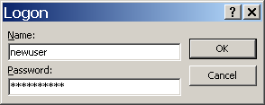

Figure ‑ User Logon Screen

The JCMS Welcome window displays at startup. Click the *Start (Workstation)* or *Start (Handheld Device)* button to begin work. The *Main Button Bar* is displayed next. From this button bar forms can be opened for entering and viewing JCMS data.

Check with the Administrator if entering the logon and password he/she provided does not result in the JCMS welcome screen appearing.

# Basics on Using JCMS

## What are Owners and Secretaries?

Access to the functions of the database is restricted on a form-by-form basis. That is, each form is programmed to allow access to JCMS for certain users (based on their security level). JCMS defines a security hierarchy with three levels of permission: Administrator, Owner, and Secretary. The Administrator can access all forms and all data; owners can enter mice, matings, experimental plans, samples, and experimental data and access all data entry and query forms from the Main Button Bar; secretaries can usually access only a limited subset of data entry forms.

Within the database, *mice*, *matings, experimental plans,* *experimental data,* and *samples* have *owners*. The owner of a mating also owns any *litters* produced by that mating. The owner of an experimental plan also owns any experimental data that is part of the plan. Owners may use all forms that have access permission to the database at an *owners* or *secretary* level. Forms for editing a mouse, mating, litter, experimental plan, samples, or experimental data usually restrict edit permission to owners only.

*Secretaries* may use only those forms with secretary level access. Additionally, secretaries are associated with owners (by being members of an owner’s secretary group); thus, secretaries can only work with data associated with a specific owner.

It is possible for a user to be both an owner of their own mice and to act as the “secretary” for one or more other owners.

The Administrator will have decided the owner or secretary status of each user and set this up as part of the user’s logon. The Administrator may also change the default security access level for most forms.

## Changing Passwords

When a user logs in for the first time, he/she may not have a password or may have a special password assigned by the Administrator. To create or change this password, select from the main menu, **tools – security – user and group accounts** (Office 2007: Database Tools tab, Administer – Users and Permissions, User and Group accounts; Office 2010: File tab – Users and Permissions – User and group accounts)**.** Click on the **Change Logon Password tab** and add or change the password. Only you can change your password.

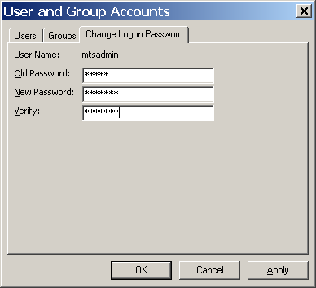

Figure ‑ Dialog Box: Change Password

## Button Bars

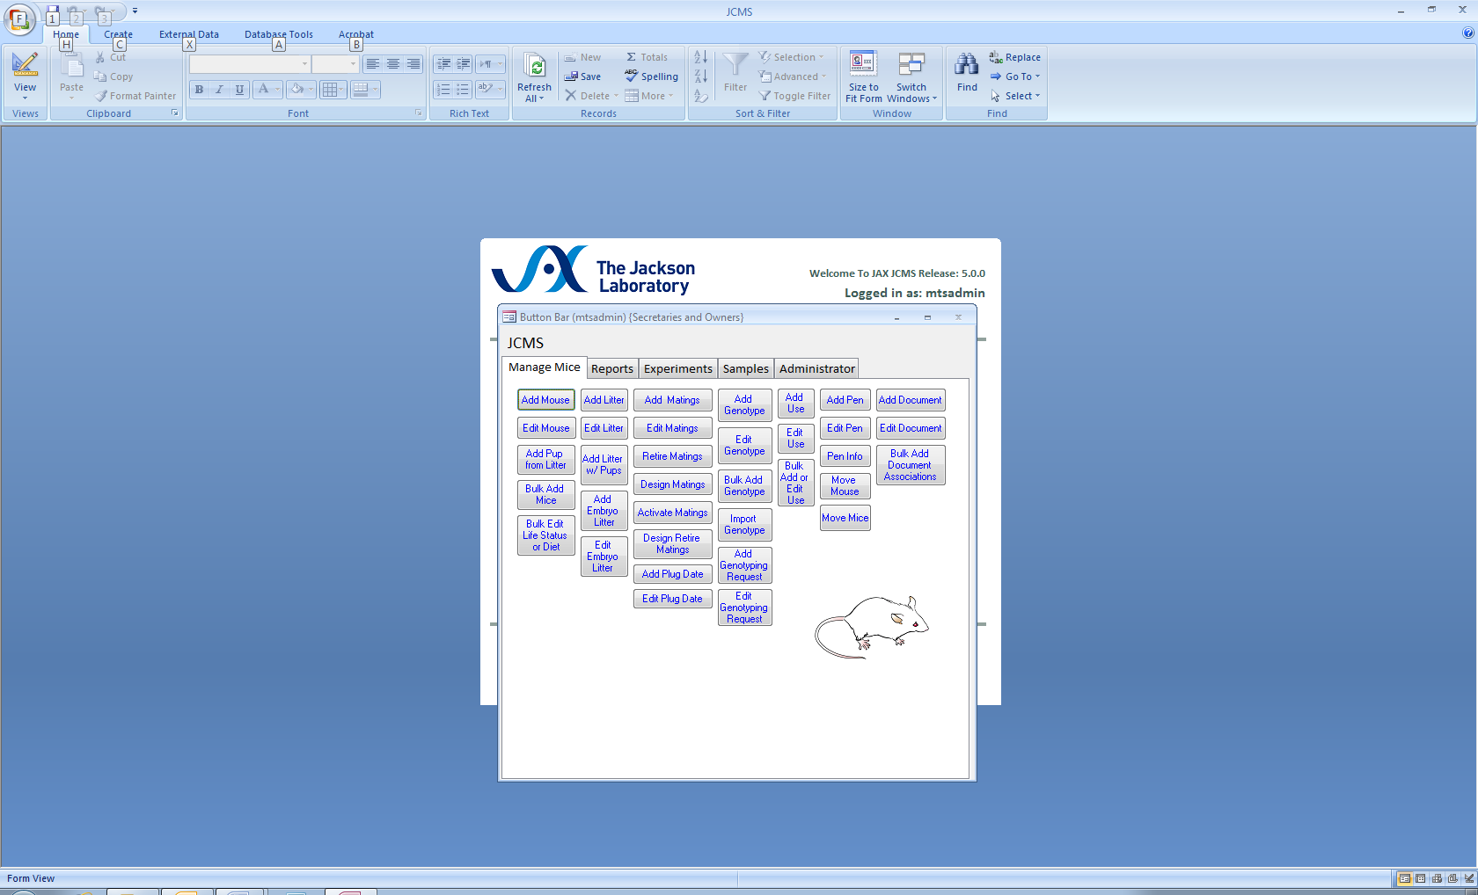

Figure ‑ Main Button Bar

JCMS uses button bars to provide easy access to its many functions.

Clicking buttons on the button bar(s) opens JCMS forms. After pressing the start (workstation) button, the main button bar opens and is always open from then on (until JCMS is shut down). The main button bar cannot be closed, but can be minimized.

The main button bar is organized into sections with tabs and then into columns for different functions. Note that some buttons will appear to not work for “secretaries” because they do not have permission to open that form. The Administrator button will work only for the Administrator.

## Using the Forms

Forms may be **closed** or **minimized** using the normal Windows minimize () button and close (**x**) button. Multiple forms may be open on the screen at one time, however updates submitted on one form may not be updated on another open form. Close and reopen the other form to see all updated information.

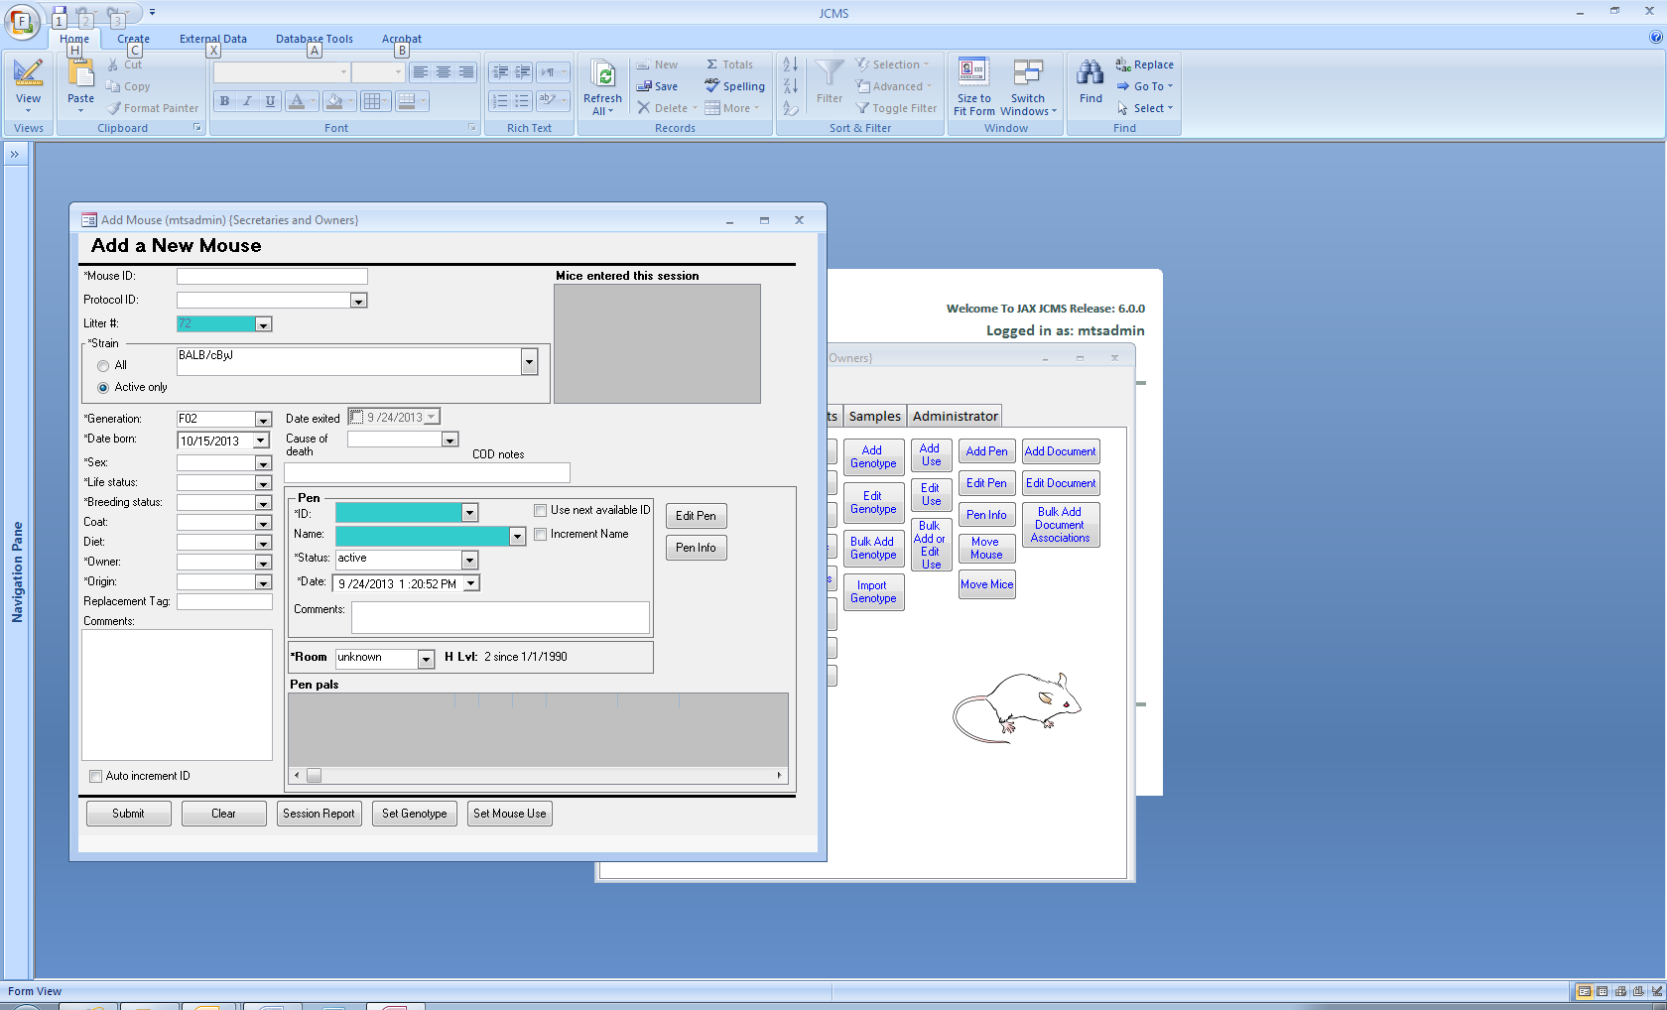There are several general form types: edit, add-new, request reports, and query. Some forms allow combined functionality (e.g. allow you to add new or edit). Basic data entry is done using text boxes that are white. Text boxes that are blue-green in color are “active” boxes. Entering a valid identifier in an active box followed by moving the cursor out of the box (by tabbing or clicking the mouse pointer elsewhere) will cause the database to display information associated with that item.

Figure ‑ Example of a text box

Data entry boxes with a drop down list (click on the down arrow) allow choosing an item from a list. The item can also be typed directly into the box; as you type, the first item in the list that matches the characters typed so far is displayed. In either case, press tab to accept an item and move to the next field. Most drop down lists are limited to selecting items in the list and anything else that is typed will be rejected.

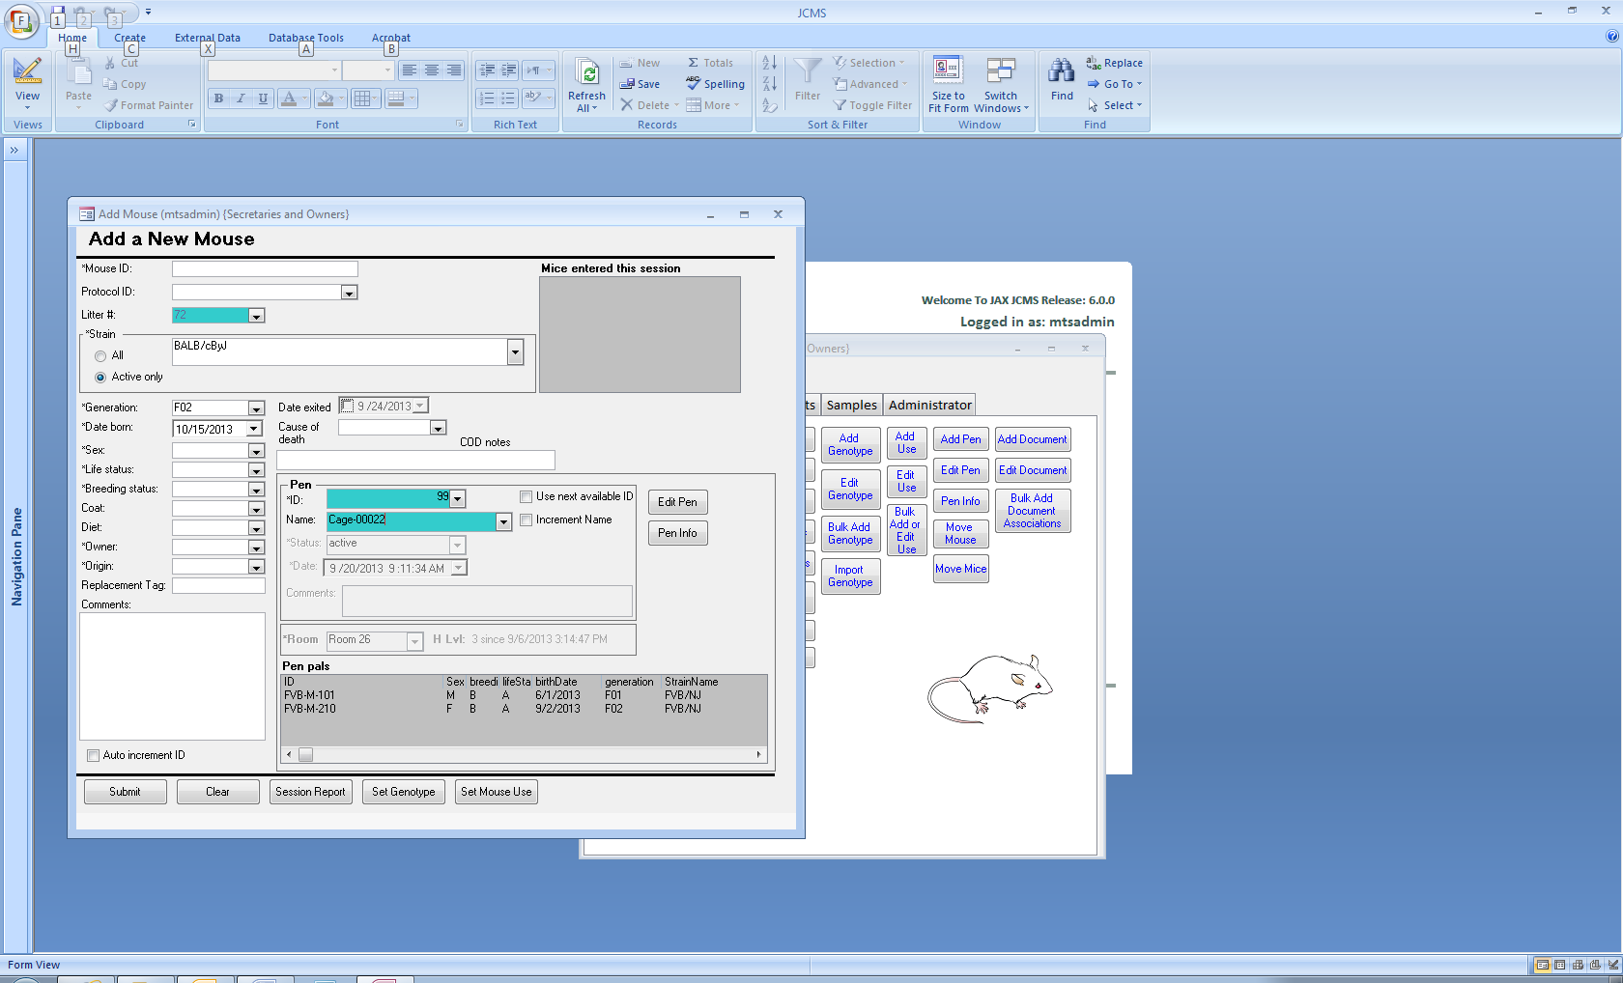

Figure ‑ Example of regular form buttons

Gray boxes display information that cannot be changed using this form. All forms can be navigated through quickly by tabbing to move forward and shift tabbing to move backward through the fields. When tab does not work, try pressing Control and Tab simultaneously.

Any form that has a **Submit button** will not update the database until this button is clicked. If a form is closed before hitting the submit button, changes made on the form will not be saved in JCMS.

The **Clear button** is used to remove all data from the form. The clear button does not delete data from the database.

Extra button(s) on the form will often open another form showing data associated with an ID on the first form (mouse, litter, mating, pen, experimental data, etc.) For example, the **Set Genotype button** on the edit mouse form opens the add genotype form showing data for the mouse ID used on the edit mouse form, all ready to work with.

### Special Features of Some Forms

Why are adding and editing functions kept separately on different forms? In general, add and edit forms will look very similar to each other. Different forms are used because creating a new record is a separate function from changing an existing one. If an error has been made on an add form, then open the edit version of this form to correct it. Edit forms limit editing capabilities based on the *owner* or *secretary* permission status.

Color fields on submit: by default, some of the forms use auto-color. After a new record is submitted to the database, all the text fields (except checkboxes and dates) have their background colored green. When these fields are visited by tabbing or using the mouse, the colored background disappears. The purpose of this feature is to prompt visiting each field when doing a lot of data entry so that values from the previous record are not erroneously entered into the new record. This feature may be turned off by the Administrator in the setup variables by changing MTS_AUTO_COLOR to false.

Pen Info Button: this button allows viewing the contents of a pen related to the form. When this button is pressed the pen info form appears with a list of all mice in the pen and other pertinent information about the pen.

Auto Increment ID check box: when this box is checked, the main ID field of the form is automatically incremented after JCMS has been updated (new record added or edited for this ID). This feature is useful when entering a lot of information that uses successive ID numbers. NOTE: ID numbers may have characters and leading zeros in them. Thus, the ID number cd012 would increment to cd013, and 099 would increment to 100 (as examples). The default for this check box to be set to on or off on most forms is changed in the setup variables by the Administrator using MTS_DEFAULT_AUTO_INCREMENT, JCMS_ACTIVATE_MATINGS_INCREMENT, etc. Some forms always default to NOT auto increment regardless of the value of this setup variable.

## Navigation Buttons

Some forms will use a special set of navigation buttons to move from one record to another.

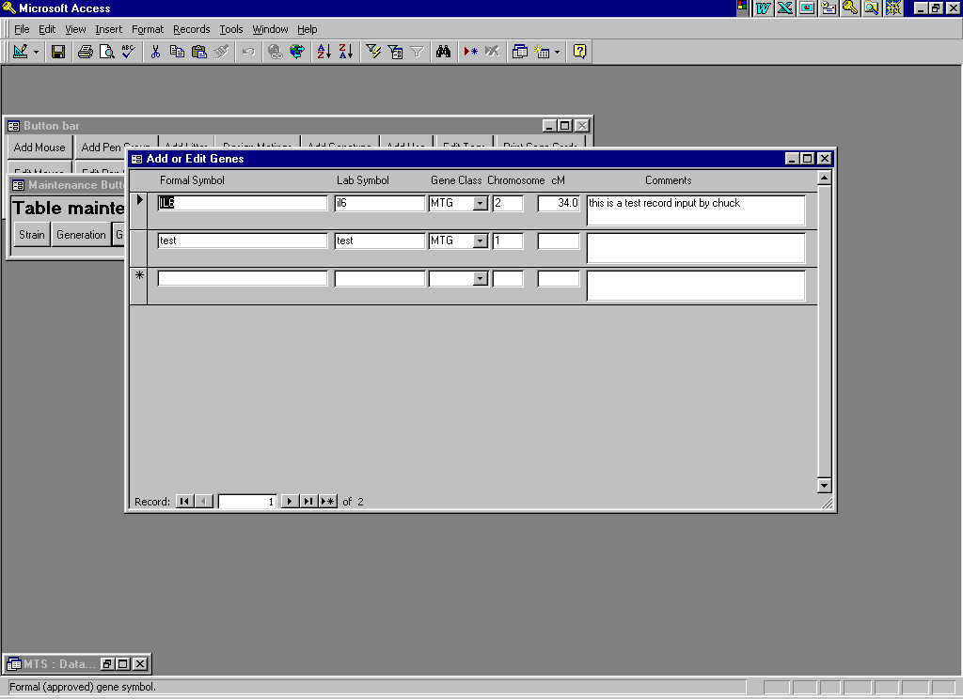 Clicking will move forward by one record, **|** will move to the last record, **\*** will provide a blank space to enter a new record. The number in the box indicates which record is currently displayed (first, second, third, etc.) Records are numbered by the order they are sorted into in the database. If the sort criteria is changed, this number may change for the record on display, it only reflects the record’s relative placement in the sort order.

## Session Reports

Session box: session boxes give some history information about this edit session. A session lasts for the period of time the form is open on the screen. A typical session box shows the ID and one or two bits of important information about each record entered or edited. The most recent entries are listed first in the list box.

Printable session report: use the Session Report button to see a print preview of a more detailed session report than is available in the session box.

## Printing

JCMS will use the default printer as set up on the client machine. Most reports will first display in print preview mode on the screen in order to help save printing unnecessary pages.

Use the *Select Default Printer* button (Administrator tab) to temporarily change the default printer for one JCMS session. The change will not affect the Windows default printer for any other program.

Many modern printers will use the sheet feeder as the default whenever there is paper in the sheet feeder. To print cage cards, open the sheet feeder and load the cards into the envelope feeder part of it. Also set the printer to use as straight a paper path as possible. Many printers have an option for sending sheets out the back if it is open or have a toggle switch to change the path.

Forms are not designed to print nicely on a page, use a report for a quality printout of information in a form. However, there are circumstances where it may be advantageous to print a copy of a form.

Use the **printer icon on the toolbar** with caution; this will often try to print the entire table, not just the values shown on the form on the screen. To determine if the form fits on one page of paper, try using the **print preview button** on the toolbar. If the screen is truncated on the right, change the page setup to landscape. This will also show if the results give all the records in the table instead of just one. Use the **close** button on the print preview window to get back to the form or the print icon to print what is shown in the preview.

To **print just a selected record** from forms that print the whole table, use the File menu. **Select Print from the File menu** and the print dialog box will open. Under the print range, pick **Selected record(s).** Now, only the record on the form or with the cursor in a field on it will print.

Most forms will not **print with all blank fields**. When the cursor is placed into a new blank record, *print the selected record* results in only the header for the form. To print a blank copy, first create a dummy record, placing something such as a decimal point into the required fields. Then print this selected record and delete it. Also note that only the Administrator has permission to delete records from some of the tables.

## Statistics

Click the Data Stats button on the Reports tab to get information on the total number of pens, mice, and matings in the database.

# Mice

## Mouse IDs

Each mouse must have a unique mouse ID number containing up to 16 characters. JCMS will not allow entry of duplicate ID numbers. The following setup variables may be used to help create sequences of mouse IDs when mice are added in groups.

### Automatically Incrementing Mouse IDs

Many forms have a check box labeled “Auto increment ID”. When the box is checked, after successfully adding a new mouse, the next mouse ID in sequence will be suggested.

The setup variable JCMS_MOUSEID_INCREMENT_RIGHTMOST indicates which portion of the ID to increment if it contains more than one numeric section. For example, if the setup variable is “false” the base ID 0015BALB-600 would be incremented to 0016BALB-600 and if it is “true” it would be incremented to 0015BALB-601.

Note the numeric portion of the ID that is incremented is limited to a 10 digit number. Using numbers larger than that will return a message “Unable to increment ID”. Longer numbers may be used if the mice are entered individually on forms such as Add mouse and Add mouse at wean.

### Base Mouse Numbers

The forms Bulk Add Mice, Add Litter w/Pups, and Handheld Add Litter w/Mice allow entering multiple mice at once. There are two methods of determining what mouse ID to start with.

1. The setup variable MTS_MOUSE_ID_PREFIX contains a character string used at the beginning of a mouse ID. JCMS keeps track of the last integer used in the sequence and automatically increments it when adding mice. For example, if the prefix is “A” and the last mouse ID added was A98, JCMS will use the sequence A99, A100, A101, etc. This option is the default on the forms.
2. The default (MTS_MOUSE_ID_PREFIX) may be overridden by selecting the check box “**Use Base ID**” or “**Use base mouse number”** and then entering a starting mouse ID for the sequence. A list of the current mice is provided on the non-handheld forms to help with determining the sequences in use.

## Adding Mice

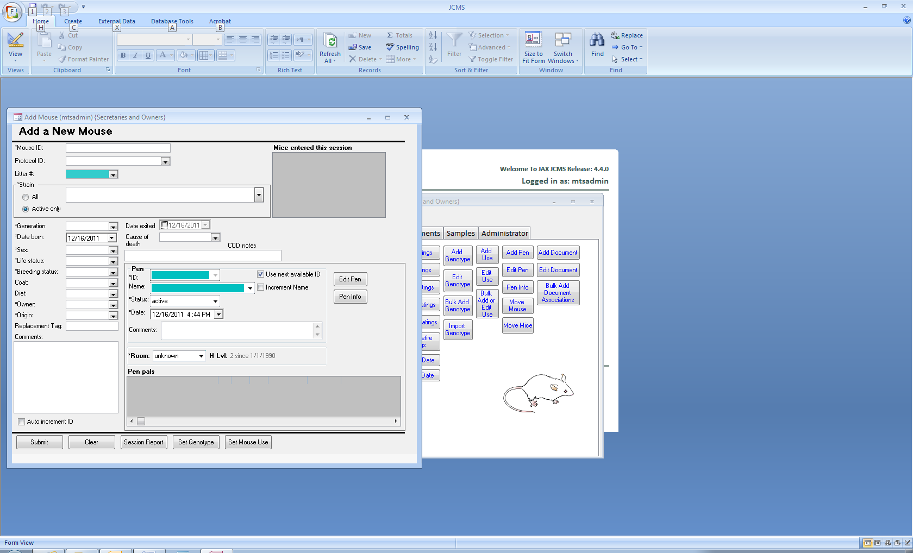

Figure ‑ Add Mouse Form

Use the **Add Mouse** button on the manage mice tab to open a form for adding mice one at a time. If adding mice to the database when they are weaned, consider using the **Add Mice at Wean** instead. It will automatically fill in the information from the litter for each mouse, saving time.

If this version of JCMS has been set up to use a prefix on the mouse ID, this is only entered if JCMS is creating the ID numbers. On this form, the prefix must be entered on the ID number by the user.

When mice are added, they must be assigned to a pen. The pen information section of these forms is used for this purpose. If the pen ID or pen name selected on the form already exists, the room, list of mice already in the pen, and other information will be retrieved and displayed in the pen information section. To add a new pen for this mouse, check “Use next available ID” to create it with the next available pen ID. Or uncheck the box and enter an unused pen ID by hand. Pens may have duplicate pen names but the pen ID is always unique.

The “Submit” button must be pressed to add the mouse into JCMS. If an error message is given, the error must be corrected and the submit button pressed again. A successful submission will result in a message stating, “Mouse *xxx* submitted” in red on the form. The session box will also list the mouse ID, pen ID, and pen name.

The Add Mouse form ignores the setup variables JCMS_AUTO_RETIRE_PENS and JCMS_AUTO_RETIRE_MATINGS.

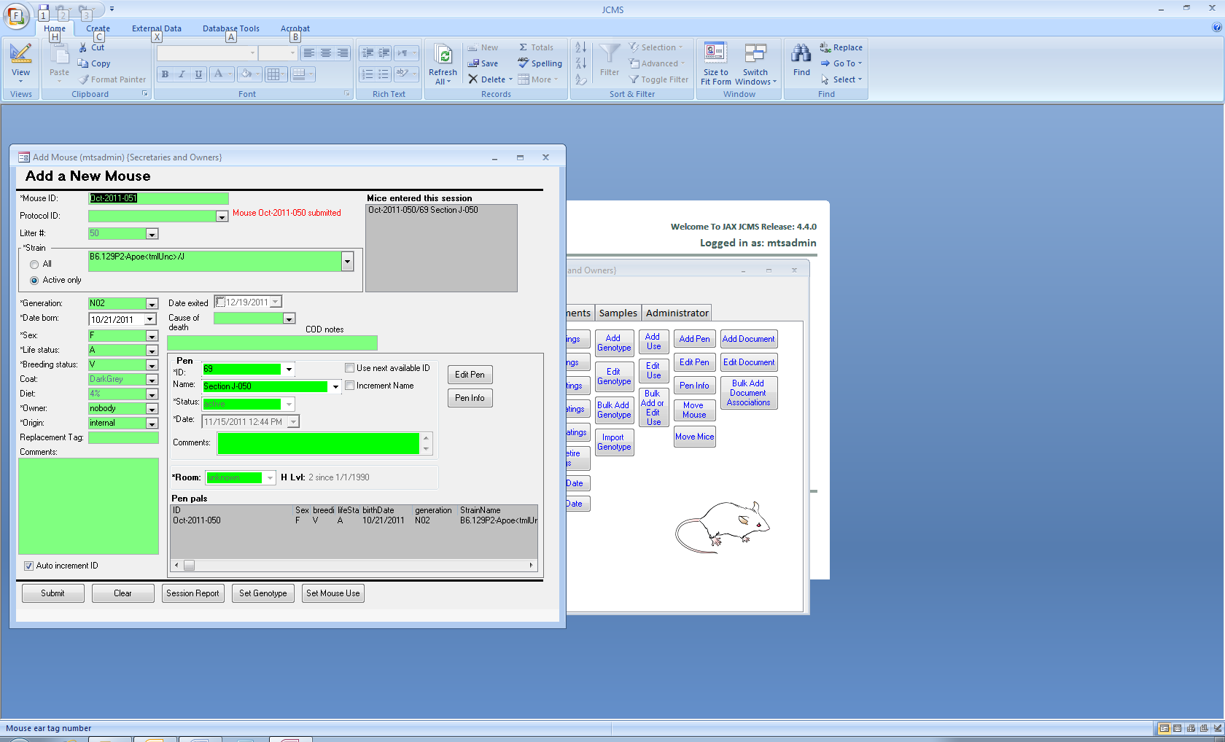

Figure ‑ Add mouse form after a successful submit

## Editing Mice

Changes are made to individual mice using the **Edit Mouse button** to open the edit mouse form. This form works in the same manner as the Add mouse form. If a selected mouse has genotype information associated with it, it will be displayed on the form.

### Changing the ID of a Mouse

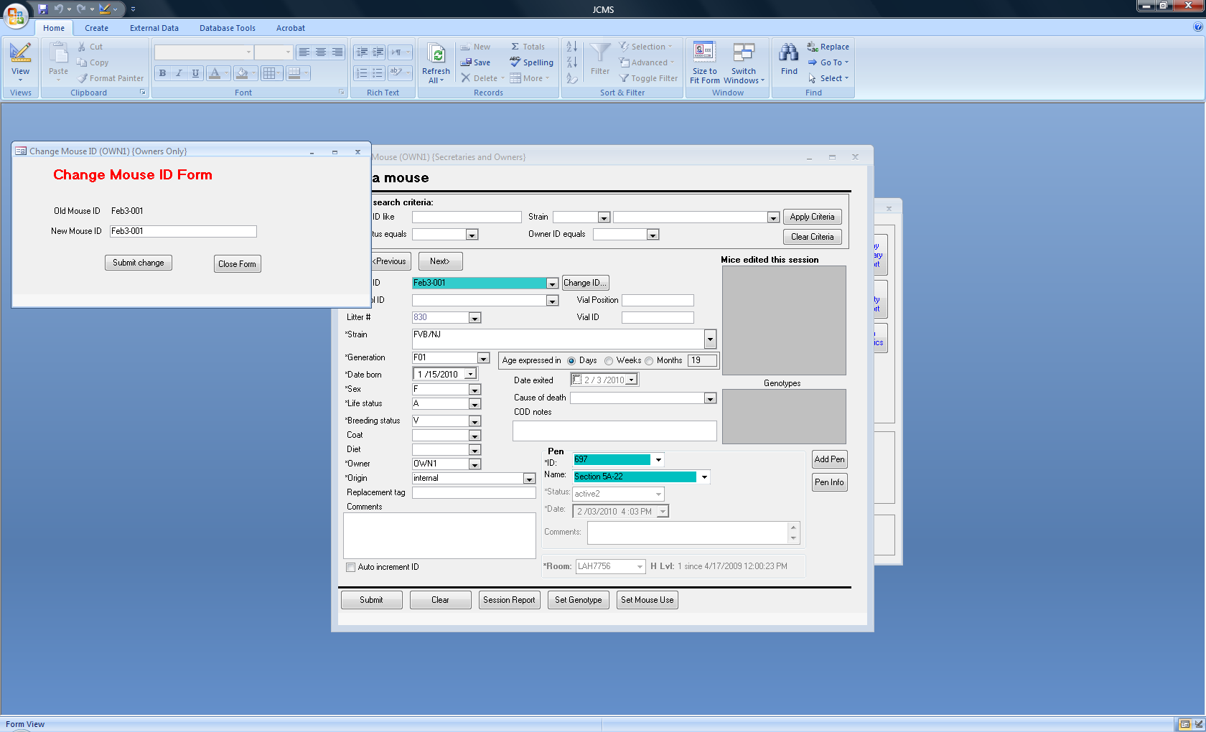The ID of any mouse in JCMS may be changed as long as the new name is unique in the database. For example, if mice are ear notched so they are unique in a pen, punches may need to be added to the mouse ear when the mouse is moved to a new pen. A code could be appended at the end of the mouse ID number to indicate its current ear-punch value (e.g., 2373-R, 2373-L, 2373-RR, 2373-LL, 2373-RL, 2373-RRL, 2373-RLL, 2373-RRLL. When the mouse moves, and the notch changes, update the mouse ID accordingly. To change a mouse ID, use the mouse edit form. Click the Change ID button on the form. Fill out the dialog box with the new ID and press submit change to change the mouse ID in JCMS. (The ID may not be changed to an already existing ID).

Figure ‑ Change Mouse ID Form

The Edit Mouse form also allows you to navigate through the mice in the database - a mouse browser.

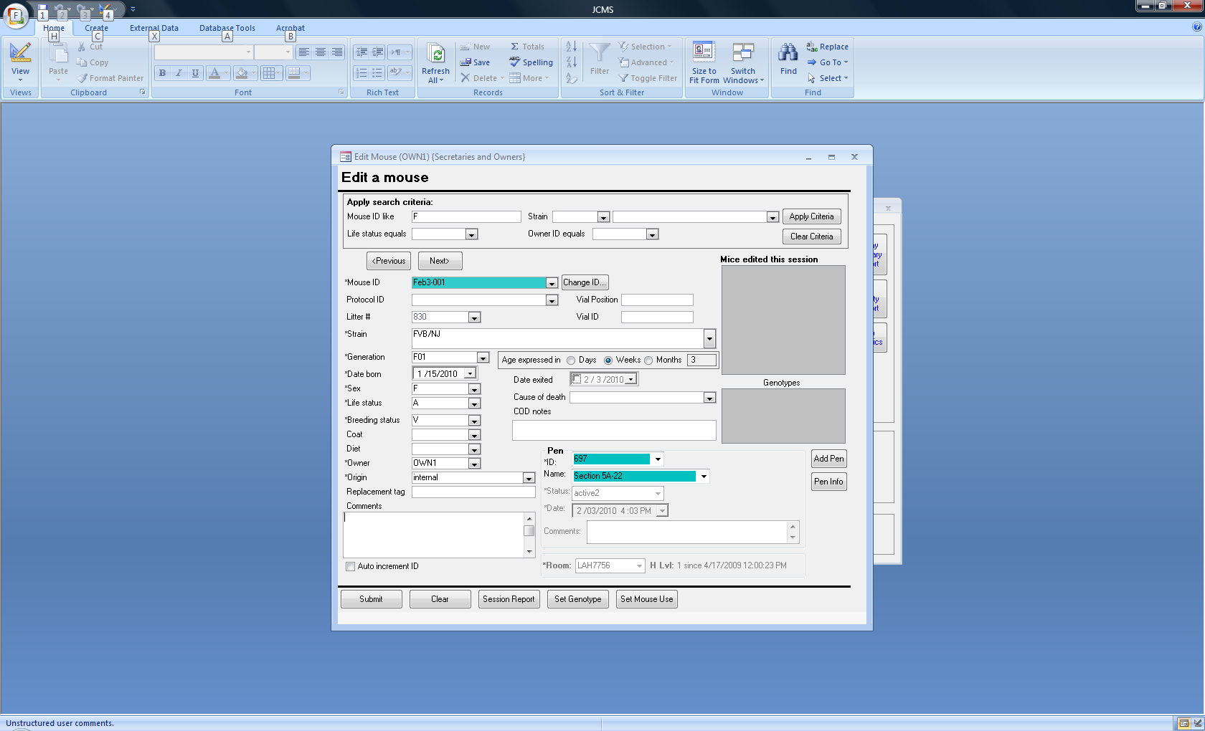

Figure ‑ Edit Mouse With Browser Functions

The user can set search criteria and apply them to the mice in the database. When applied, only those mice meeting the criteria will become available in the lower section for viewing or editing. The criteria are ANDed together, that is, for a mouse to be included it must meet all of the selected criteria. Some fields support substrings while others (life status and owner) accept only exact matches.

A live mouse may not be put into a retired pen. This form will retire pens and matings on the mouse exit date if the setup variables JCMS_AUTO_RETIRE_PENS and JCMS_AUTO_RETIRE_MATINGS are true. Note that resurrecting a mouse will not resurrect its retired matings or pen.

## Importing or Bulk Adding Mice

This form is useful when bringing a group of mice in from outside the colony or when adding a new group of mice that are all similar. The group must all have the same information for the required fields, the fields marked on the form with an *. JCMS will automatically generate unique mouse ID numbers and will increment by one for each additional mouse imported. Set the Base ID to the first ID number to be used. This form will not add any mouse ID Prefix specified in the setup variables; enter the prefix as part of the base ID.

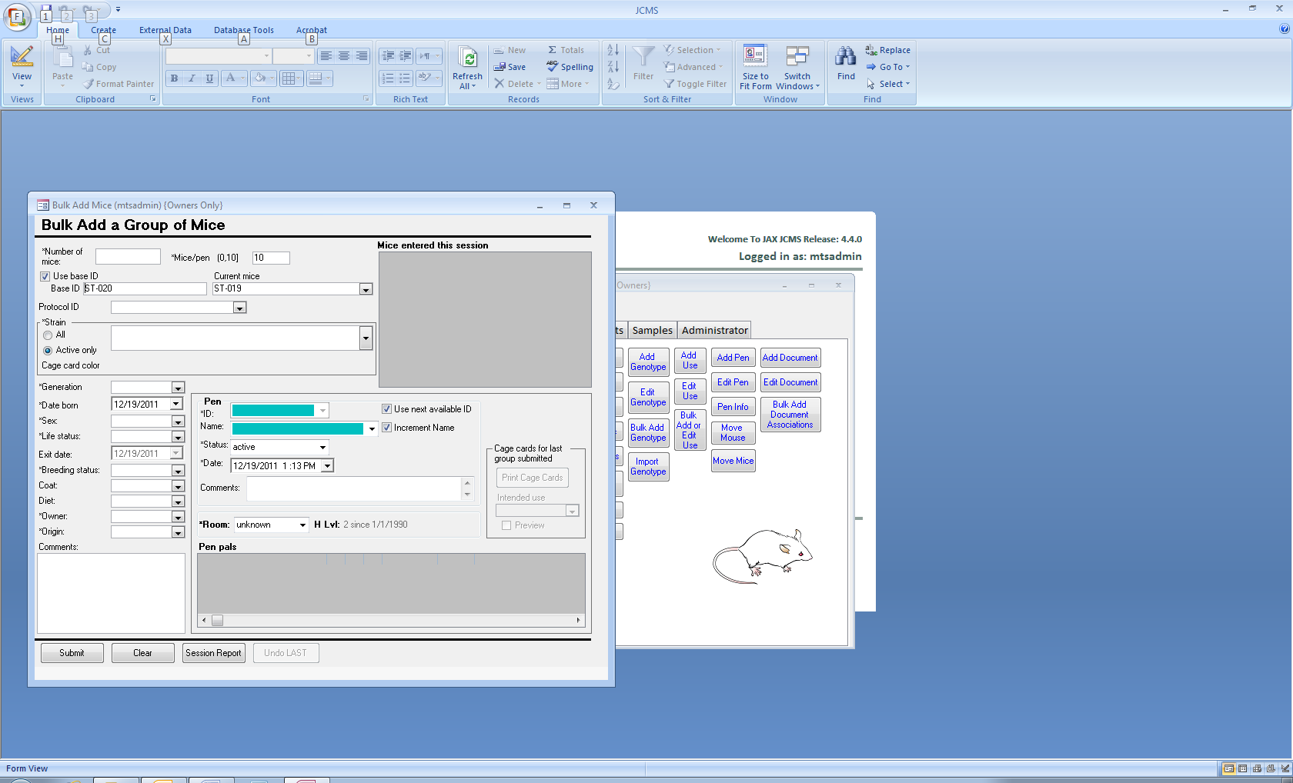

Figure ‑ Bulk Add Mice Form

The new pens will be automatically assigned and filled with the number of mice specified. “Use next available ID” must be checked. Note that live mice may not be put into a retired pen.

Once mice are added, cage cards can be printed. Any intended use entered on this form will only be printed on the cage cards; it will not be saved with the mouse.

Do not use this form if the mice have a dam and sire already in JCMS. Create a litter and use one of the litter forms instead. Otherwise, it will not be possible to create a pedigree tree.

## Adding Pups

The Add Pup from Litter form is used to add mice into the database when they are weaned. This form adds mice one at a time and must be used if the litter record has already been created. If not, consider using the Add Litter w/Pups form instead. That form will add the litter record plus all the pups as weaned mice in one step. Which form will work best is dependent upon the workflow.

Once the litter # is entered, the form will display the strain, generation, date born, wean date, and tag date from the litter record. It automatically sets the life status to alive and breeding status to virgin.

Any change made to the wean date or tag date on this form will also update the litter record when the mouse is submitted.

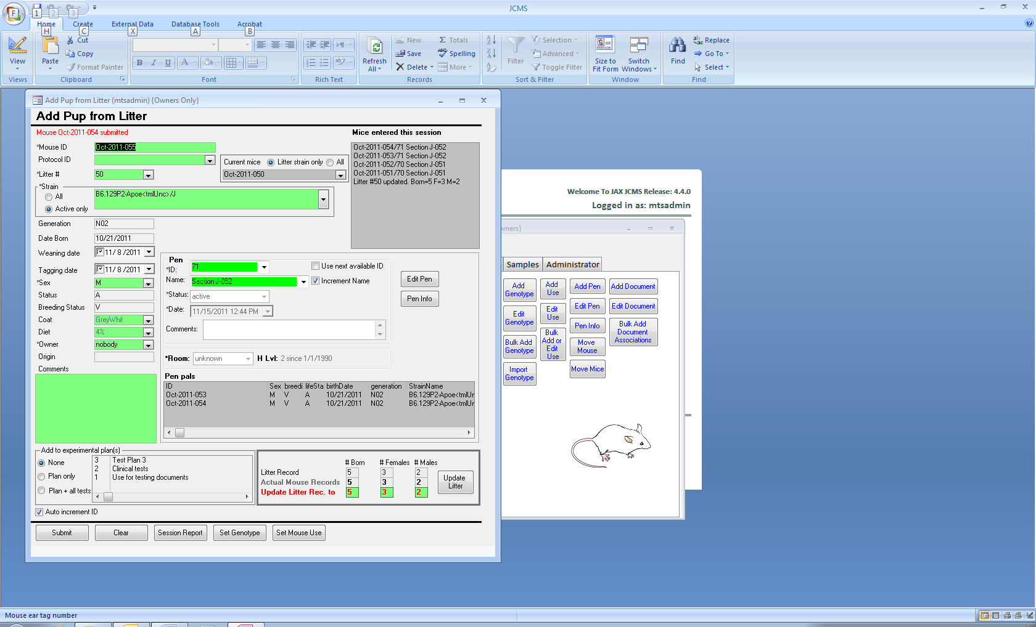

Figure ‑ Add Pup from Litter Form

The current mice box (top center) is an aid for determining the next mouse ID to use if a sequence of ID numbers should be maintained. It shows the existing mouse IDs.

As mice are added, the litter record box (bottom right of form) is updated to show the actual number of mice in JCMS for this litter. Once all pups have been added, click the Update Litter button to change the litter record to the numbers shown in the red “update” boxes. The “update” boxes may be changed by the user to any desired number (or blank). If pups have died, the number born or females/males in the litter record may be different from the actual mouse records.

As mice are added, they may also be added to experimental plan(s) and all the experimental tests in those plans. The session box will list the plan and test IDs.

When the setup variable MTS_RELAXED_PEN_NUMS is false a “Next ID” button is displayed instead of the “Use Next Available ID” check box. This button will provide a pen ID. Make sure to use the Pen Info button and print the cage card.

Note that a live mouse may not be put into a retired pen.

## Changing Life Status or Diet of a Group of Mice

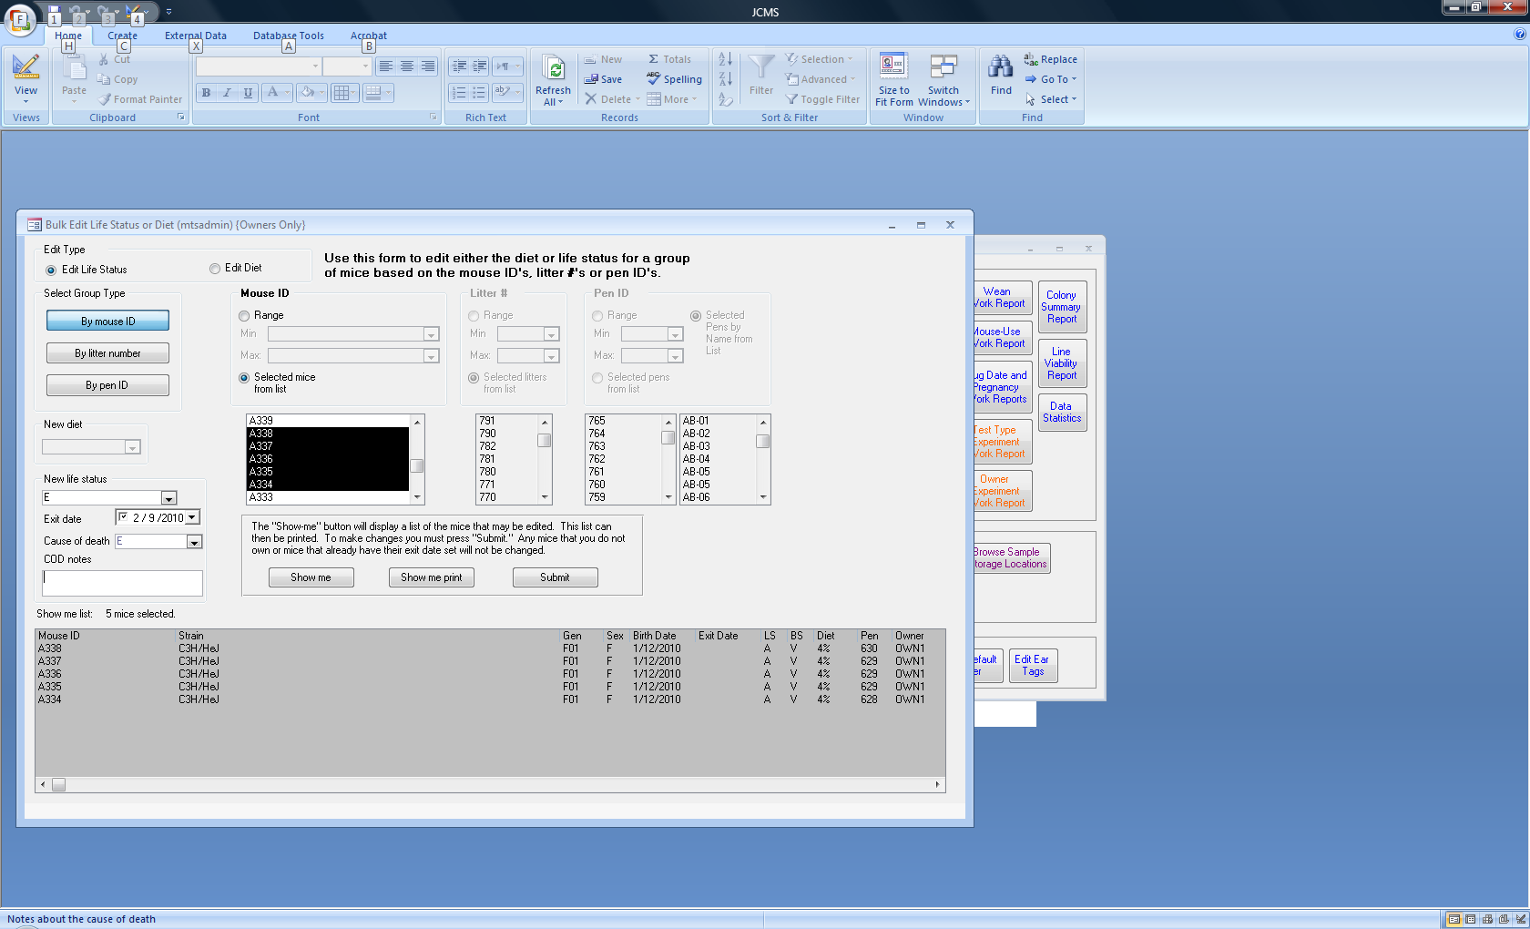

Figure ‑ Form: Bulk Change Life Status or Diet

JCMS allows users to do a few edit operations en-mass. Select the Bulk Change Life Status or Diet button. First select change the life status or change the diet. Mice may be picked for the edit operation by litter, pen, or mouse ID. Use the “Show me” button to display a list of mice that may be affected by the operation when submit is pressed. No changes are made to the mice until submit is pressed. Any mice not owned by the current user or that already have their exit date set will not be changed. Use the “Show me print” button for a printable list of the mouse changes. If the setup variable JCMS_AUTO_RETIRE_PENS is true, pens now containing only exited mice will be retired as of the exit date. If the setup variable JCMS_AUTO_RETIRE_MATINGS is true, all mice that are exited have their matings checked. Those active matings now consisting of only exited mice will be retired as of the exit date.

## Changing Life Status using the Handheld Forms

The Bulk Exit handheld form allows changing the life status of all mice in the selected pens at once. All the mice must be changed to the same new life status, exit date, and cause of death. This form does not allow changing a mouse to a non-exit life status. It also will not make any changes to mice that already are exited. If the setup variable JCMS_AUTO_RETIRE_PENS is true, pens now containing only exited mice will be retired as of the exit date. If the setup variable JCMS_AUTO_RETIRE_MATINGS is true, all mice that are exited have their matings checked. Those active matings now consisting of only exited mice will be retired as of the exit date.

## Change Life Status of an Individual Mouse using Handheld

Use these handheld forms to change the mouse life status. Select pens and use **Bulk Exit** to simultaneously exit and wean all mice in the pens. Select one pen and use **Individual Mouse Change Life Status** to change the life status and exit information for selected mice in that pen. The new life status, exit date, and cause of death will be the same for all mice. Using the **Change** form, a mouse may be changed from an exit to a non-exit life status. However, if the pen is retired, the mice in the pen may not have their life status changed to a non-exit life status (retired pens are expected to be empty, i.e. the mice left in them are no longer alive). Either move the mice into an active pen or change the pen to no longer be retired.

If the setup variable JCMS_AUTO_RETIRE_PENS is true, after changing the life status of the mice, pens now containing only exited mice will be retired as of the mouse exit date. If the setup variable JCMS_AUTO_RETIRE_MATINGS is true, all mice that are exited have their matings checked. Those active matings now consisting of only exited mice will be retired as of the exit date. Note that resurrecting a mouse will not resurrect its retired matings.

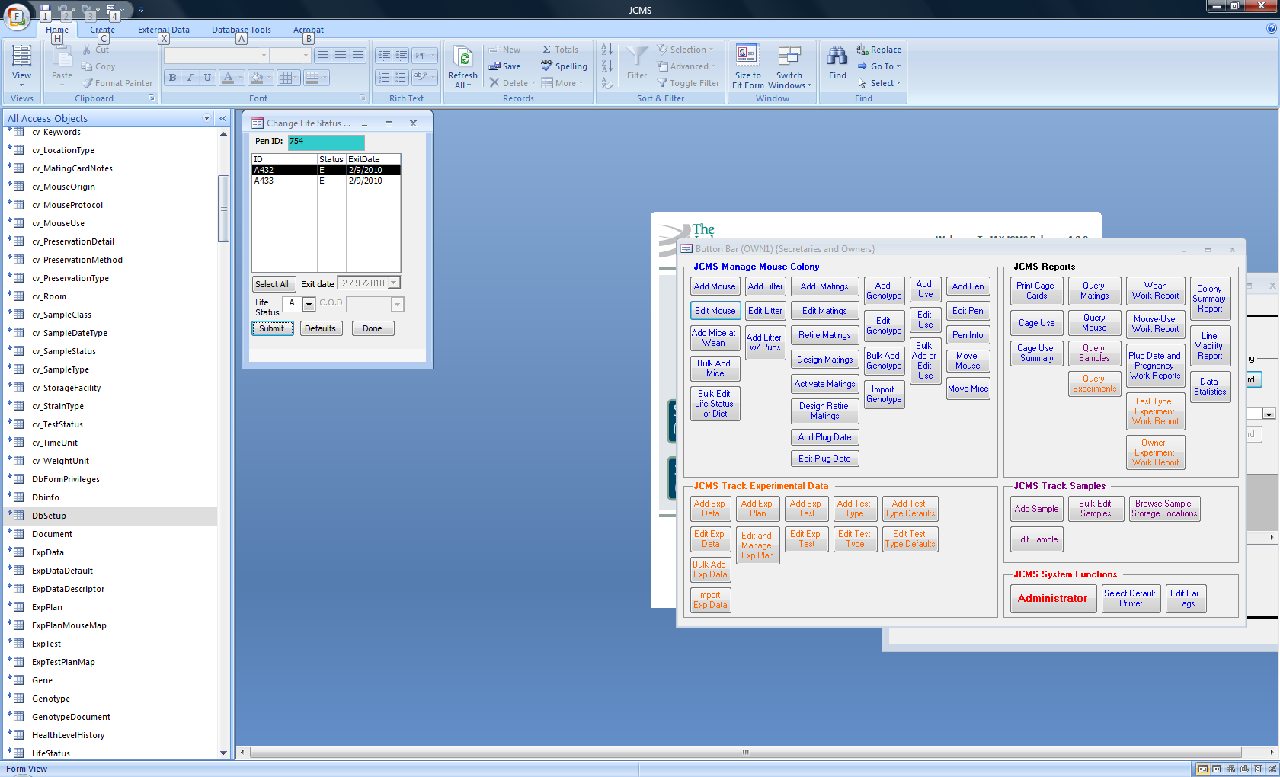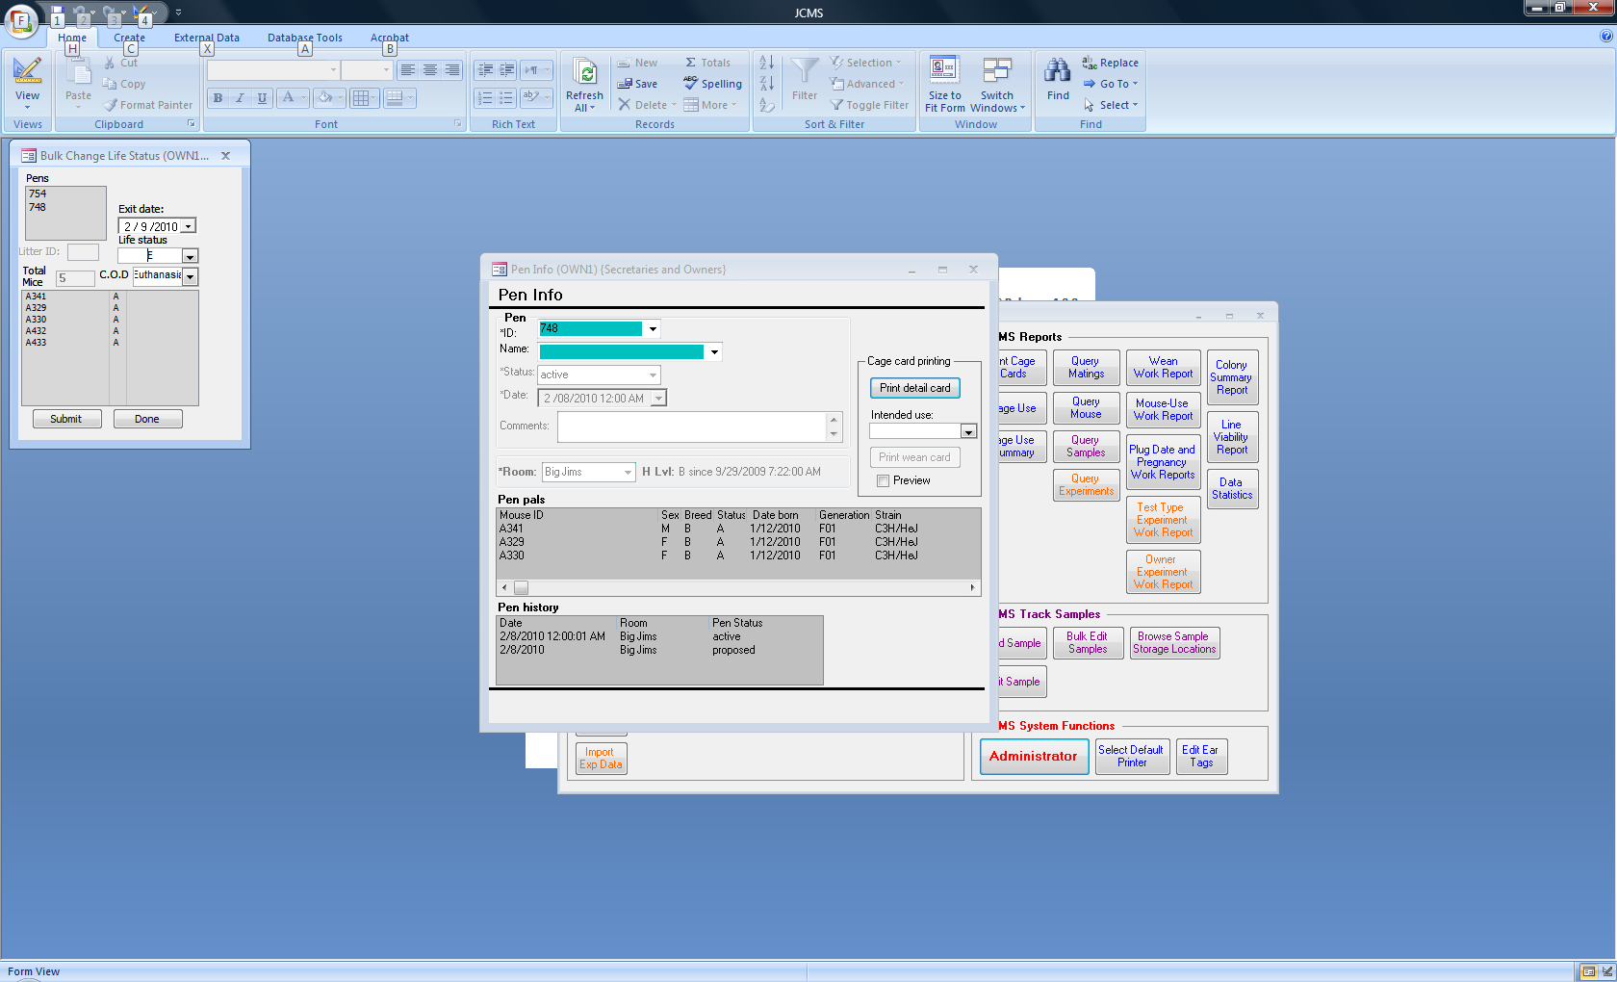

Figure ‑ Individual Mouse Change Life Status Handheld Form

Figure ‑ Bulk Exit Handheld Form

# Pens and Cage Cards

In JCMS we use the terms pen and cage interchangeably.

All mice reside in a cage or pen. In JCMS each pen has a unique pen ID number. A pen may have an optional pen name that does not have to be unique. A pen may be empty. A pen has a pen status, such as proposed, active, or retired, and a history of when the pen’s status changed and when it moved between rooms.

## Manage Pen Configuration Form

The Manage Pen Configuration form, accessed from the Administrator button bar, provides an interface for changing the settings of setup variables related to pens. See section 3.4 for more details.

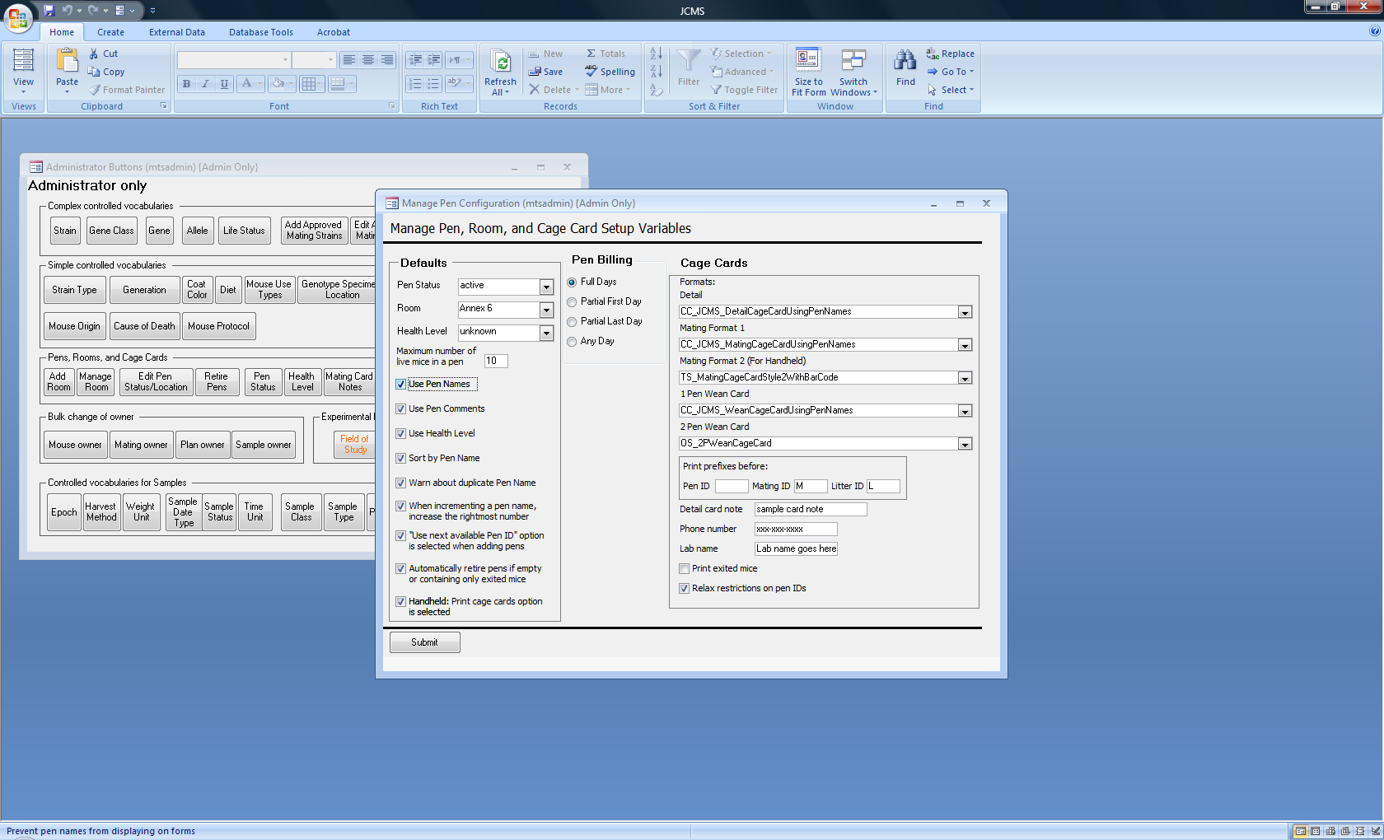

Figure ‑ Manage Pen Configuration Form

The default *pen status* and *room* name are used to automatically pre-set these values on forms where new pens are added. Most forms (except some of the handheld forms) provide an option for overriding the default. Similarly, the default *health level* is used on the form where new rooms are added. The health level is always associated with a room.

Many add forms limit the number of live mice in a pen to the number specified in the *maximum number of mice in a pen* which may be overridden on the form. This number is used to separate the mice into different pens when adding a large litter or group of mice at once.

*Pen names*, *pen comments*, and room *health level* are optional and do not have to be used.

When using pen names, it may be convenient to “*sort by pen name*”, which will cause some drop-down lists to be ordered by the pen name instead of pen ID. It is possible to have *duplicate pen names* (the pen ID will always be unique). When duplicate pen names are not desired, have JCMS *warn* before adding a duplicate pen name.

When adding pens, if “*increment name*” is checked on the form, the pen name shown will be incremented in the same fashion as mouse IDs. *Increment rightmost* will add one to the rightmost integer. If not selected, one will be added to the leftmost integer. The numeric portion of the pen name that is incremented is limited to a 10 digit number. Using numbers larger than that will return an “Unable to increment” error message. Longer numbers may be used if the pen names are entered individually by hand.

Pen ID numbers are unique integers that are either generated by JCMS (and therefore assured to be unique) or provided by JCMS users. When “*Use next available ID*” is checked, JCMS will assign the next largest pen ID. If the user prefers to generate pen IDs, they may hand enter them instead. JCMS will never allow duplicate IDs to be entered into the database. JCMS will also warn if a user tries to enter a pen ID much larger than any previous pen ID used (it keeps track of the largest pen ID used). The largest pen ID that can be entered into JCMS is 2,000,000,000. Very large pen IDs may not print out correctly on all cage cards due to lack of space. If this is a problem, cage cards can be configured to have more space for display of the pen IDs. A short string of characters can be prefixed on Pen IDs generated by JCMS when they are printed. The Administrator must specify this string in the *PEN_ID prefix* setup variable.

*Mating ID* and *Litter ID prefixes* may also be specified for printing on cage cards.

When *automatically retire pens* is selected, any time a mouse is moved, pup is weaned and moved, or a mouse’s life status is changed to an exit life status the pen is checked to determine if it is empty or only contains exited mice. If yes, then the pen is retired using the date of the change (exit date, wean date, mating date, or today’s date).

If the *handheld: print cage cards option* is checked then certain handheld forms open with the print cage card check box selected.

Pens have a *history* that records the date and time a pen was established, retired, had its status changed, or was moved into a different room. JCMS provides the default *pen status* terms proposed, active, and retired. The user may add other terms. A pen status may be either billable or non-billable. For example, a proposed pen may not contain mice and, therefore, is not billed; a retired pen also contains no live mice and is not billed.

*Pen billing* is used by the Cage Use and Cage Use Summary reports to determine how many pens to count each day. For reporting purposes, a pen is either “billable” (counted) or “non-billable” (not counted) on a specific date. Use the Administrator *pen status* form to change the billable attribute of a pen status term. When counting, a “partial” day is a day when a pen was moved into or out of a room or a day when a pen’s status changed from a billable to a non-billable status. The date a pen was established is a “partial” day. The date a pen was retired is a “partial” day.

JCMS supports several *cage card formats*. Each type of format must have a cage card *report* selected. For example, a detail cage card could use the report CC_JCMS_DetailCageCardUsingPenNames or MW_DetailCageCardLandscape.

The *Detail card note*, *Phone number*, and *Lab name* are printed on many cage card formats.

*Print exited mice* specifies if a cage card should list all mice in that cage, including those with an exit life status, or show only those still alive.

*Relax restrictions on pen IDs* indicates if the user should have an unrestricted ability (checked) to create pens or if some forms will only create pens that already have had a cage card (possibly blank) printed with the pen ID on it.

## Rooms and Health Level

*Health level* is associated with a *room* and a *history* of health level changes is maintained for each room. The Administrator has several forms used for manipulating the health level and room terms.

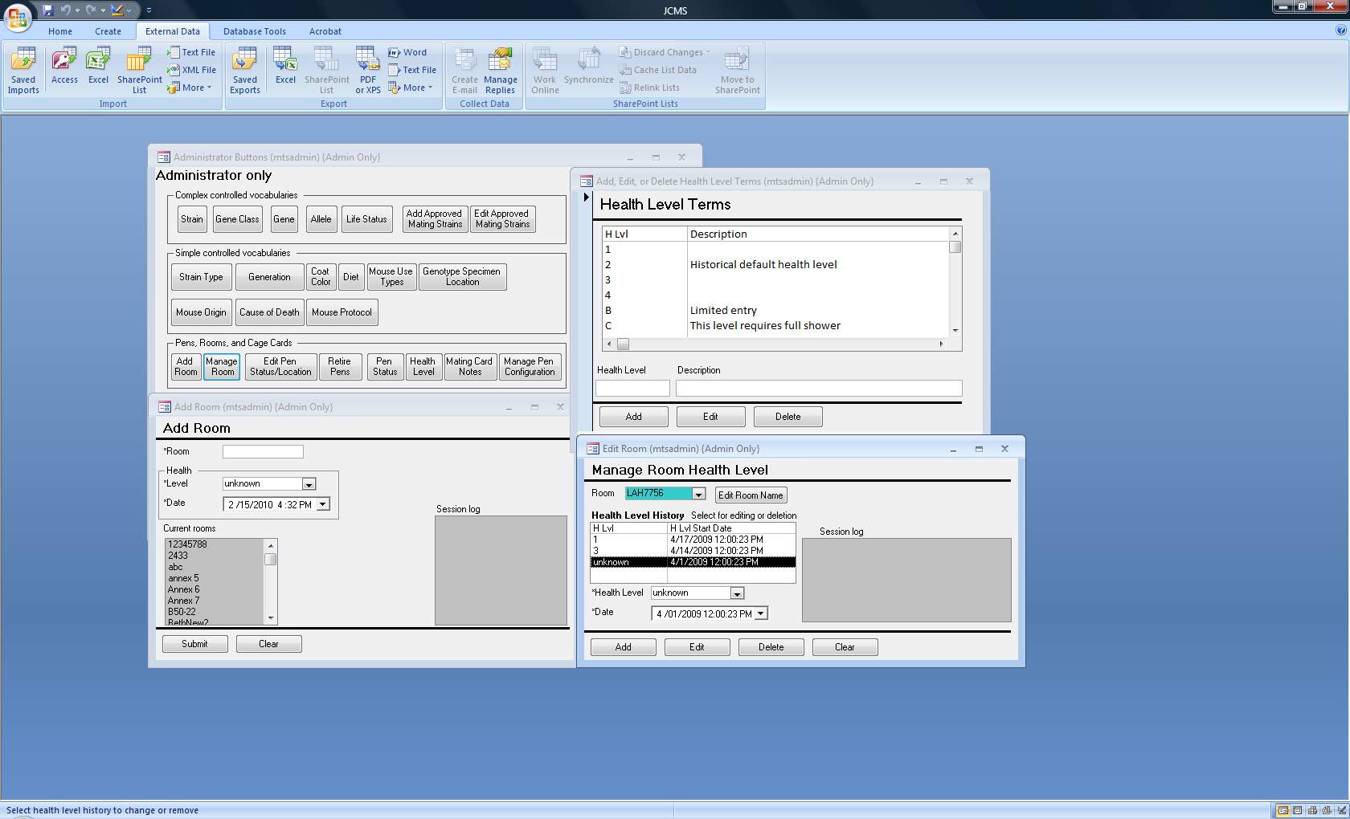

Figure ‑ Administrator Forms for Managing Room and Health Level

Health level terms may be not be deleted unless the term has no association (past or present) with a room. An edited health level term will be changed in all places where it was used. An edited room name will be changed in all places where it was used. If the date/time of a health level change is incorrect it may be edited using the *Manage Room* form. If a health level has been incorrectly associated with a room it may be deleted using the *Manage Room* form, however the room must have one health level associated with it.

## Adding Pens

New pens are added when new mice are created in the database using the **Add Mouse, Bulk Add Mice, Add Mice at Wean,** or **Add Litter w/ Pups** forms. A new pen can be created when changes are made to a mouse using the **Edit Mouse** form. The **Add Matings** form will automatically generate new pens. The **Design Matings** form will assign pen IDs to matings and the pen is created in the default room with a status of proposed. When the mating is activated using the **Activate Matings** form the pen’s status will also be changed to active as of the mating date. The handheld forms **Add Litter w/Mice** and **Make a Trio or Pair Mating** will create pens using the default room name and default pen status term.

### Pen Info Form

The pen information form can be accessed from the manage mice tab and from many other forms that contain a *Pen Info* button.

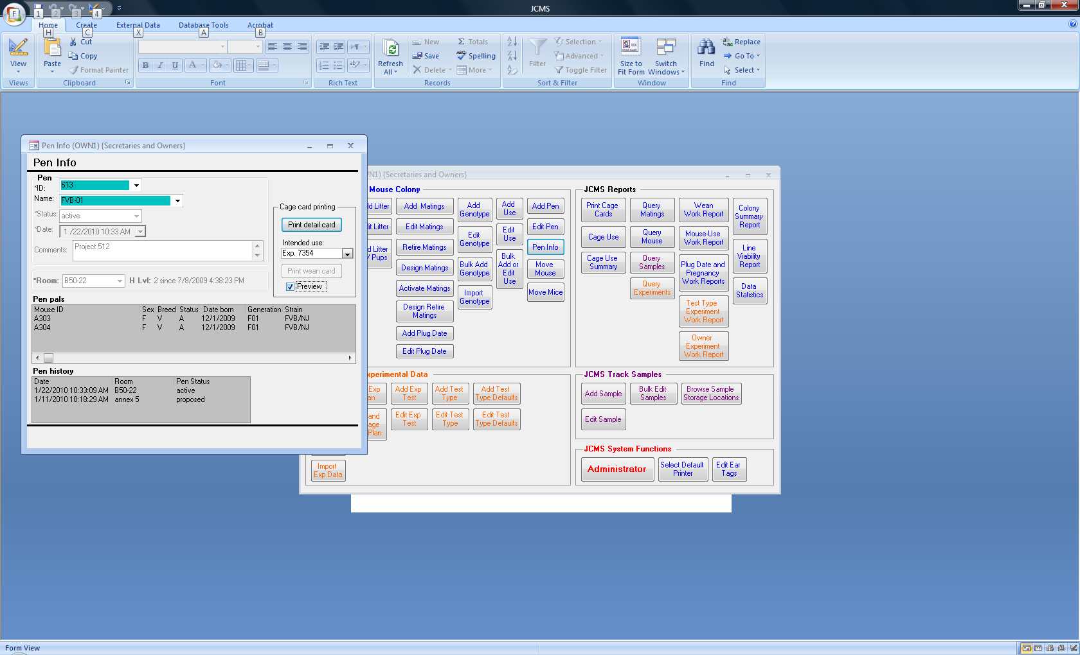Select a pen by pen ID or pen name. The mice currently in the pen are listed (“pen pals”) and the history of the status and room changes for the pen are displayed.

Figure ‑ Pen Info Form

Cage cards may be printed or previewed using the detail format or wean format if the pen contains mice all from the same litter. An optional *intended use* may be printed on the card. This use is not saved in JCMS or associated with the pen. It simply provides a way of printing a short note on the card.

### Add Pen Form

Figure ‑ Add Pen Form

The add pen form can be accessed from the manage mice tab and from many other forms that contain an *Add Pen* button. When *Use next available ID* is checked JCMS will assign the pen ID number. When it is unchecked, a number may be hand entered. An existing pen name may be selected for incrementing (*Increment name* must be checked).The pen that is added will have a name that is one larger than what is shown in the name field (for example, FVB-01 will be added as FBV-02). Note that if increment name is not checked or the name has no numeric portion to increment, a duplicate pen name can be added with a unique pen ID. After submitting the new pen, a blank cage card for it may be printed.

## Editing and Retiring Pens

The edit pen form can be accessed from the manage mice tab and from many other forms that contain an **Edit Pen** button. Select a pen ID or pen name and the current information for that pen will appear.

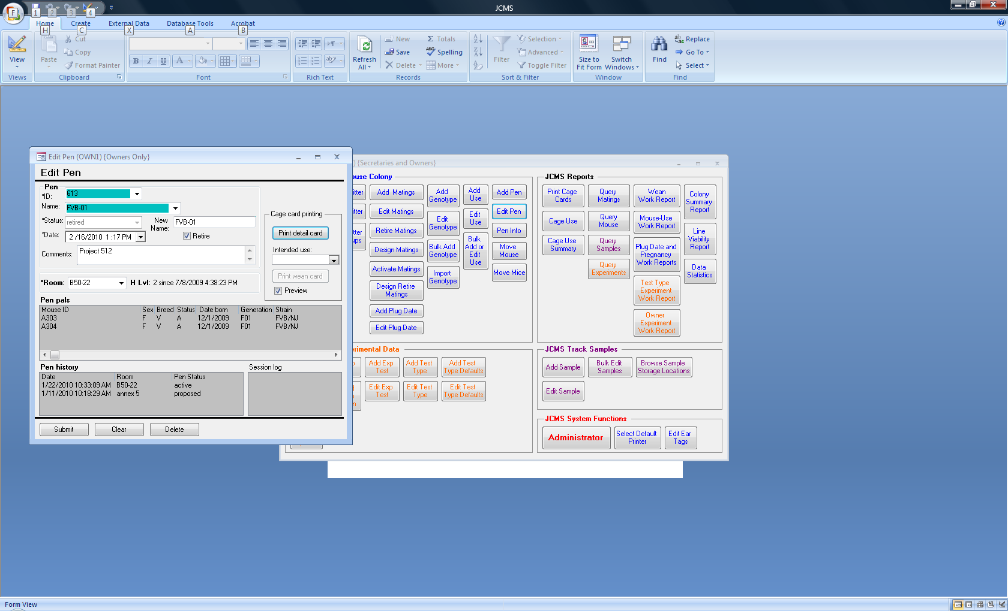This form may be used to move a pen into a different room or to change the pen status. Enter the date/time of the change before submitting it. A successful change will be displayed in the pen history list. To change the pen name, enter the change in the *New Name* field. To remove the name, enter blanks in the New Name field. The pen ID may not be changed. The pen comments may be edited.

Figure ‑ Edit Pen Form

When retiring a number of pens, check the *Retire* box and the pen status field will be displayed as “retired” instead of the current status, saving having to change the status box before submitting.

A pen containing live mice (mice with a non-exit life status) may not be retired.

## Moving Mice between Pens

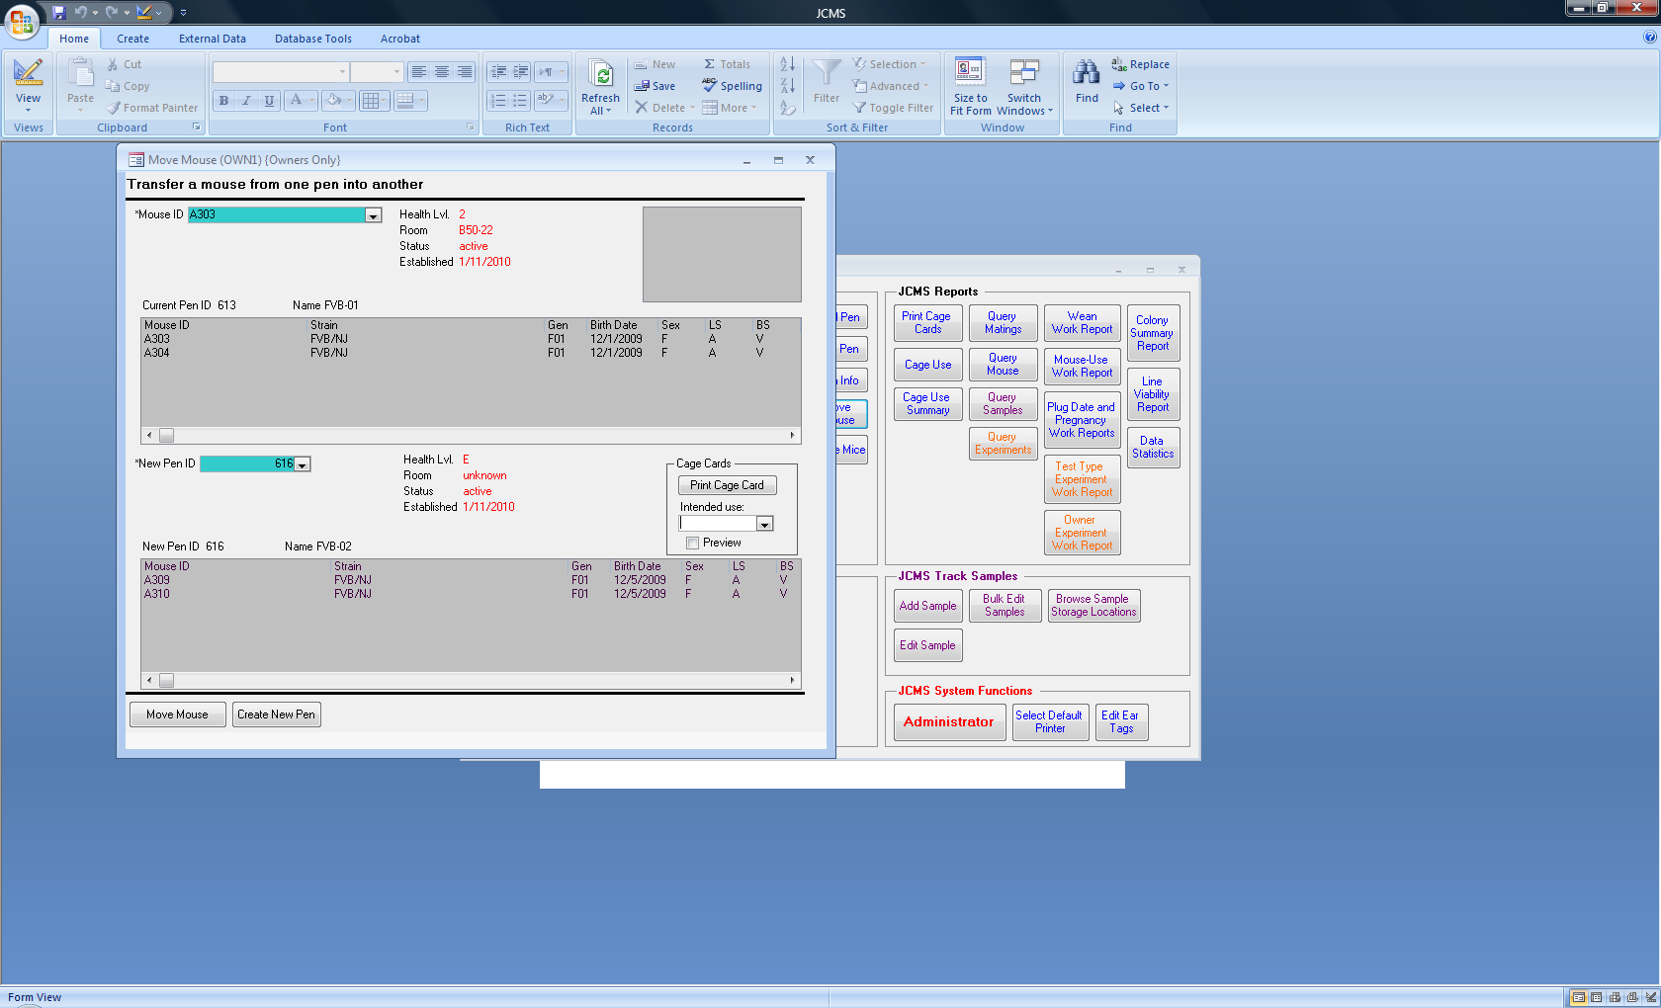There are two forms for moving mice. The **Move Mouse** button on the manage mice tab is used for moving one mouse at a time. Select the mouse and then the pen to put it into.

A detail cage card may be printed for the selected pen.

A live mouse (non-exit life status) cannot be moved into a retired pen.

When mice are moved around they may need to be moved into pens that do not exist yet in JCMS. In this case, use the **Create New Pen** button to add the pen.

Figure ‑ Move Mouse Form

The session box will indicate the mouse ID moved and it’s old and new pen ID number.

The **Move Mice** button on the manage mice tab will open the handheld move mice form. See below for a description.

## Moving Mice Using Handheld

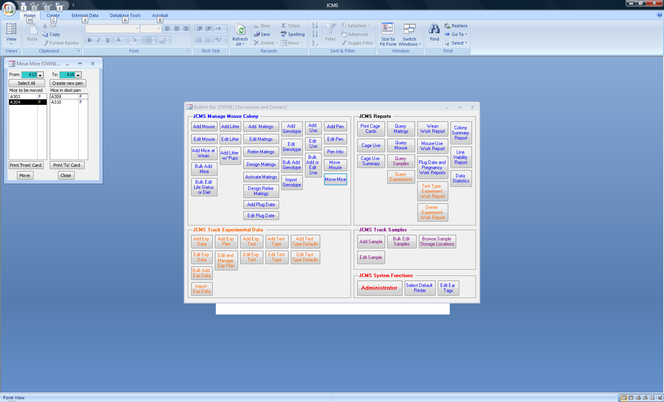When opening from the handheld main menu, select the two pen ID numbers and choose *Move Mice*. When opening from the manage mice tab the form will show the two highest pen ID numbers. Select one or more mice to move. A new pen may also be created to move the mice into.

Figure ‑ Handheld Move Mice Form

The Move mice form allows optional printing of new cage cards for both the *from* and *to* pens.

## Printing Blank Cage Cards

Most forms that allow the creation of a pen also provide a method of printing cage cards. Blank cage cards may be printed using the **Print Cage Cards** button on the reports tab. No pen records are put into the JCMS database. These blank pre-numbered cards are created to prevent the accidental use of duplicate pen IDs in the mouse room. Blank cards that are not used (because they are lost, damaged, etc.) have numbers that may never be used in the database. If the setup variable MTS_RELAXED_PEN_NUMS is set to false, this form may be used to print pen IDs on cage cards for later use.

## Retiring Pens Automatically

JCMS may be configured to attempt to retire pens automatically when the setup variable JCMS_AUTO_RETIRE_PENS is set to true. Every time a mouse’s life status is changed from a non-exit life status to an exit life status JCMS will check if the pen it is in should be retired. Every time a mouse is moved into a new pen, JCMS will check if the old pen should be retired. The retired date will be the date of the action (exit date of the mouse or today’s date if the mouse is moved). A pen will be retired if it is empty (contains no mice) or if it contains only mice that have an exit life status.

Note the following exceptions:

* A pen will not be retired twice in a row.
* A pen will not be retired if the retire date would be prior to some action that is already recorded in the pen history. (For example: the mouse’s exit date might be last week and this pen’s status was changed this week.)
* Changes to a pen’s status are not just date sensitive, they are also time sensitive. Wean dates are not time sensitive and are considered to occur at midnight on a particular day. Midnight (12:00:00 AM) is the earliest time something can occur.
* The retire date used will be the date that pertains to the mouse that is changed. This means that if there are exited mice in the pen whose exit dates are more recent than the exit date entered for the last mouse, the pen retire date could end up being prior to those exit dates. Suggestion – watch the order that mice are exited so the most recent one is done last.
* The bulk forms for changing life status will attempt to also retire all pens. However, if an exception occurs in the middle of retiring pens, JCMS will stop retiring pens and not try to continue. Correct the exception and use the Administrator’s bulk retire function to complete retiring the pens.

## Bulk Retire Pens

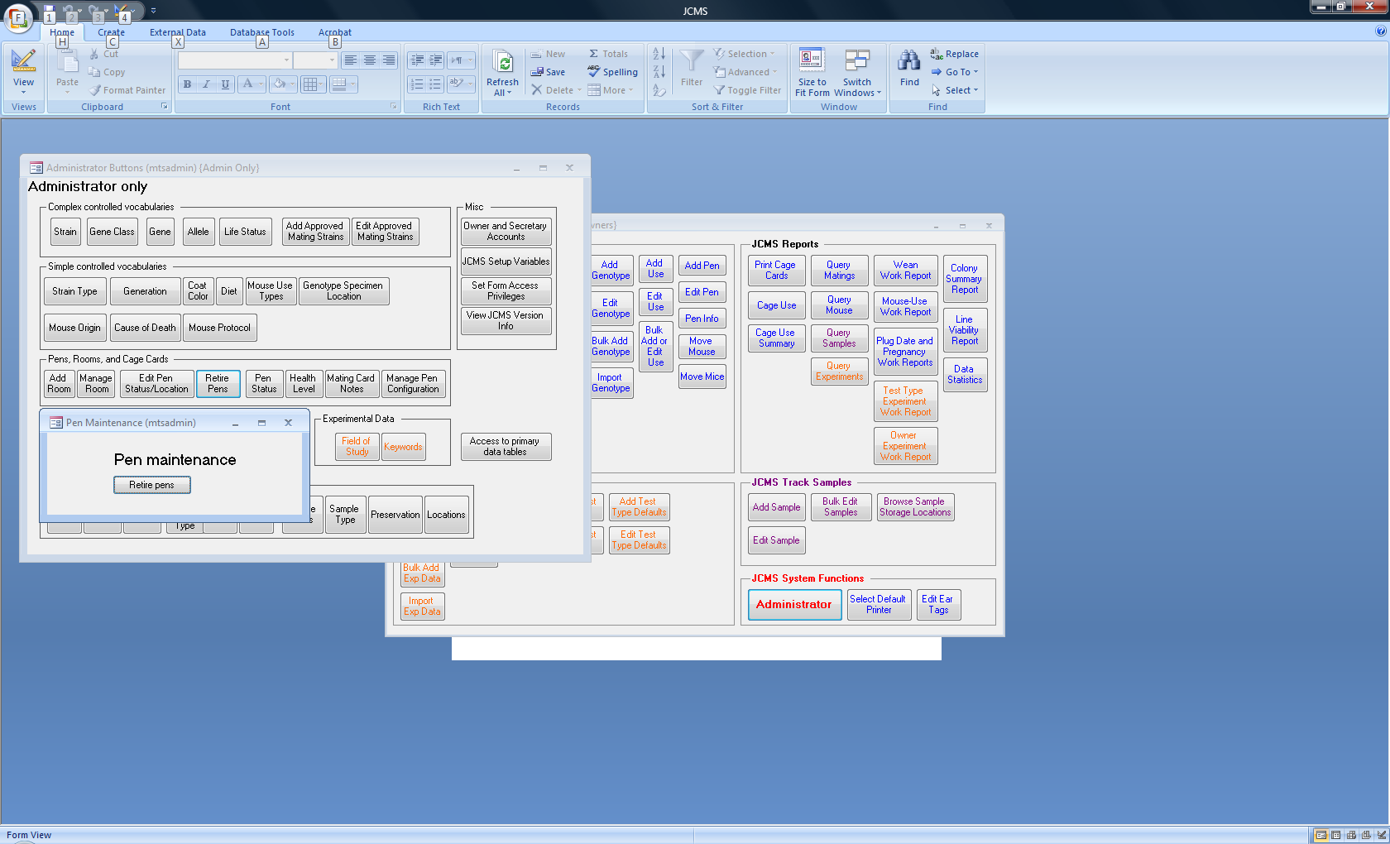Bulk retiring of pens is an Administrator function, found on the Administrator button bar. Use the **Pen Maintenance** button to open this form and click the **Retire Pens** button. This will search the database for pens that are empty (have no mice in them or have only mice in them that have an exit life status). These pens will have their pen status set to retired on today’s date.

Figure ‑ Pen Maintenance Form

NOTE: the pen maintenance function can take a long time to complete. Trial runs show that on a Pentium III 600MHz computer running JCMS with 2000 pens, the pen maintenance functions take about 3 minutes each to run. The compute time will probably grow as n(logn) (but could be as bad as n2, depending on how MS Access optimizes its queries), where n is the number of cages in the database. If you have more than 10,000 pens, you should consider running the pen maintenance functions when you have several hours available in which the database will not be used. You should also back up your database (JCMS_db.mdb or MySQL) before running these functions just in case they take too long to complete. Whether or not this precaution is necessary will not be known until we have more experience with JCMS performance with very large data sets.

## Correcting Pen Status and Date Errors

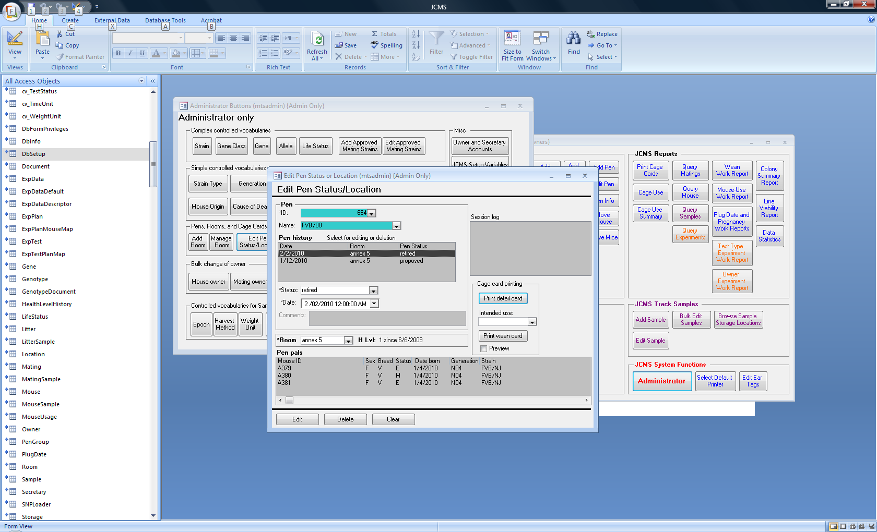

Figure ‑ Edit Pen Status/Location Form

The Administrator uses the Edit pen status/location form for correcting errors to pen history records. Select a pen history row and edit it using the fields below the pen history list. A pen must always have one pen history record, others can be deleted.

## Cage Use Reports

The two cage use reports are designed to provide information on the number of cages (pens) that should be paid for during a particular time period. Only the cages that have a “billable” pen status on a date are counted. Pen status terms are defined as either billable or non-billable. Use the Administrator *pen status* form to change the billable attribute of a pen status term.

If the pen status terms are set up to track a cage “use”, then by filtering the report results for a specific billable pen status, the number of cages for that “use” are listed. For example, a pen status term “breeding” could be used for all pens containing a mating pair. By setting the filter option for status to “breeding” only those pens are counted. Additional filter options may be selected. All the filter options are combined (ANDed) together and further limit the results. For example, the report could count cages in a specific room, with a specific owner and strain.

A pen’s status may change in the middle of a day. *Pen billing* is used to determine if a pen is counted on a half day (partial day) during which its status changed between billable and non-billable. For example, the date a pen was established is a partial first day. The date a pen was retired is a partial last day. Full days count only the “non-partial” days. Any day counts all partial days.

### Cage Use Report

Figure ‑ Cage Use Report

This report may be printed or exported to Excel. Several filter options may be chosen at once.

**Important Notes**:

If JCMS has a large number of cages and a long date range is selected, the report may run noticeably slow. It may be best to run this report overnight in this case.

If a status that is non-billable is selected as a filter option, the pen count will always be zero.

All strains have an associated stock # (JR #). It is not possible to select a stock number for one strain and a different strain as simultaneous criteria and receive a correct pen count. Use either stock # or strain as the criteria.

### Cage Use Summary

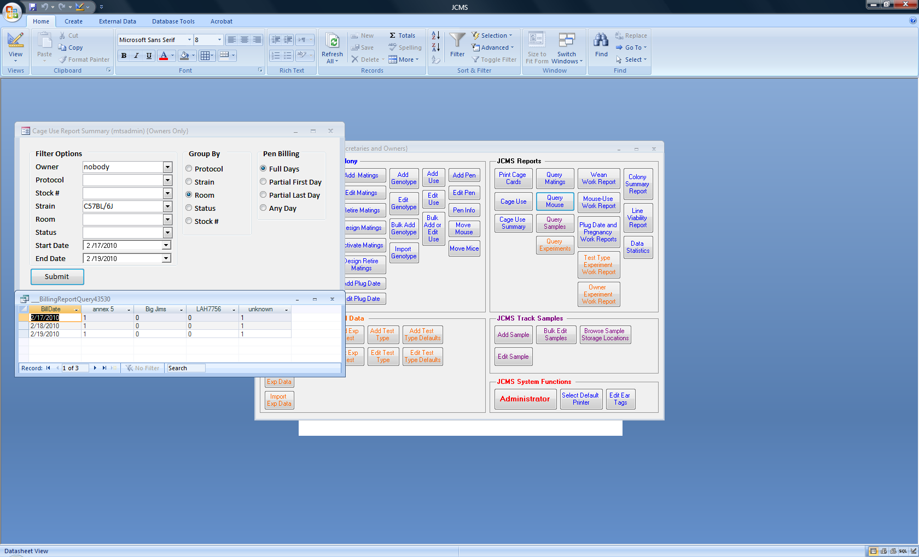This report is formatted as a datasheet (spreadsheet-like columns) and may be printed or exported to Excel. The resulting columns are limited to only those in the selected “Group” that have pens that match the filter options.

If a column contains all zeros, then there are an unknown number of pens that match the criteria, but all those pens have a non-billable status. For example, in Figure 7‑11, owner “nobody” has C57BL/6J mice in pens in 4 rooms, but the pens in Big Jims and LAH7756 happen to all be retired and, therefore, the count is zero for those rooms. “Nobody” has never had any C57BL/6J mice in the room “B-52” so there is no column for B-52 in the report.

Figure ‑ Cage Use Summary Report

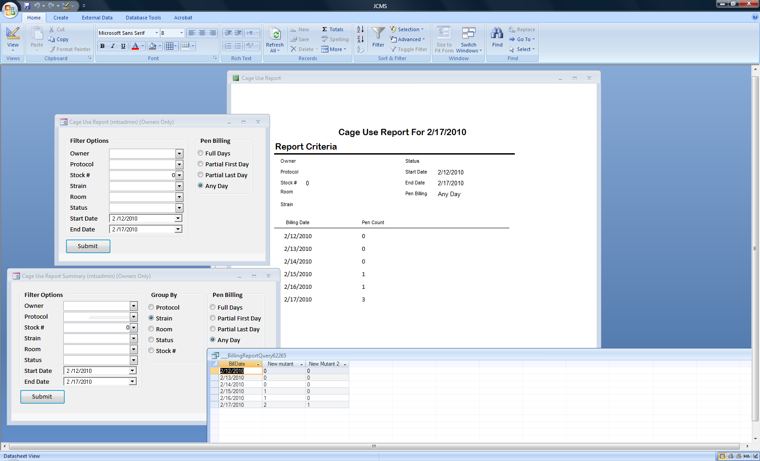

Figure ‑ Cage Use Summary (bottom) vs. Cage Use Report (top)

The important notes listed above for the cage use report also apply to the summary report with the following exception.

If a stock number that applies to several strains is chosen as the filter criteria and strain is chosen for grouping, the results can be seen by strain. For example, in Figure 7‑12 the strains New Mutant and New Mutant 2 both have stock # zero.

There are some counting difficulties in the case where a cage contains mice with different characteristics (protocol or strain/stock#). A cage is counted only once, not multiple times. Which protocol or strain/stock # it is counted for is selected by random. The following combinations of criteria and grouping exhibit this problem.

Filter by protocol --- group by strain

Filter by strain --- group by protocol

Filter by stock # --- group by protocol

No filter --- group by protocol

No filter --- group by strain

No filter --- group by stock #

To see accurate results, filter by both criteria (example: filter by protocol and strain).

NOTE: It is possible to assign the same stock # to more than one strain (for example, if none is assigned, the stock number will be zero or blank). If a stock number associated with several strains is selected, the cage count will indicate the total number of cages for all those strains. If several strains have no stock number or a stock # of zero, they will all be counted and reported in one column with a header of 0.

# Matings

JCMS is flexible in that you can choose to either set up matings on the computer (design mating) or do the mating work in the mouse room or laboratory and later enter the information into JCMS (add mating). If the design first method is used, then the mating must be *activated* on the computer after the mating is implemented in the mouse room.



Figure ‑ Mating to Weaning Diagram

This diagram shows a *typical* flow of information from JCMS to the mouse room and back to JCMS. Dashed boxes are optional. JCMS also has a special add litter form for use for those who prefer to wean mice before entering the litter information into JCMS.

### Automatic Litter Number Generation

JCMS can generate litter numbers automatically. To use auto litter numbering, set the setup variable MTS_AUTO_LITTER_NUMS to “on.” When this variable is set to on, JCMS generates litter numbers and associates the litter numbers with a mating.

Litter numbers are generated by JCMS in batches. The size of the litter number batches is a function of the setup variable called MTS_NUM_AUTO_LITTER_NUMS (the number of automatic litter numbers). It is recommended that the value of this variable be set to 10 or 100. By using a round number (like 10 or 100) it is easy to identify a litter as being the first, second, third etc., by simply looking at the litter number.

## Technical Matings

In addition to a Natural (N) mating between one or two dams and a sire, JCMS supports Embryo Transfer, Ovary Transfer, and In vitro Fertilization matings.

* Embryo Transfer (ET) involves an embryo sample and host dam
* Ovary Transfer (OT) involves an ovary or ovarian tissue sample, host dam, and sire
* In vitro Fertilization (IVF) involves an egg sample and sperm sample

All matings except IVF may have a natural (live birth) litter. All mating types may have an embryo litter. An embryo litter consists of harvested embryos or embryonic stem cell samples. To obtain a live birth from an IVF mating, create embryo sample(s) that are then used in an embryo transfer mating.

## Which Mating Forms to Use?

Design Mating is used by those who want to set up their matings on paper by using the computer ahead of time. Activate Matings must then be used after the mating has been performed in the mouse room. These two forms are only used for natural matings. Others prefer to first do the matings in the mouse room or laboratory, then return to the computer and use the Add Mating form to enter the information. The Add Mating form may also be used in the mouse room on a laptop computer. If handheld computers are used in the mouse room, there is a special Do Pair or Do Trio mating form to use.

The Edit Mating form is provided for correcting any errors that were made in previous data entry.

Eventually, the mating will be ended or “retired”. Some plan the ending of natural matings ahead of time using the Design Retire Matings form. All matings use the Retire Matings form when ended. When the Design Retire matings is used first, information given in the design stage is used for the defaults on the Retire mating form. This information may still be changed to reflect last minute changes made in the mouse room.

Sires are often used in more than one mating simultaneously. JCMS will warn that a mouse is already in use in another unretired mating.

Cage card note choices are set up by the Administrator by using the Administrator button bar.

## Approved Mating Strains

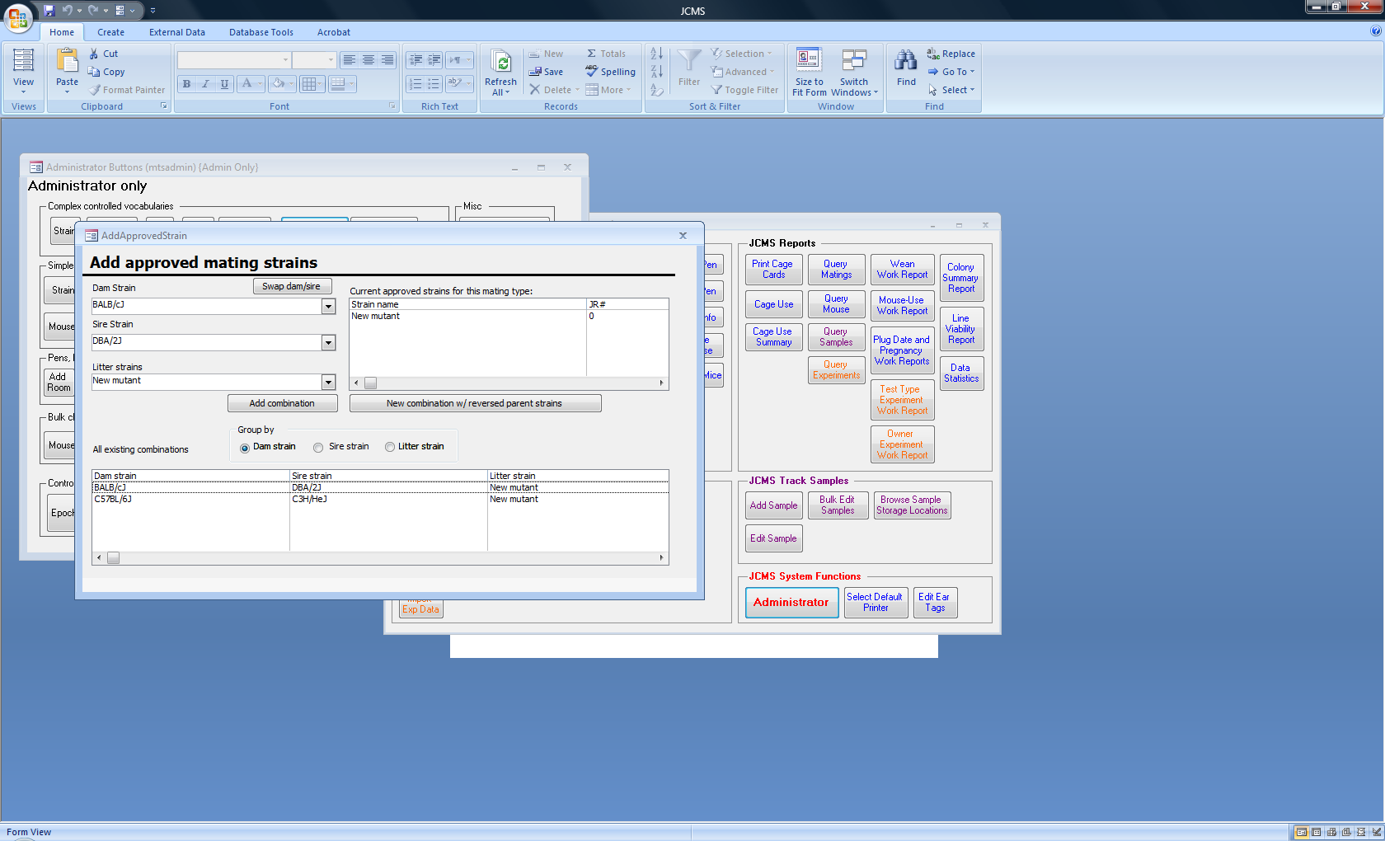

Figure ‑ Add Approved Strains Form

The Administrator has the optional ability to create a table of approved litter strains. An approved litter strain field is a function of the dam strain and the sire strain. A sire strain and dam strain combination is **not** unique. That is, a sire and dam strain combination may result in multiple litter strains. The special case of when the sire and dam strains are the same will result in that strain always being ‘approved’ and need not be entered in the database. Approved strainrecords can be active or inactive. Inactive records are ignored as candidates for litter strains. They are kept in the database for documentation purposes and possible future use.

The “approved matings” radio button on the mating forms will be initialized to the value of JCMS_ENFORCE_APPROVED_MATINGS in the setup variables. When this is set to true, only approved litter strains may be selected. The user may change the radio button setting to active or all and enter the unapproved strain.

The forms for adding and editing approved litter strains are invoked from the Administrator tab by clicking the **Administrator** button. Use the two buttons: **Add Approved Strains** and **Edit Approved Strains**.

## Designing a New Mating

Figure ‑ Design Mating Form

Matings can be set up “on paper” before they are implemented in the mouse room. The mating information may be printed on a cage card to be used by the mouse room workers. Once the mating is set up in the mouse room, JCMS must be updated using the *Activate* *mating* form described below. This form is limited to designing natural matings.

Use the **Design Matings** buttonto open the form. The choices of mice may be limited to only live mice (use the select only live mice check box) and to one strain (use the strain/stock # criteria choice above the dam or sire).

Use the blue-green drop down boxes to select the dam(s) and sire. Dam2 is optional. It is not possible to enter the mating date at this point. When “approved only” is selected, only approved litter strains will be provided as a choice.

There are a number of “proposed” data items that can be entered on the design mating form (such as proposed diet). These items are stored in the database but not associated with the mice until the mating is activated (using the Activate mating form). The “proposed” data items allow printing out the information to bring to the mouse room. When the mating is selected for activation, the “proposed” items become the defaults so they don’t have to be reentered unless a change has been made.

**Click on the Submit button** to add the mating into the database. If there are no error messages, JCMS will automatically generate a mating number and a pen in the default room with a pen ID, pen status of proposed, and today’s date as the pen established date. The mating number and pen ID will be listed in the session box.

After the submit is successful, the **Print Cage Card button** will be activated. Printing cage cards is an optional step. The card printed will show the mating that was just submitted and the proposed pen ID number.

The **Clear button** is used to clear all the fields at once.

## Activating a Mating

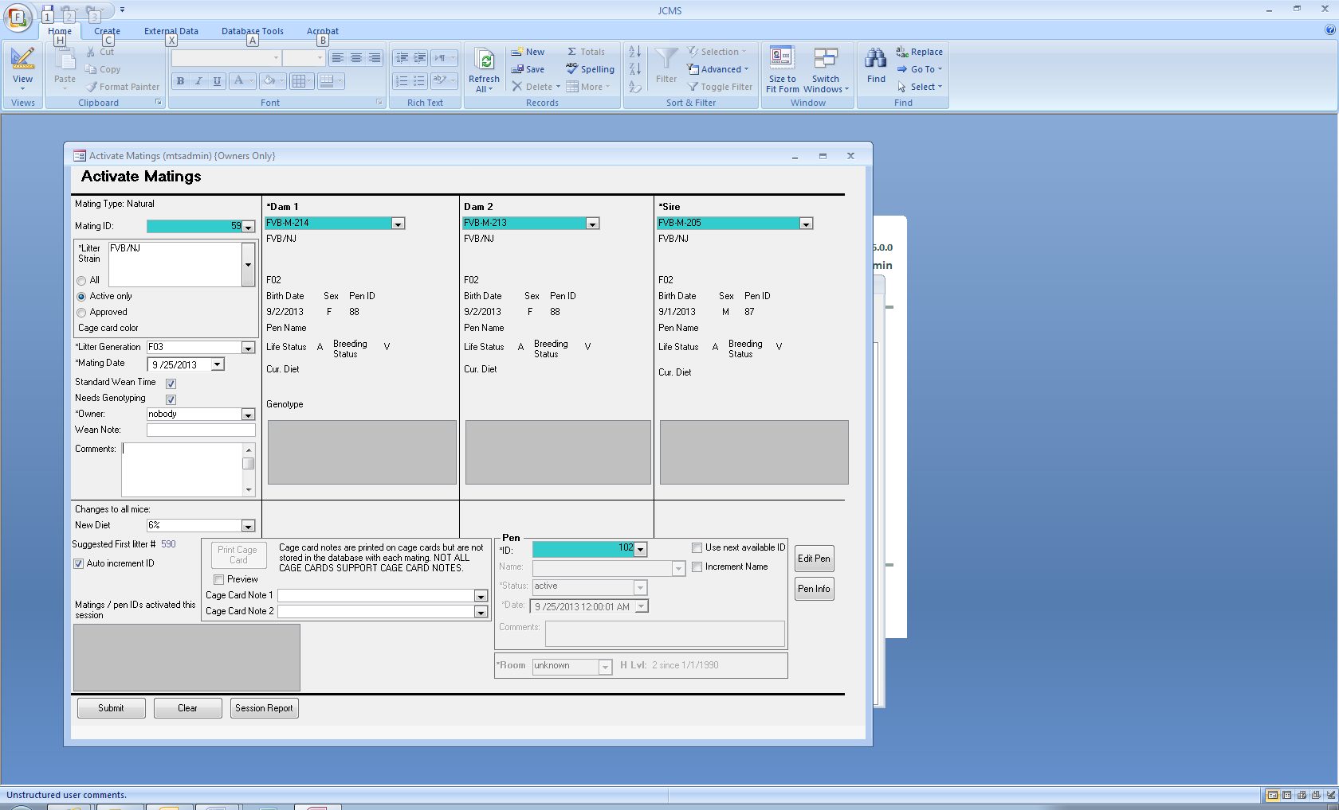

Figure ‑ Activate Mating Form

Once the matings have been set up in the mouse room, use the **Activate Mating** button to enter the mating date and any changes. First select the mating ID number and the mating as it was set up will appear. If a different dam or sire was used, they can be changed using the drop down boxes. When “approved only” is selected, only approved litter strains will be provided as a choice.

When a mating is activated, the diets for each mouse in the mating will be automatically updated according to the new diet combo box. The default **new diet** will be the **proposed diet** specified with the design mating form. The diets for each mouse can be changed by selecting a new diet from the combo box if the proposed diet is not the actual diet.

The suggested pen ID will be used unless a different pen is selected and the three mice will be moved into it. The pen status is changed to active on the mating date. All fields that were changed will be displayed in red after a successful submit. The mating ID and pen ID will also be added to the session box.

There is no way to delete a mating. If three completely different mice were used, use the Add Mating form to create a new mating instead.

When the setup variable JCMS_AUTO_RETIRE_PENS is true, if the pens vacated by moving the dams and sire are now empty, the pens will be retired on the mating date.

## Add a Natural Mating

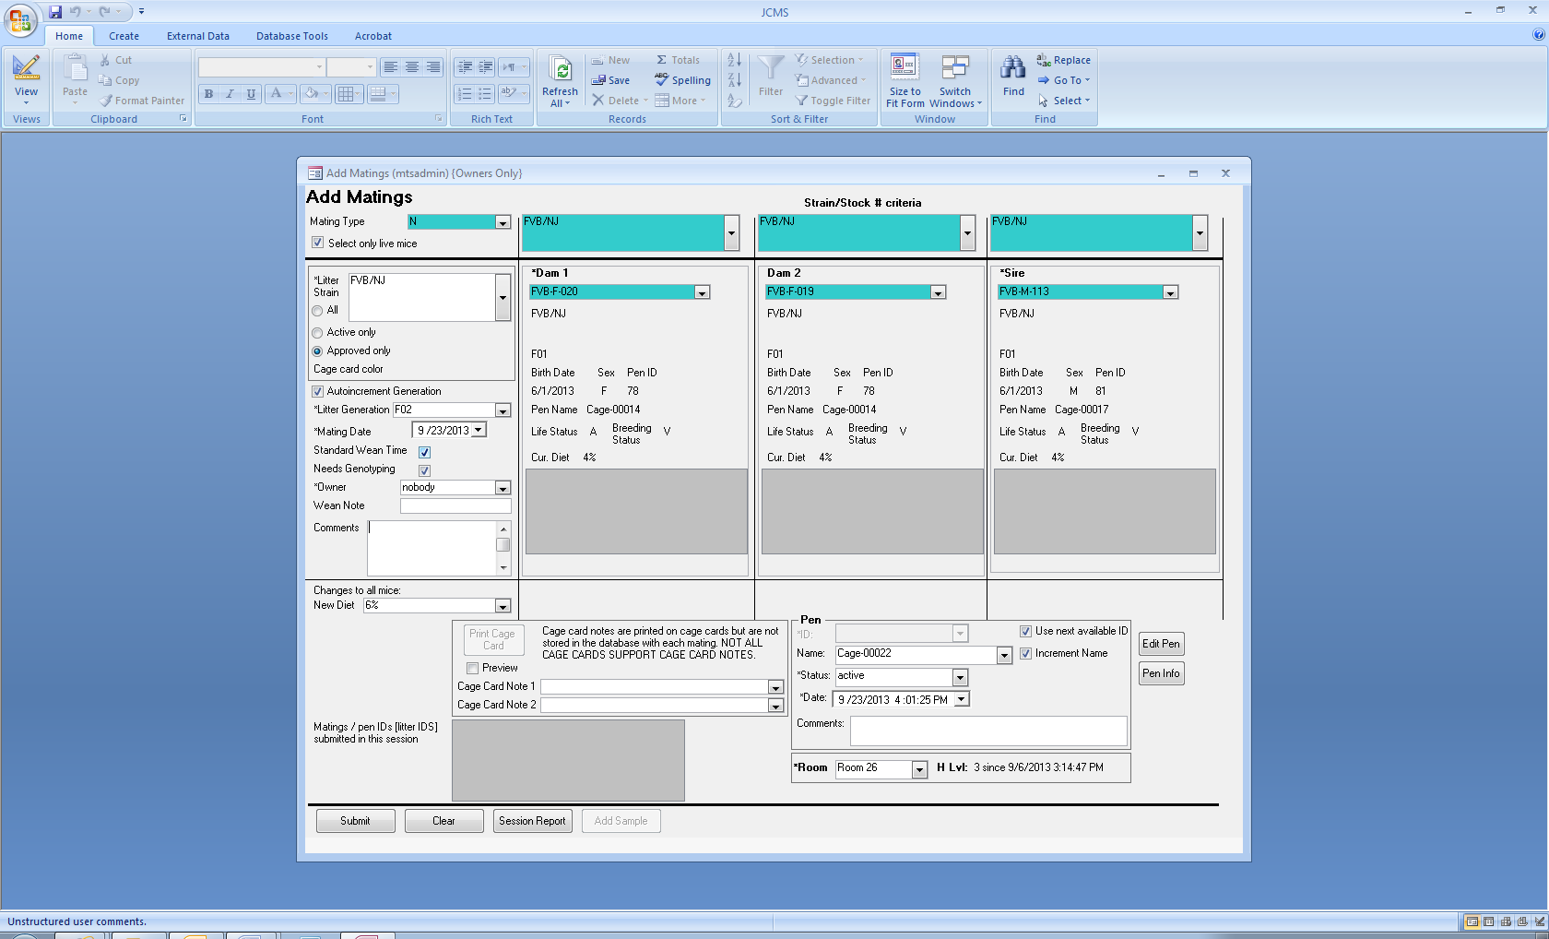

Figure ‑ Add Mating Form

The **Add Matings** form allows designing and activating a mating on one form. This form is useful for those who implement the matings in the mouse room or laboratory and then want to come back to the computer to enter the data or for those who use laptops or other computers in the mouse room.

The choices of mice may be limited to only live mice (use the select only live mice check box) and to one strain (use the strain/stock # criteria choice above the dam or sire). Use the drop down boxes to select the dam(s) and sire. Dam 2 is optional. When “Approved only” is selected, only approved litter strains will be provided as a choice.

On this form, there is a check-box on the lower right hand side that, when checked, tells JCMS to put the mice in this mating in the next available pen. If the check box is un-checked, then a pen ID number must be manually entered in the pen ID box or an existing pen must be selected.

When the setup variable JCMS_AUTO_RETIRE_PENS is true, if the pens vacated by moving the dams and sire are now empty, the pens will be retired on the mating date.

Hint for tab key users: In order to tab out of the dam1, dam2, sire, host dam, and sample drop down boxes, hold down both the Control key and Tab key simultaneously.

## Add a Technical Mating

Use the same Add Mating form that is provided for adding a natural mating. In the upper left, select the mating type. The form’s columns will change to allow selection of the appropriate mating components. The choice of samples are limited to sample class “Live” and sample types embryo, egg, ovary, ovarian tissue, and sperm. The select live mice check box and strain/stock # criteria will also limit the choices for sample, host dam, and sire.

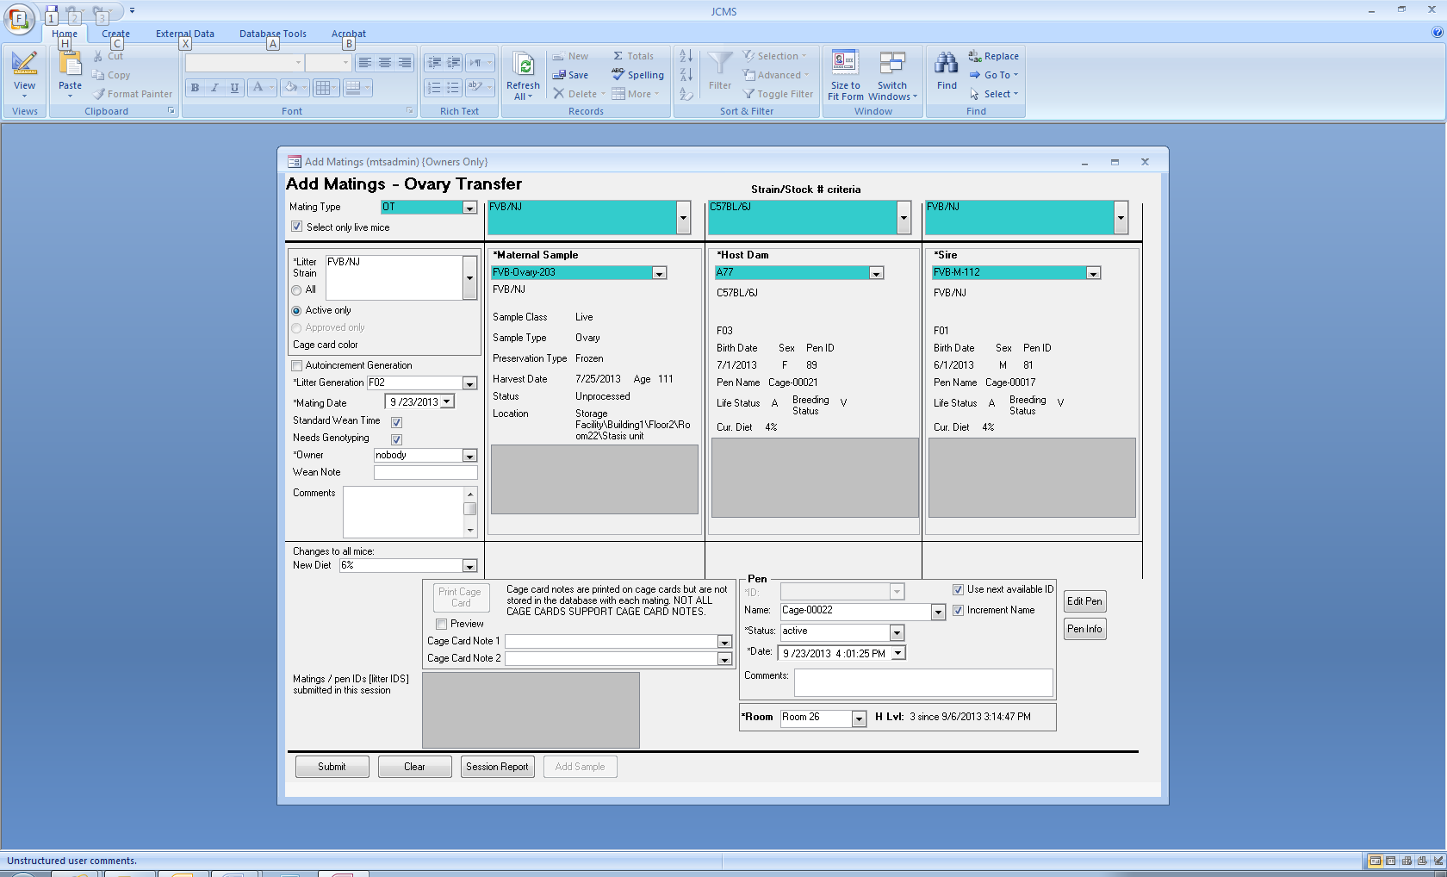

Figure ‑ Add Ovary Transfer Mating

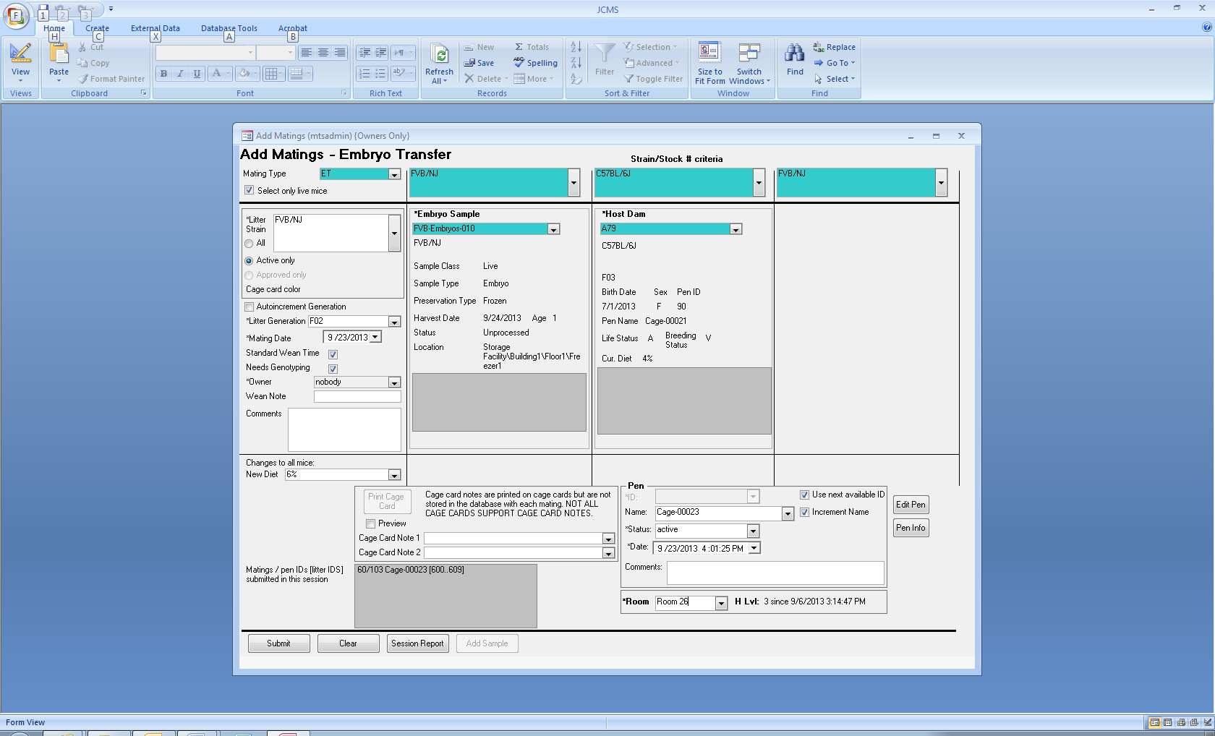

Figure ‑ Add Embryo Transfer Mating

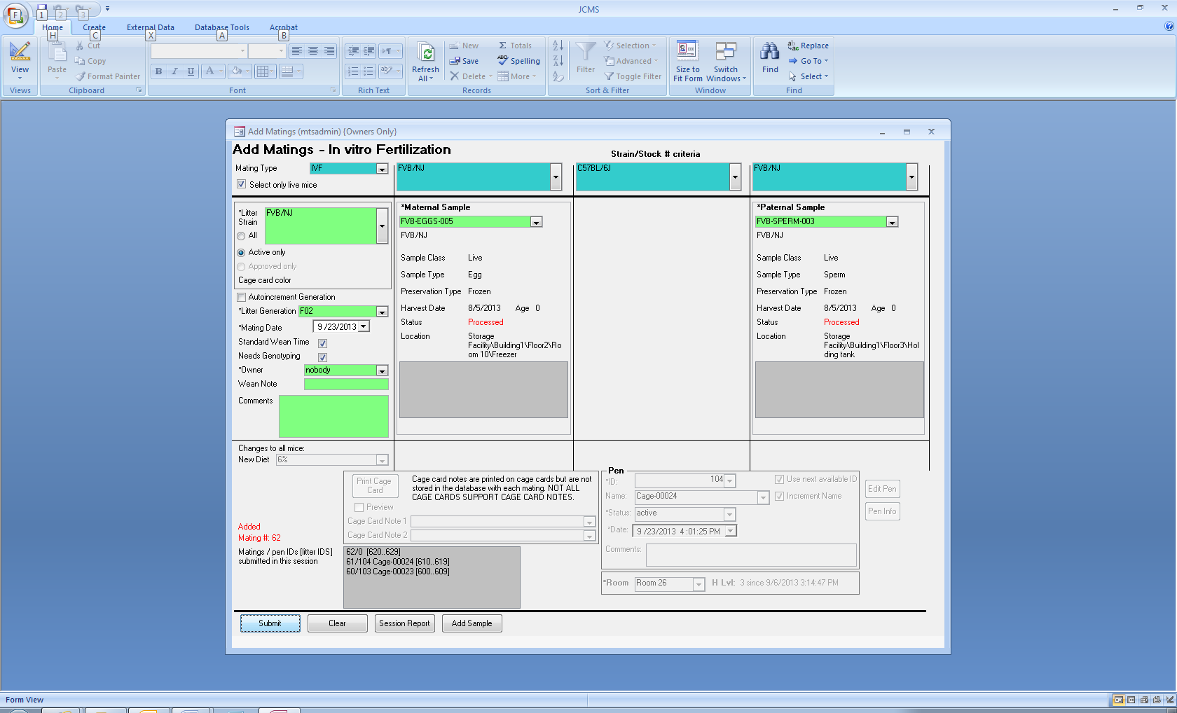

Figure ‑ Add In vitro Fertilization Mating

Once a sample becomes part of a mating, its status is changed to “Processed”. Once an IVF mating is created, the Add Sample button on the bottom of the form is enabled. It will open the Add sample form allowing creation of an embryo or other type of sample. Note that IVF matings are not associated with a cage.

Creating pups from an IVF mating is a multi-step process. First create the mating, next create embryo samples, and finally, use the embryo sample in an embryo transfer mating.

## Edit a Mating

Edit an existing mating using the **Edit matings** form. With this form it is possible to select new mice (dam 1, dam 2, host dam, and sire) or samples and change the basic mating information. A duplicate or new cage card can be printed from this form.

**NOTE:** If a new dam 1, dam 2, host dam, or sire for a mating is selected, it may be necessary to do other cleanup work. For example, the mouse that was in the mating and the new dam, host dam, and/or sire, may need to have their breeding status and diets changed (use the edit mouse form). It may also be necessary to use the move mice form to move the replaced mice to appropriate pens. If a pregnant dam is moved out of a mating, the pedigree information for her litter may be lost.

The edit matings form does not automatically make changes to any of the mice in the mating (unlike the activate mating form which changes breeding status, diet, and pen automatically); however, a warning will display, telling exactly which mice to make changes to.

## Design Matings to be Retired

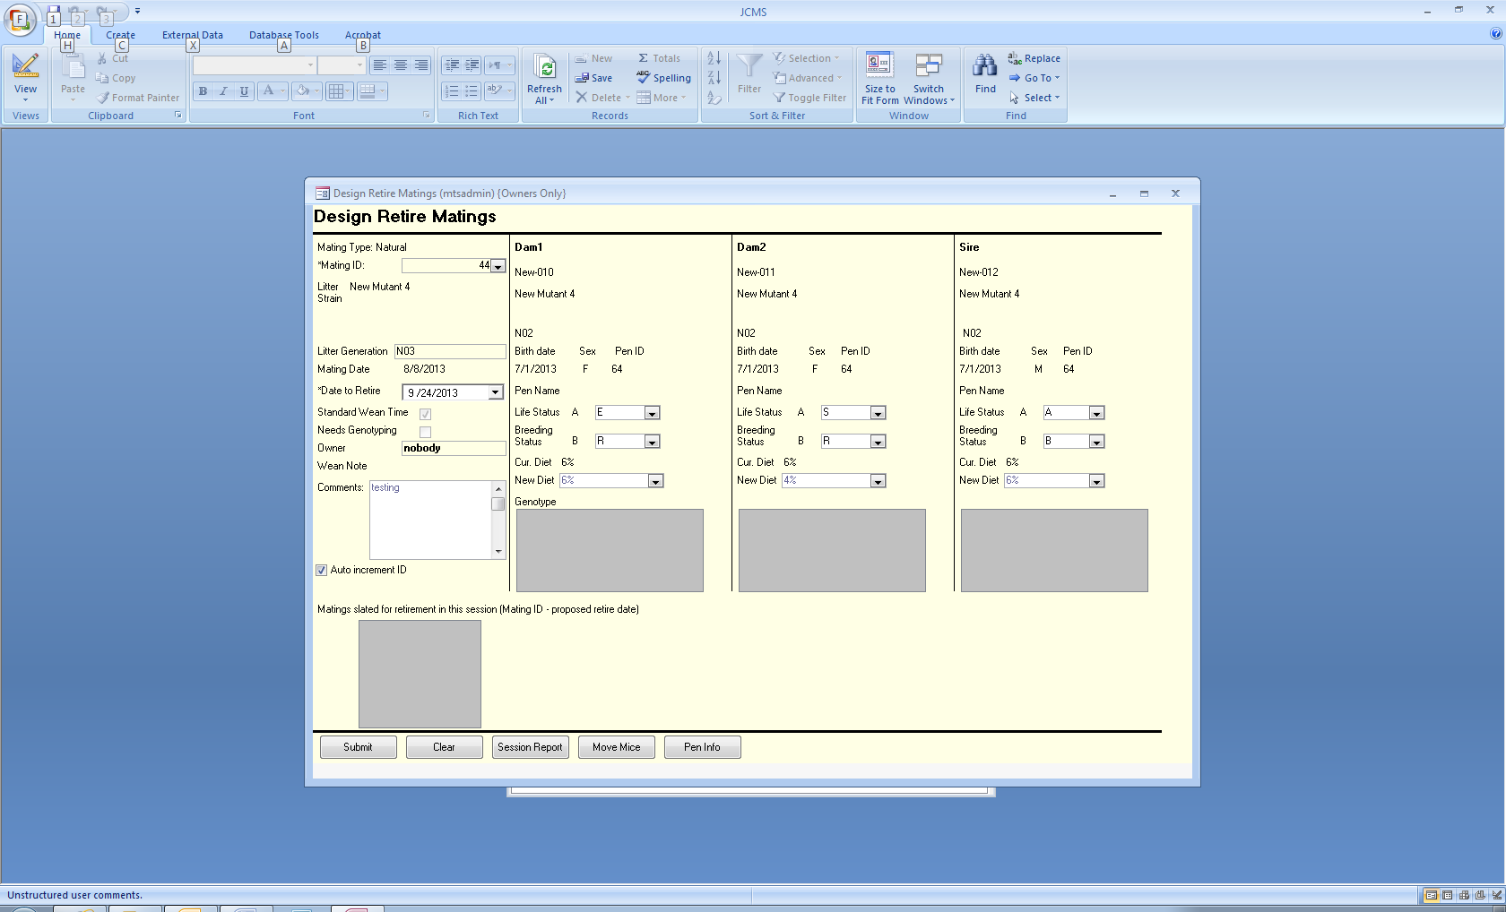 Figure ‑ Design Retire Matings Form

Natural matings can be retired in two steps. First, on the computer decide which matings to retire (design step). Next go to the mouse room and do the work, then come back to the computer and actually retire the matings on the computer. Or, the *design* step can be skipped.

The design retire matings form allows setting up a work list of matings to retire without actually making changes to the primary mating information in the database. The database stores **proposed** information in the mating table. When this form is used, it only updates the **proposed** fields in the database. Thus, no changes will be seen when a query for mating or mouse information is made. The idea is to set up a work report (by printing out copies of the Design retire matings form as you work). Then, after the work has been completed in the mouse room, use the Retire matings form to actually update the primary information in the database. When selecting a mating to retire, the proposed information (entered previously in the Design Retire matings form) will appear as the defaults in the Retire matings form. Any changes can be made at this point (to reflect what really happened in the mouse rooms) before submitting the changes to the primary information in the database.

## Retire a Mating

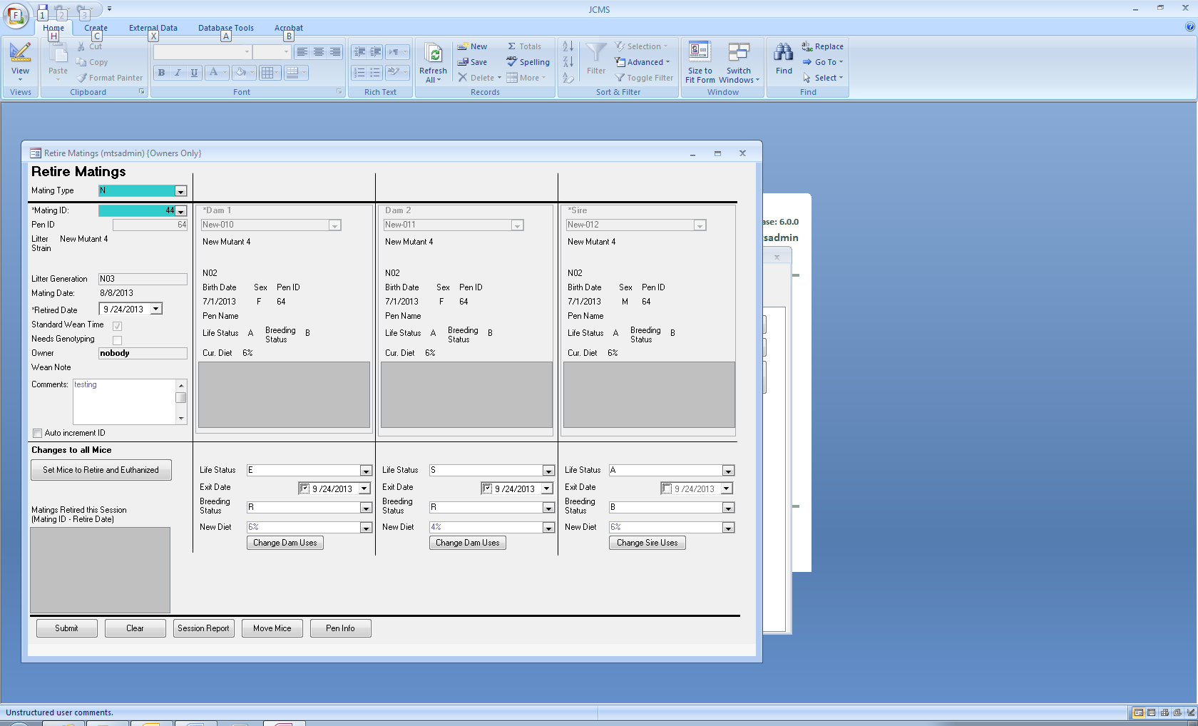

Figure ‑ Retire Matings Form

Once the matings have been retired in the mouse room, the date retired must be entered into JCMS. Technical matings also should be retired using this same form. Use the **Retire Matings** button. Select the mating type and mating ID from the blue/green box. Only matings that have not already been retired are available for selection. All information about this mating will display as soon as the cursor is moved out of the drop down box by tabbing or clicking elsewhere. Enter the date retired. The dam and sire life statuses can be changed to an exit status by using the drop down menus. Similarly, the breeding status can be changed to R for retired breeder and a new diet can be selected. No changes occur until the **Submit button** is clicked.

The retire mating form also has a *Set Mice to Retire and Euthanized* button which sets the mouse life status to the value of the setup variable JCMS_DEFAULT_EXIT_TERM and the mouse’s breeding status to retired (R). Using this button also sets the date exited to the date retired. Note if the default term is not euthanized, the button will display the default term on it.

## Working with Matings using a Handheld

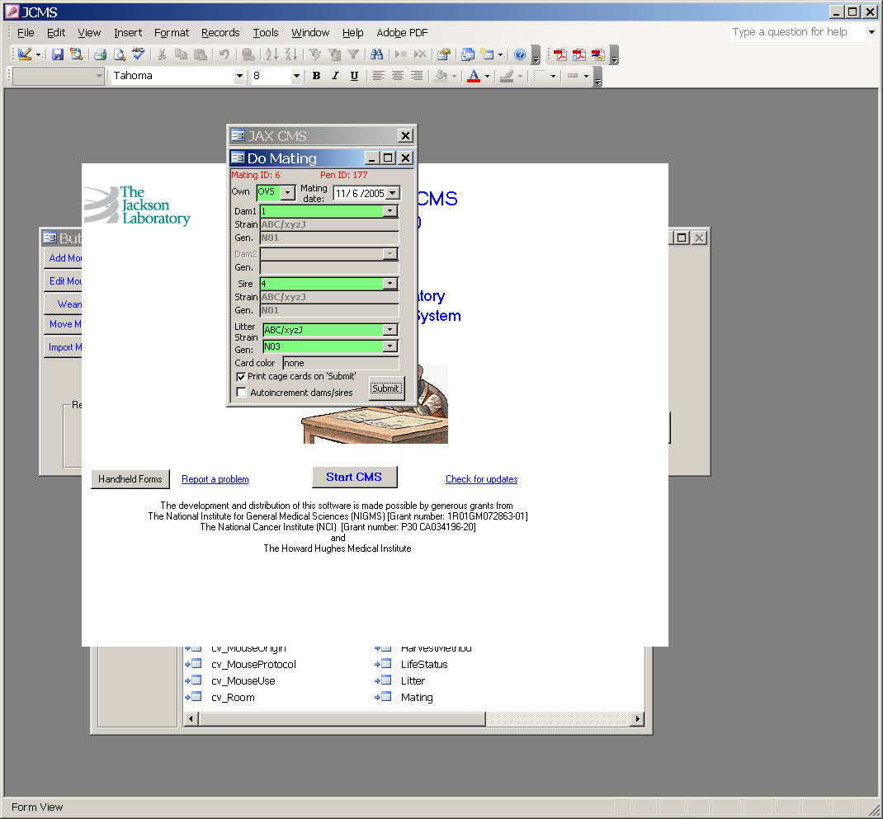

Figure ‑ Handheld Form: Pair Mating

Natural matings can be created using handheld computers by scanning or entering pen IDs. Two types of matings are available, pair or trio. A cage card can optionally be printed showing the pen ID, Mating ID, and suggested litter numbers. The automatically assigned pen ID and Mating ID will also be shown at the top of the form. Only active strains are shown as choices for the litter strain.

## Automatic Retiring of Matings

It is possible to have JCMS attempt to retire matings as a background function if the setup variable JCMS_AUTO_RETIRE_MATINGS is set to “True”. When a mouse’s life status is changed to an exit life status, JCMS will check the following:

* Is the mouse in any matings?
* If so, check each active mating and retire those where all dams, host dams, and sires have an exit life status.
* The retire date used will correspond to the exit date for this mouse.

Note: This check is done only for mice whose current life status is a non-exit status. It will not be done if the life status is changed from one exit status to another or if the exit date is changed.

# Litters

JCMS associates litters with matings. Each litter must have a unique litter ID number associated with it. JCMS can generate litter ID numbers or you can use your own litter number scheme.

All litter forms except those for handhelds show a list of all litters currently associated with the selected mating.

## Automatic Litter Number Generation

JCMS may be set up by the Administrator to automatically generate litter numbers. Once this function is set on, all JCMS users will have automatic litter numbers generated. Note, however, JCMS does not enforce which litter numbers are used (even if it generates a set of numbers); it is up to you when you enter a new litter in JCMS to decide which number to use. If you prefer to use your own litter number series, then turn off the JCMS litter number generator.

### Turning Automatic Litter Numbering On or Off

The Administrator controls automatic litter numbering from the Administrator button bar, using the button for *JCMS Setup Variables*. The variable called MTS_AUTO_LITTER_NUMS can take the values “on” or “off”.

### Setting the Number of Litter Numbers that are Generated for Each Mating

JCMS increments its internal litter number counter by a value specified in the *JCMS Setup Variables* table. Set how many litter numbers should be allocated to litters by changing the value of this variable. NOTE: to prevent any confusion, it is best to set this number when first starting to use JCMS and then not change it. We recommend that this number be set to 10 unless you really have long breeding pairs that you track. The number of litter numbers that are generated is set by the JCMS Setup Variable called MTS_NUM_LITTER_NUMS (from the Administrator button bar, click the JCMS Setup Variables button).

Changing the number of litter numbers can create minor confusion (but no date problems) because the add and edit litter forms show the range of litter numbers associated with each mating. The range of numbers is calculated from the first suggested number plus the number of numbers generated (as specified in the MTS_NUM_LITTER_NUMS variable). The only point of confusion will be on the litter forms that may show an incorrect range for matings that were allocated a different number of litter numbers (if this is confusing, don’t worry; just don’t change the MTS_NUM_LITTER_NUMS variable very often).

## Which Litter Forms to Use?

Multiple step process:

Using this approach, first identify the litters from the mating and record them in JCMS (Add Litter button). When the pups are sexed and/or tagged, add the number of male and female pups to the litter record (Edit Litter button). Next use the Wean report (Wean Work Report button) to get a listing of litters that should be weaned during a particular time period. Finally, add the weaned pups and their wean and tagging dates to JCMS (Add Pup from Litter button).

One step process:

Add the litter to the database when the mice are weaned by using the Add Litter w/ Pups button. This form allows adding all of the litter information AND adding the pups as individual mice in one step.

Handheld forms:

Use the Add Litter w/Mice choice from the handheld forms to enter a new litter at weaning. This form will create a litter record and then create the newly weaned mice in pens. It will not enter the wean date in the litter record. Use the Handheld Wean or Wean and Exit form to enter the wean date into the litter record.

## Adding Litters

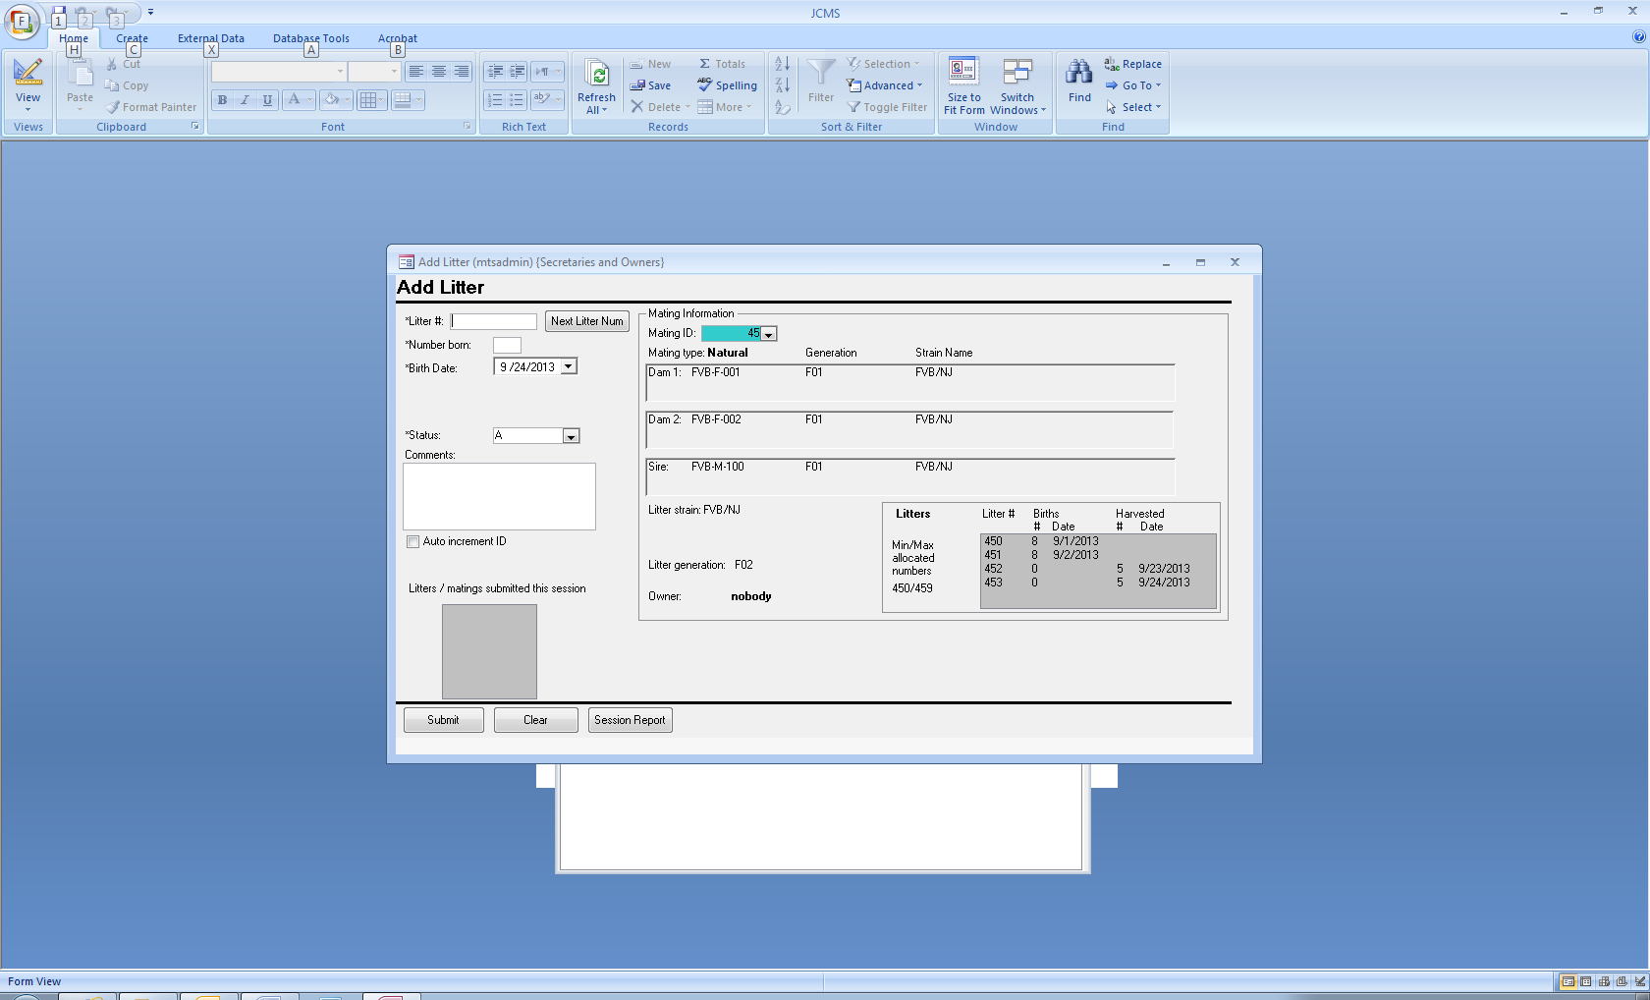

Figure ‑ Add Litter Form

To add a new litter, specify the Mating ID number. The mating information will show on the screen. Type the litter number into the litter number box or use the *Next Litter Num* button. Litters that were successfully added will be listed in the session box along with their mating ID number. Embryo litters are listed in the # harvested and date columns. Live birth litters may be added to natural, embryo transfer, and ovary transfer matings. Use the Add Embryo litter form to create litters that are composed of harvested samples.

## Wean Report

Figure ‑ Wean Work Report

The **Wean Work Report** button on the reports tab will open the request wean report form. It is used to request a listing of litters that have not yet been weaned by returning all litters with a status of “A” and no recorded wean date. A start date is entered to eliminate from the list all litters that will be too young on that date for weaning. Litters will be selected that are 18 or more days old (for the standard wean time) or 28 or more days old (for long weans) on the start date. The resulting list may also be limited by selecting only certain mouse owners. Note the defaults for the standard and extended wean times are setup variables (JCMS_STANDARD_WEAN_TIME and JCMS_EXT_WEAN_TIME) that may be changed.

The report is available in three formats: sorted by strain, sorted by room and strain, and ready to export to Excel.

## Editing Litters

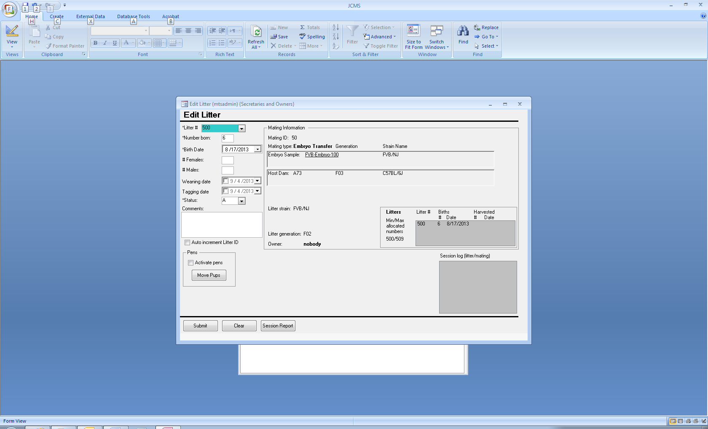

Figure ‑ Edit Litter Form

Only litters that have the litter type “live birth” are shown on this form. However, the mating could be natural, embryo transfer, or ovary transfer. Click on the **Edit Litter** button to open the form. Select the litter number from the drop down list. When the cursor leaves the litter number box (either via tabbing out of the box or by using the mouse to go to another box,) the litter data will appear on the form.

No changes are made to the database until the **Submit button** is clicked.

The **Clear button** clears all edit fields in order to start over. However, if the clear button is pressed by accident then recover simply by clicking on the litter number box and then moving the cursor back out of the box (to redo the query).

When pups are weaned, this form is used to enter the number of males and females, weaning date, and tagging date. Only an owner or owner’s secretary has permission to use this edit form.

Note that it is possible to use the Add Litter w/Pups form to create mice in proposed pens prior to the pups being weaned (possibly on the tagging date). These pens can be activated (pen status changed to active on the wean date) by entering the weaning date on this form and checking the *activate pens* box.

If the Add Litter w/Pups form was used to give the pups mouse IDs and the pups were left in the mating pen, after entering the wean date for the litter, use the *Move Pups* button to open the Handheld Move Mice form and transfer the pups into the weaning pens.

If a sample ID is underlined, it may be clicked to open the Edit Sample form. The purpose of this feature is to allow viewing the sample information. If a change to the sample strain is made, it will not be shown on the litter form. Select the litter again on the litter form in order to refresh this information.

## Wean Litters

Use the **Add Pup from Litter** button to open this form. Each newly weaned mouse is entered individually. The wean and tag dates for the litter may also be entered on this form. See Adding Pups section 6.5 for a description of this form.

## Adding Litters with Pups at Weaning

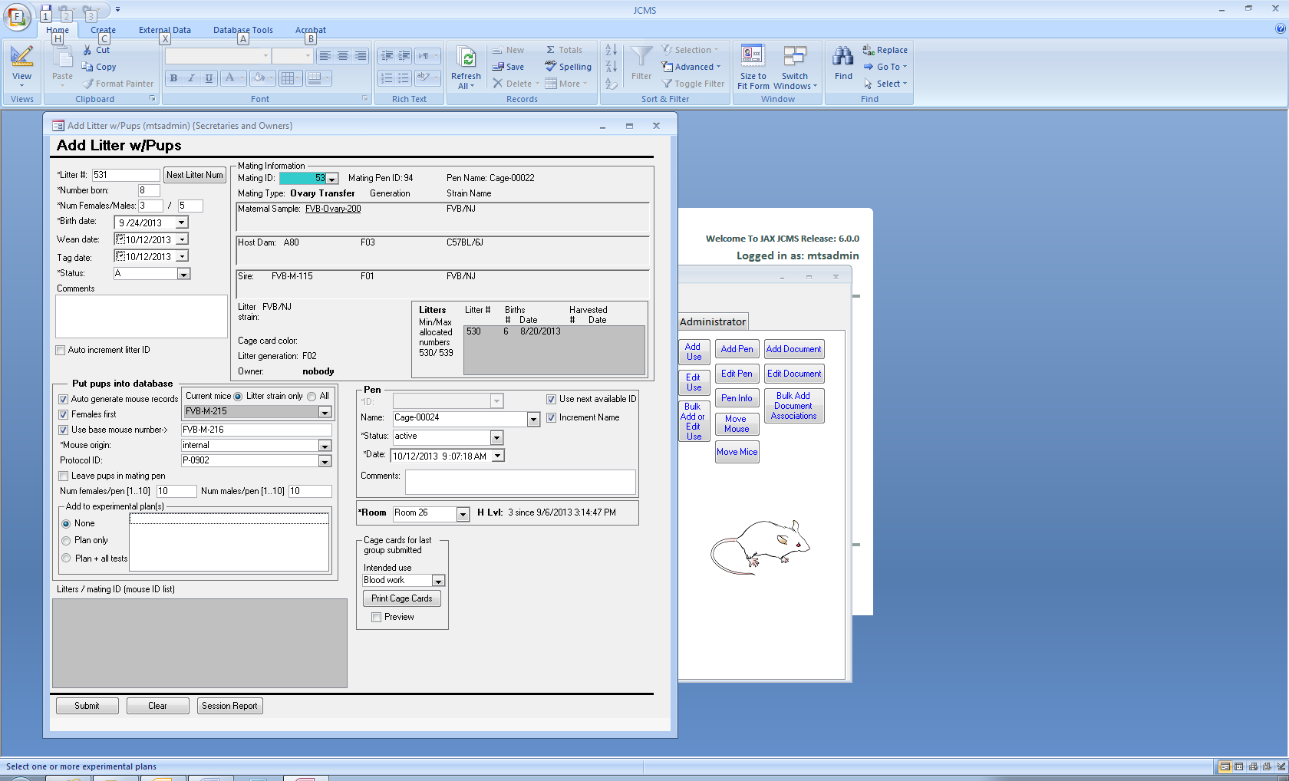

Figure ‑ Add Litter w/Pups Form

This form is used to both add the litter into JCMS and add all pups as mice with individual mouse IDs in one action. Natural, embryo transfer, and ovary transfer matings may have live birth litters. Use the **Add Litter w/Pups** button. First select the mating and then enter the litter number by typing it or using the *Next Litter Num* button. Enter the rest of the litter information. The current mice drop down box is there to help determine the last mouse ID number used. When the base mouse number is blank, selecting a current mouse number will cause the next number in the sequence to be placed in the base mouse number box.

As mice are added, they may also be added to experimental plan(s) and all the experimental tests in those plans. The session box will list the plan and test IDs.

Several workflows are supported by this form.

1. Create the weaned mice and litter all at once. Pups will be placed into new pens.
   1. Enter the wean date and optional tag date
   2. Select auto generate mouse records
   3. Enter a starting pen ID or use next available ID
2. Create the litter with tagged pups remaining in the mating pen
   1. Enter the tag date but no wean date for the litter
   2. Select auto generate mouse records
   3. Select leave pups in mating pen
   4. When it is time to wean the pups, use the Edit litter form to enter the wean date for the litter. Then click on the *move pups* button, which opens the *Move mice* form. Transfer the mice into their new pens.
3. Create the litter with tagged pups placed into “proposed” pens. This allows printing the cage cards for the new pens even though they are not yet in use. The cards might later be used in the mouse room to indicate where to put the pups when they are weaned.
   1. Enter the tag date but no wean date for the litter
   2. Select auto generate mouse records
   3. Enter a starting pen ID or use next available ID
   4. Use the pen status “proposed” and the tag date
   5. Note that JCMS will now show the pups located in the proposed pens, even though they physically are still in the mating pen.
   6. When the pups are weaned enter the wean date for the litter and change the pen(s) status to active using either
      1. Edit litter form: make sure activate pens is checked when the wean date is submitted
      2. Handheld forms: scan the pen IDs on all the proposed cards for the litter, select the wean option, make sure activate pens is checked, submit the wean date.

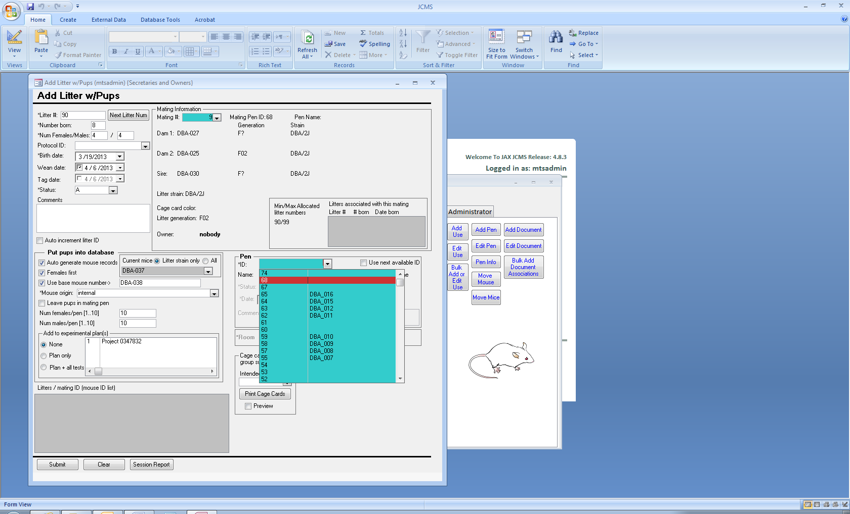This form normally creates pens starting with the next available pen ID. However, a starting pen ID may be specified so long as the pen sequence created does not already exist and there are enough sequential pen IDs available to hold all the pups in the litter. Note that empty or retired pens may not be used. The starting pen ID must be typed into the pen ID box. For example, if there is a gap between 68 and 74, then 69, 70, 71, 72, and 73 are available.

**Figure 9‑5 Example of a pen gap**

## Weaning Mice using a Handheld

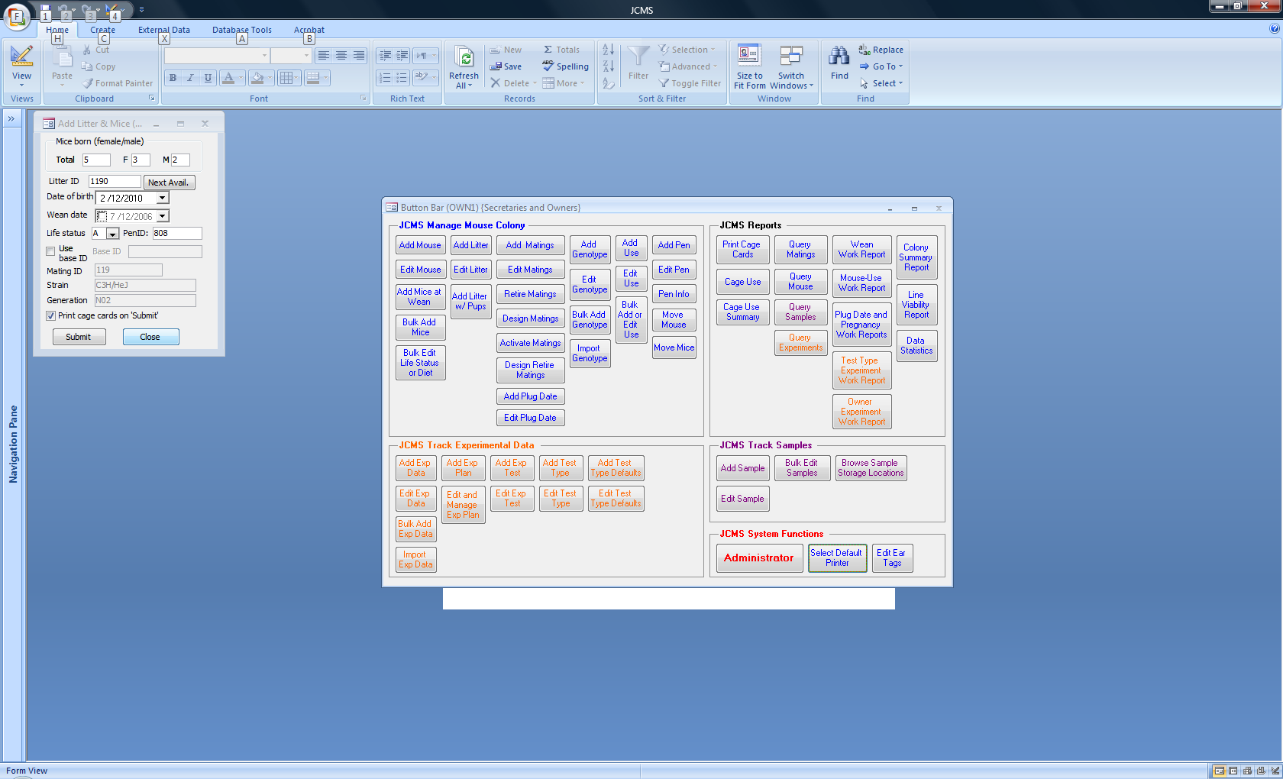

Figure ‑ Handheld Forms: Weaning and Add litter and mice

Handheld Forms: Weaning and Add litter and mice

These three forms are provided for using handheld computers in the mouse room for weaning mice. Scan the pen ID of a mating pen and select **Add litter w/mice** from the handheld main menu. This will open the Add litter and mice form. Use the **Next Avail** button to select the litter ID. Enter the litter information and a Base ID number (mouse ID number to start with) for the new mouse records. Printing cage cards will provide the proper labeling for the new pens. Submit will create a new litter record for this mating, new mouse records for each member of the litter, and new pen records with a pen status of *proposed*. This form does not enter the wean date into the litter record. Setup variable defaults are used for all values that cannot be entered (room name, mouse ID prefix if no base ID is specified, maximum number of mice in a pen).

To enter the wean date into the litter record, scan one of the new pens and select **Wean mice** from the handheld main menu. Enter the wean date and click submit. This will enter the wean date for the whole litter. If proposed pens should be activated (pen status changed to active on the wean date) make sure to scan all the pen IDs for the litter. If one is missed, repeat using the form, the pens will be activated even though a message will indicate the wean date is already entered.

A second method of entering the wean date is to enter it when the mice in the pen are given their exit date. Scan the pen IDs and select **Bulk Exit** from the handheld main menu. Enter the wean date, exit date, life status, and cause of death (C.O.D.). If the mice in the pen have already had a wean date entered, it will not be changed, so this form can also be used just to exit mice. If the setup variable JCMS_AUTO_RETIRE_PENS is set to true, if all the mice in a pen are given an exit life status, the pen will be retired on the exit date.

The setup variable MTS_THRESHOLD_MICE_BATCH_OPERATION should be set to a maximum number of mice to be weaned or exited at once. If the number of mice listed is greater than this limit, a warning message is displayed, which offers the choice to continue or cancel.

# Embryo Litters

An embryo litter is created by harvesting embryos or embryonic stem cells from a dam in a mating. The harvested material can optionally be recorded and tracked as a Sample. For specific information about how JCMS tracks samples, see Section 20.

## Add Embryo Litter w/Samples

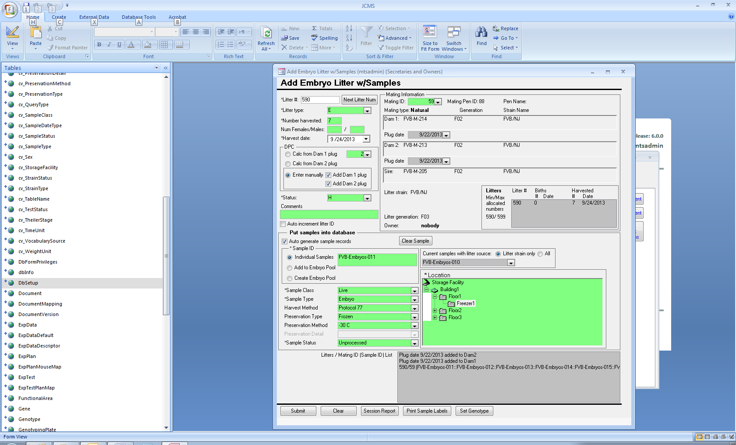

Figure ‑ Add Embryo Litter with Sample records

Start by selecting the mating. Any type of mating (natural or technical matings) may create an embryo litter. Any previous litters and existing plug dates will be displayed. Use the next litter button to obtain a litter # from the allocated litter number series.

The days post conception (DPC) is required and, if samples are created, this number is saved as the age in days from conception in the sample record. A table showing the relationship between the DPC and Theiler Stage is provided to aid in determination of the proper number. This table is derived from e-Mouse Atlas (EMA):

<http://www.emouseatlas.org/emap/ema/theiler_stages/StageDefinition/stagedefinition.html>. The EMA Anatomy Atlas of Mouse Development uses embryological mouse models to provide a digital atlas of mouse development. It is based on the definitive books of mouse embryonic development by Theiler (1989) and Kaufman (1992).

The DPC may be entered using one of these methods:

* Manually by selecting from the table
* Calculated from either Dam1 or Dam2 plug date
  + This requires that a plug date has previously been entered (see Section on Plug Dates). JCMS will calculate the DPC using the plug date selected in the mating information section of the form and the harvest date entered on the form. It will update the DPC displayed on the form when the harvest date or plug date selections are changed.

Checking “Add Dam 1 plug” and/or “Add Dam 2 plug” will update the plug date records with a new plug date for the specified dam(s) when the litter is added. The plug date is added as obsolete. It is determined from the harvest date minus DPC.

If sample records are created, there are three options:

* Individual samples: Create a sample for each embryo harvested. The number of samples created is equal to the # harvested shown on the form.
* Create embryo pool: Create only one sample record.
* Add to embryo pool: Select an existing sample with a litter source. The litter record will be added to that sample. Samples are able to have multiple sources. In this case, the pool of embryos comes from several litters.

The sample ID must be unique. If several samples are created, the ID must contain a number that can be incremented in the same fashion as mouse IDs are incremented. Use the “Current samples with a litter source” combo box to select an ID to use for starting the incrementing. If the sample ID box is blank, the next ID in the sequence will be placed in it, unless the choice is to “Add to embryo pool”. In that case, select the ID of the embryo pool.

See Section 20 on Samples for information on the other sample fields. Note that no weight or description is saved in the sample record(s). The owner is set to the mating owner.

## Edit Embryo Litter

This form is provided for correcting errors in the basic litter information. Only litter types ‘E’ (harvested embryos) or “ES” (embryonic stem cells) may be edited using this form.

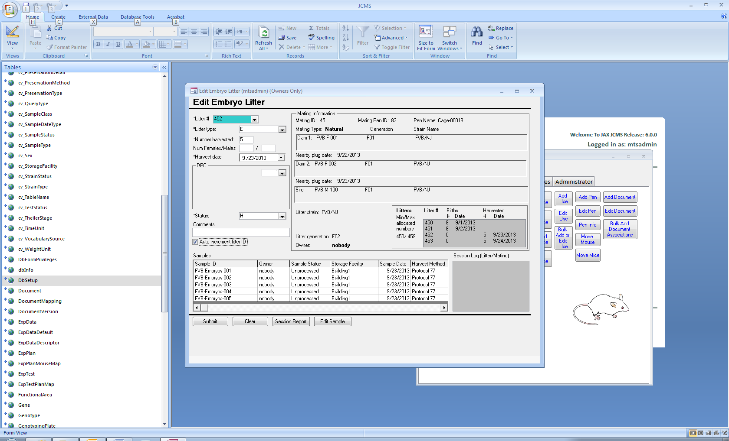

Figure ‑ Edit Embryo Litter form

When there are two dams, JCMS is unable to tell which dam was the mother of this litter. If this information is important, we suggest you place it into the comments field or create separate matings for each dam.

The “nearby plug dates” displayed on the form are a best guess selected as a plug date within the JCMS_GESTATION_PERIOD (number of days) just prior to the harvest date.

A change made to the harvest date or DPC value will NOT update any associated sample or plug date records.

To make a change to one of the samples, click on the sample ID and then press the “Edit Sample” button, which will open the Edit Samples form.

# Plug Dates and Pregnancy Checking

Vaginal plugs form following copulation. The plug date table is used to record the date a plug is observed and associate it with a dam and mating. Later, the plug date may be marked obsolete to indicate the dam has given birth or that conception did not take place. Over time, a dam may accumulate a series of plug dates. Only natural matings may have plug dates entered.

Plug dates are used to generate several reports containing the following types of information:

* Stage of pregnancy (lists dams by strain and date of plug).
* Work report: dams to check for plugs (lists dams by strain that currently have no plug)
* Plug date history for mice or matings (lists all the dam’s plug dates)

Pregnancy checks:

* Plug Date work report: dams to check for conception/pregnancy (lists dams by strain and date of plug).
* Pregnancy Check work report: for those not using plug dates, this report lists all matings with no litter in the pen and ignores any plug dates.

## Add Plug Date

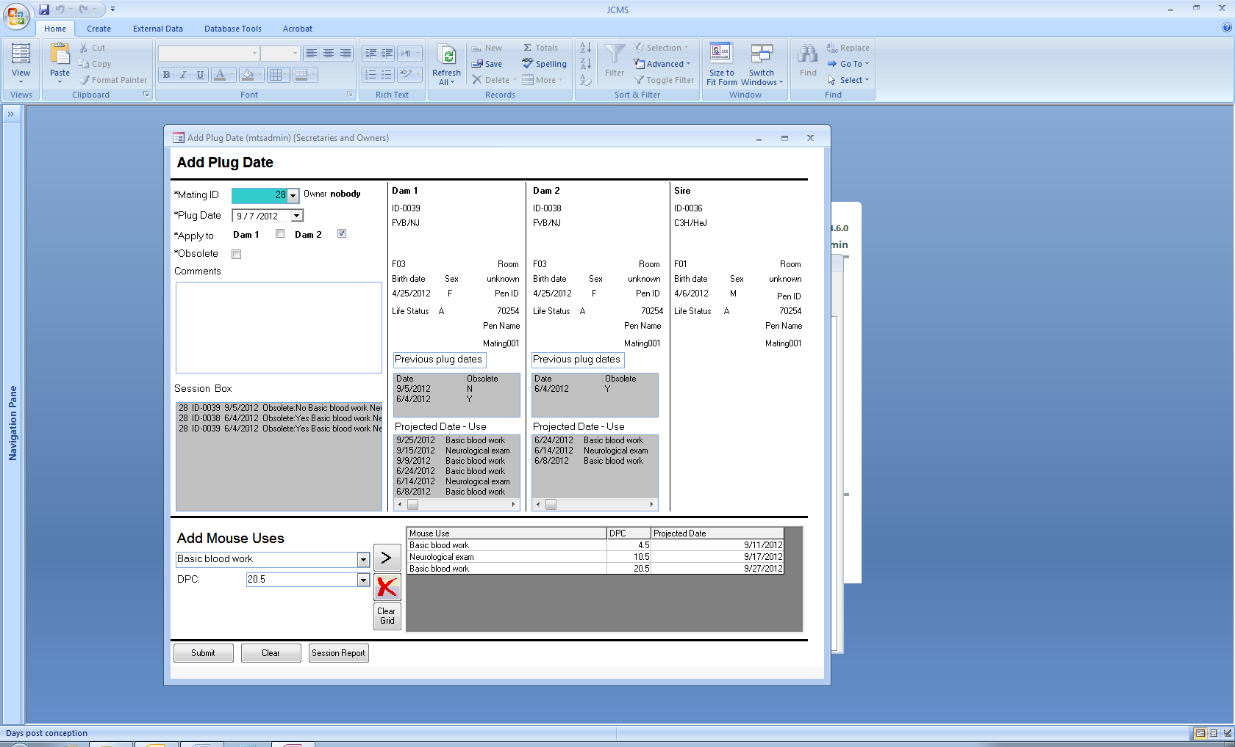

Figure ‑ Add Plug Date Form

The plug date is associated with a particular dam in a specific mating. Only matings that are active (not proposed or retired) are listed as choices. To add the same plug date to both dam 1 and dam 2 at the same time, check both *apply to* boxes. If a dam has previous plug dates that are associated with a different mating, they will not be displayed on this form.

Mouse uses that are associated with a date post conception (DPC) may be entered at the same time the plug date is entered. Fill the grid at the bottom of the form with the uses and DPC. The projected date will be calculated based on the plug date. The projected date is updated whenever the plug date is changed on the form. Previously entered uses are shown for each mouse to help prevent accidental duplication. The maximum choice for the DPC value is set by default to 21. To set it to a different value, change the setup variable JCMS_GESTATION_PERIOD.

## Edit Plug Date

Only plug dates that are associated with an active mating (not proposed or retired) may be edited or deleted. Select the plug date to edit from the list below the dam by double clicking on it. Once the specific plug date record is displayed on the left side of the form, the comments, obsolete check box, and plug date may be changed. Mark plug dates obsolete to keep the dam from being listed on the plug date and pregnancy stage report. A dam’s plug dates must all be obsolete for her to be listed on the plug check report.

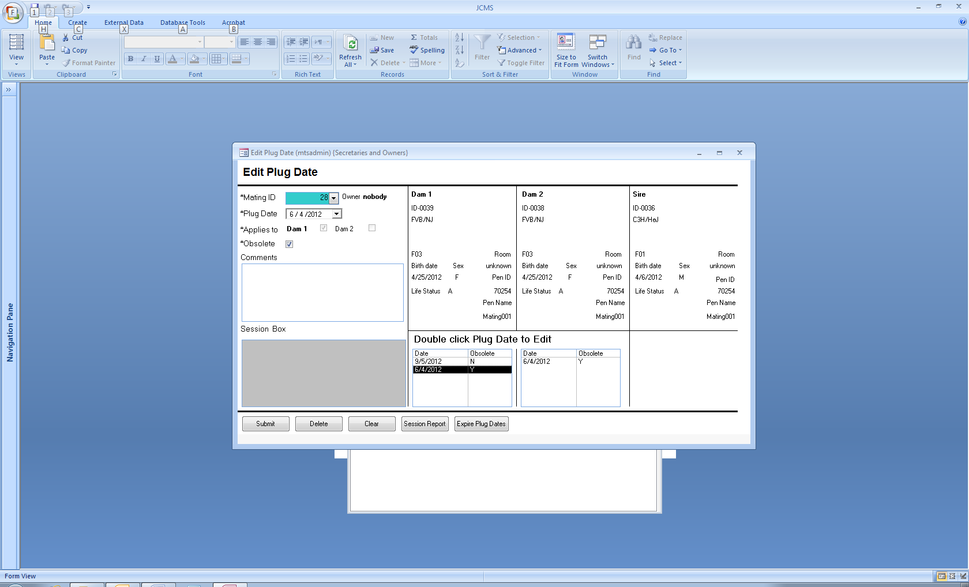

Figure ‑ Edit Plug Date Form

To delete a particular plug date, double click it on the dam’s plug date list. The delete button will become an available choice. If any editable field is changed on the form (plug date, obsolete, or comments), the delete button will no longer be a choice. This is to prevent accidentally deleting instead of editing a plug date.

### Automatically mark plug dates as obsolete

The **Expire Plug Dates** button found on the Edit Plug Date form is used to mark **all** plug dates prior to a certain date as obsolete. The date is calculated by subtracting the value of the setup variable JCMS_GESTATION_PERIOD from today’s date. The default value is 21 days. For example, if today is November 12, 2012 minus 21 yields the date October 22, 2012. This action must be confirmed before any changes are made.

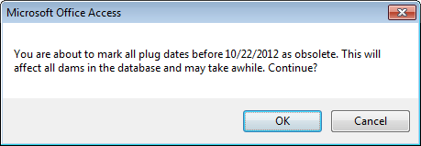

Figure ‑ Confirm plug date expiration

## Plug Date and Pregnancy Check Work Reports

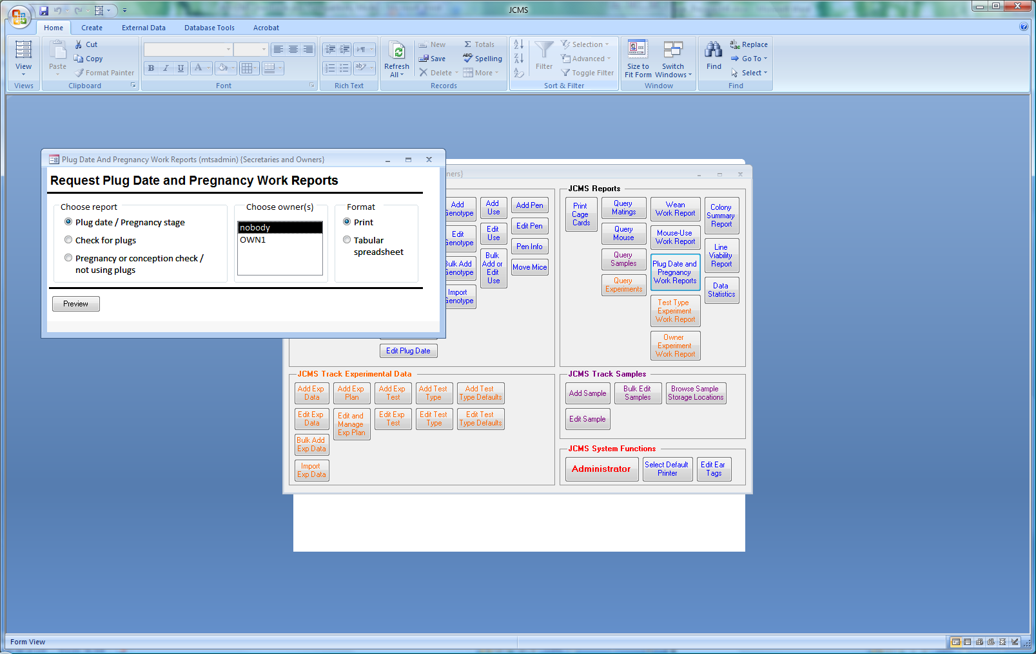

Figure ‑ Form: Request plug date or pregnancy reports

Three different reports are selected using this form. Any report may be filtered by owner. The tabular spreadsheet format may be exported to Microsoft Excel. If Microsoft Office 2007 gives the message “Excel found unreadable content…” answer “yes” to recover the contents. No data will be lost.

### Plug Date / Pregnancy Stage Report

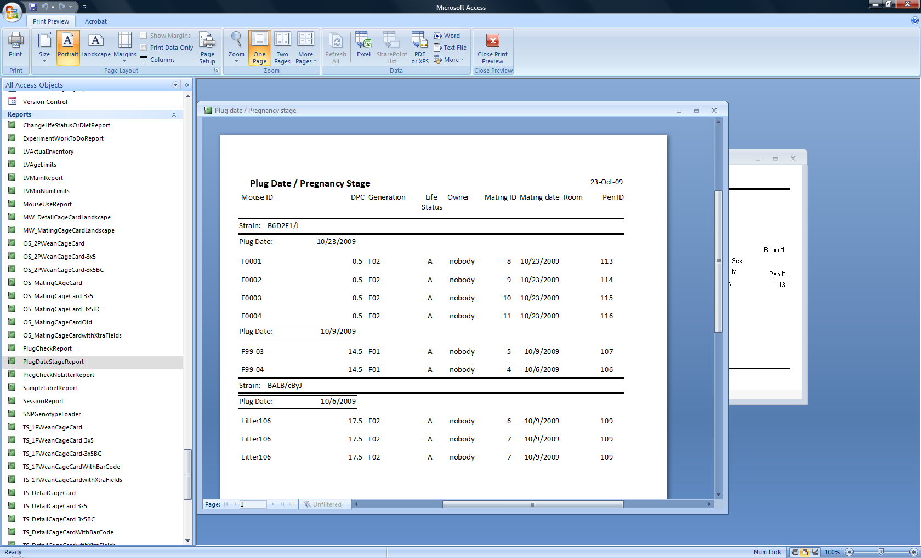

Figure ‑ Sample plug date / pregnancy stage report

This report is sorted by strain, plug date, room, and pen ID. It lists for active matings, all plug dates that are not marked obsolete. In the sample report shown above, dams A2, F3, and F1 are listed several times because they have multiple plug dates that are not marked obsolete. For this report to be accurate, all old plug dates must be marked obsolete.

Use this report to determine the pregnancy stage by calculating the number of days between today and the plug date. Use this report to list dams that should be checked for conception, pregnancy, or litters based on their plug date.

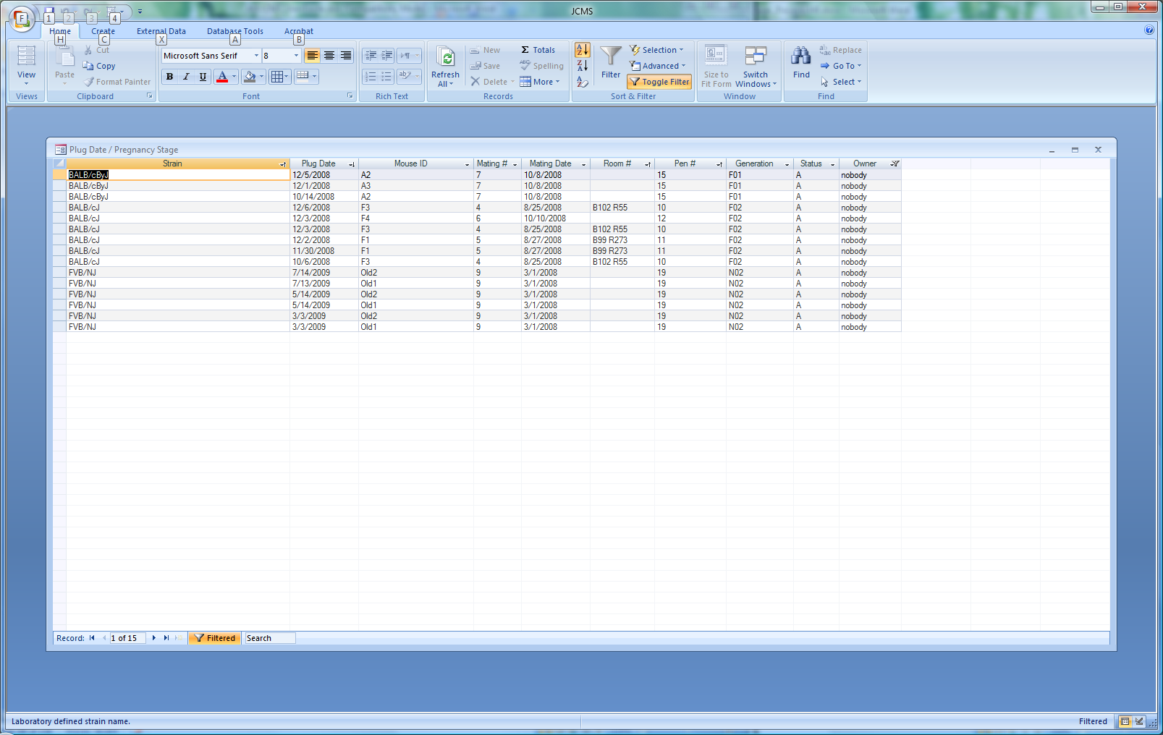

Figure ‑ Sample tabular spreadsheet format plug date / pregnancy stage report

### Plug Check Work Report

This report lists all active matings where one (or more) dams have no plug (i.e. all the dam’s plug dates are marked obsolete or it has no plug dates). The report is sorted by strain, room, and pen ID.

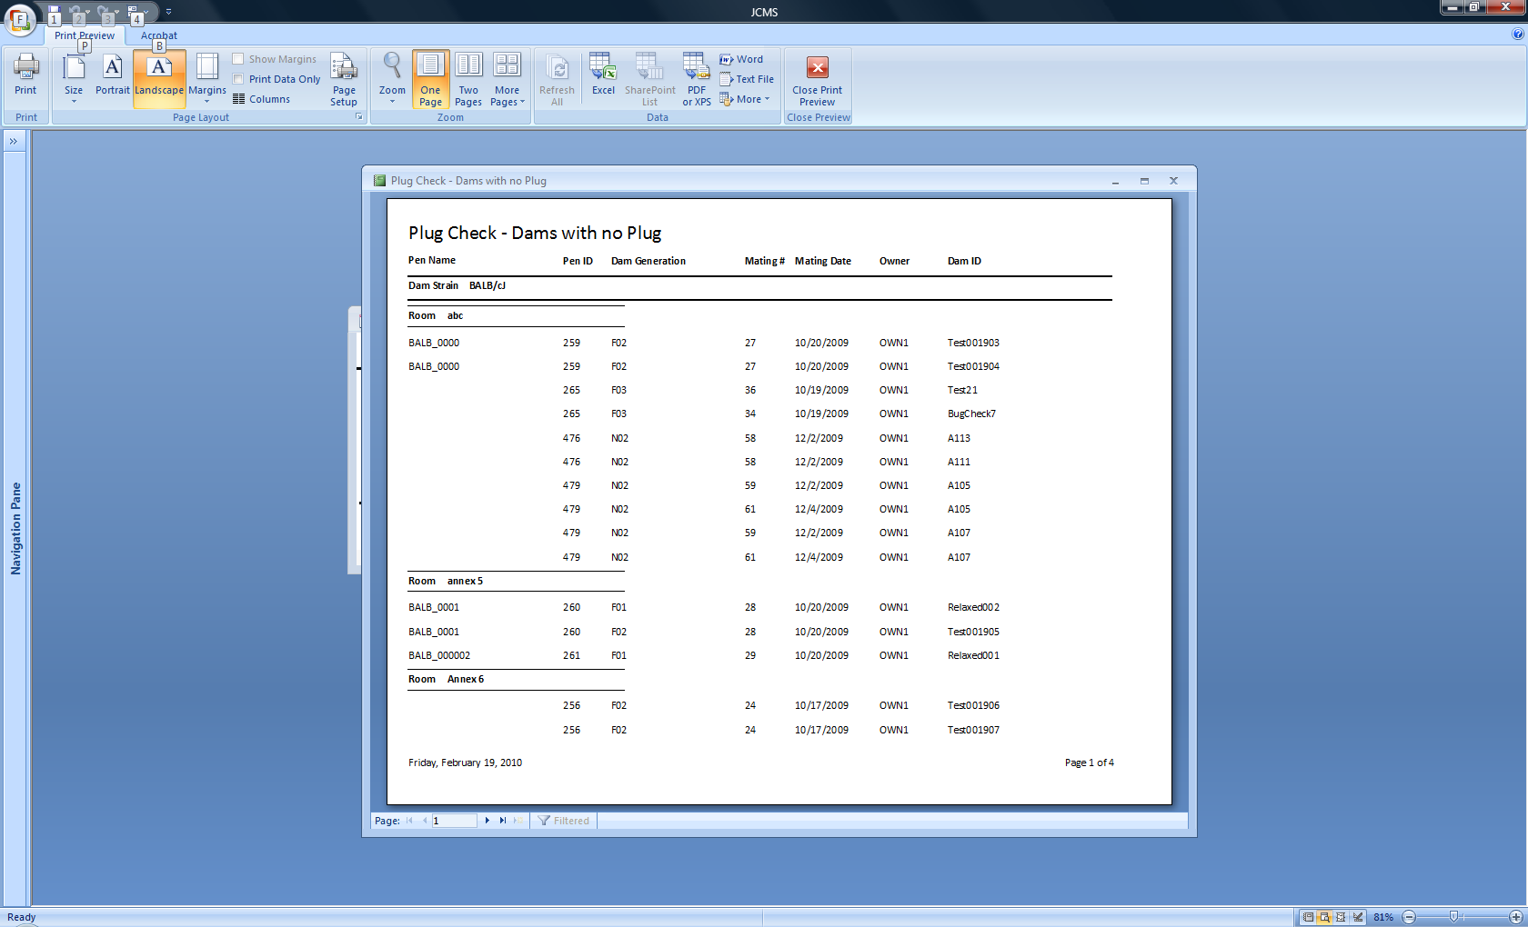

Figure ‑ Plug Check Report

### Pregnancy Check Work Report

This report ignores plug dates. It lists active matings that have no litter in the pen. A mating has no litter if all litters associated with the mating have a wean date or it has no litter records associated with it. A litter that has a status other than “A” for alive will be ignored since a litter with a status such as born dead might not have a wean date.

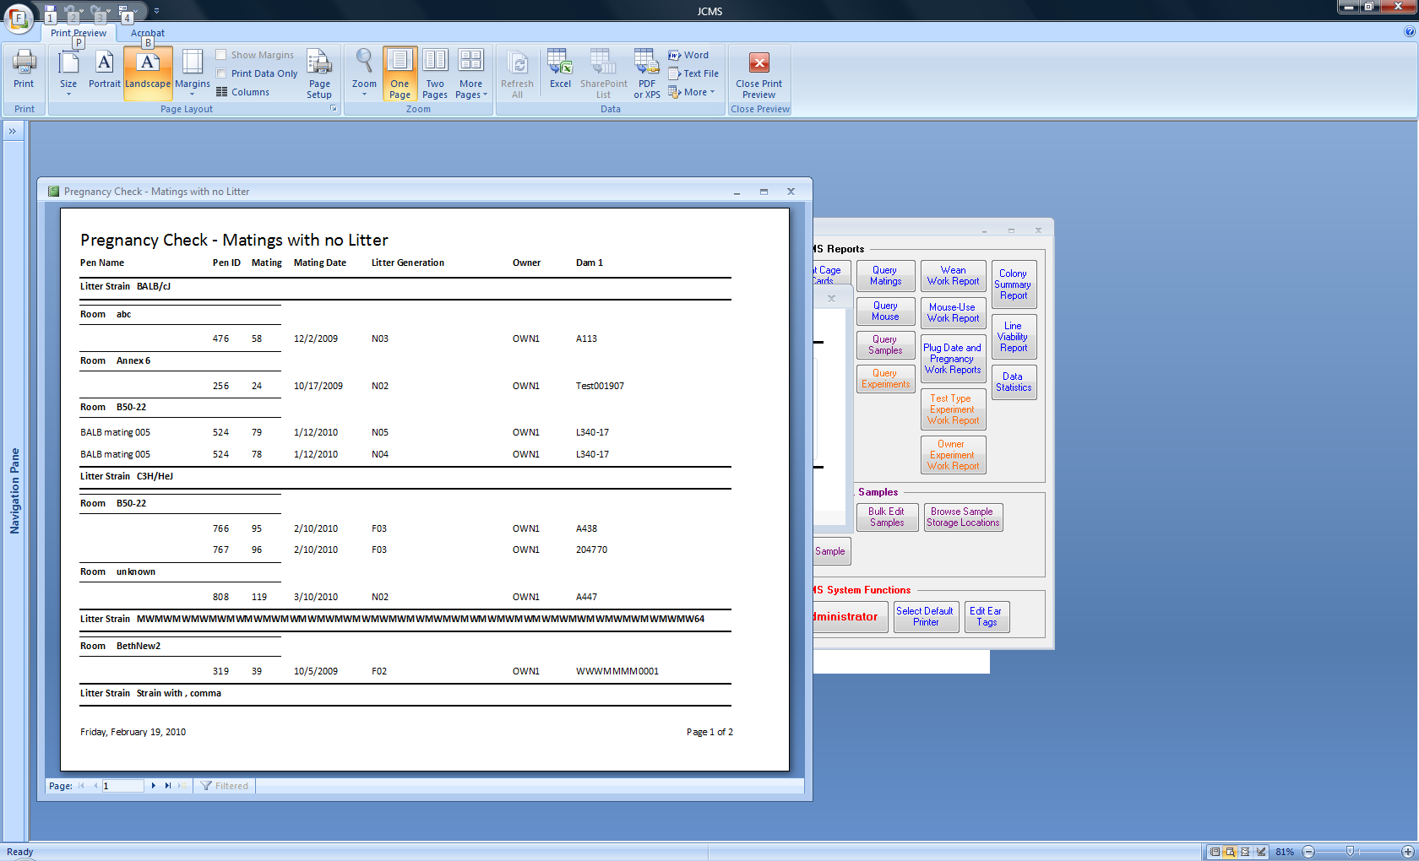

Figure ‑ Sample pregnancy check work report

### Plug Date History

Use the Mouse Query or Mating Query to obtain a list of all plug dates recorded for selected dams or matings.

# Breeding Performance Reports

There are six variations of the Breeding Performance Report. Access them from the Reports tab on the main button bar.



Figure ‑ Select the Breeding Performance Report

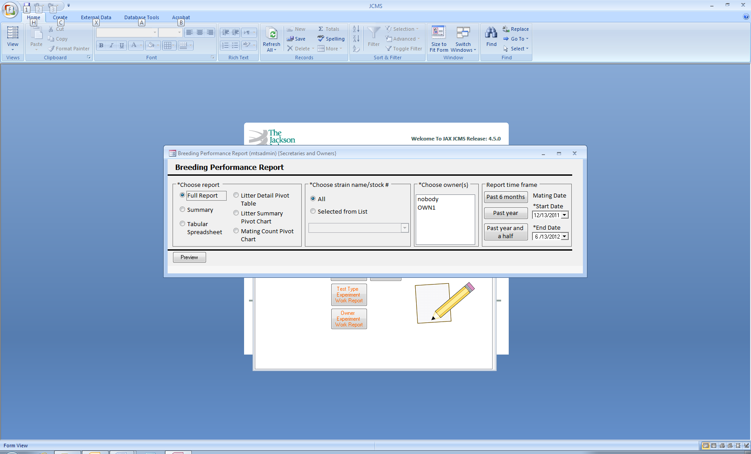

Figure ‑ Form: Request a breeding performance report

Only natural matings and their litters are shown on these reports.

The criteria for the report include the following:

* Time frame
  + The data included will be for all matings with a mating date within the start and end date range. Litters associated with the selected matings, whose birth date is within the date range are included. Use the buttons to set a 6, 12, or 18 month time span or enter the exact dates for the range.
* Strain
  + Include all strains or one selected from the list
* Owner
  + Select one or more from the list

## Full Breeding Performance Report

The complete report includes details on all matings and associated litters, including the mating ID; mating and retired dates; dam1, dam2, and sire; current pen ID and pen name for dam 1; litter ID; birth, wean, and tag dates; # born, # females, and # males. There are summary rows for the total number of matings, litters, # born, # females, # males, and matings with no litters for each mating, strain, and owner. The litter status (A for alive, H for harvested, B for born dead, D for dead at weaning, K for killed, and M for missing) is listed for each litter. Note that harvested litters will normally have a # born of zero.

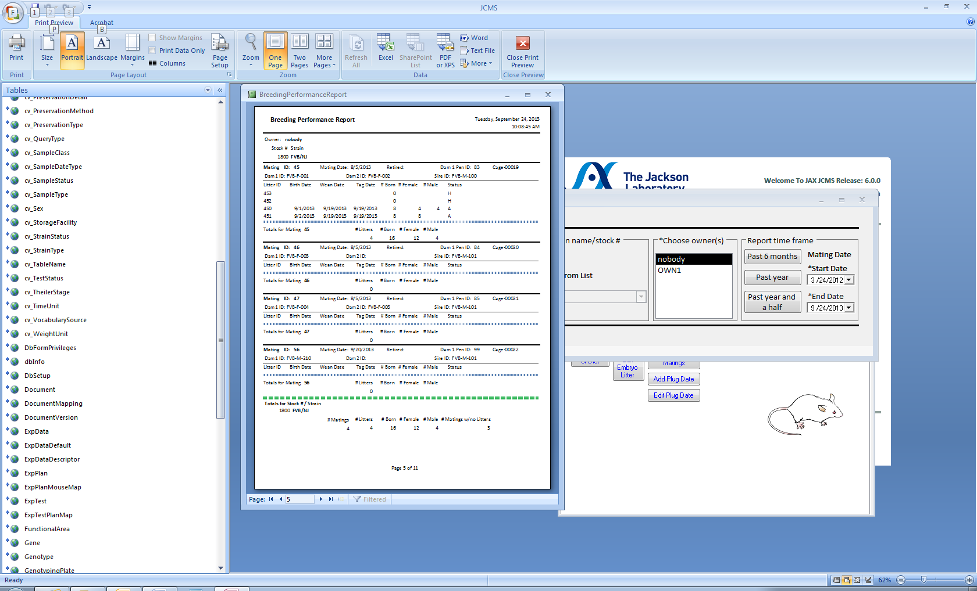

Figure ‑ Detail section of the report

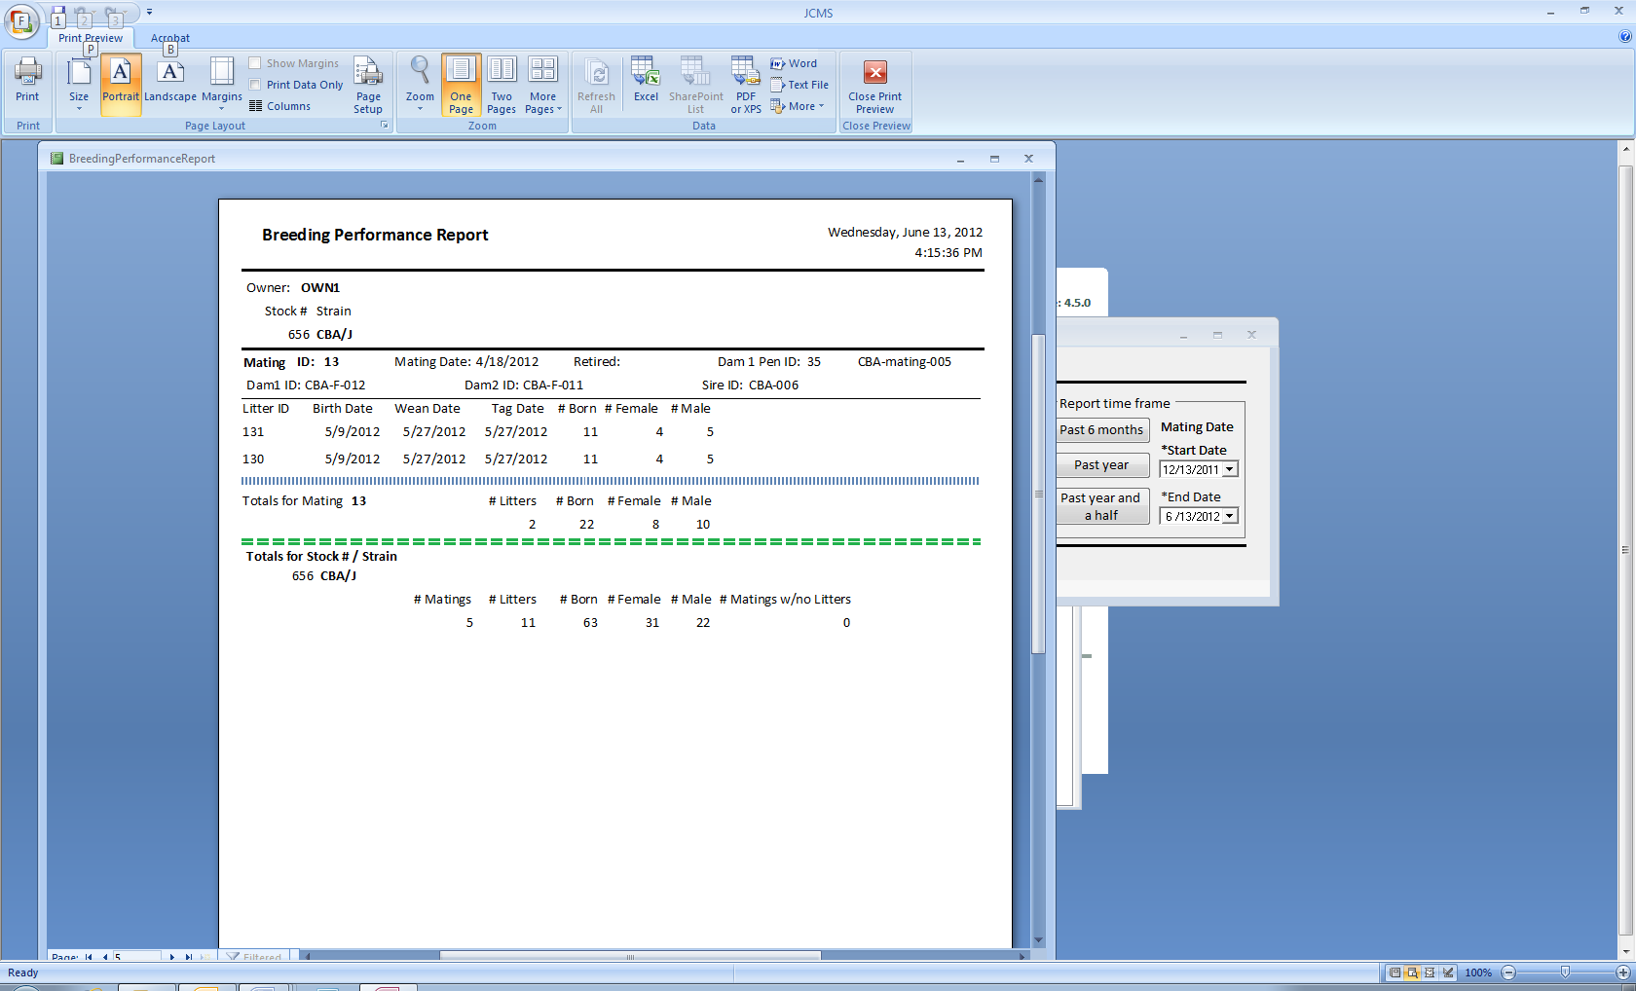

Figure ‑ Strain total section of the report

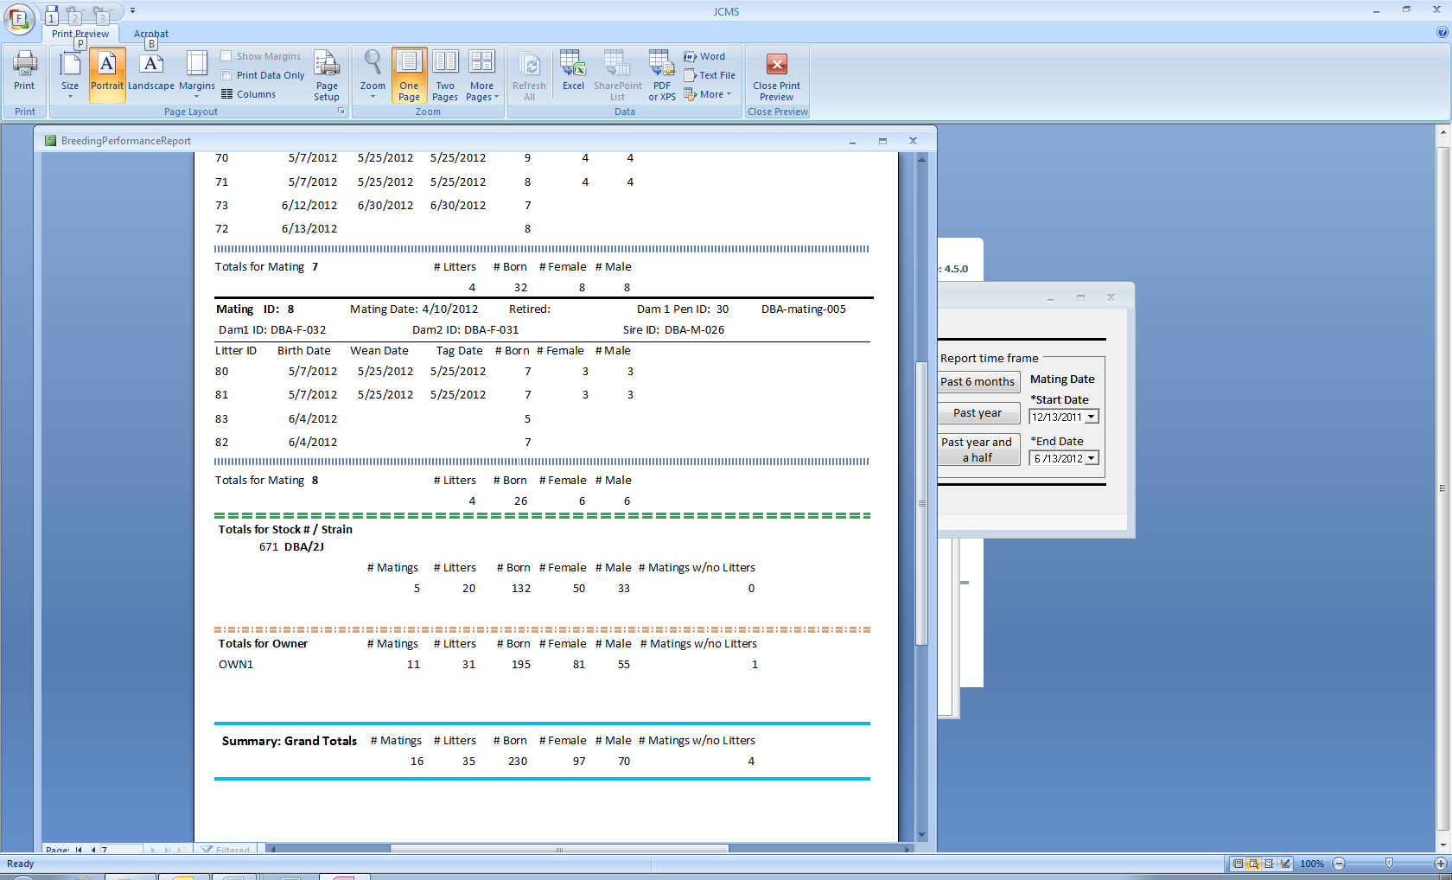

Figure ‑ Owner and grand total section of the report for all strains

## Summary Breeding Performance Report

The summary report provides the same totals as the full report but eliminates the detail section that shows each litter.

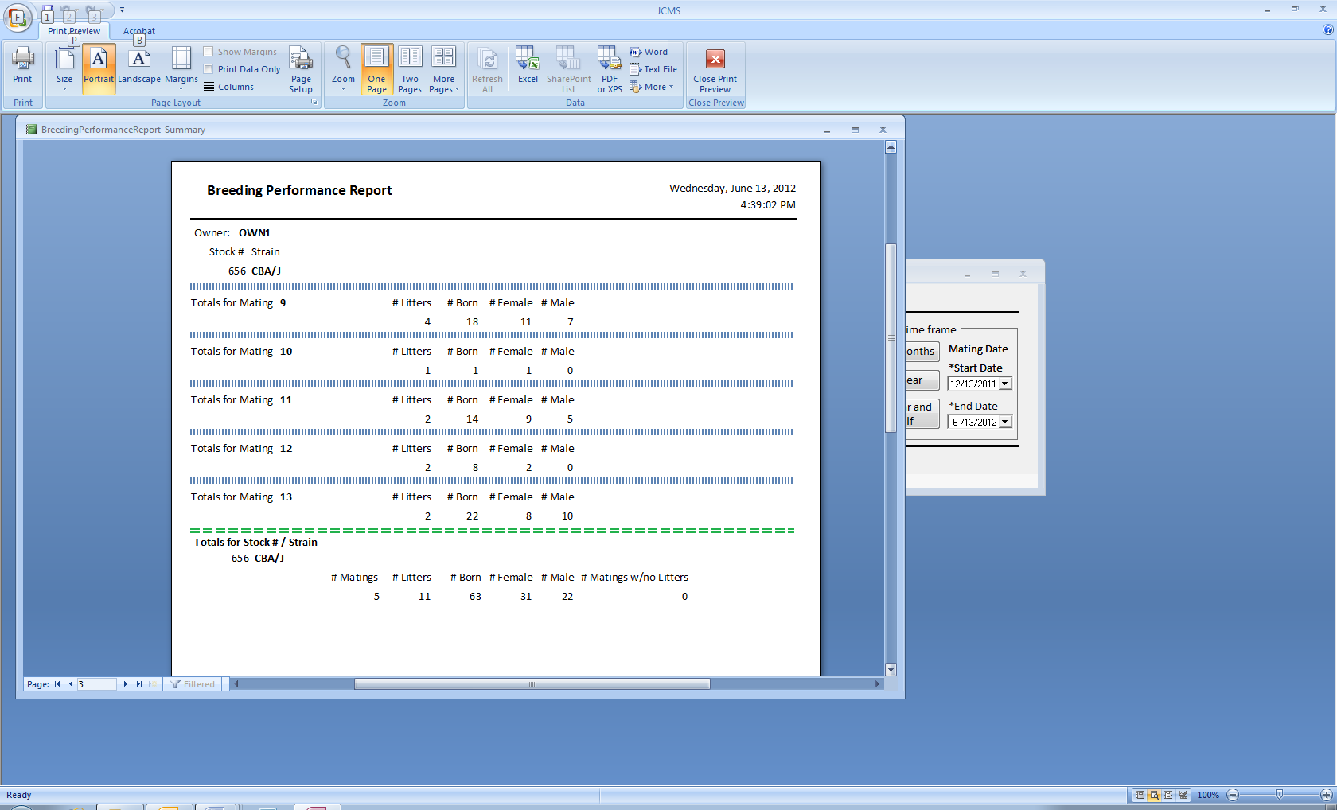

Figure ‑ Summary shown for one strain

## Breeding Performance Report Tabular Spreadsheet

The tabular spreadsheet provides the data in a format that can be easily exported to Excel. There is one row for each litter or, if the mating has no litters, one row for the mating.

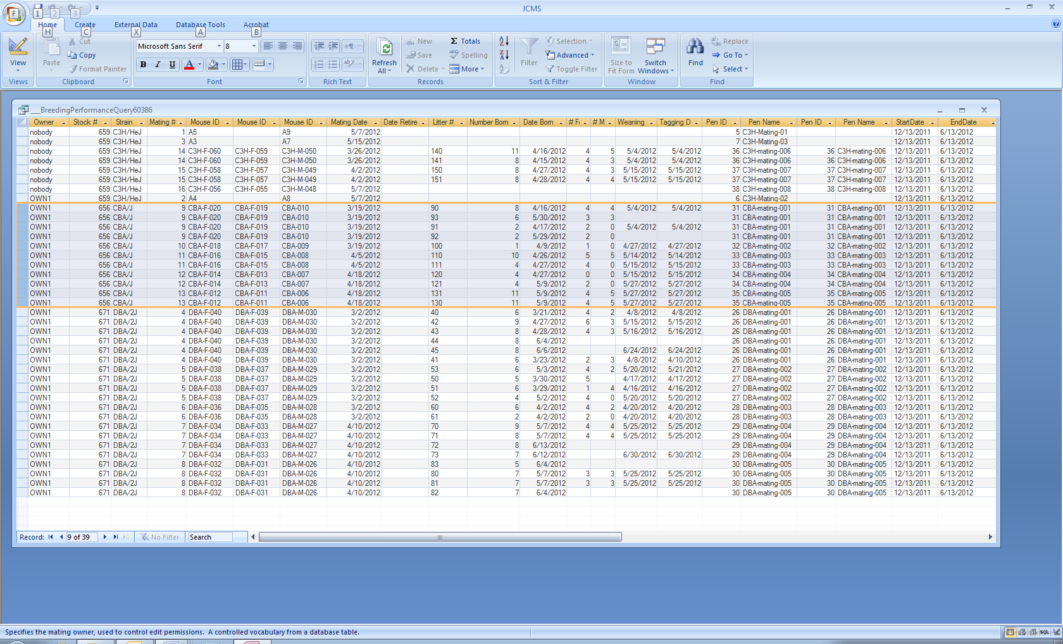

Figure ‑ Tabular spreadsheet format

## Breeding Performance Report Litter Detail Pivot Table

The litter detail pivot table provides a dynamic table showing the # born, # females, and # males for each mating and litter broken out by year/quarter/month.

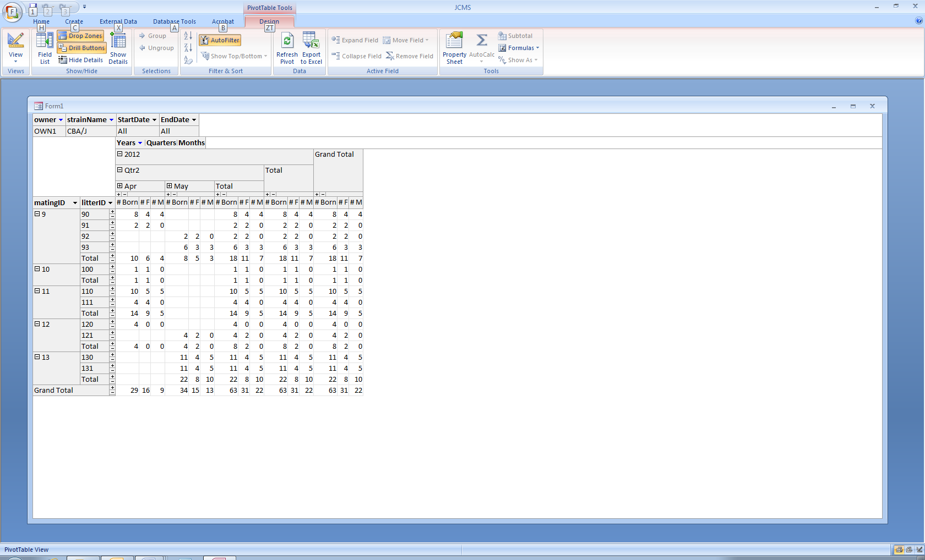

Figure ‑ Litter detail pivot table

## Breeding Performance Report Litter Summary Pivot Chart

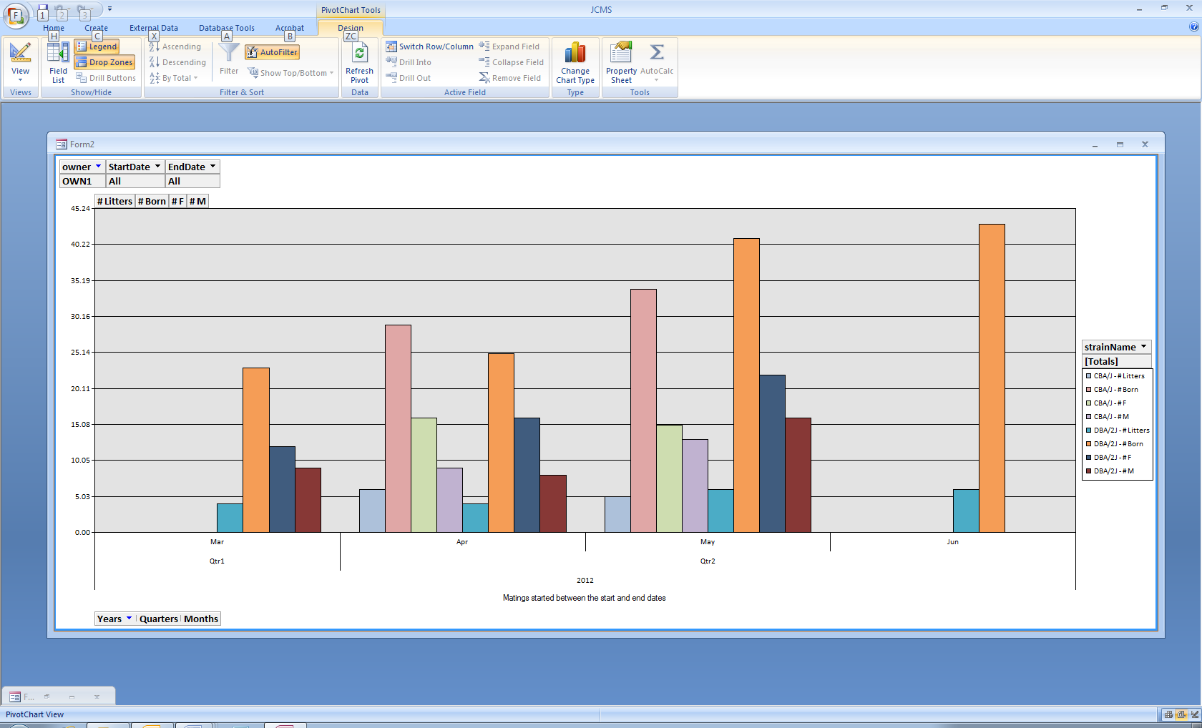The litter summary pivot chart provides a dynamic column graph showing the # litters, # born, # females, and # males by year/quarter/month.

Figure ‑ Litter summary pivot chart

## Breeding Performance Report Mating Count Pivot Chart

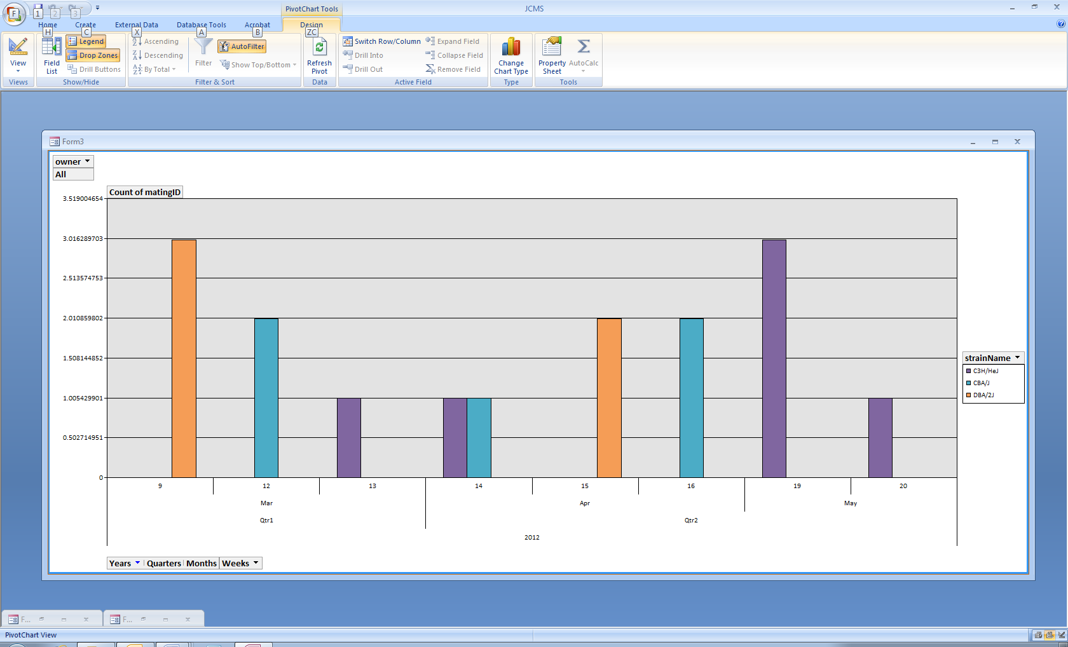The mating count pivot chart shows the number of matings started by year/quarter/month/week.

Figure ‑ Mating counts by week

## How to Use the Dynamic Features of a Pivot Table or Chart

Microsoft Access pivot charts and tables contain a number of customizable elements. JCMS has saved these charts and tables as a temporary form associated with the requested data (matings and litters for the time frame, strain, and owner criteria). These forms will be removed by JCMS when the application is closed. The forms are named sequentially as Form1, Form2, Form3, etc. We encourage manipulation of the forms to show the data in different ways. These changes are only displayed on the temporary form and do not change the underlying data. After changing a table or chart you can’t get it back to a previous format, simply request the pivot table or chart again, creating a new temporary form.

Pivot tables and charts may be printed once the desired format is achieved. The size of the form can be adjusted by dragging the corners. Below are some tips about how to make changes.

### Changing the Chart Type

Below is an example of what the mating count pivot chart looks like if it is changed to use the 3-D chart format. Changing the chart type is on the PivotChart Tools – Design tab (yellow circle).

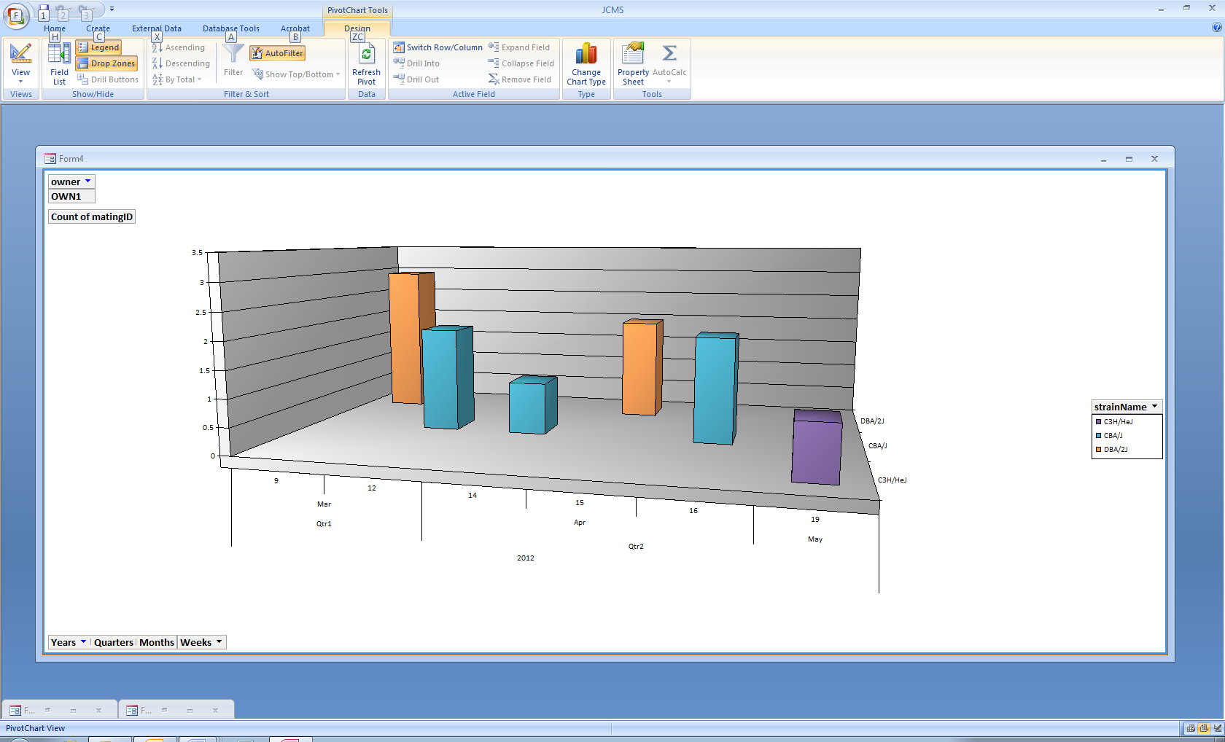

Figure ‑ Chart changed to 3-D and only one owner

### Showing Only Some of the Criteria

The charts and tables contain sections called “drop zones” (an example is shown in the purple circle above). Click on these to refine the possible choices. In the chart above, only “OWN1” has been selected instead of all owners.

The tables contain “drill buttons” that may be used to show or not show details. In the table below Qtr2 has been summarized (+) and March has been expanded (-) to show the birth dates of the litters.

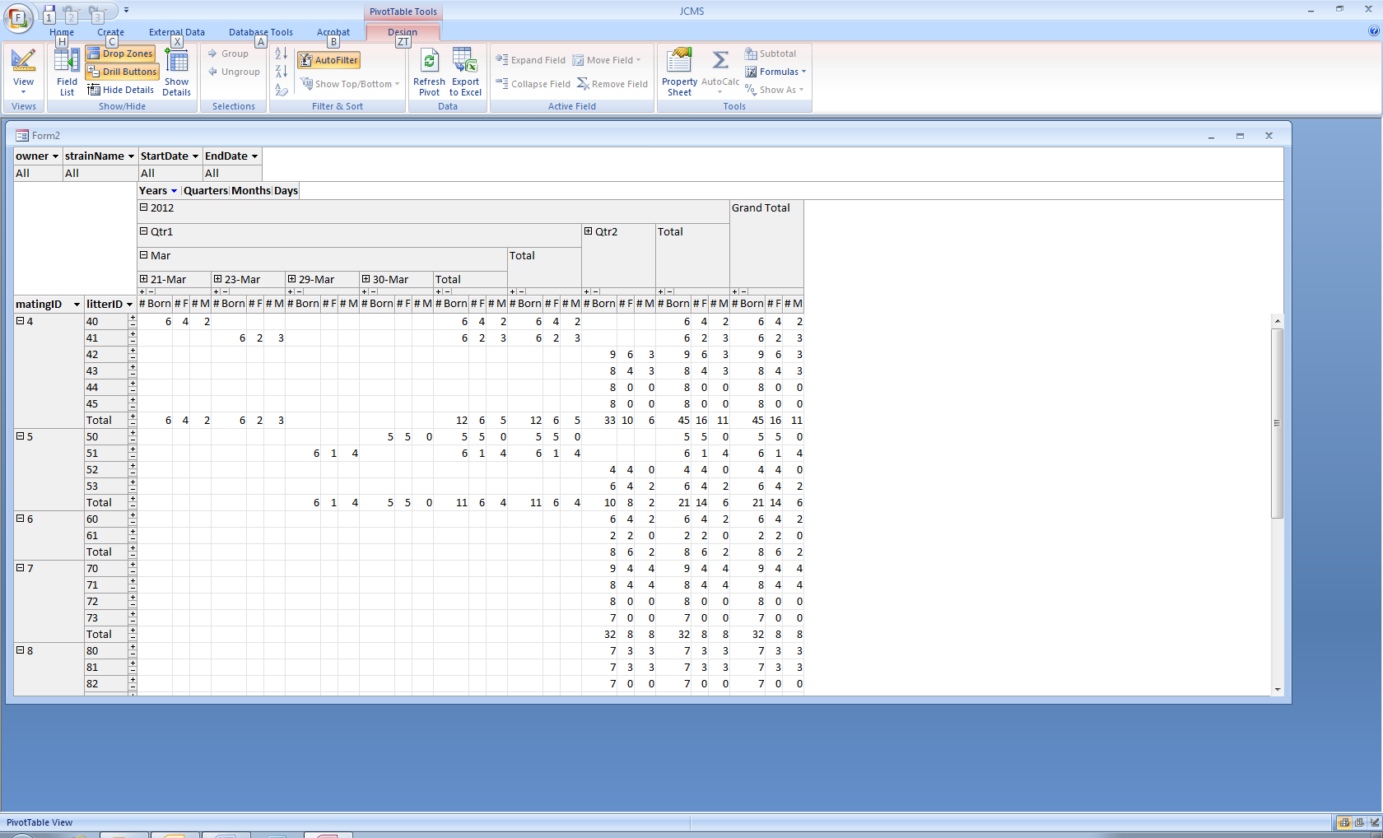

Figure ‑ Changed "drill buttons"

### Adjusting the Axis Scale

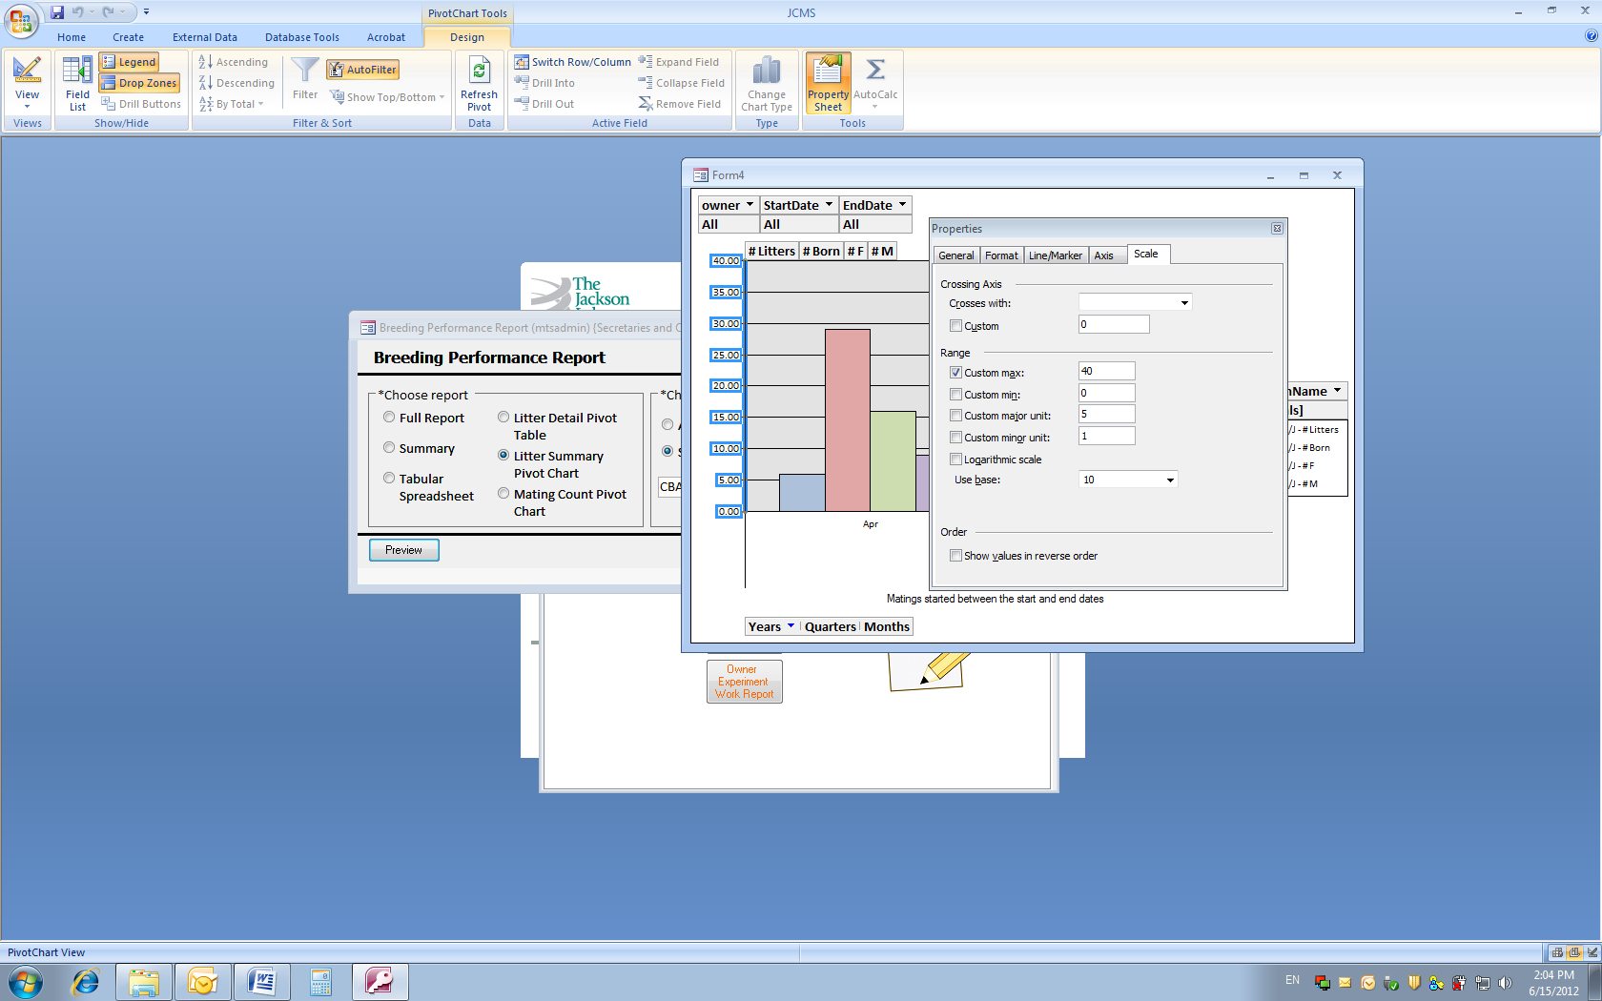

The left axis sometimes displays a large number of significant digits. To adjust this, click on the axis. Then click on the Property Sheet icon on the ribbon. Select the Scale tab in the properties dialog box. Change the range to use a custom max value and custom major unit.

Figure 12‑13 Properties dialog box

### Switch from Pivot Chart to Pivot Table

It is possible to change any pivot table into a pivot chart or vice versa. Click on the View button on the ribbon to select either PivotTable View or PivotChart View.

Figure 12‑14 View button

### Viewing Values for Portions of a Pivot Chart or Table

Hover the mouse over a column on a pivot chart or cell in a pivot table to see a box containing the values summarized by that element.

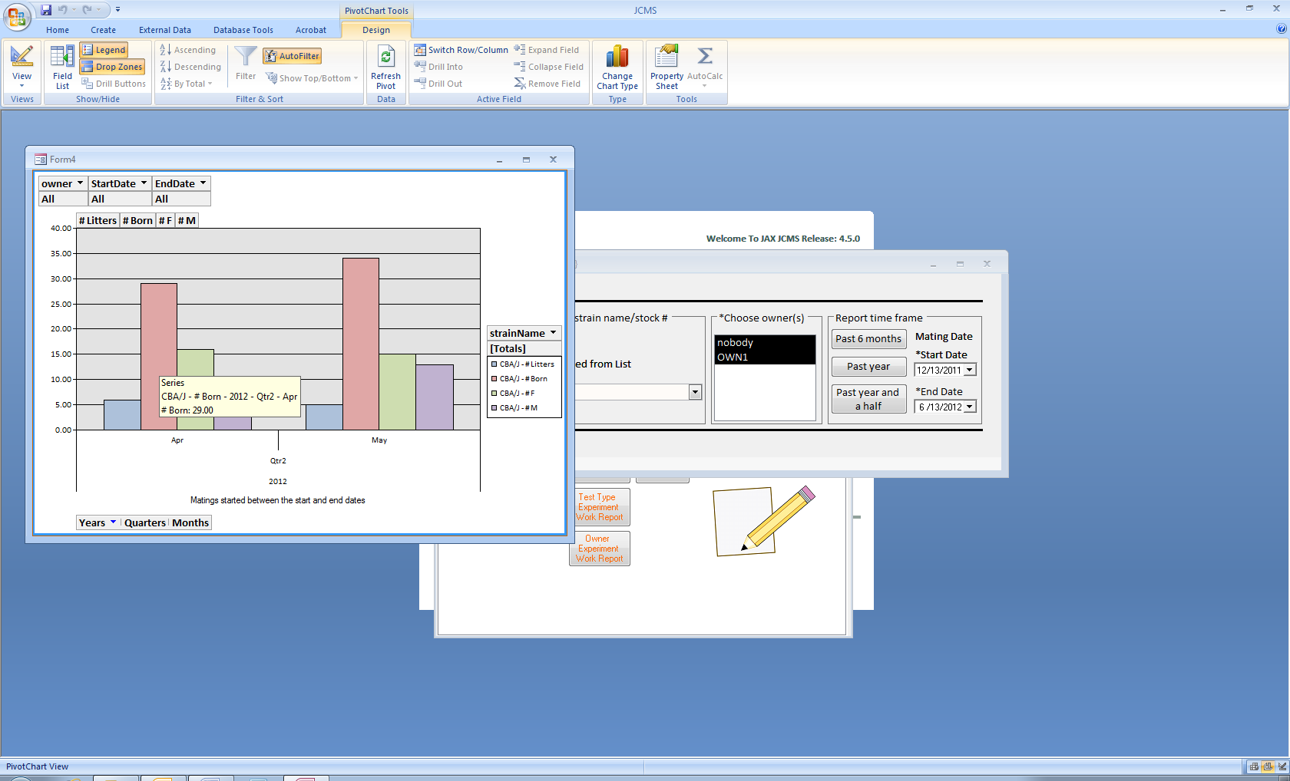

Figure ‑ Hover over a column with the mouse to see the values

# Genotyping

## How Does Genotyping Work?

Any mouse or sample may have several genotypes. Each genotype consists of a gene and the two alleles that were found for that gene. In JCMS, alleles are associated with specific genes or gene classes. The JCMS forms that display alleles that may be associated with a gene use both criteria (association to the gene and association to the gene class) to come up with a list of alleles that may be associated with a given gene.

The Administrator is responsible for setting up the available genes, alleles and gene classes. See section 3.3.7 on initializing controlled value (CV) tables for genes, alleles, and gene classes for more information on how these are set up.

The following Gene Class values are preset, but may have been changed or added to by the Administrator.

|  |  |
| --- | --- |
| *Class name* | *Comments* |
| E | endogenous |
| MKO | multi allele knock out |
| MTG | multi allele transgene |
| TG | trans gene |
| KO | knock out |
| KI | knock in |
| Floxed | tissue specific knock out |
| CTK | Combination transgene + KO |

## Adding a Genotype to a Mouse or Sample

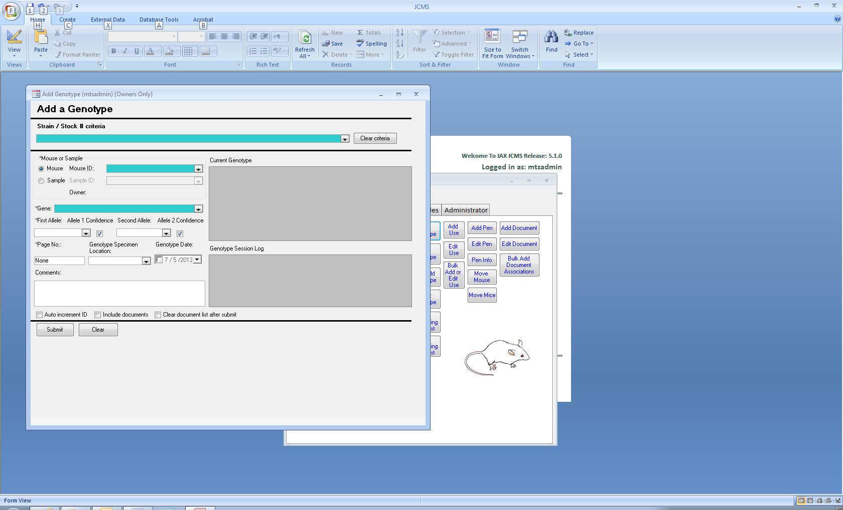

Figure ‑ Form: Add Genotype

Click the **Add Genotype** button on the manage mice tab to open this form. To add a new genotype, specify the mouse ID or sample ID. The current genotype will show on the screen. Next select the gene. Now the alleles that have been set up for the chosen gene will appear as choices in the first and second allele drop down boxes. The first allele and page number are required fields. If there is no page number, enter “None” in this field.

If the allele drop down boxes are blank, make sure a gene has been chosen. If they are still blank, have the Administrator add the alleles to the controlled value (CV) tables.

Strain/Stock # criteria: Select a value in the strain/stock # combo box to limit the mouse ID and sample ID choices. Use the *Clear criteria* button to show all the mouse and sample ID choices.

### Mouse-Genotype Documents

Documents (computer files) may be associated with a mouse-genotype, but not a sample genotype. First check “include documents” to show the document list on the form.

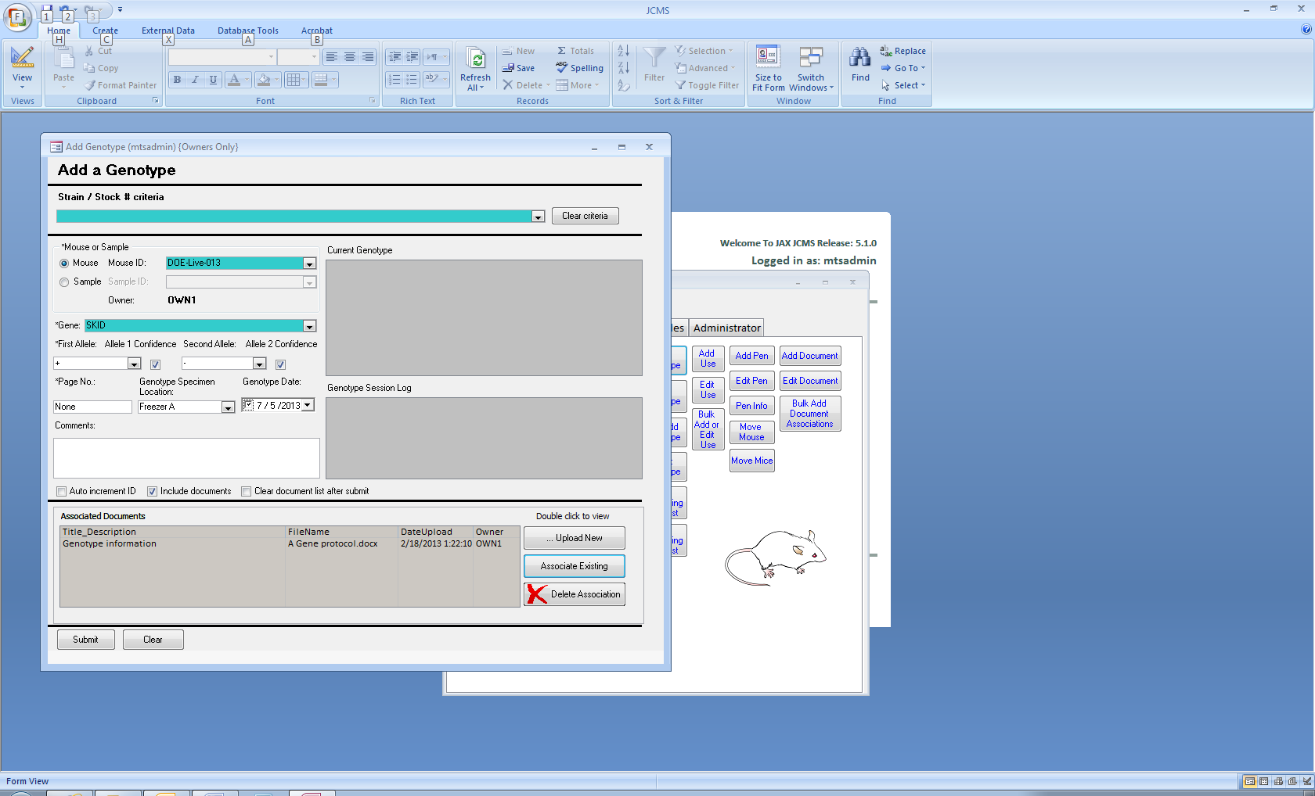

Figure ‑ Add genotype documents

This portion of the form is used to add document associations to a specific mouse-genotype combination. First create a list of one or more documents using the Upload New, Associate Existing, and Delete Association buttons. The document associations are created at the same time as the genotype record, when the submit button is clicked. The associated documents are copied into a special “genotype folder”. Upload new is used to copy the file into the folder and also add it to the list of associated documents for this genotype. The Associate Existing button is used to select a file that has already been uploaded into the genotype folder and optionally associated with other mouse-genotype combinations. The “Delete association” button is used to remove a document from the document list. It does not delete the file or remove it from the genotype folder. See Documents (section 17) for more information on document and file handling.

Double clicking on a row in the document list will treat the file as a hyperlink and open it in the default browser. Use the “clear document list after submit” check box to save time selecting documents to associate if they should be associated with multiple mouse-genotype combinations.

## Editing a Genotype

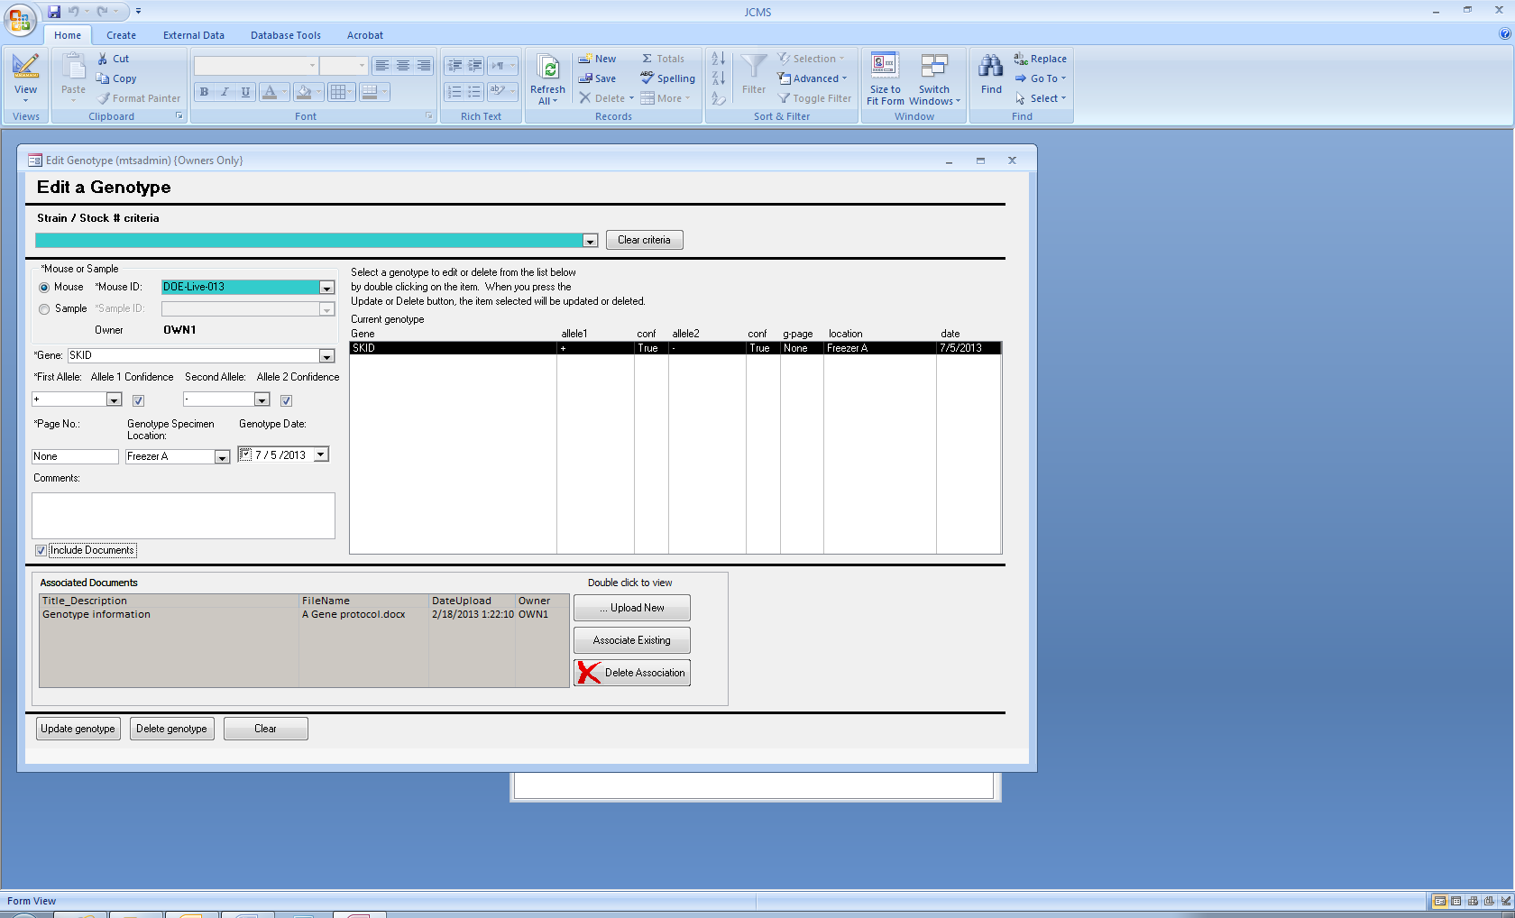

Figure ‑ Form: Edit Genotype

Click the **Edit Genotype** button on the manage mice tab to open this form. To edit a genotype, first select the Mouse ID or Sample ID. Then all the current genotypes for that mouse will show in the list box on the right side of the form. Double click on the genotype to be edited or deleted and that information will appear in the boxes on the left side of the form. Click the Delete genotype button to remove this genotype. Make changes to the information in the boxes and then click Update Genotype to edit it.

Documents that are associated with this mouse-genotype combination are also edited when the update genotype button is clicked. Use the Upload new, associate existing, and delete association buttons to make changes to the list of associated documents. These changes are not finalized until the update genotype button is clicked.

Delete association does not remove the document from the genotype folder. Delete genotype will automatically remove all document associations for this mouse-genotype but does not remove the files from the genotype folder. For more information on document handling see section 17.

## Adding a Genotype to a Group of Mice

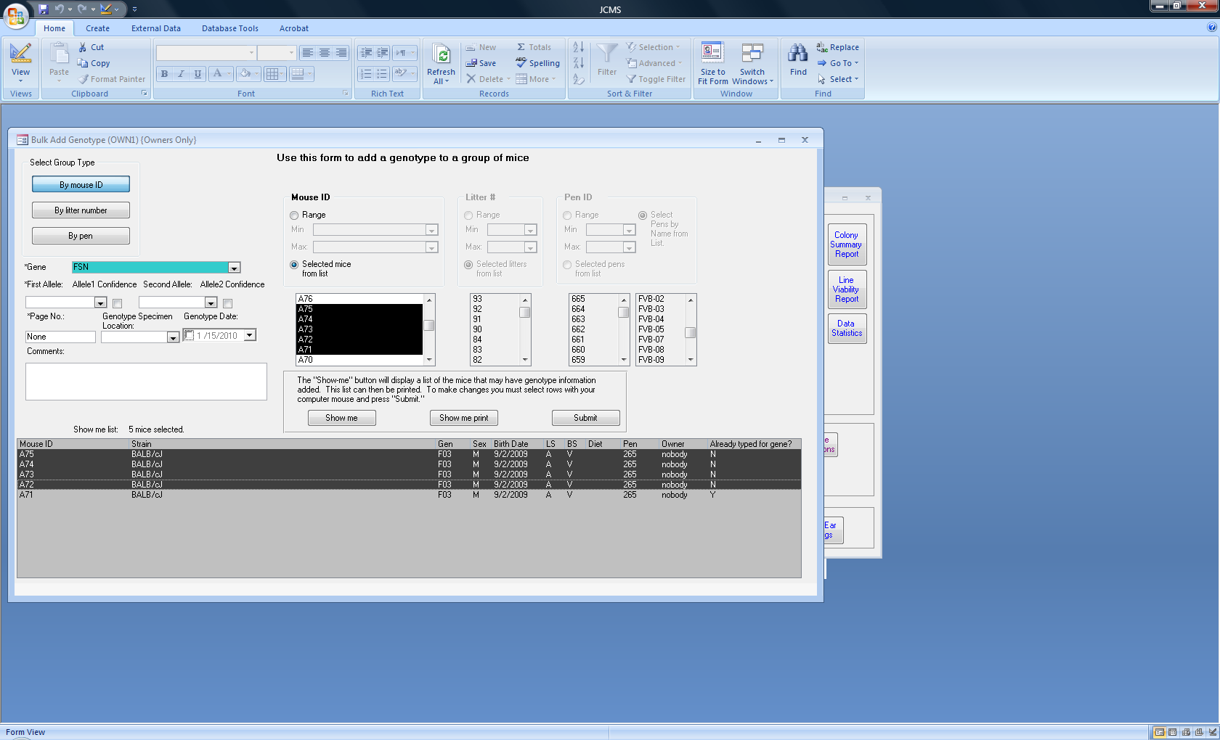

Figure ‑ Form: Bulk Add Genotype

Use this form for mice with an identical genotype. Click the **Bulk Add Genotype** button on the manage mice tab to open this form. Select the group of mice by mouse ID, Litter ID, or Pen. Click the **Show Me** button to see the list of possible mice in the group. Enter the genotype information on the left side of the form in the same fashion as on the Add Genotype form. Now, select the specific mice to have the genotype added by clicking on them in the show me box. Hold down the shift key to select a range or the ctrl key to select one at a time. Any mouse that already has this genotype will have “Y” listed in the “Already typed for gene?” column. If they are included in the group that is submitted, they will not have it added again or changed.

## Genotype String Format

The administrator can configure how genotype strings are displayed and if the confidence level is shown or not. Three setup variables are used to indicate the string's appearance.

The default display of a genotype is: gene AB/CD? where nothing is displayed for high confidence and ? represents low confidence and the allele names in this example are AB and CD.

The setup variables for the confidence level: JCMS_ALLELE_CONF_HIGH and JCMS_ALLELE_CONF_LOW may be set to a value that is 8 characters or less.

The setup variable JCMS_ALLELE_GENE_SEPARATORS specifies one character that is used before the alleles and one at the end. The default is no entry. If no characters are given, one space will be placed between the gene name and the alleles.

Note that the characters ‘ (single quote) “ (double quotes) ; (semicolon) and , (comma) are not allowed. Cage cards do not print the allele confidence levels.

Table ‑ Examples of genotype strings

|  |  |  |  |
| --- | --- | --- | --- |
| JCMS_ALLELE_  CONF_HIGH | JCMS_ALLELE_  CONF_LOW | JCMS_ALLELE_  GENE_SEPARATORS | RESULT |
| -Y | -N | [] | gene[AB-Y/CD-N] |
| blank | (?) | blank | gene AB/CD(?) |
| blank | blank | : | gene:AB/CD |
| (y) | (n) | <> | gene<AB(y)/CD(n)> |

## Genotype Work Report

The genotype work report is used to generate a list of litters due for genotyping during a particular time span.

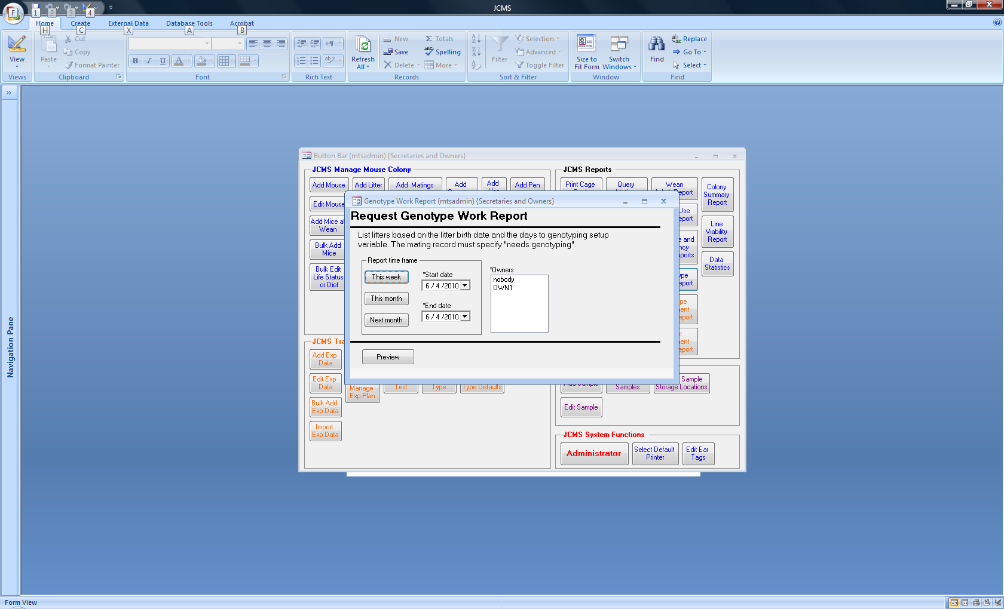

Figure ‑ Request a genotype work report

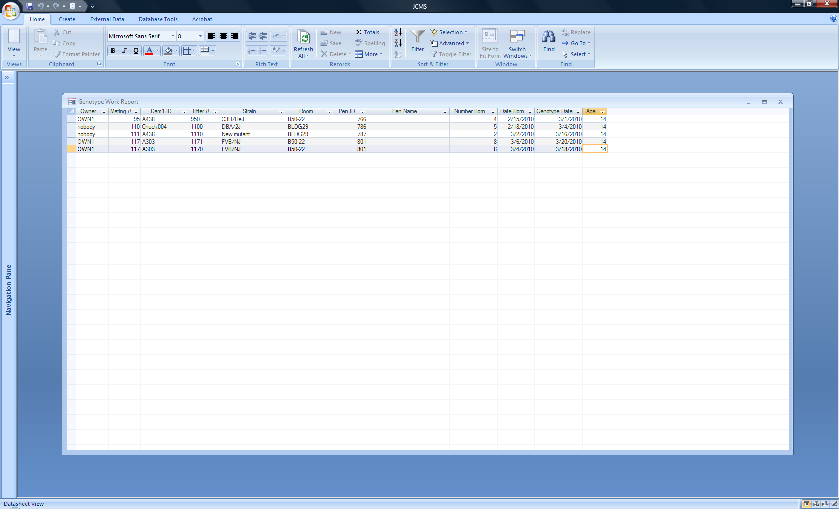Only litters whose matings have “needs genotyping” set will be on the report. The setup variable JCMS_DAYS_TO_GENOTYPE is used to determine how many days after birth genotyping is expected to be done. The default value is 14 days. JCMS is unable to determine if the genotyping has been done, therefore, all litters whose expected genotype date is within the selected time span are listed.

Figure ‑ Genotype Work Report

# Genotype Loader

There are two methods for importing mouse genotype data into JCMS.

* Use a comma separated value (CVS) file of genes, gene markers, or SNP data.
* Use a special file provided by the Jackson Laboratory Transgenic Genotyping Service (TGS).

Additionally, for Jackson Laboratory users, a genotyping request may be sent to the Transgenic Genotyping Service (TGS).

Details on the TGS options are included in Appendix 1 at the end of this document.

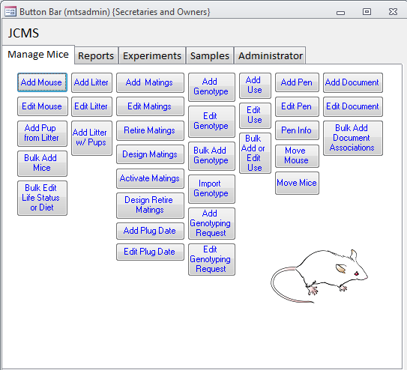

Figure ‑ Form: The main button bar with the "Import Genotype" button visible

## Import genotypes from a comma separated value (CSV) file

The genotype loader utility imports genotyping information and maps the rows and columns from a comma separated value (CSV) file to tables in the JCMS database. The result of the importation will be a set of new genotyping records for a given group of mice.

The software reads a formatted input file, parses it, validates it, and automatically populates the genotype records for the mice identified in the file.

Each file can be successfully loaded only once. If the user tries to load the file a second time it will generate error messages.

Note: This utility was originally written to import SNP (single nucleotide polymorphism) genotypes. Therefore, the acronym SNP may appear occasionally. The user can justifiably substitute the word “gene marker” or “gene”. The resulting records are the same.

**The JCMS setup variable JCMS_ENABLE_GENOTYPE_IMPORT must be set to true in order to bulk import genotype information from a file.**

### Input File Format

There are a number of rules concerning the format of the input file. These are described fully in this section of the user guide.

The input file is a comma separated value (CSV) file. A CSV file has one row per line and columns separated by commas. The file can be created by any text editor or can be generated from Microsoft Excel. Only CSV files are accepted by the genotype loader.

The contents of **row one, column one** must contain the string:

JAX-CMS SNP Genotype Import vers 1.0

If this value is not present then JCMS will abort the importation.

**Row one, column four** starts the *gene* identifiers. If these do not appear in the Gene table in JCMS then first the user will need to add them.

In **row two, column four** begin the *gene class* identifiers. These are optional.

Beginning in **row three, columns one through three** are the *Mouse ID*, a *Vial ID*, and a *Position* id, respectively. These values must be unique throughout the file. Stated another way, they can only appear in an input file once.

**Columns four to the end of the line** contain the allele identifiers associated with the genes from row one of the same column.

Alleles have a confidence level associated with them. Please note that when loading genotype data from a CSV file the confidence level is automatically set to high. They can be modified later by using the **Edit Genotype** form.

Parsing of the input file stops when:

1. the mouse ID column is empty OR
2. the gene marker column is empty OR
3. the allele column is empty.

**Example import file:**

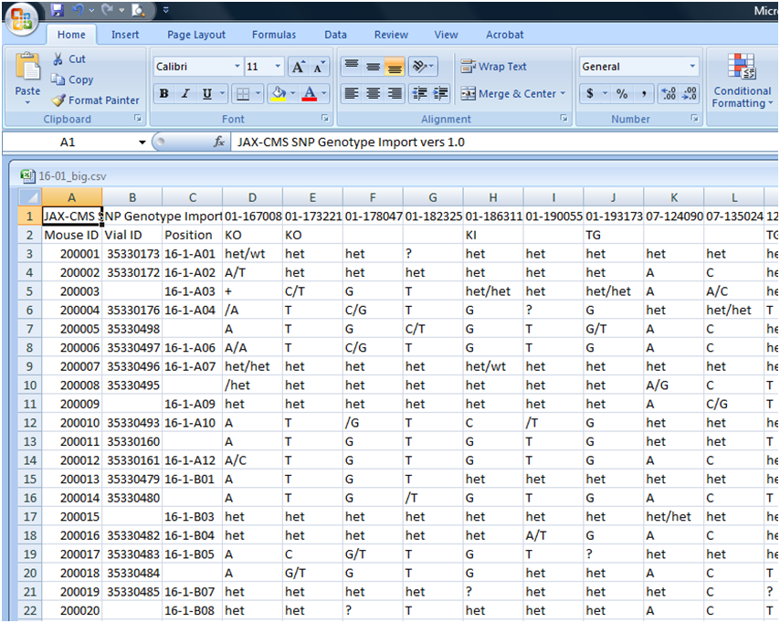

File Identifier (row 1, col 1)

Gene designations

(row 1, col 4 …)

Gene class

(row 2 col 4…)

Mouse IDs

Allele designations

Position in the tray, i.e. genotype specimen location (optional)

Vial ID (optional)

Figure ‑ Spreadsheet: the input file as seen in MS Excel

The table below lists the components of the input file and whether they are mandatory or not. The column values are case insensitive. It also provides more details about the values in the columns, their meaning, and how they map to the JCMS database tables.

Table ‑ The mapping of the input fields to the data tables

| **Field** | **Mandatory** | **Properties** | **Description *[Table.column]*** |
| --- | --- | --- | --- |
| Mouse ID | Yes | Alphanumeric, 16 characters maximum | Unique identifier. Mouse IDs must exist in the database prior to importing the file.  *[Mouse.ID]* |
| Vial id | No | Alphanumeric, 16 characters maximum | Maps to the *sampleVialID* tag field. Must be unique.  *[Mouse.sampleVialID]* |
| Position | No | Alphanumeric, 16 characters maximum | Maps to the *sampleVialTagPosition*.  *[Mouse.sampleVialTagPosition]* |
| Gene class ID | No | Alphanumeric, 16 characters maximum | Optional field. If present identifies a class of genes.  *[cv_GeneClass.GeneClass* and *Gene.geneClass* fields] |
| Gene markers | Yes | Alphanumeric, 32 characters maximum | Treated as gene names.  [*Gene.labSymbol*] |
| Allele designations | Yes | Alphanumeric, 8 characters maximum. | Associated with the gene marker (Gene) not the gene class.  *[Allele.allele, Genoytpe.allele1, and Genoytpe.allele2]* |

### Alleles

Alleles can be represented four ways in the input file. The table below lists the four ways along with examples and the results produced by the example.

Table ‑ Genotype loader allele representations

|  |  |  |
| --- | --- | --- |
| **Allele representation** | **Example** | **Result** |
| Two string separated by a slash | “abc/xyz” | Allele1 = “abc”, allele2 = “xyz” |
| A single string | “hom” | Allele1 = “hom”, allele2 = “” |
| A string followed by a slash | “cre1 /” | Allele1 = “cre1”, allele2 = “” |
| A slash followed by a string | “/cre1” | Allele1 = “”, allele2 = “cre1” |

### Import File Integrity Checks

The following table lists the tests performed and exceptions caught.

Table ‑ Genotype loader error messages

| **Rule** | **Exception** | **Action** |
| --- | --- | --- |
| Row one, column one does not contain a valid genotype file identifier. | File is not an import file. | Popup message box: “The file <filename> does not appear to be a valid JAX-CMS formatted genotype importation file.” <ok> After clicking OK the file dialog exits. |
| All mice IDs from the input file must exist in the database. | A mouse ID is not found | Record the error as “Mouse Id doesn’t exist in the database, no allele and genotype records are created for that mouse id’ in the error log generated at the end and skip this mouse record in the file. |
| Mouse record must have an empty vialID or it must match the current value. | Mouse record has a sampleVialID that is not NULL and is different from the value we are trying to write. | Record the error as “Vial id doesn’t match the value in the input file’ in the error log generated at the end and don’t update the mouse record. |
| If a gene name (marker) exists in the database then the gene class in the input file must match. | Gene and Gene class tuple from input file do not match what is in the database. | Record the error as ‘Gene already exists in the database but geneclass doesn’t match the value in the input file” in the error log generated at the end and do not add the gene / gene class tuple to the database. |
| Input file must be in a valid format (con’t) | File is a valid file but does not conform to the expected format. | Popup message box: “input file <filename> is not in a valid format. <additional info>” (ok)    The validation dialog remains visible with the error message and any additional info entered into the ‘details’ box but the only option is the Cancel button. |
| Mouse ID(s) not unique | Mouse ID (recipient ID) <id> already exists in database at line | Popup message box: “Mouse ID (recipient ID) <id> already exists in database at line <n>.” and abort the operation |
| Not a CSV file | Invalid file | Popup message box: “Invalid file” and abort the operation |
| Missing mouse id field in the input file | Missing Mouse ID at line | Popup message box: “Missing Mouse ID at line <n> in the input file” and abort the operation |
| Missing Gene in the input file | Missing Gene at line | Popup message box: “Missing Gene at line <n>” and abort the operation |
| Missing Allele in the input file | Invalid Allele at line | Popup message box: “Invalid Allele at line <n>” |

### Select the type of Import

The “Import Genotype” button appears in the ‘genotype column’ on the manage mice tab. It opens a dialog box used to indicate which import to use. Select “Import JCMS *.csv format file”.

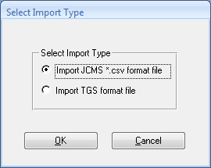

Figure ‑ Select import type dialog box

**The JCMS setup variable JCMS_ENABLE_GENOTYPE_IMPORT must be set to true in order to bulk import genotype information from a file. This is the default.**

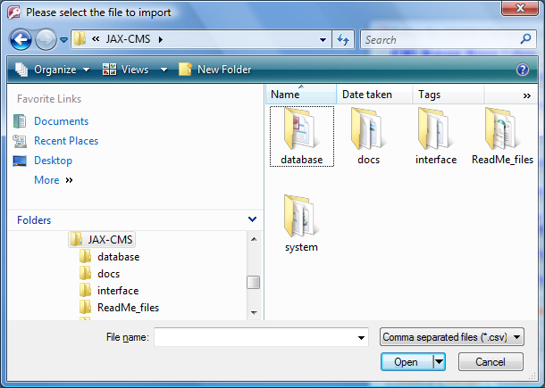When functional, clicking OK brings up a standard file open dialog. See Figure 14‑4. The user can browse to files or type in a pathname, including a network (UNC) pathname. It accepts only comma separated value (.csv) files.

Figure ‑ The file open dialog

#### If the user clicks cancel, then the message “Request to upload the file was cancelled” is displayed and the operation is aborted.

#### If the input file is not a comma separated value file the error message “The file xxx.csv is not in a valid format” is displayed and the operation is aborted.

### Verification

Once a file is selected and verified, the software runs a series of validations against it. If any of the validations fail, the user will not be able to import the genotypes. If all the validation tests pass, the user may still elect to cancel.

Figure 14‑5, Figure 14‑6, and Figure 14‑7 show the user notification dialog that appears during validation, after a successful validation, and after the import, respectively.

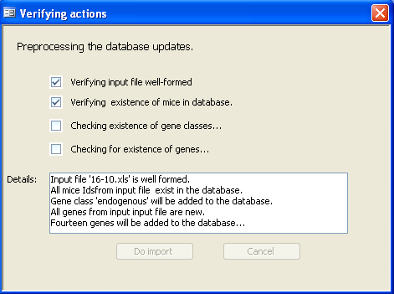

Figure ‑ The user notification screen during validation

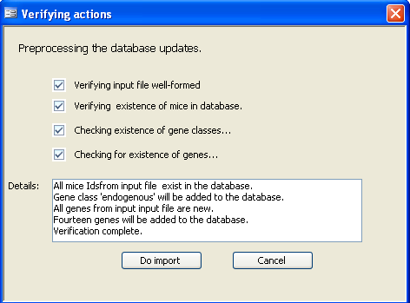

Figure ‑ The user notification after validation

The validation process:

1. Checks the input file contents of row 1, column 1 to be the string “JAX-CMS SNP Genotype Import vers 1.0”, If this value is not present then error message “The file xxx.csv does not appear to be a valid JAX-CMS formatted genotype importation file” is displayed and the operation is aborted.

#### Once the file is validated, the software checks if the gene class from the input file exists in the database, if not it is added to the database.

#### Tests if the gene markers exist in the input file, if not then error message “Gene doesn’t exist” is displayed and aborts the operation. If the input file contains gene markers then the software checks that those genes exist in the database, if not the genes are added to the database.

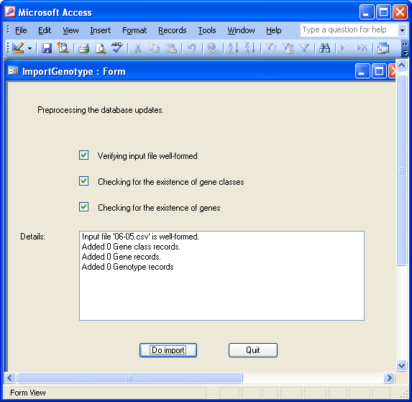

Figure ‑ The user notification after import

When the user clicks the **Do Import** button, the software:

1. Checks if mouse ID from the input file exists in the database. If not it is recorded in the load report and the row is skipped. If it does exist then it checks if the user has permissions to edit the mouse.
2. Updates the mouse record with new vial Id and vial tag position values.

#### Checks if the allele(s) from the input file exist in the database; if not, it adds all the new alleles to the database.

#### Checks if the genotype record for each mouse, gene, and allele exists in the database; if not, it adds all the genotype records with respective mouse, gene, and allele to the database

### Genotype Load Report

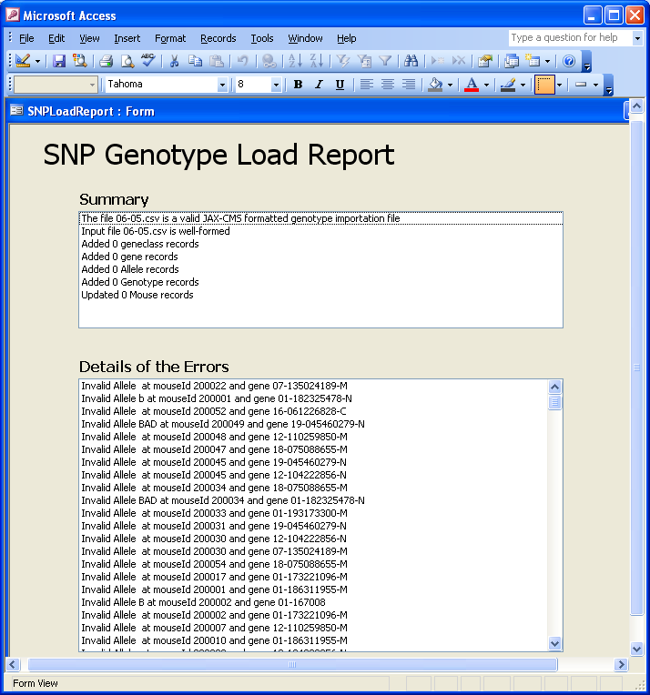

Figure ‑ Genotype Load Report

#### A load report is generated at the end of the import process.

This form is invoked from the Import Genotype form after the importation process is done. It gives the summary of the input file verification, count of gene classes added, genes added, alleles added, genotypes added, and mice updated in the database. It also gives the list of errors encountered during the importation process.

# Scheduling Procedures (Uses)

## How do Mouse Uses Work?

Mice may be assigned various uses over time. JCMS uses the term “use” to refer to a procedure, protocol, test, experiment, examination, assessment, etc. that was done with a mouse at a particular point in time. Some “uses”, such as taking a weight measurement, may be repeated several times over the life of a mouse.

Uses may have a use age that provides a projected date for the use. The projected date can be used to generate a report of work that needs to be done during a particular time frame. When the use is complete the actual date is entered, and up to 10 fields are available for entering data results (text format). The mouse use Calendar (Section 16) is used to display the projected and/or actual dates by the month, week, or day. Uses that are associated with plug dates and a date post conception (DPC) may be entered at the same time as the plug date (Section Add Plug Date).

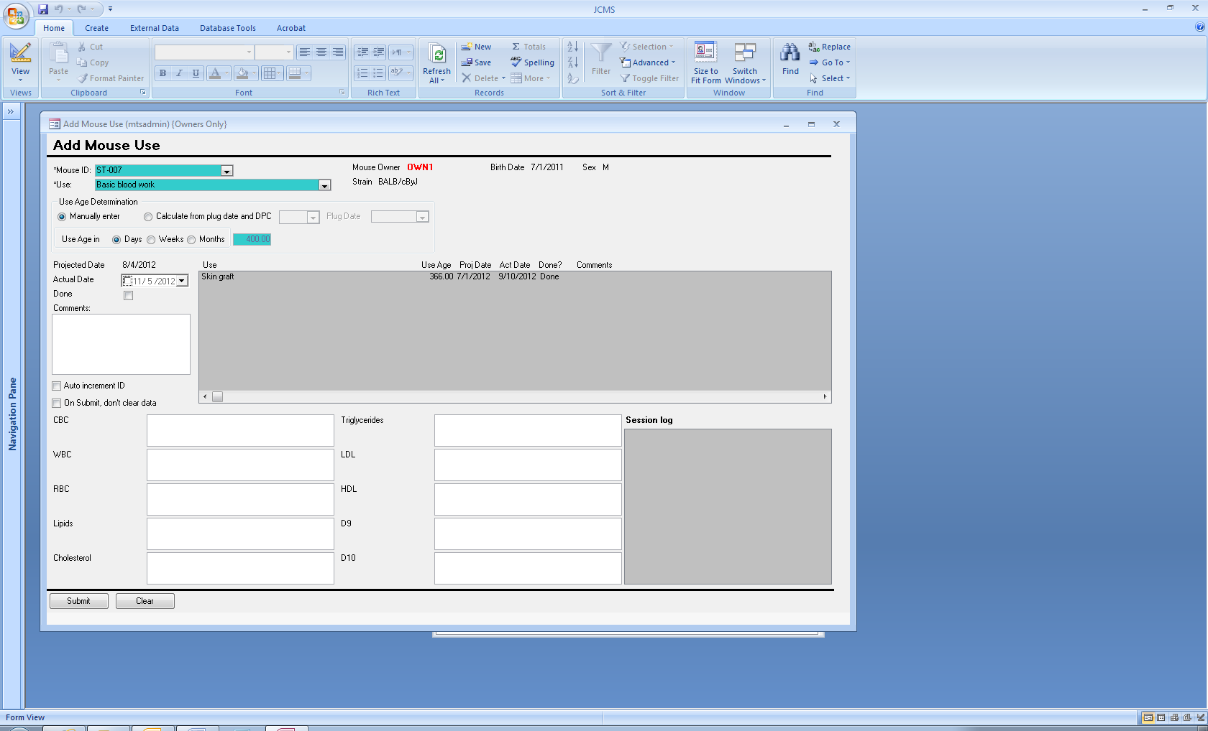If the “mouse uses” system does not provide enough flexibility or data collection, use the Experimental Plan portion of JCMS instead. Experimental plans allow for user-designed experimental tests and metadata plus more complex scheduling.

## Adding a Use to a Mouse

Figure ‑ Form: Add Use

Click the **Add Use** button on the manage mice tab. Enter the mouse ID. Any current uses for this mouse will display in the gray list box. The use age is stored in days. Use the “Days/Weeks/Months” radio buttons to indicate how the use age is displayed. JCMS will convert months or weeks into days by using 30.4375 days in a month and 7 days in a week. With each use, some information may be stored in the comment field. The ten fields at the bottom of the form are provided to store results or other information associated with this use. It is the responsibility of the user to keep track of what the data in each field means. A suggestion is to include a meaningful caption for each field when the use term is added (by the administrator). If there is no caption for the field it is labeled as D1, D2, …D10 on the form.

The projected date is always calculated. Select the “manually enter” radio button and the projected date will be calculated based on the mouse’s birth date. Select the “calculate from plug date and DPC” radio button and the projected date will be set to the plug date plus DPC (rounded down). The use age is then calculated as the difference between the mouse’s birth date and the projected date. It is assumed that the mouse was not exited prior to the projected date.

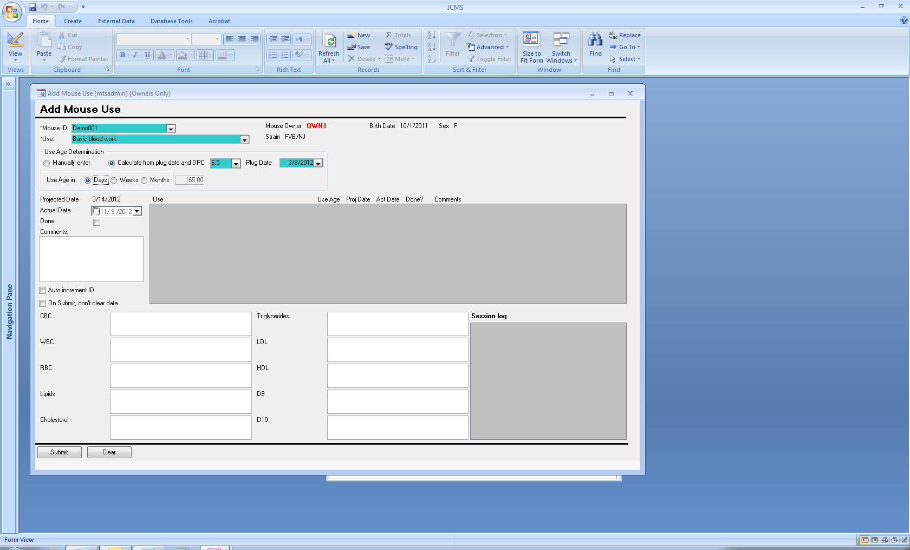

Figure ‑ Adding a use based on a plug date

## Mouse Use Work Report

Use the **Mouse-Use Work Report** button on the reports tab to request a listing of mouse uses. There are multiple criteria including projected or actual date, use status (done or not done), owner, and life status. The date may be within a range or open-ended by un-checking either the “from” or “to” date. It is possible for a mouse-use to have no projected or actual date. Include these mouse-uses by checking “include if no date.”

This report is designed to be printed in landscape format. If the print preview shows the report in portrait format, change the page layout to landscape.

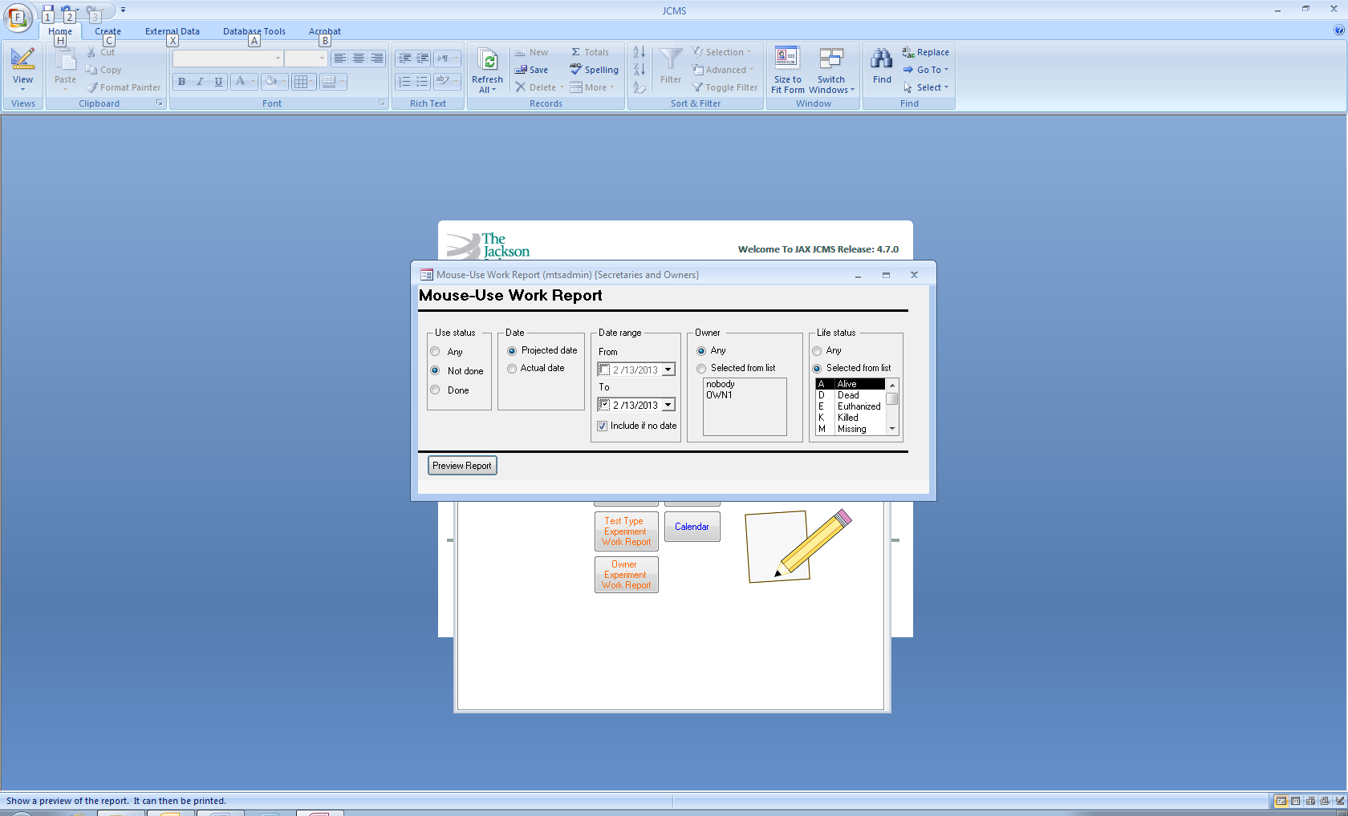

Figure ‑ Request mouse use work report

## Editing a Mouse Use

Figure ‑ Form: Edit Use

Click the **Edit Use** button on the manage mice tab. Enter the mouse ID. Any current uses for this mouse will display in the gray list box. To edit a use, double click on the use in the list box. The values for this use will appear in the white editing boxes. Press the Submit button for the changes to be saved or the Delete button to remove the selected use from JCMS. New uses cannot be added on the edit use form, only changes to existing ones.

Often data results are repetitive. When using the auto increment ID function, it is not possible to repeat the data for the next mouse as this is an edit form. To make repeat entry of the same data easier, there are two buttons on the form. Click on **Copy Data to JCMS Clipboard** before clicking the Submit button. Select the proper use from the next mouse. Click the **Paste Data from JCMS Clipboard** and the data fields will have the values from that previous mouse pasted into them. No other fields will be affected by this special paste. The clipboard will continue to contain these values so they may be pasted into a third, fourth, etc. mouse use. This clipboard cannot be used to paste these values into any other application.

## Adding or Editing a Mouse Use for a Group of Mice

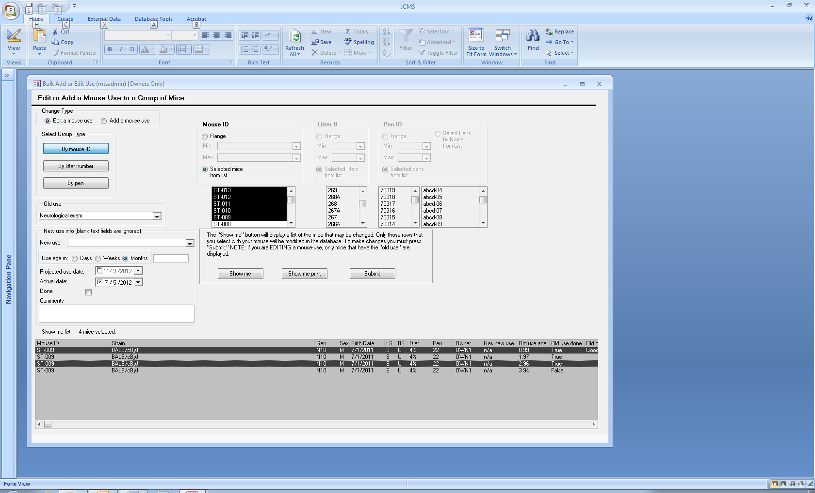

Figure ‑ Bulk Add or Edit Use Form

Click the **Bulk Add or Edit Use** button on the manage mice tab. This form allows both adding and editing mouse uses for a set of mice. Both functions cannot be done at once, first choose add or edit. The group may be selected by mouse ID, Litter #, or Pen ID. Click the **Show Me** button to see the list of possible mice.

Edit use*:* specify an “*old-use*” (the *use* to be edited). Only mice that have the “*old-use*” will be displayed in the “*show-me*” list. Thus, it is possible to select mice to work on from one of the selection criteria list boxes, and potentially none will be displayed in the show-me list because they do not have the *old-use*.

One mouse can be scheduled for the same use multiple times. Thus is it possible to see the same mouse listed multiple times in the show-me box. *Use* records can be distinguished from each other by looking at the old-use age. This form requires first selecting the mice to be modified and then choosing which of possibly many *use-records* to change.

Only the new use info fields that contain information in them will be changed. Blank fields are ignored. The exception to this is the *Done* field. All selected use records will be changed. If all fields in the new use section are blank, JCMS will verify that the done field should be changed.

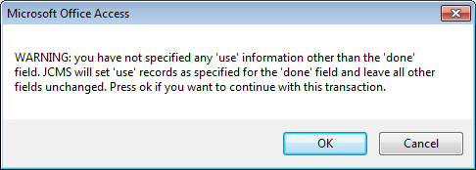

Figure ‑ Warning about making a change to the "done" field

NOTE: When editing a use, the contents of the comment field will replace any existing comments associated with the specific set of uses being edited. This may seem counter intuitive when thinking in terms of editing the comments. However, this edit function is designed to copy over any existing information unless the comments field is blank. It is not possible to use this form to completely remove the comments.

Add new use: select the “add a mouse use” choice and specify the mice to be operated on via one of the three selection criteria (mouse ID, pen, or litter). It is valid to add the same use many times for one mouse. This form will not calculate the projected use date; it must be entered on the form and will be the same for all selected mice. The birth date, use age, and projected date will not be synchronized unless the user carefully determines them.

# Calendar

The calendar is used to display the mouse uses scheduled for a particular date. To open the calendar, click on the Calendar button on the Reports tab.



Figure ‑ Open the calendar

The request mouse use calendar form will open. Specify one or more mouse uses, strains, and owners to be shown on the calendar. Mouse uses have a status of done or not done. The calendar can show only those that are not done yet or can be used to show a history of all those that were done on a particular date.

Click the Display Calendar button.

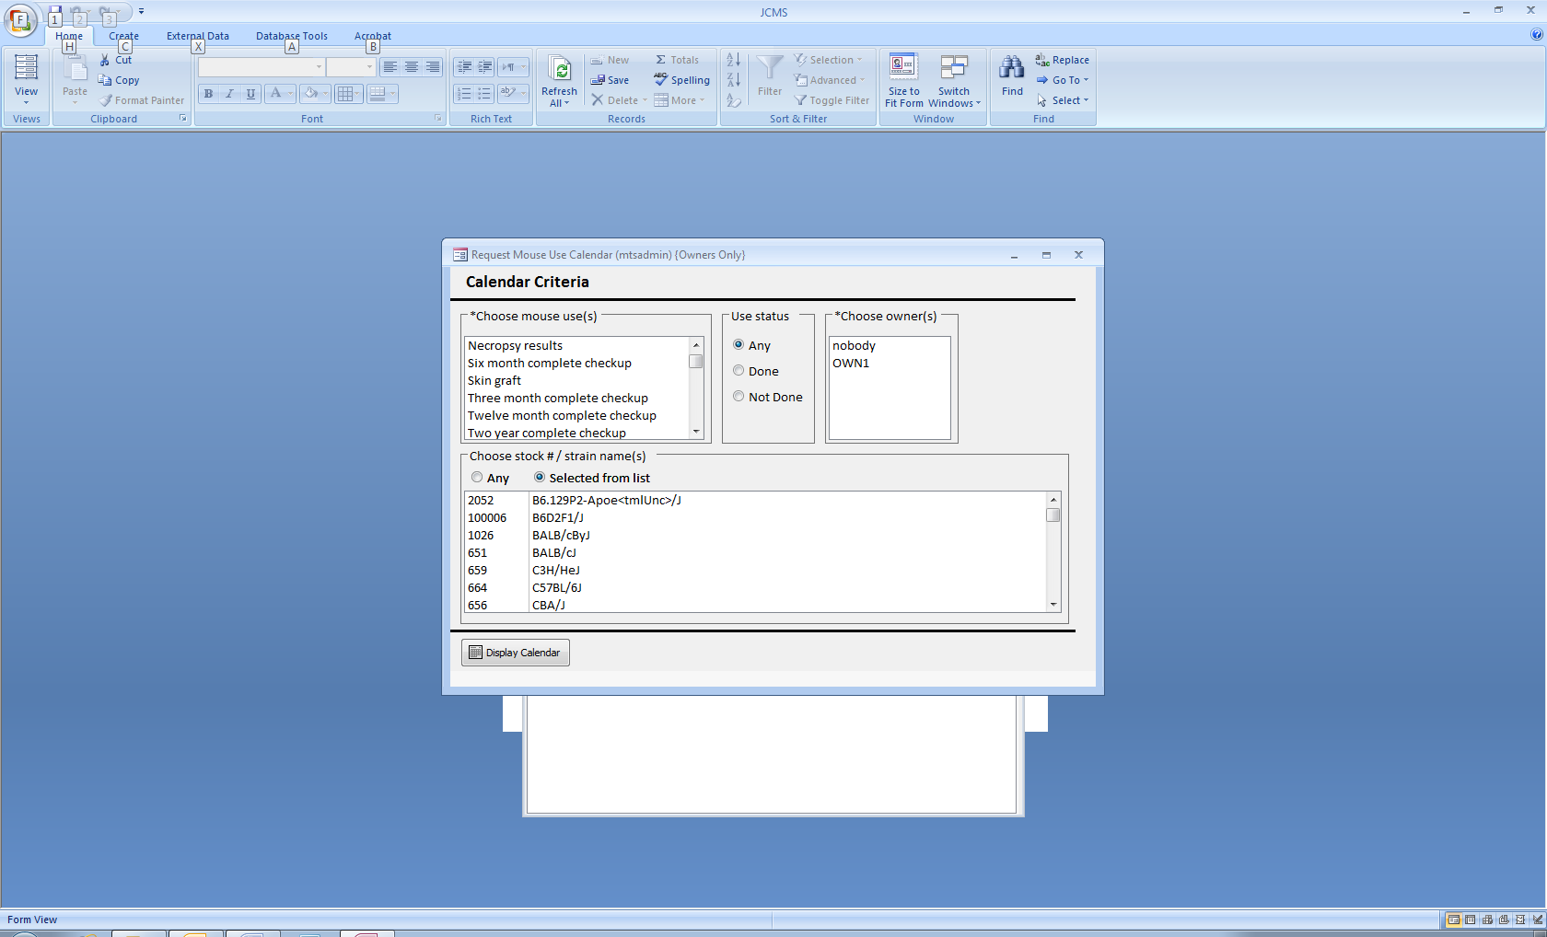

Figure ‑ Form: Request mouse use calendar

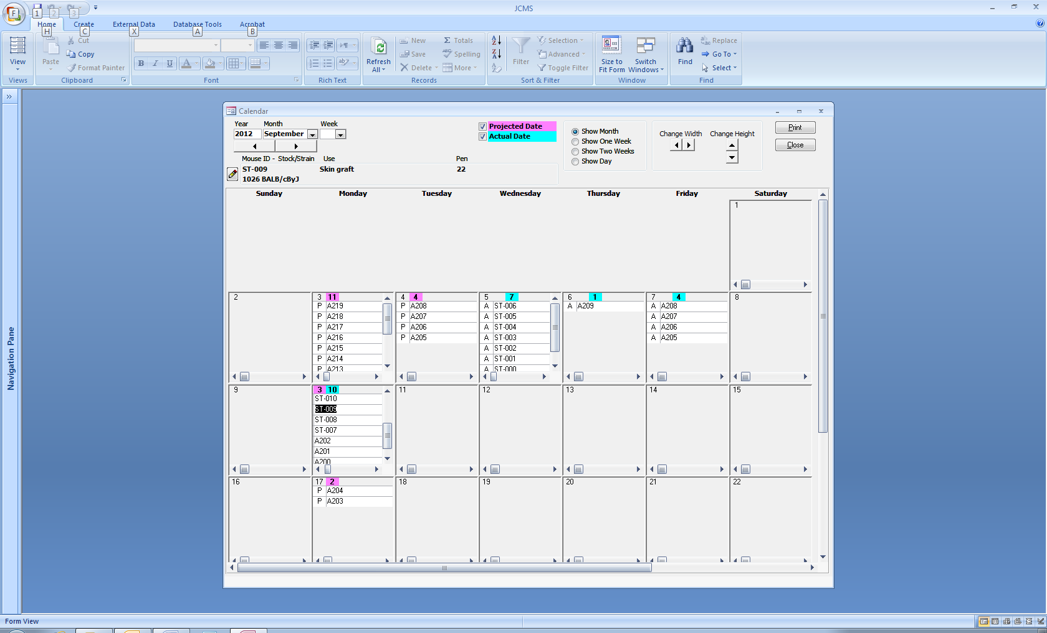

Figure ‑ Example of a mouse use calendar

The calendar displays two dates, the projected date (date the use is planned for) and the actual date the use was completed. Check and/or uncheck the projected and actual dates (yellow oval) to add or remove them from the calendar. Projected dates are marked with a “P” and actual dates with an “A”.

Click on a row in the calendar (green circle) and the details of that mouse use are displayed (blue oval). Also the scroll bars on the bottom of the date box may be used to see the same details [mouse ID, use, pen ID/pen name, and stock #/strain].

The size of the date boxes can be adjusted by using the Change Width and Change Height buttons. The year, month, and week can also be changed.

The format of the calendar can be changed from month to one week, two weeks, or one day.

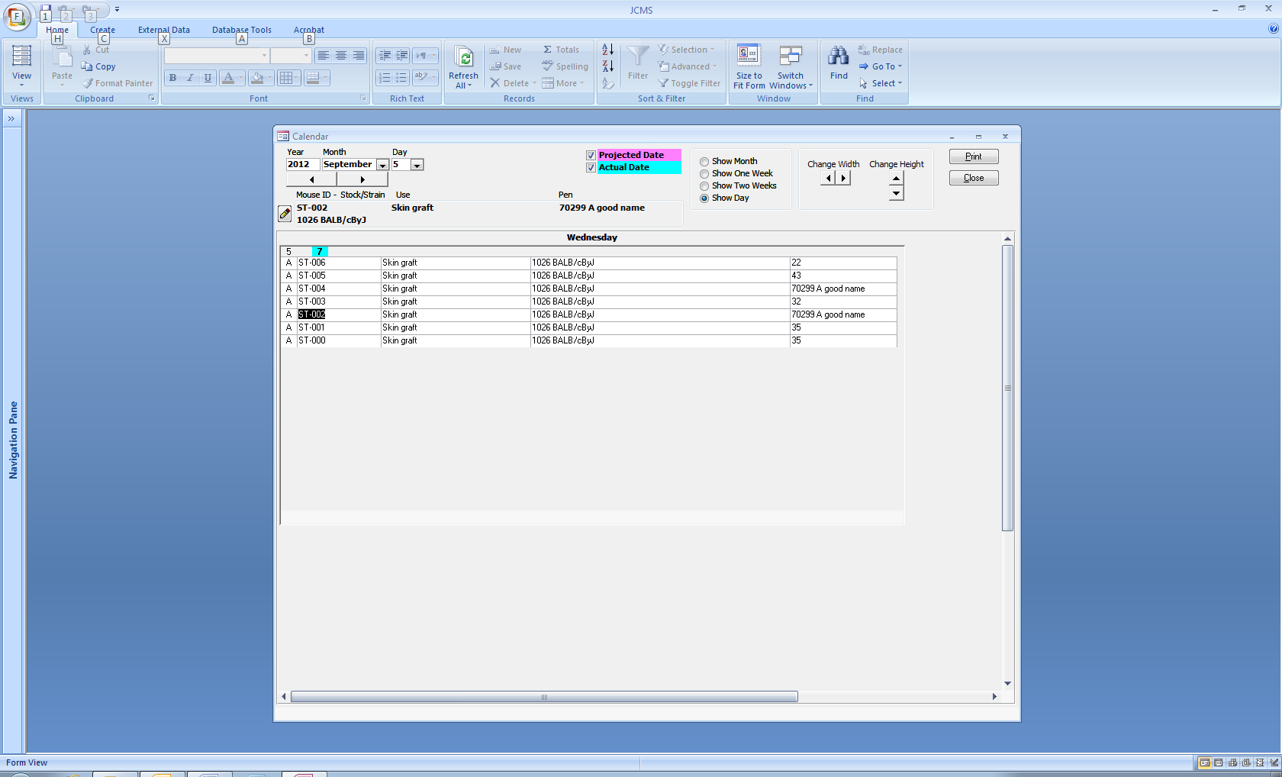

Figure ‑ Single day format

## Edit a Mouse Use Shown on the Calendar

To open a mouse use for editing, click on the pencil icon button or on the use (black circles). This will open the Edit Mouse Uses form as shown below. Please note that the calendar is not automatically refreshed to show changes made to the mouse use. To see the changes, close the calendar and reopen it.

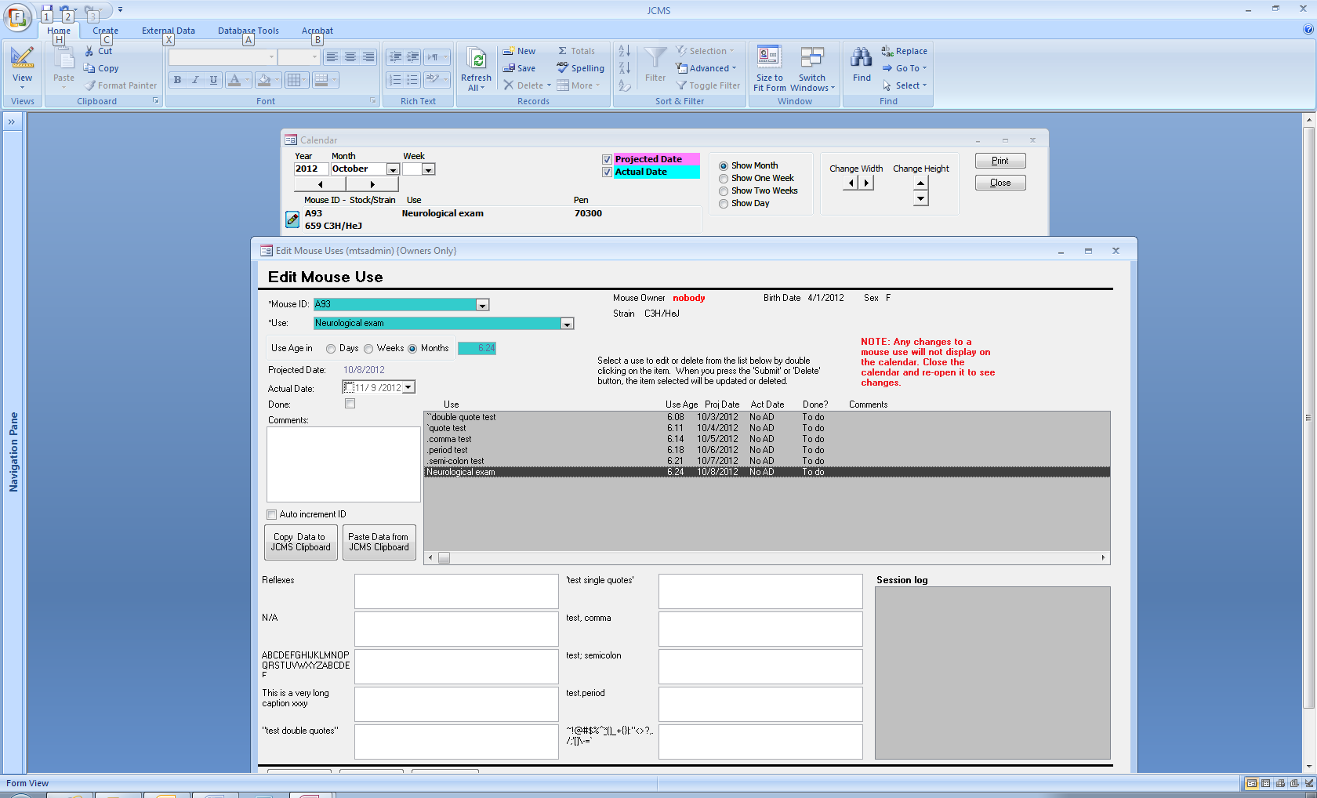

Figure ‑ Opening the edit mouse uses form

## Mouse Use Details Form

Double click on a row on the calendar or on the mouse ID, pen, or stock#/strain (orange circles) to open the Mouse use details form showing information about that specific mouse use.

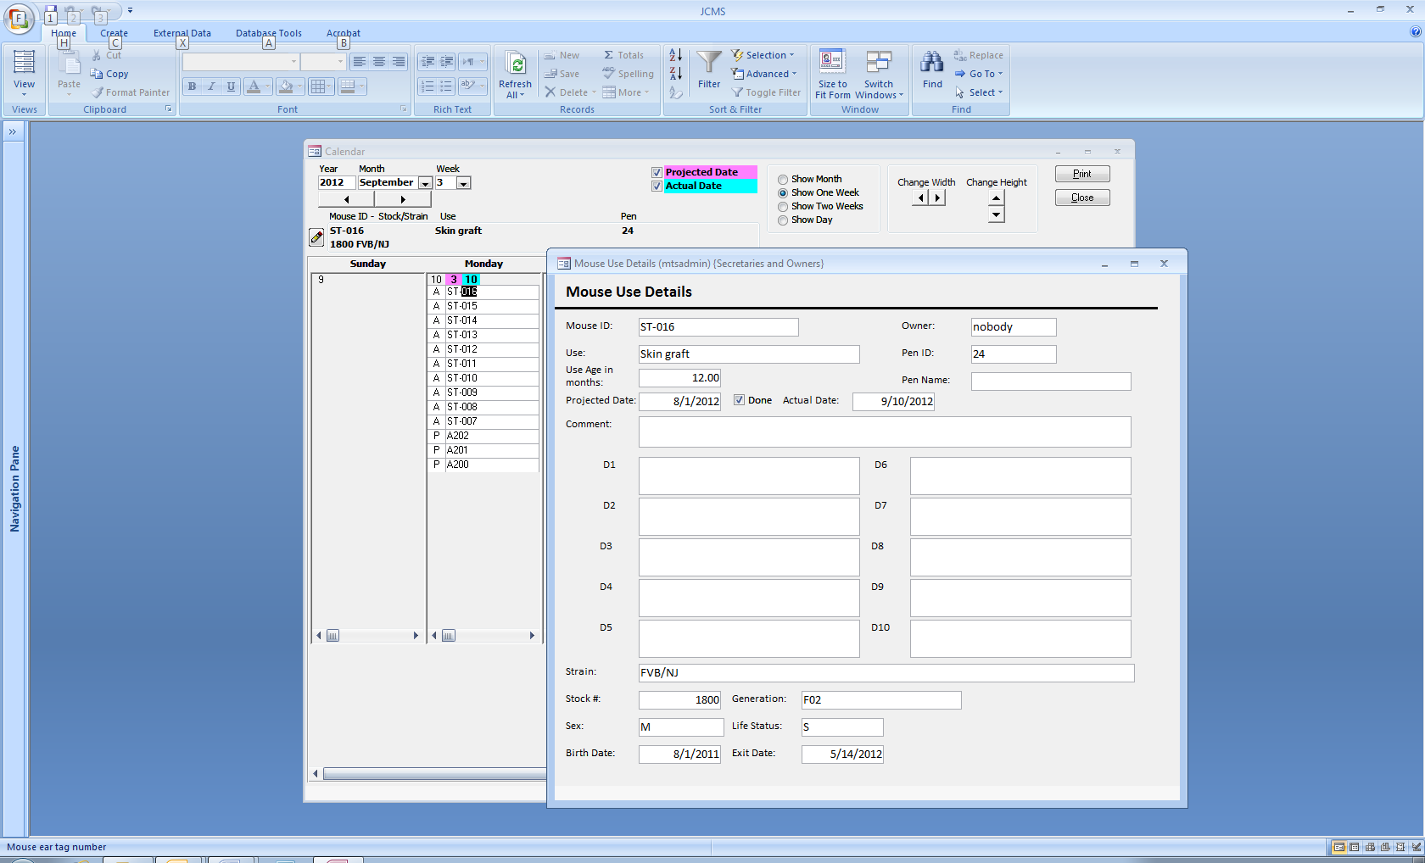

Figure ‑ Mouse use details form

## Print a Calendar Report

Use the Print button to obtain a report formatted for printing that shows all the rows on the calendar.

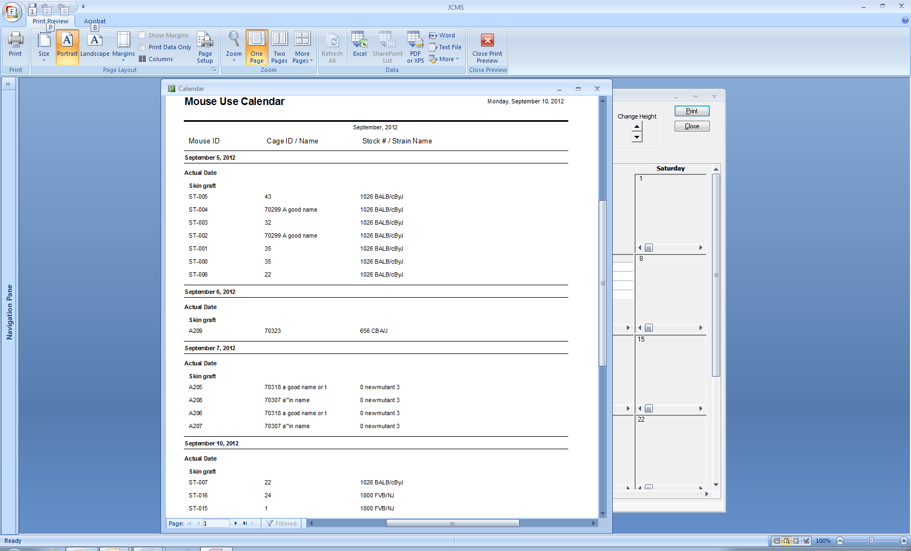

Figure ‑ Example of a calendar printout

### Suggestions for speeding up the calendar form

When the database is large, the calendar may take a long time to open. An active hourglass is visible during the wait for the calendar to display. To reduce the waiting time, try to limit the criteria to only one or two owners. The more owners included, the slower the search is to find all the mouse uses. Limit the criteria to only one or two mouse uses. Allow “any” strain instead of selecting certain ones.

# Documents

A document is a computer file, which may be associated with one or more IDs in certain JCMS categories, such as a mouse, sample, mouse genotype, experimental data, etc. In the first implementation of this feature, one or more documents may be associated with a mouse-genotype combination (a specific mouse ID and one of its genotypes). The description of this feature uses mouse genotype in the examples. Associations to other categories are now available.

## Document Storage

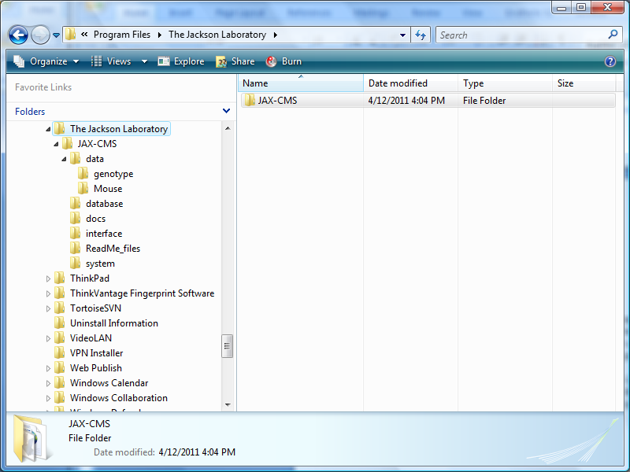Any file stored on the computer may become a JCMS document. JCMS does not incorporate the documents into its database. It moves a copy of the original file into a special “data” folder and maintains a link to the file in the JCMS database. JCMS allows the user to open the file by treating this link as a standard hyperlink, opening the file in the default browser or program depending on the defaults set on the user computer. This link will be broken if the user manually moves or deletes the file from this folder.

The JCMS Setup variable JCMS_DATA_FILE_DIRECTORY specifies the path to the data folder. This is the root directory where all JCMS document files are stored and it needs to be set before using this feature. Typically, the value of this variable is set to the directory where JCMS is installed, for example:

C:\Program Files\The Jackson Laboratory\JAX-CMS\data

Figure ‑ Possible data file setup for documents

The subfolders, such as *genotype* and *Mouse* shown in Figure 17‑1, will be created by JCMS when needed. All mouse-genotype documents are copied to the genotype folder, all documents associated with a mouse ID are copied to the Mouse folder, all documents associated with a sample ID are copied to the Sample folder, etc.

## Adding (Uploading) Documents

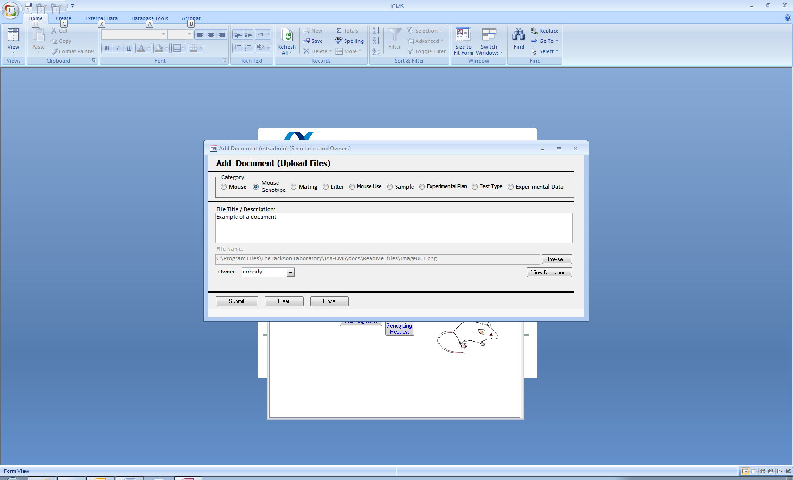

Figure ‑ Add document form

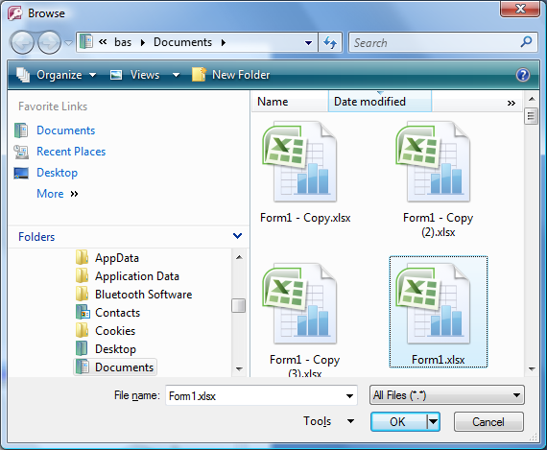When a document is added (uploaded) to a JCMS document folder, the file will be copied to the folder, given a title/description and assigned an owner. A document may be added from the Manage Mice tab by using the *Add Document* button. Documents added this way will not be associated yet to an ID.

The *Browse…* button is used to open a file browser window for selecting the file to copy. The *View Document* button is used to open the file hyperlink prior to copying it. The file will not be copied into a JCMS data folder until the *Submit* button is clicked.

Figure ‑ File browser

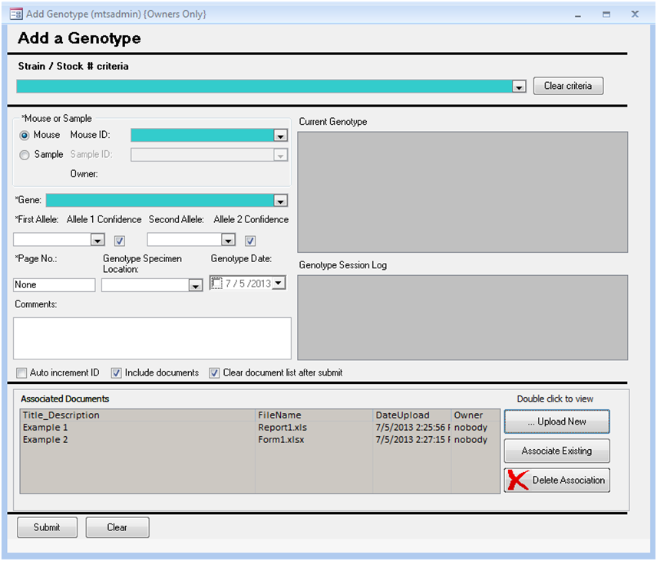

Figure ‑ Upload New button

An alternative method for adding a document and associating it with an ID is to use the …*Upload New* button on the Add or Edit form for the ID. This button will open the Add Document form, where one or more documents may be added. When the Add Document form is closed, those documents will be displayed on the Associated Documents list (example: Report1.xls and Form1.xls in Figure 17‑4.) All documents in the list will be associated with the ID (mouse-genotype in this case) when it is added using the *Submit* button.

## Selecting Documents to Associate

Once a document has been added to a document folder it may be associated to many different IDs by using the *Associate Existing* button on an add or edit form. This button opens the Associate Documents form. Several criteria may be used on this form to search for the appropriate document(s), including upload date, owner, and a text string in the file name or title/description. The *Search* button will fill the documents list with the matches. Select one or more documents in the list and click the *Associate* button. (If the search button does not work and MySQL is used for the database management system, make sure the setup variable JCMS_DATABASE_DBMS is set to MySQL.)

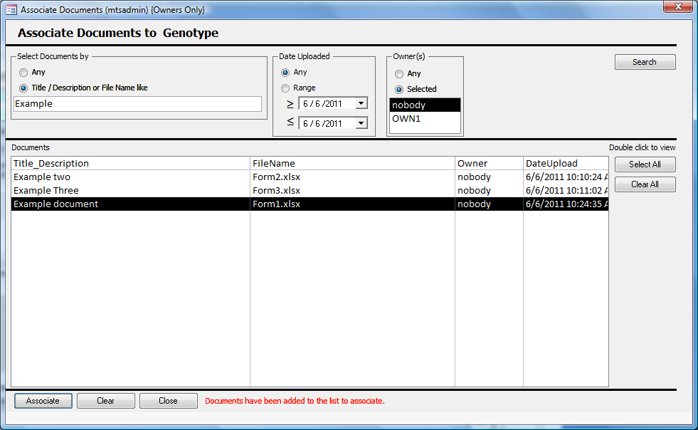

Figure ‑ Associate Documents form

This process may be repeated. When the Associate Documents form is closed, all documents that were selected will appear on the original add or edit form in the associated documents list.

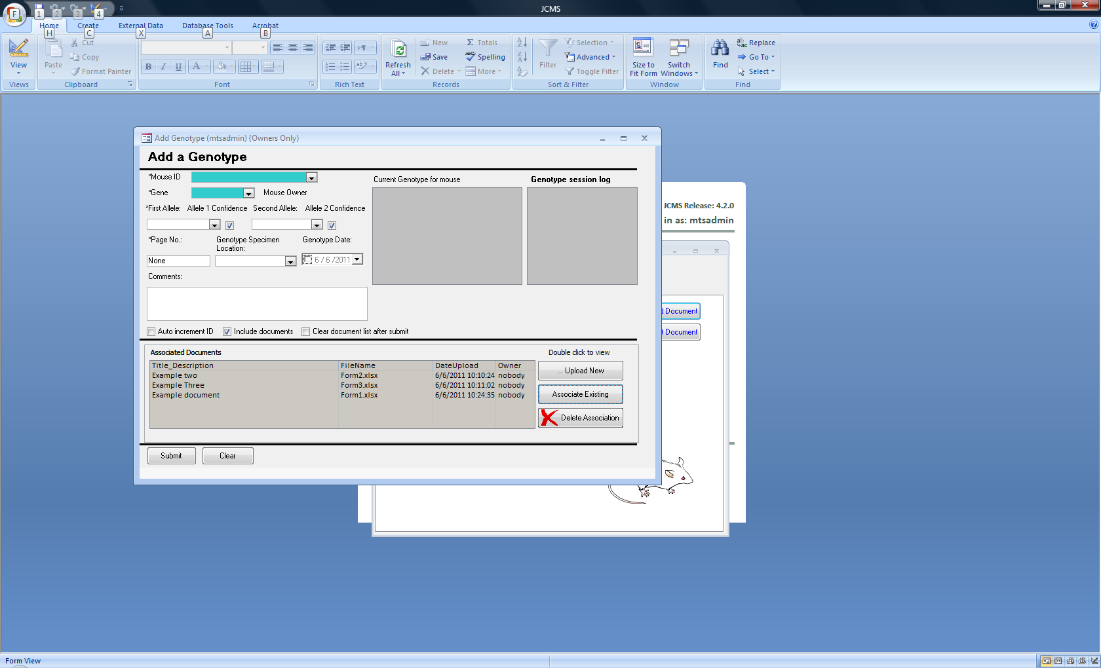

Figure ‑ Associate Existing button

The *Delete Association* button is used to remove documents from the list of associated documents. It does not delete the document.

Any changes to the associated documents list are not saved until the add or edit is submitted.

## Edit Document

Use the *Edit Document* button on the Manage Mice tab to open this form. It is used to change the document owner or file title/description. A *Search* button is provided at the top of the form to use in selecting the proper document by a combination of date uploaded, owner, category, or a text string in the file name or title/description. From the list of documents, choose one to edit by highlighting it and clicking the *Select* button. The *Submit* button must be used to save any changes.

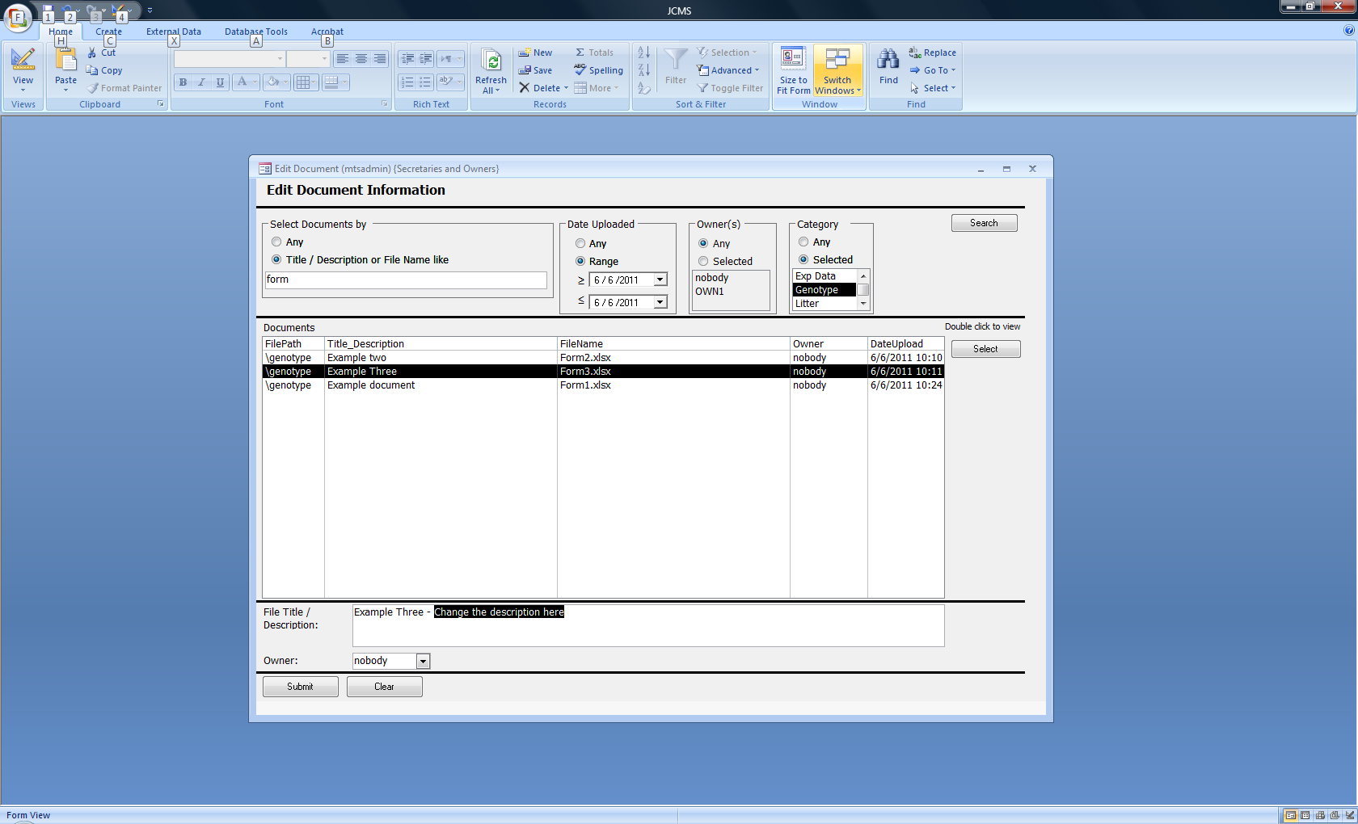

Figure ‑ Edit Document form

If the search button does not work and MySQL is used for the database management system, make sure the setup variable JCMS_DATABASE_DBMS is set to MySQL.

## Bulk Add Document Associations

The bulk add documents form allows adding associations between multiple documents and multiple IDs at once. It is opened from the Manage Mice tab.

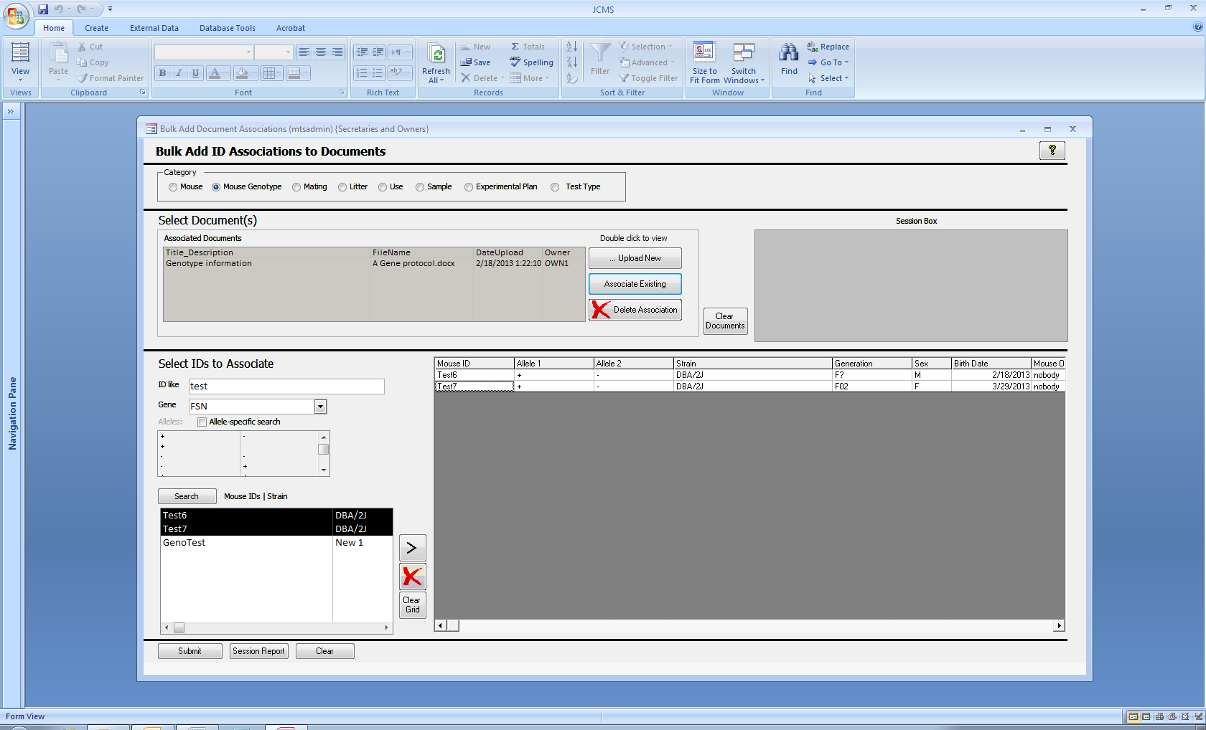

Figure ‑ Bulk Add Document Associations form

Documents may only be added to one category at a time. The select documents section works as described above for the add genotype form.

The select IDs to associate section will change depending on the selected category. It is used for entering criteria to fill the search list (bottom left of the form) when the **Search** button is clicked.

Select IDs to associate to the document(s) and use the > button to move them into the grid on the right side of the form. The red X button is used to remove the selected row from the grid. If no row is selected, the bottom row is removed.

Two categories, experimental plan and test type have drop down boxes that may be used to move the item directly into the grid. In the example below, selecting plan ID 2 has moved this plan into the grid.

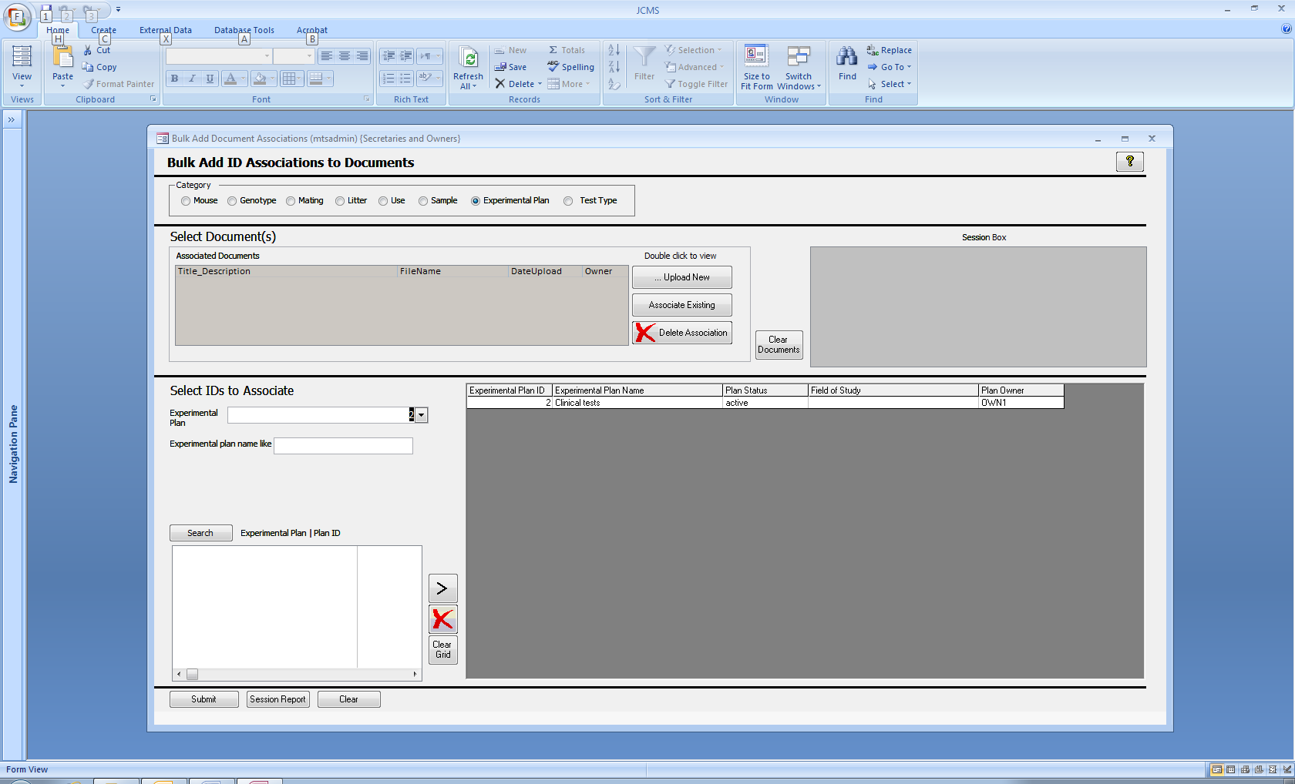

Figure ‑ Experimental plan category

Once all the IDs have been moved into the grid, use the **Submit** button to create the document associations. The session box and report will list associations that have been created and a second list of those that already existed.

Note that if a document will be associated with items from different categories, it will need to be uploaded once for each category.

# Queries

## Colony Summary Report

Some useful queries within JCMS are pre-packaged into reports. The Colony Summary Report is one of these.

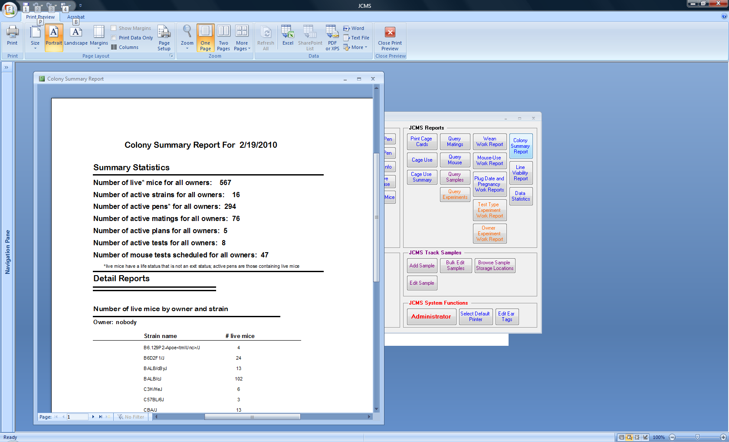

To invoke it click on the **Colony Summary Report** button on the reports tab.

The Colony Summary Report function produces a report that summarizes the state of the colony in a number of important areas. The report presents the information at a global level and additionally breaks it down in a detailed view by owner.

The report displays:

* total number of live mice
* number of active strains
* number of active pens
* number of active matings
* number of active experimental test plans
* number of active experimental tests
* number of mouse tests scheduled

Figure 18‑1 Colony Summary Report

Note: If mice in a pen have different owners, the pen will be counted more than once in the summary, once for each owner. Therefore, the total number of pens will agree with the sum of the number of pens each owner has.

## What are Queries used for? – or How to Search the Database

One of the most important functions of JCMS is to provide methods of searching for answers to specific questions about the data. The best way to obtain copies of the data entered into JCMS is by using one of the special query forms to set up a **search**. All searches have two parts, the question (criteria) and a description of the data to return (result fields to show).

### Basics on using the Query Forms

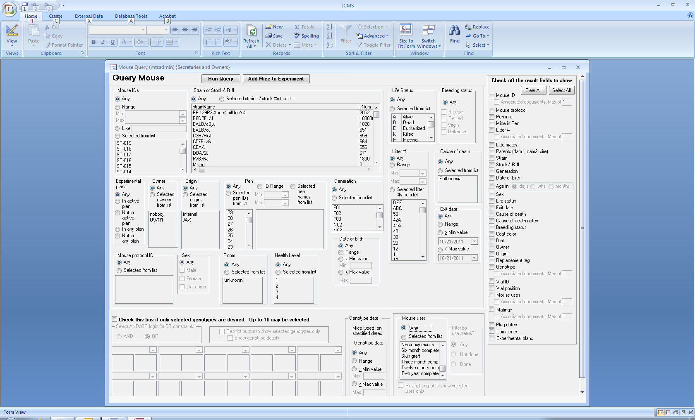

Figure ‑ Mouse Query Form

The above sample query form shows the general layout of the query forms. Each form provides many choices for the **criteria.** The criteria specify how to decide the data to return. Criteria that are not used are set to **Any**. These possible criteria are ignored. The second part of a query is to indicate what **result fields** to return. The query forms all have a set of check boxes on the right side listing choices of result fields.

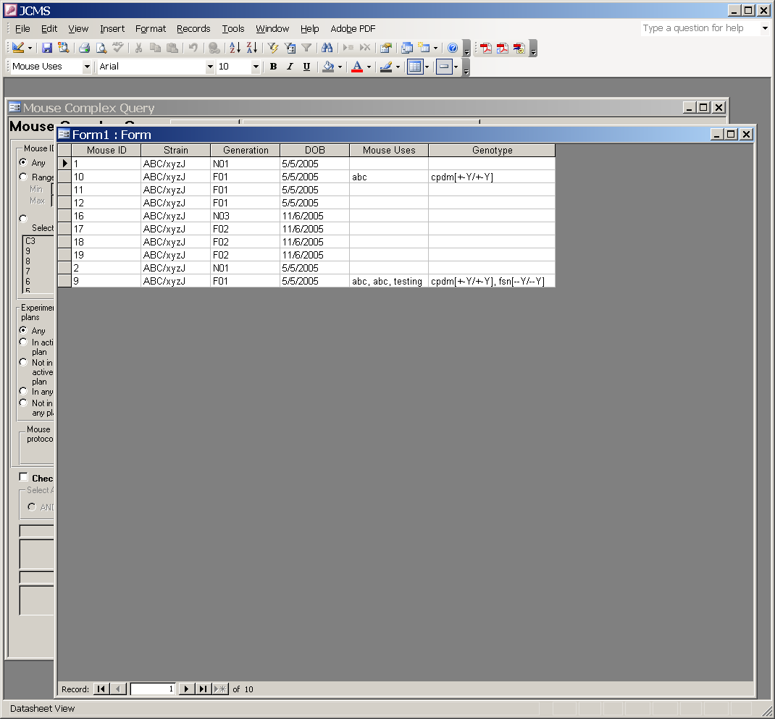

Figure ‑ Datasheet: Mouse Query Results

The Query forms allow extraction of information from JCMS into a datasheet form by clicking the **Run Query** button. This output of a query looks like a spreadsheet with a column for each result field, but it cannot be edited. The example above shows the results of a query asking for a particular strain. The datasheet can be easily **exported into Microsoft Excel** by selecting on the menu bar Tools – Office Links – Analyze it with Microsoft Office Excel (Office 2003) or selecting on the ribbon External Data – Export – Excel (Office 2007).

Figure ‑ Query: Do you want to save changes to Form?

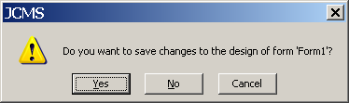The contents of a query form in JCMS cannot be saved between sessions. To keep the information from a query, be sure to export it to Excel before leaving the JCMS session.

When the datasheet form is closed, a prompt appears with the option to save the query form that has been created. However, saving the form in JCMS will not preserve the query information between JCMS sessions. It is best to NEVER SAVE A QUERY FORM IN JCMS. Always answer **No** to this dialog box.

### How to Select Query Criteria

Figure ‑ Query Form: List Box Criteria

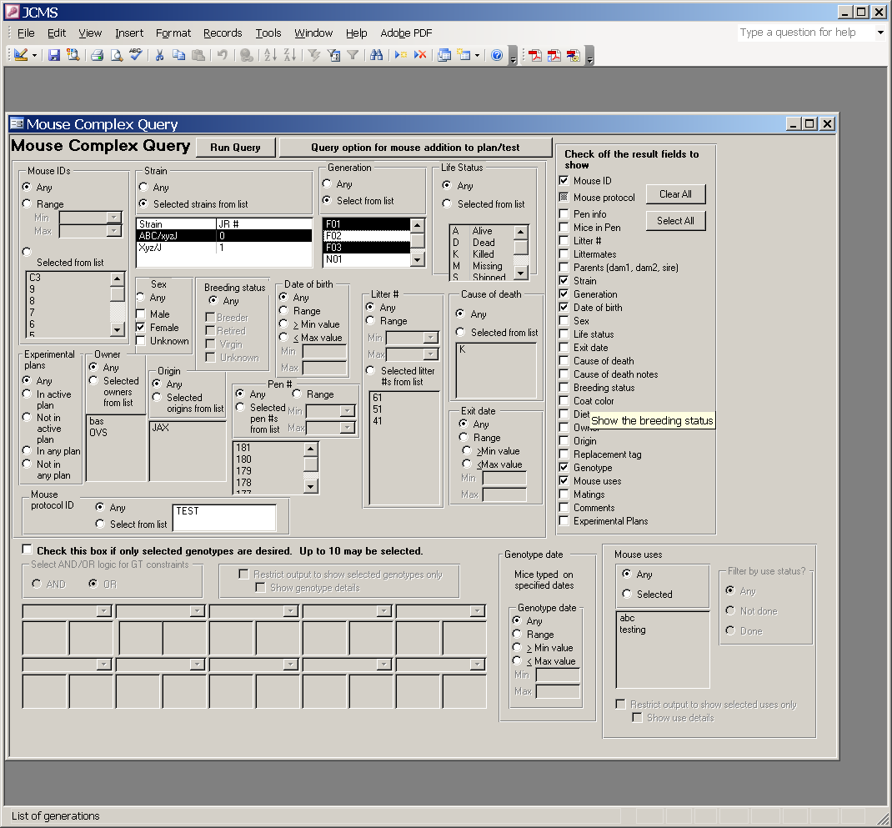For many of the criteria choices there is a list box and some push buttons. Push buttons allow specifying to select specific criteria items from the list box, or if you don’t care about a particular criteria item, select the “Any” button. Select individual items in the list box by holding down the control key (ctrl) on the keyboard and, while holding down the key, use the mouse to select individual items by clicking on them. A range of items may be selected from the list box by holding down the shift key while using the mouse to select the first and last in the range. If the ctrl or shift key is not held down, selecting an item from the list box clears all other selections.

The example criteria are: show all mice with generation equal to F01 or F03.

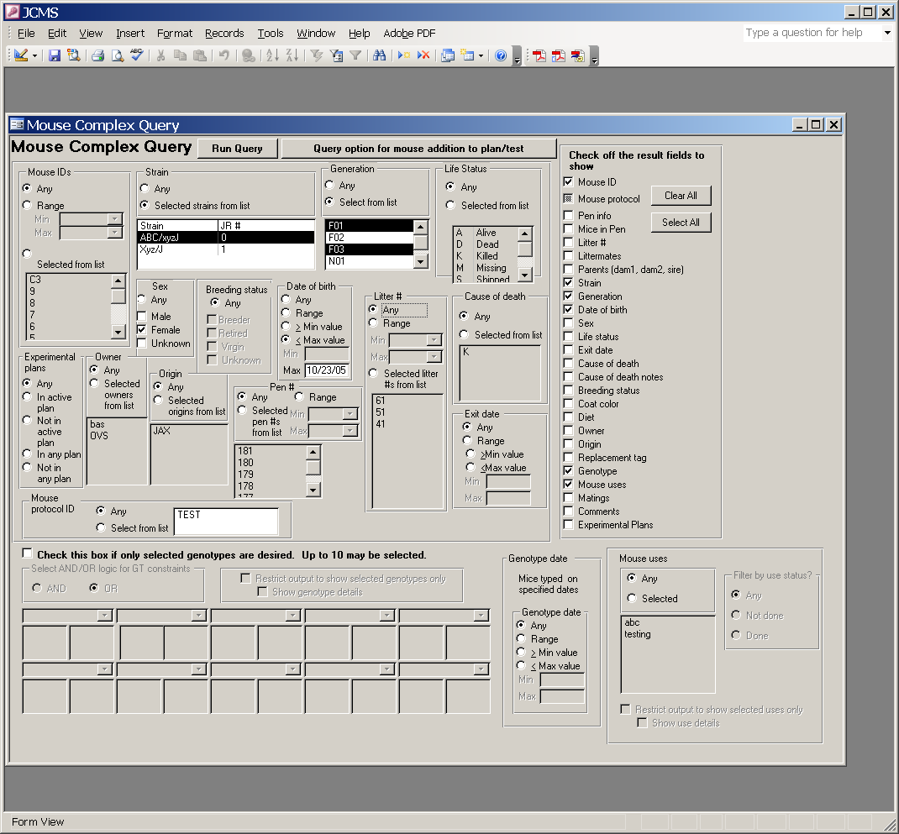

Another push button option is “Range.” Using this option allows specifying a minimum and maximum value or range of values for the query. Only mice between the minimum and maximum range, including the minimum and maximum values, will be included in the query results.

The example criterion is: show all mice with a date of birth less than or equal to 10/23/2005.

Figure ‑ Query Form: Range Criteria

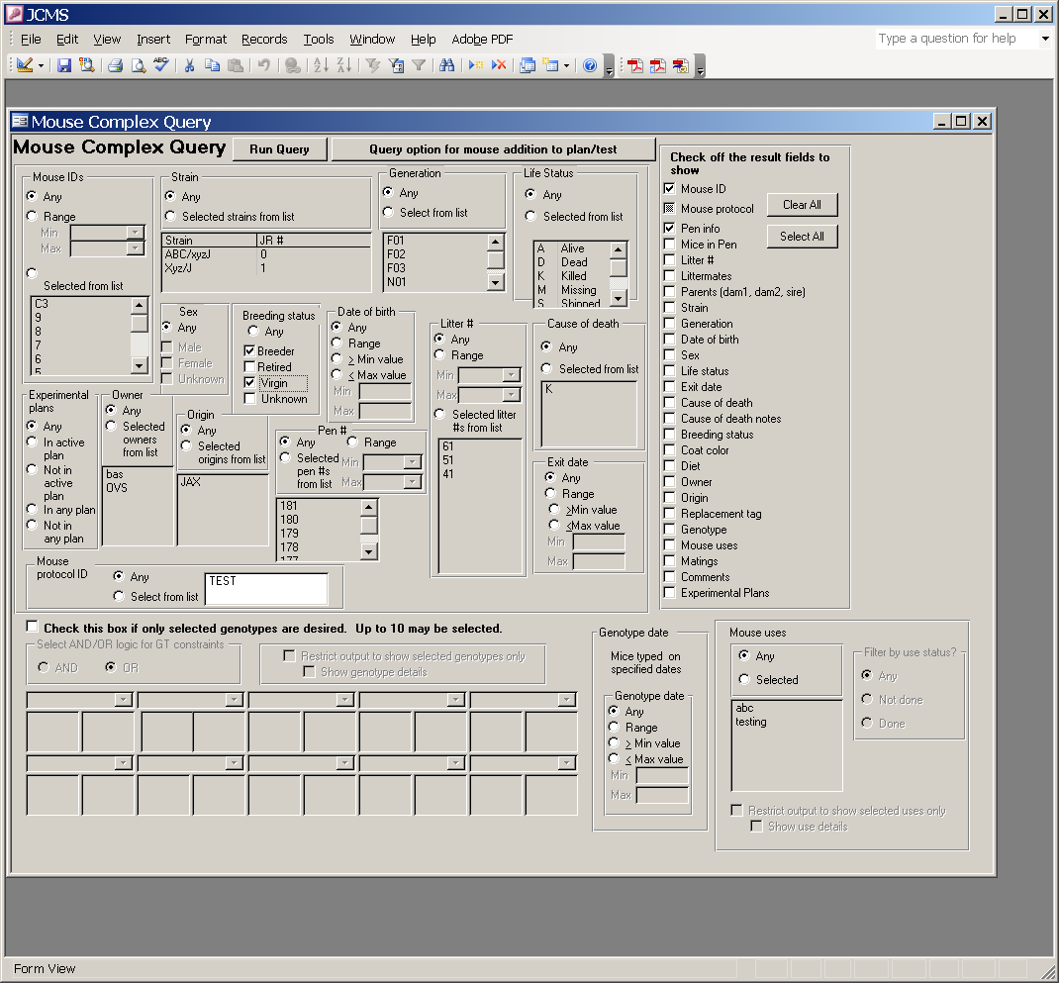Another type of criteria choice provides multiple check boxes. If the “Any” button is selected, no check boxes are available (they are all gray and cannot be clicked on). Click the any button to unselect it to make the check boxes white (available to choose). Multiple check boxes may be chosen or unselected by clicking on them with the mouse.

The example criteria are: show all mice that are breeders OR virgins.

Figure ‑ Query Form: Check Box Criteria

When more than one criterion is set to something other than “Any”, the criteria is put together using “AND” Boolean logic. If the three examples above were used the criteria becomes: show all mice with (generation equal to F01 OR F03) AND (a date of birth less than or equal to 10/23/2005) AND (are breeders OR virgins).

Click the **Run Query** button to see the results. The Clear all and Select all buttons will only clear the choices of result fields. The criteria choices must all be cleared individually by clicking the any buttons. Output result fields must be specified for the query. If no fields are selected, an error message will be displayed.

### Like Criteria for Mouse ID

Figure ‑ Query Form: Like Criteria

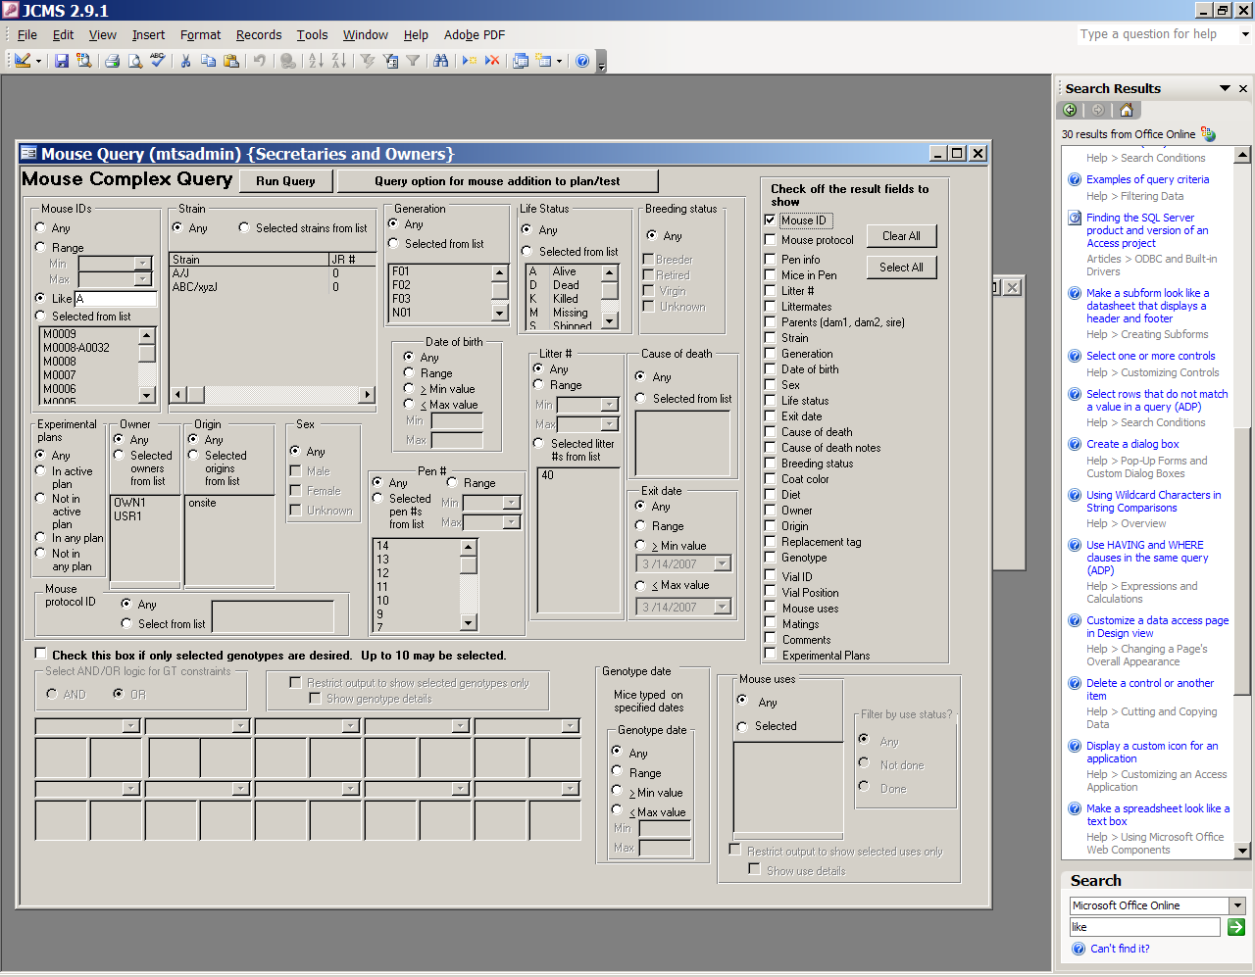The Like criteria will return all mouse IDs that contain the string entered in the text box. In the example shown in the figure, only M0008-A0032 will be returned. Entering “00” would return all of the mouse IDs shown in the list.

JCMS has converted the string entered in the Like box to *A*. Otherwise the criteria of A would return only one mouse whose ID was exactly A. If a leading or ending * is entered by the user, no * will be added by JCMS. This allows entering *A to return all mouse IDs ending with A and A* to return all mouse IDs beginning with A. Standard wildcards as described below will work in the search. The information below is from Microsoft Access Help.

Built-in pattern matching provides a versatile tool for making string comparisons. The following table shows the wildcard characters you can use with the **Like** operator and the number of digits or strings they match.

|  |  |
| --- | --- |
| **Character(s) in *pattern*** | **Matches in *expression*** |
| ? or _ (underscore) | Any single character |
| * or % | Zero or more characters |
| # | Any single digit (0— 9) |
| [*charlist*] | Any single character in *charlist* |
| [!*charlist*] | Any single character not in *charlist* |

You can use a group of one or more characters (*charlist*) enclosed in brackets ([ ]) to match any single character in *expression,* and *charlist* can include almost any characters in the ANSI character set, including digits. You can use the special characters opening bracket ([ ), question mark (?), number sign (#), and asterisk (*) to match themselves directly only if enclosed in brackets. You cannot use the closing bracket ( ]) within a group to match itself, but you can use it outside a group as an individual character.

In addition to a simple list of characters enclosed in brackets, *charlist* can specify a range of characters by using a hyphen (-) to separate the upper and lower bounds of the range. For example, using [A-Z] in *pattern* results in a match if the corresponding character position in *expression* contains any of the uppercase letters in the range A through Z. You can include multiple ranges within the brackets without delimiting the ranges. For example, [a-zA-Z0-9] matches any alphanumeric character.

### Mouse Age

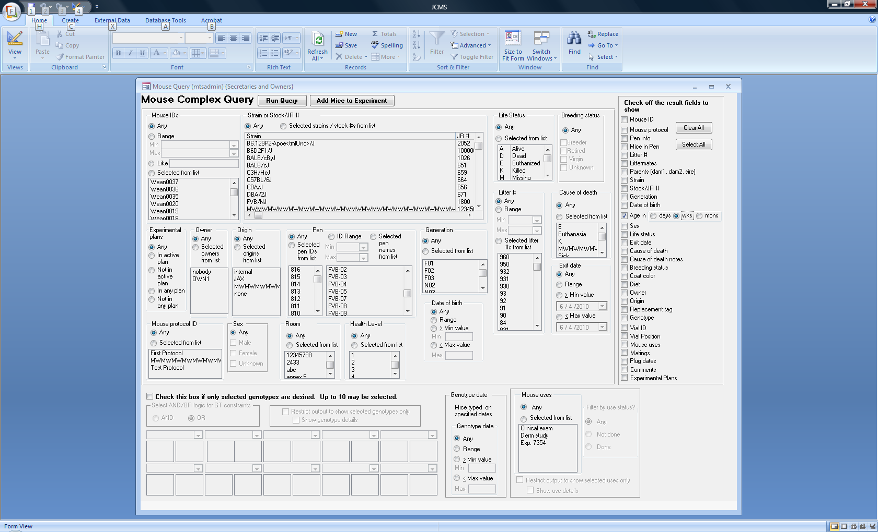The mouse age may be returned as days, weeks, or months depending on the selection. Two columns are returned in the results, one giving the mouse’s age today for non-exited mice and the second giving the mouse’s age on the exit date.

Figure ‑ Mouse age result choice

### Filtering Strains or Stock #’s

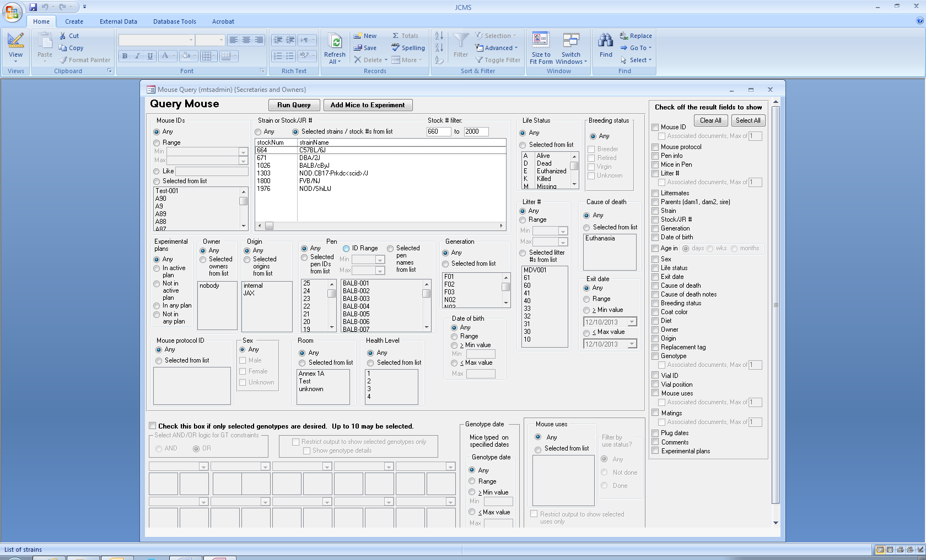A filter is available for the strain name/ stock # choices. When the setup variable JCMS_STRAINNAME_FIRST is set to false, a stock # filter is displayed. A range of numbers may be entered. If only one number is entered, the list will be displayed starting with it as the minimum stock # or ending with it as the maximum stock number. The strains are displayed in stock number order. When the setup variable is set to true, the filter works similar to the like criteria described above for the mouse ID. The strain names will be displayed in alphabetical order.

Figure ‑ Strain or Stock # Filter

## Mouse Query

The basics of using this query form are described above. Below is an explanation of how to use the genotype, documents, and mouse use portions of the mouse query form.

### Query by Genotype (QGT)

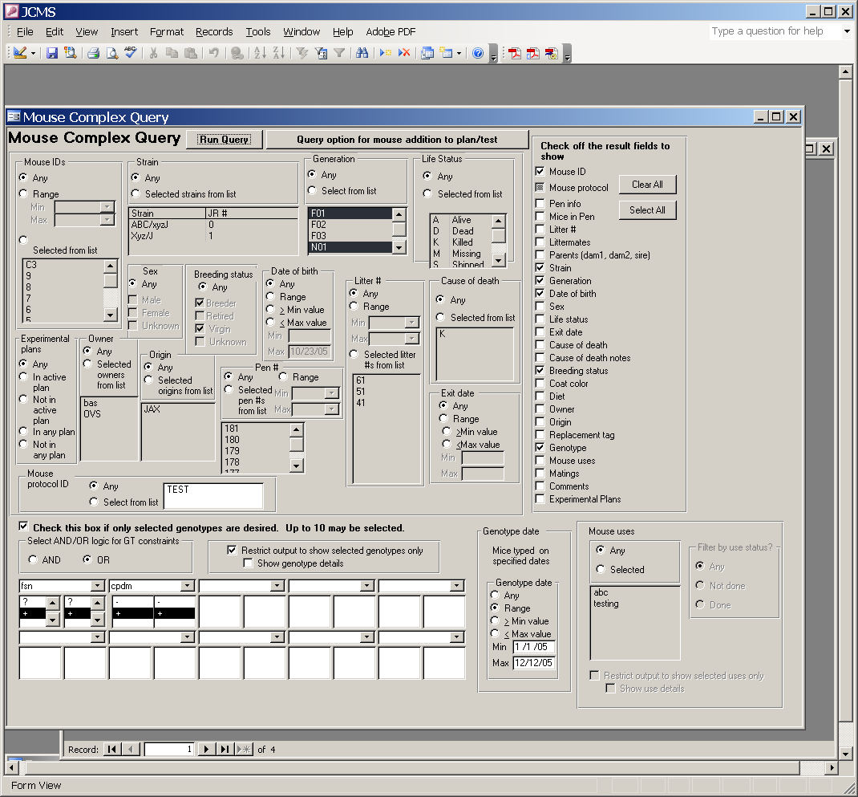

Figure ‑ Query Form: Genotype

As part of the mouse query, it is possible to query for mice by genotype. That is, select only those mice with a particular set of genotypes (up to 10 may be specified). To use the QGT option, first select the check box near the bottom of the form that enables this feature.

It is important to understand that QGT constraints have two levels: the Gene level, and the allele level. For each Gene, it is possible (but not required) to select one or two alleles that must be matched in order for the query to return results.

There is a choice of using AND logic or OR logic (use the push button just above the QGT selection boxes to choose a logic type) when combining constraints at the Gene level. But at the allele level AND logic is always used.

For example, suppose there are three genes X, Y, and Z. And for each of these genes there are allele possibilities x1, x2, y1, y2, y3, and z1, z2 where the letter “x” associates with gene X etc.

Using OR logic you could select all mice with genotype X(x1,x2) OR Y(-,-). The “-“ means you don’t care what alleles are associated with the gene. This selection would return all mice that have the specific genotype of X(x1,x2) and all mice that have been genotyped for gene Y. There can be overlap in the sets since a mouse could have genotype X(x1,x2) and also Y(y3,y2).

Using AND logic you could select for mice with genotype X(x1,x2) AND Y(-,-). Only mice that have both the specific genotype X(x1,x2) and have also been genotyped for gene Y will be found.

Mice shown may also be restricted by the date they were genotyped. The genotype date selection criteria will further limit the mice that are found to only those mice genotyped on a specific date or date range.

### Interpreting the Genotype Output

Any mouse may have zero or more genotypes. Each genotype is reported in the following format:

labSymbol[allele1-conf/allele2-conf]

Example: bax[1-Y/0-N].

The allele confidence is reported as “Y” for “yes,” we have confidence or “N” for “no,” we do not have confidence. The use of [] as gene separators and Y or N for gene confidence may be customized using the setup variables JCMS_ALLELE_GENE_SEPARATORS, JCMS_ALLELE_CONF_HIGH, and JCMS_ALLELE_CONF_LOW.

### Restricting Genotypes in the Query Output

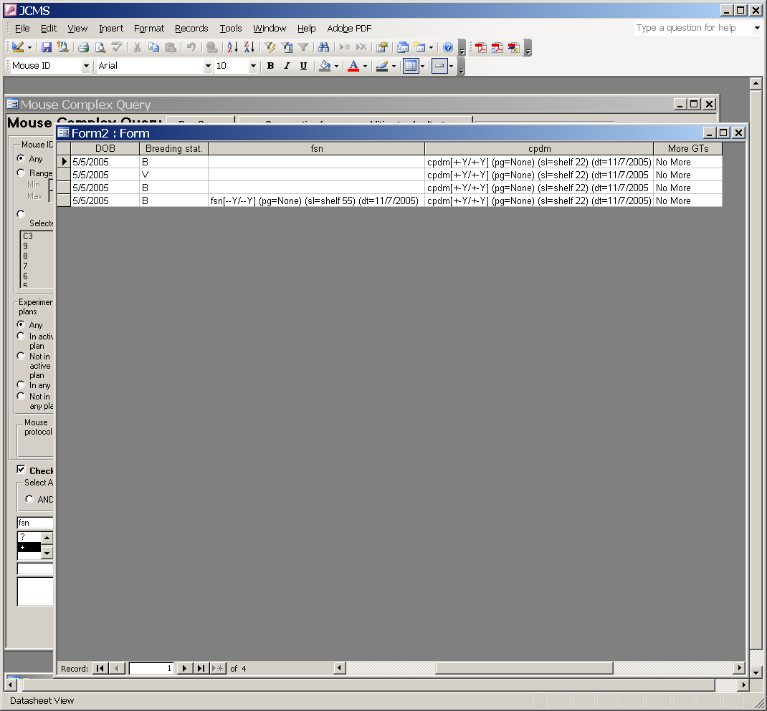

Figure ‑ Query Datasheet: Restricted Genotype Output

If the box for restricted genotype output is checked, only the genotypes for the genes selected in the genotype constraints will be output. When this option is used, each genotype is reported in a separate column in the output form. Genotype details, view the sample location, and page number for the sample may also be requested. Since a mouse may have been typed for more genes than those selected, a column is added to the output form that indicates if there are “More” genotypes for this mouse or “No More” genotypes for this mouse in the database.

Below is an example of a genotype with the genotype details; **pg** is page number and **sl** is sample location. sl=NONE implies that there is no information about sample location in the database. Also **dt** is the genotype date field. In this case the date was not stored in JCMS so it is listed a no date.

Sod1[1-Y/1-Y] (pg=g7-84) (sl=NONE) (dt=no date)

### Listing Documents Associated with Genotypes

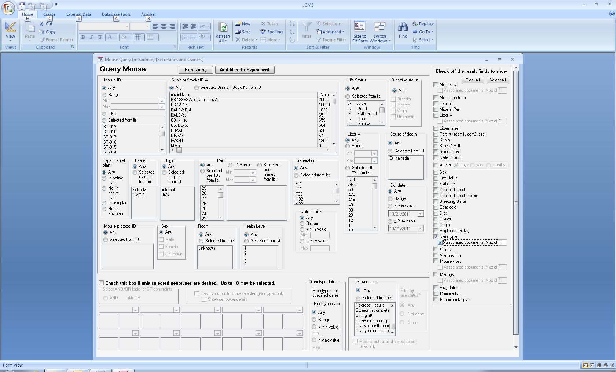

Documents associated with mouse-genotype combinations may be requested in the output only when genotype is also requested. Up to 10 columns of documents associated with a genotype may be requested. An extra column is added that will indicate if there are more documents than columns. For a search that lists multiple genotypes in one output column it is not possible to recognize that the same document is associated with several of those genotypes, possibly causing the document to be listed in more than one column.

Figure ‑ Requesting documents in the query output

### Listing Other Associated Documents

Documents associated with a mouse ID, litter #, mouse use, or mating may also be requested, up to a maximum of 10 per category. In order to list documents, the associated category must be checked. An extra “More Documents?” column is added that will indicate if there are documents that were not listed for a category. The full path to the document is returned as an active hyperlink, which may be clicked to open the document file.

### Query by Mouse Use

As part of the Mouse Query, it is possible to set up criteria for mouse uses. If multiple uses are selected the results will include all mice that have one of the selected uses (i.e. the uses are ORed together in the query). If the check box to restrict output to only the selected uses is checked, JCMS will put each selected use in a separate column (instead of putting all of the uses in one comma delimited list). Use details (such as comments) can also be shown this way. If a mouse has more uses than those displayed, the *more uses* column will have the word *more* in it. To be sure to see all uses for all mice selected in the query, the restricted output checkbox must be unchecked. Mouse uses must be checked in the results fields in order for the “restrict output to show selected uses only” check box to be enabled (see green circle). The “show use details” checkbox will not be enabled unless the “restrict output to show selected uses” box is checked.

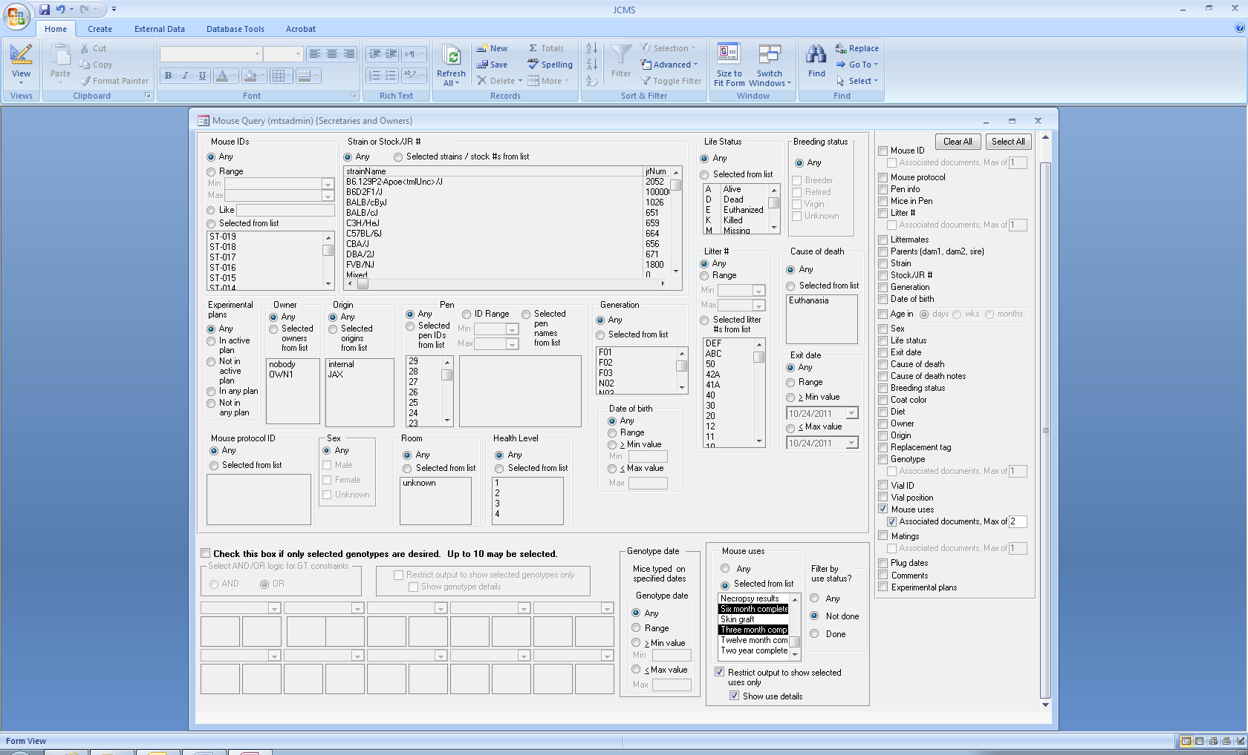

The output can also be restricted to show only mice that have selected uses that are *not done* or *are done*. For example, this feature can be used to show all mice that have not yet been tested for a specific use.

The use details use the following codes: UA for use age, PD for proposed date, comments, and DATA: D1=, D2=, etc for the data field values.

Figure ‑ Query Form: Mouse Use

User note: use the Mouse-Use Work Report button on the Reports tab to generate a report of all mice that are scheduled for use.

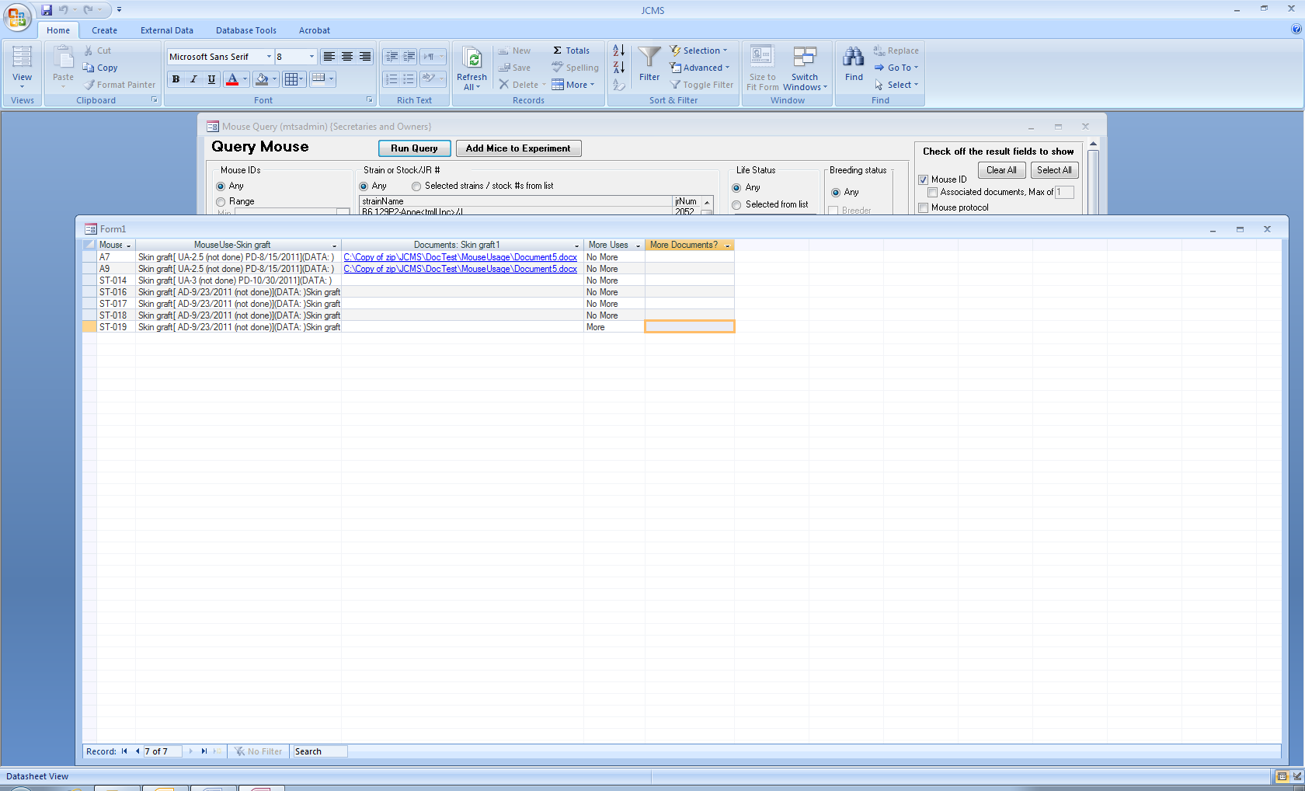

Figure ‑ Query Datasheet: Mouse Uses

#### Mouse query failure created by certain special characters in a mouse use type term

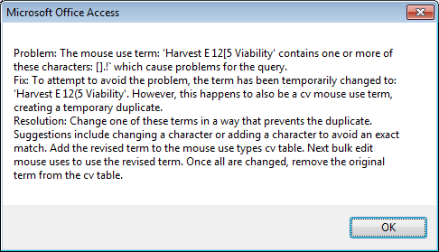

Figure ‑ Mouse query - use term error message

When a mouse use term contains one or more of these special characters: period “.”, left bracket “[”, right bracket “]”, exclamation point “!”, or accent grave “`”, JCMS replaces them in the column header of the output. No changes are made to the data. The message above outlines a rare situation where the character substitution will not work.

## Mating Query

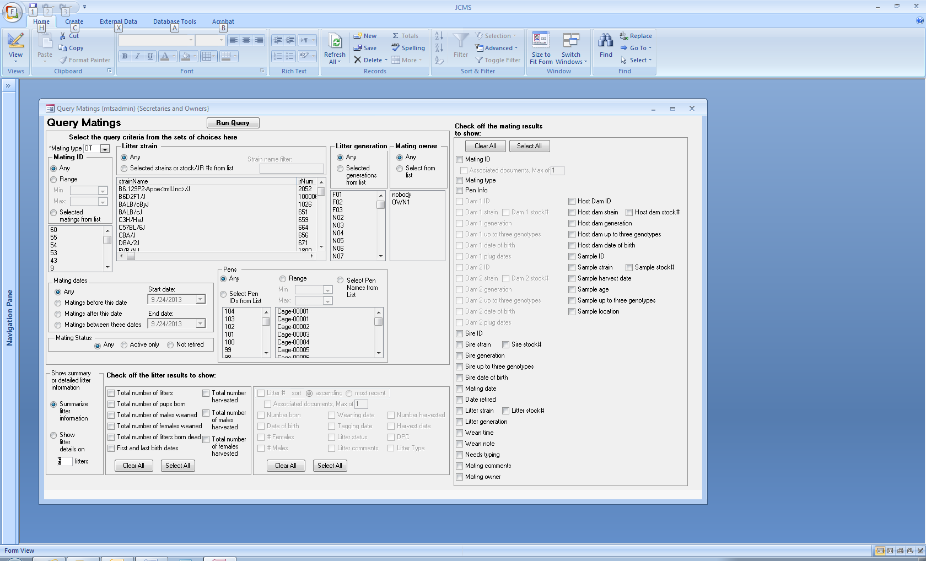

Figure ‑ Query Mating Form

The basics of using this query form are described above. The query is limited to showing only matings from one of the four mating types at a time: Natural (N), Embryo Transfer (ET), Ovary Transfer (ET), or In vitro Fertilization (IVF).



The results section column on the right will change so that only the pertinent result choices may be selected.

In addition to the normal results field column on the right of the form, the mating query has a special results section at the bottom of the form for checking off the litter results to show. Choose either summary litter information or detailed litter information.

Figure ‑ Mating type selection

WARNING: in the litter detail section it is possible to choose to view information on up to 10 litters. However, it is important to understand that if all fields are selected for 10 litters of detail information, the output form will have over 100 columns on it. This can get unwieldy very quickly and it might overload the system resources. If it is necessary to view a high number of litters, then be sure to select only one or two fields for output in the litter detail section. 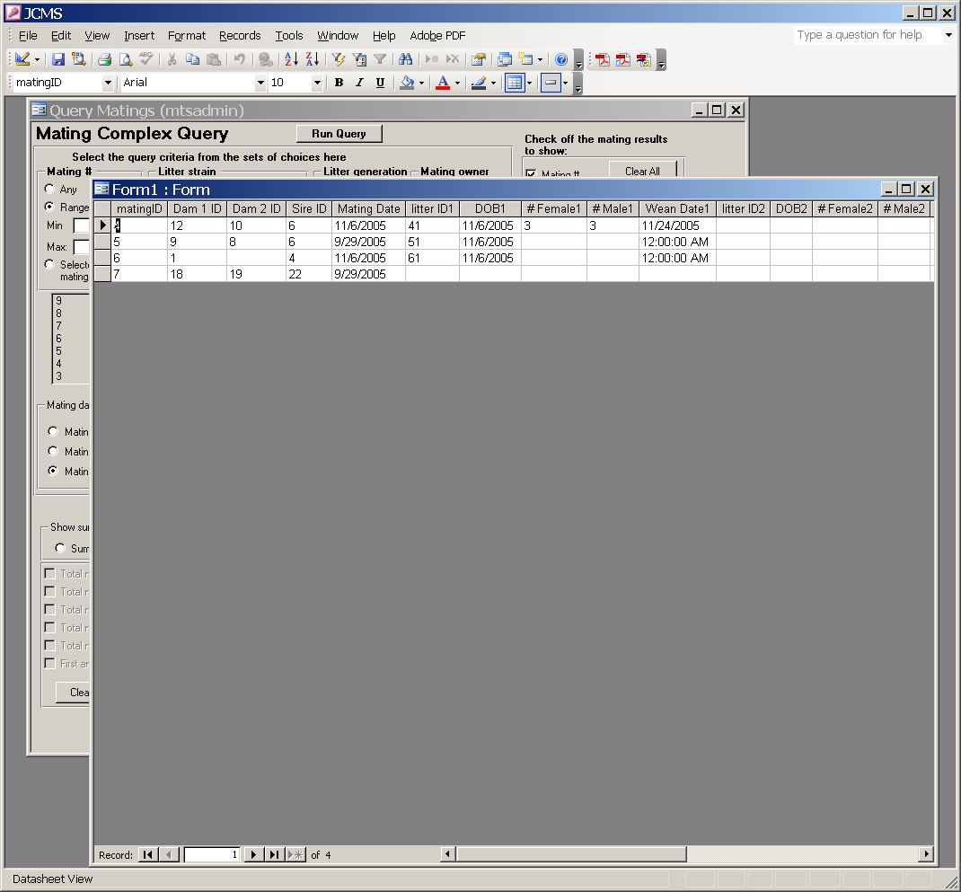

Figure ‑ Query Datasheet: Mating

## Experimental Data Query

The basics of using this query form are described above.

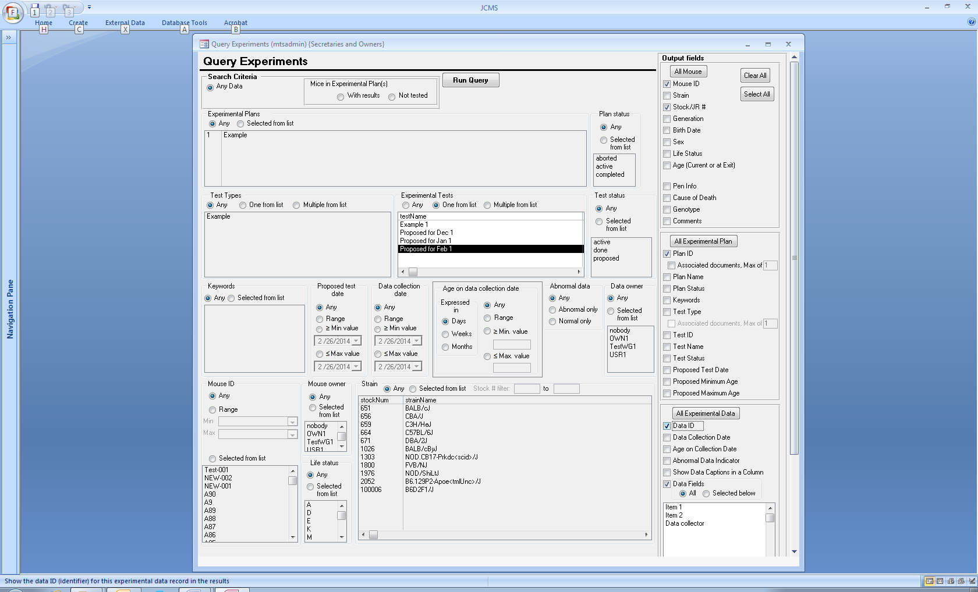

Figure ‑ Query Experiment Form

This form offers three choices when selecting the criteria:

1. Any data. Results will be returned for all mice that have experimental data records associated with them. This can result in a mixture of results that include data from experimental plans and data records that are not part of experimental plans.
2. Mice in experimental plan(s) with results. The results will only include mice that have experimental data records AND are part of an experimental test. The rest of the criteria should specify the experimental test(s) and other choices. The possible choices have been limited to eliminate those that would cause a conflict. For example: an experimental test is always part of only one plan, therefore it is not possible to choose a plan name as this plan might not include the test that was chosen, a situation that would yield no results. If experimental test is left set to “any” then other criteria such as a range of mouse IDs or test status may be specified. This will yield all mice with data records that fit the criteria AND which are part of some experimental test.
3. Mice in experimental plan(s) not tested. This will give results for all mice that have been pre-selected for the experimental test, but have NO DATA RECORD for that test. No criteria except the one test may be specified. The output result field choices will not include the “All Experimental Data” section.

When only one test type is specified in the criteria, it is possible to choose output results using a data caption list instead of the generic D1, D2, D3, etc. list. To see the data result captions as a column header make sure to use the “Data Fields” option. If the query criteria options create a mixture of test types, the results may have different types of values in the D1, D2, D3, etc. list. In this situation, check “show data captions in column” so the caption will appear in the results in a column next to the data value.

### Documents Associated with Experimental Data

An experimental plan and test type may have documents associated with them. These documents may be requested as output fields, up to a maximum of 10 per experimental plan or test type. In order to list documents, the associated category (plan ID or test type) must be checked. An extra “More Documents?” column is added that will indicate if there are documents that were not listed for a category. The full path to the document is returned as an active hyperlink, which may be clicked to open the document file.

A test type may have a result field defined with the format of “file” indicating that the information stored in that field is a document. All data results are displayed formatted with the standard blue underline used for a hyperlink. However, only actual file paths will act as a hyperlink. If the color is annoying, the underline and color of a column in the datasheet may be changed by using conditional formatting. In Excel they may be changed by changing the cell formatting.

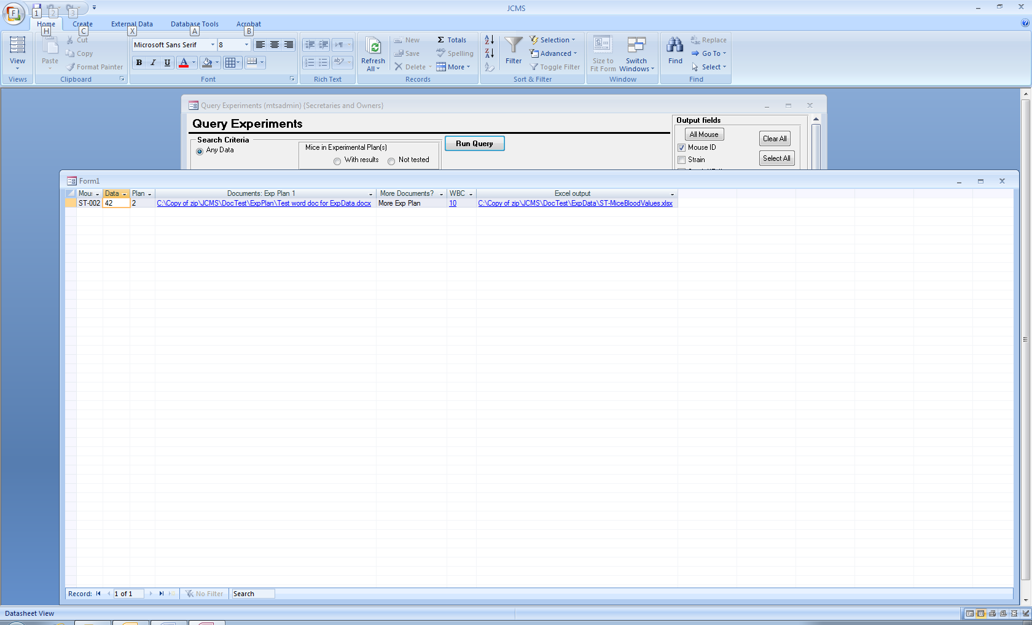

Figure ‑ Experiment Query Datasheet

In the figure above, one document associated with the experimental plan is shown. The “More Documents?” column indicates this plan has other documents associated with it. Two data results columns are show. “WBC” and “Excel output” are the captions for these data results.

## Sample Query

This query is described in the Samples section 20.6.

## Microsoft Query

Microsoft Query (MS Query) may be used to select data from an "outside source" such as JCMS and bring it into MS Excel. In this case, MS Excel must be set up to ask for data from a Microsoft Access database named JCMS.mdb. See Microsoft’s documentation for information on using MS Query.

# Experimental Plans

JCMS provides a method for defining experiments conducted using the mice within the database, setting up definitions for the various experimental tests, data, and data defaults, and recording experimental results. It can also be used to setup, track, and schedule mice for use in the experiments.

The following tables are used:

Figure ‑ Diagram: Experimental Plan Tables

**Mouse**

**Experimental Plan**

**Experimental Data**

**Experimental Test**

**Test Type**

**Experimental Data Defaults**

**Experimental Data**: One experimental data record consists of a set of data results for a mouse. A mouse may have many experimental data records, each one for a different test. Each experimental data record has to have an associated test type record that defines the format of the data results. Usually, each data record is associated with a test within a plan. However, it is possible to create data records that are not associated with a plan/test.

**Experimental Plan**: A definition of one experiment or project, referred to as the plan. The plan is used to coordinate the tests, mice planned for use in a test, and results. Each plan may have many mice scheduled to be part of it. Conversely, a mouse may be scheduled into many plans.

**Experimental Test**: One plan usually consists of several different tests (procedures). Some tests will be repeated multiple times perhaps using different sets of mice or with changes in protocol. JCMS considers each repetition a separate experimental test. Each test may have many mice scheduled to be part of it. Conversely, a mouse may be scheduled into many tests. A test must have one plan associated with it and one test type. The test type defines the format of the data results for this test. A test may have many experimental data records (results) associated with it, one for each mouse scheduled for the test.

**Test Type**: To make the repetition of tests easier, JCMS allows the user to define each type of experimental test used. This test type and data description includes a specific definition of the data collected. Up to 30 different result fields may be collected per mouse as part of one test. Each result field may have specified a meaningful caption, maximum value, minimum value, format (date, numeric, text, or file), and whether or not it is required.

**Experimental Data Defaults**: Sets of default values for particular test types may optionally be defined to help with data entry of the experimental data results. Data defaults are associated with only one test type.

Experimental data may be recorded without an association to a plan and test. However, all experimental data must be associated with an experimental test type in order to define the data result fields.

An experimental plan may have mice pre-selected for it for planning purposes. An experimental test may also have pre-selected for it a subset of the mice selected for the plan. One mouse may be selected for multiple tests within a plan and may also be selected for other plans.

## How to use an Experimental Plan



Figure ‑ Diagram: Experimental Plan

The experimental plan flow shown above is what the user will normally work with. The plan and tests will be defined. Mice will be scheduled for the various tests. Experimental data is collected and entered for the mice. Finally, reports and spreadsheets are output based on the mice and data collected.

Behind the scenes, some things have to be defined to set up the flow above. Each step is defined in detail below. The general plan definition and execution process includes:

* Define the **test types** that will be used for the tests in the plan. Once a test type is created it may be used over and over again within this and other plans. The test type defines the data results fields to be collected.
* Define the **data default** values for the test type. These values are sets of expected or standard results for some or all of the data result fields. They are used to help with data entry. These may be created at any time during the life of a plan. There may be several choices of data defaults created for a test type.
* Create the **experimental plan**.
* Create **experimental tests** for this experimental plan using the pre-defined test types. Each experimental test includes information about the proposed date, projected number of mice and ages of the mice. A specific test type may be used repetitively for different groups of mice, different dates, and/or different ages.
* **Schedule** mice into the plan and various tests. Scheduling mice is optional, if mice are not pre-scheduled, they will be automatically entered into the plan and test when the data for the mouse is entered.
* Print the **experiment work report.** This report is used to list what tests are scheduled for a particular time period.
* Enter the **experimental data** results.
* Use the **experiment query** to export results into MS Excel, determine mice that have not had the data results entered yet, and answer any other questions about the status of experimental plans, tests, or data.

## How to Create Experimental Data without using an Experimental Plan

It is possible to enter experimental data for mice into JCMS without going through the process of creating experimental plans and tests or scheduling mice. This process includes:

* Define the **test types** that will be used for the data results. Once a test type is created it may be used over and over again. The test type defines the data results fields to be collected. Pre-defined test types for a plan may also be used to create experimental data records outside of a plan. However, it is not possible to use default values for the experimental data without having an experimental test record.
* Enter the **experimental data** results.
* Use the **experiment query** to export data results into MS Excel and answer questions about the experimental data.

## Setting up Test Types (Data Descriptions)

The test type and data description must be created before experimental tests or experimental data results can be added to an experimental plan. Even if an experimental plan is not used, the test type must be created before experimental data results may be entered. Once the test type is created, it may be reused for this or other experiments and data results.

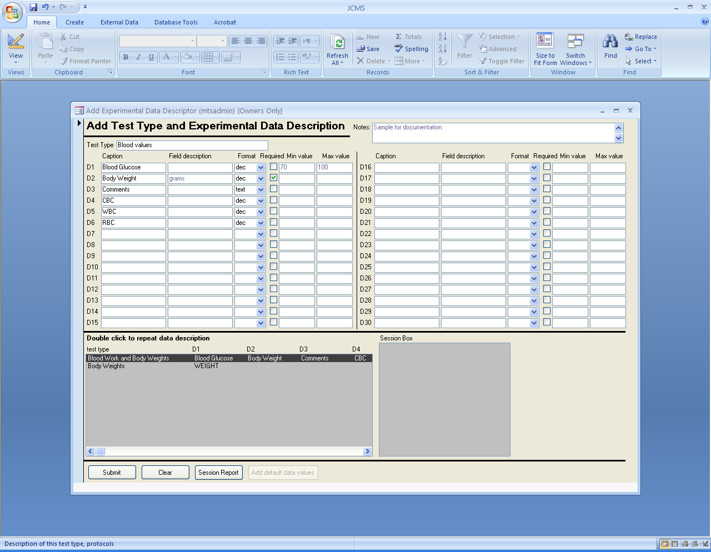

Figure ‑ Form: Add Test Type

Click the **Add Test Type – Data Description** button to open the form. This form may also be opened by clicking a button on the Add an experimental test form. Only owners or an Administrator may create test types.

Use a brief but meaningful name for the test type, up to 32 characters long. This name must be unique (not used by any other test type). Use the notes field to enter a description of the test, protocols, etc. The description may be as long as needed. Up to 30 data result fields may be defined. These are labeled D1, D2, D3, etc. on the form. The results will later be entered into an experimental data record using this description to validate them. For each data result field, enter the following:

* Caption: Used on the forms as the “name” of the data to enter. Use a short but meaningful caption, up to 32 characters long.
* Field description: An optional short description of the result field. The description might indicate the units such as cm, gm, etc. or the expected text entries such as yes/no or mutant/control. It may be up to 32 characters long.
* Format: Select text, date, file, integer, or decimal value. The format will be used during experimental data entry to check for errors. For example, when the data results are entered, if a numeric format is chosen no text or special characters will be allowed except for the normal ones associated with numbers (- +. ,). The “file” format is used to associate this data result field with a document (computer file such as an image, spreadsheet, word document, etc.)
* Required: Indicates if the field is required or not during data entry. By default, fields are not required.
* Min value: Optional field. When experimental data is entered, numeric data may not be less than this minimum value.
* Max value: Optional field. When experimental data is entered, numeric data may not be greater than this maximum value.

A list box at the bottom of the form shows test types that have already been defined. If the test type to add is similar to an existing one, double click it in the list box. The values for that test type will be repeated on the form. These can then be changed and submitted for the new test type.

After successfully submitting a new test type, click the “Add default data values” button to set up any defaults that would help with experimental data entry.

## Editing a Test Type

Click the **Edit Test Type** button to open the form. This form looks and works in the same manner as the Add test type form. New data result fields may be added to an existing test type and changes to fields may be made only if no experimental data or test type defaults exist for this test type. A test type may be deleted only if there is no experimental data in the database for this test type, no experimental tests that are using this test type, and no default data records for it.

## Setting up Default Data for Experiments

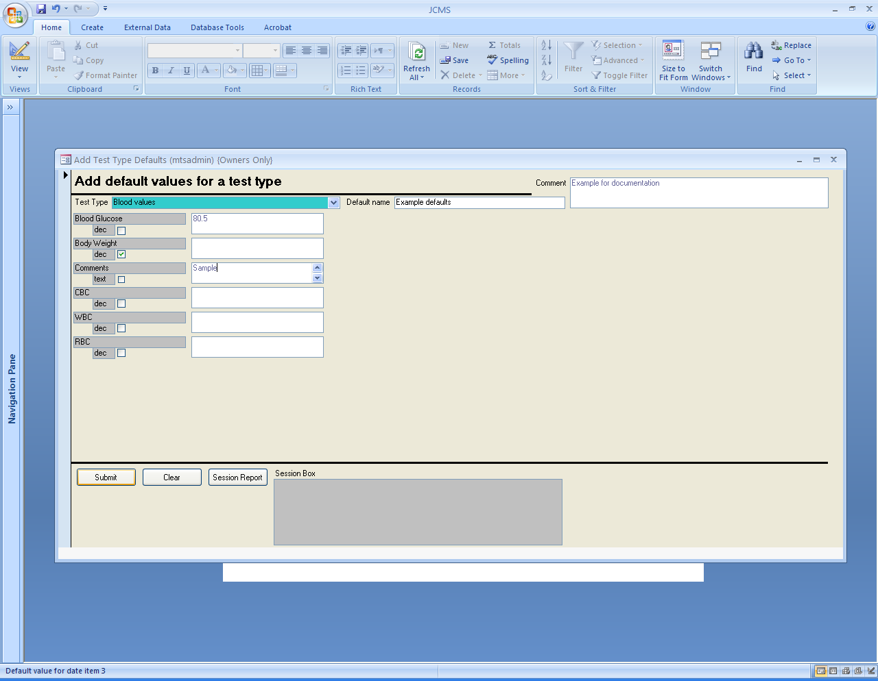

Figure ‑ Form: Add Test Type Defaults

Click the **Add Test Type Defaults** button to open the form. The Test Type defines the different data fields used for an experimental test. The test type data default values define a set of standard results that might be expected. Several data default records can be created for one test type. Each will contain one set of possible default results. There does not need to be a default value for each data value field. One of these sets of standard results (data defaults) can be selected at the creation of an experimental test. These defaults are then used when experimental data is entered to speed up the data entry process. The values that are specified have to fit within any minimum, maximum, or format that is defined for the data field. No data field is required to have a default value.

When experimental data is entered, the data defaults are displayed on the data entry form, where they may be edited to change any values that differ from the defaults.

Only the plan owner or the Administrator may create the data defaults.

## Editing Default Data

Click the **Edit Test Type Defaults** button to open the form. Only the Administrator may edit or delete a test type data default record. Any edit changes made to a data default will not automatically change any experimental test that is already using this data default. That experimental test will still contain the old defaults. To change these in an existing experimental test, edit that experimental test and select the defaults again from the list of possible data defaults.

## Adding an Experimental Plan

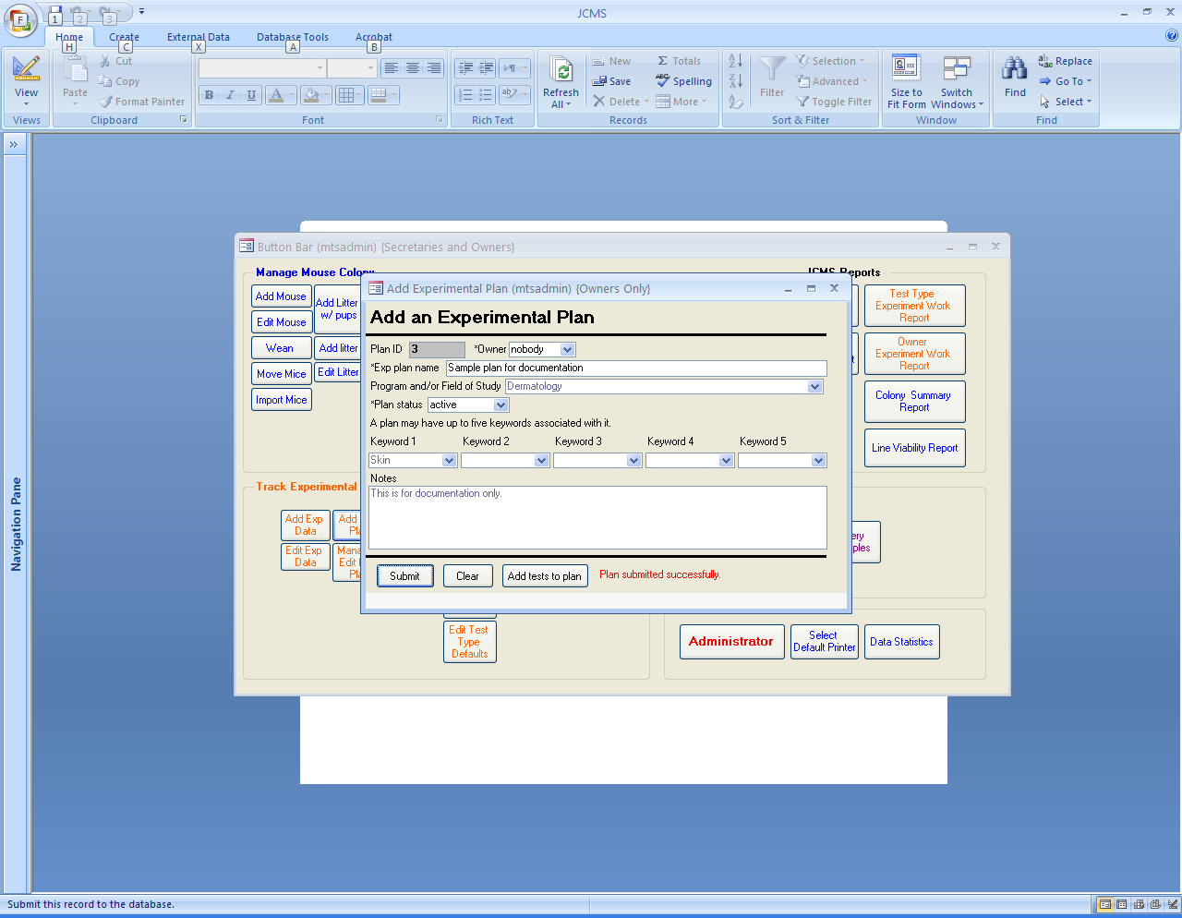

Figure ‑ Form: Add Experimental Plan

Click the **Add Exp Plan** button on the experiments tab to open the form. The plan ID number will be assigned by JCMS. All experimental plans must have an owner. All experimental data generated for this plan will be assigned this same owner. All plans must be given a name and status. The program and/or field of study and keyword fields are provided so the user may later query for plans using this information. The Administrator sets up the choices for these fields.

## Adding an Experimental Test

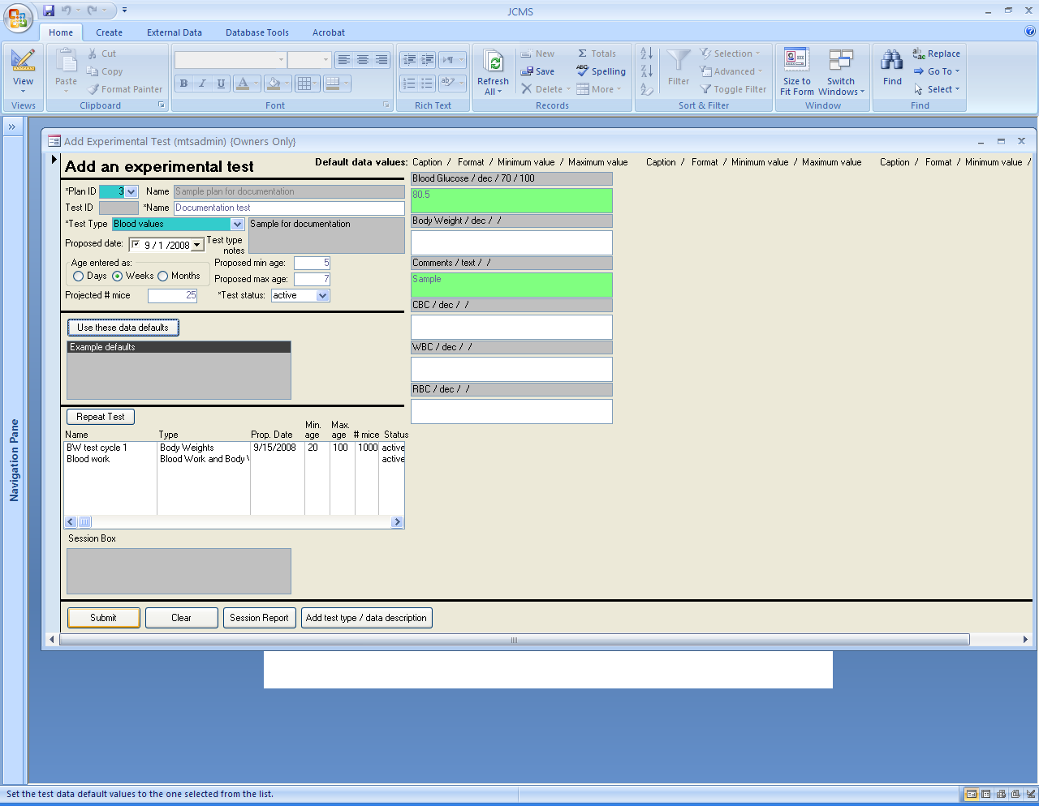

Figure ‑ Form: Add Experimental Test

Click the **Add Exp Test** button to open the form. This form may also be opened from the Add an experimental plan form or Manage an experimental plan form. Only owners and the Administrator may add experimental tests.

An experimental test is always associated with only one experimental plan. Start by **selecting the plan**.

In order to re-use existing tests (even from other plans), you can select a test from the white list box on the lower left hand side of the form and click **Repeat Test**.

Then enter a unique test name of up to 32 characters. JCMS will assign a test ID. Choose the test type. JCMS will then display the captions for the data value fields and any choices for data defaults.

Several fields are used to track the progress of the experiment including the current test status, a proposed date for the test, projected number of mice to use, and a suggested minimum and maximum age for the mice. This proposed age range may be entered in days, weeks (7 days/week), or months (30.4375 days/ month).

The caption, format, min and max values used to define the data results to be collected for this test type are displayed on the form. To help with data entry, default values for these data result fields may be entered. These default values may be chosen from a list of previously created data defaults: select the default name and click the “Use these data defaults” button on the form. Changes may then be made to the default data values to customize them for this test. A default value may not be specified for the “file” format.

## Editing an Experimental Test

Click the **Edit Exp Test** button to open the Edit Experimental Test form. Only owners and the Administrator may edit experimental tests. This form looks and works in the same manner as the Add Experimental Test form. Select the experimental test by its name and ID number. The experimental plan the test is associated with may not be changed. The test type may not be changed once experimental data exists for this test. The delete button to remove a test from an experimental plan will only function if there is no experimental data for this test and no mice have been selected for the test.

## Selecting Mice for an Experimental Plan

Three different methods may be used to select mice for experimental plans and tests.

1. The simplest method is to add the mice to the plan when the data is added. This method does not allow scheduling to be used.
2. Add the mice using the Mouse Query form. This method takes advantage of the query form criteria for selecting possible mice for the plan. A second step in the process uses the Bulk add mice from query form to add only a subset of the mice in the query result set.
3. The Manage an experimental plan form is used to remove mice from a plan and to move pre-selected mice into and out of experimental tests that are part of the plan.

## Adding Mice to a Plan using the Mouse Complex Query Form

A group of mice may be **pre-selected** (chosen for planning purposes), for experimental plans and tests. The **Query Mouse** form is used to add mice to experimental plans and tests. Click the **Query Mouse** button to open the form and use it as described in the Basics on using the query forms section to select a set of mice. No results fields need to be chosen. Click the “**Add mice to Experiment**” button. The **Bulk add mice from Query** form will open. It will show the mice selected by the query in the “mice in query results list” on the left side of the form.

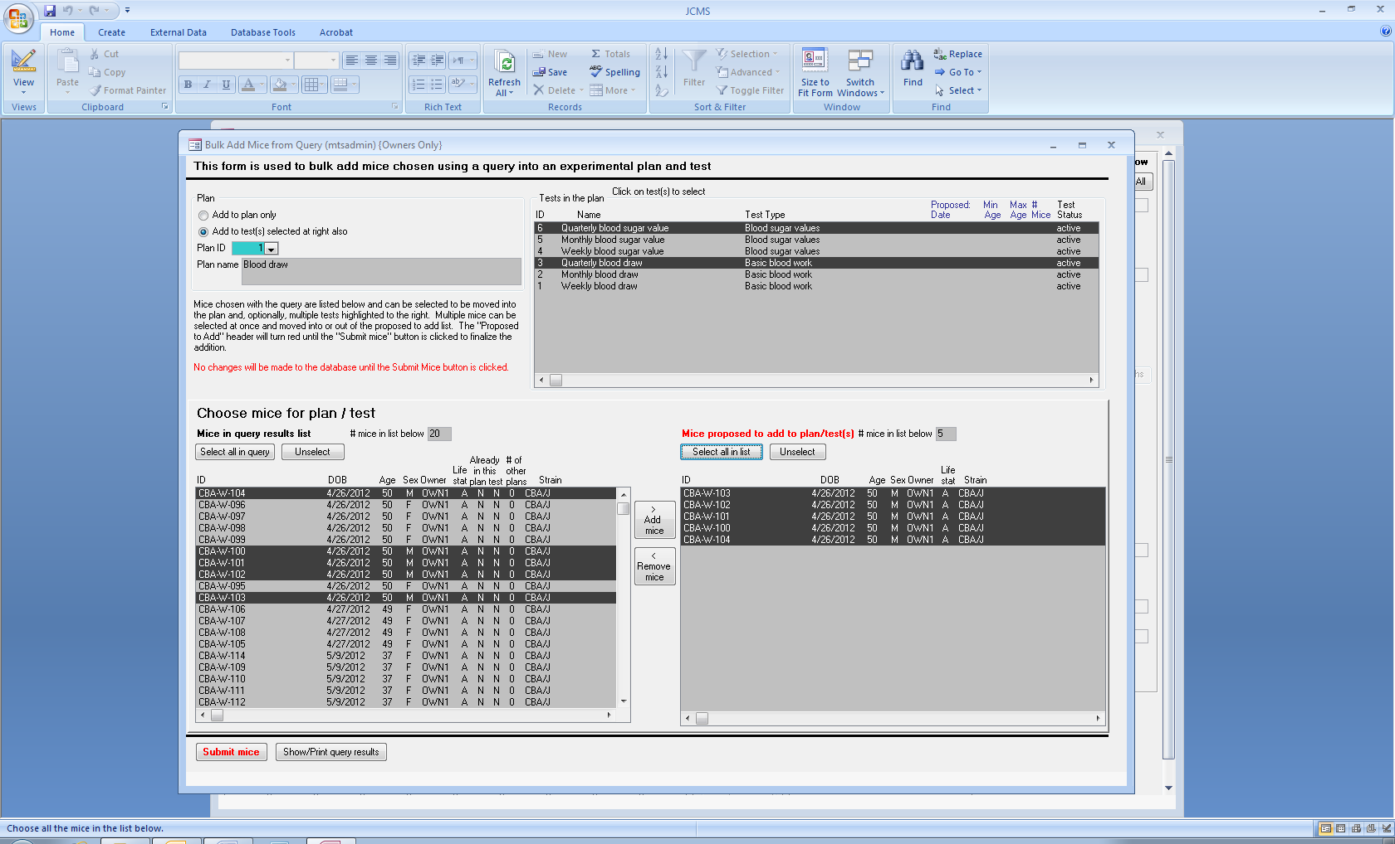

Figure ‑ Form: Bulk Add Mice from Query

Choose the plan to add the mice to. Any experimental tests that are part of this plan will now be listed in the “Tests in the plan” box at the top right of the form. It is possible to add the mice to some (or all) of the tests in this plan by selecting the tests in this box. Be sure to **select** the **“add to test(s) selected at right also”** radio button if also adding mice to tests. Otherwise, the mice will not be added to the selected tests, only to the plan. Note that a mouse cannot be added to a test unless it is also added to the plan. Mice may be added to a plan that does not have any tests. It will not be possible to add experimental data records for these mice until a test describing that data has been added to the plan. This may be done later.

Select mice to be added and click the **“> Add mice”** button to move them into the list at the right. Mice may be removed from the “mice proposed to add” list box by selecting them and clicking the **“< Remove mice”** button.

The mice in the query results list box will indicate with a Y/N if each mouse is already in (pre-selected for) the selected plan and selected test. The number of other plans the mouse is pre-selected for will also be displayed. If more than one test is selected, the Y/N will be only for the first (or top) test in the list as shown in the tests in this plan list box.

The **“Show/print query results”** button will show a print preview giving the contents of the Mice in query results list.

Once the list of mice proposed to add is ready, click the **“Submit mice”** button to make the changes to the database. A print preview of the submit report will appear on the screen. This report will indicate what actions were taken. It lists each mouse ID, the owner, and then a set of codes indicating if the mouse was added or not. The header will list the plan ID and any selected test IDs. The codes will appear in the order given in the header. The code “A” indicates the mouse was added to the plan or test and the code “E” indicates the mouse already existed in the database (previously pre-selected) for that plan or test. An additional code “C” will appear at the end of the listing if the mouse has an owner different from the owner of the plan. This is a reminder to check with the owner of the mouse before using it.

### Example of the report format:

Plan owner = ABC, Plan = 6, Test(s) = 12, 15

MOUSE ID, OWNER, PLAN, TEST(S)

123, ABC, A, A, A

456, ABC, E, A, E

789, XYZ, E, A, A, C

123, ABC, E, E, E

The above sample of a printout indicates that mouse 123 (owned by ABC) was added to plan 6 and tests 12 and 15. Mouse 456 was already selected for plan 6 and test 15. It was not already selected for test 12, so it was added to that test only. Mouse 789 was already selected for plan 6. It was not pre-selected for either test, so it was added to both. The code “C” is a reminder to check with owner XYZ for permission to use this mouse. Mouse 123 already existed for both the tests and plan (note: it may have been accidentally repeated in the list of mice to add). No more action was taken for that mouse.

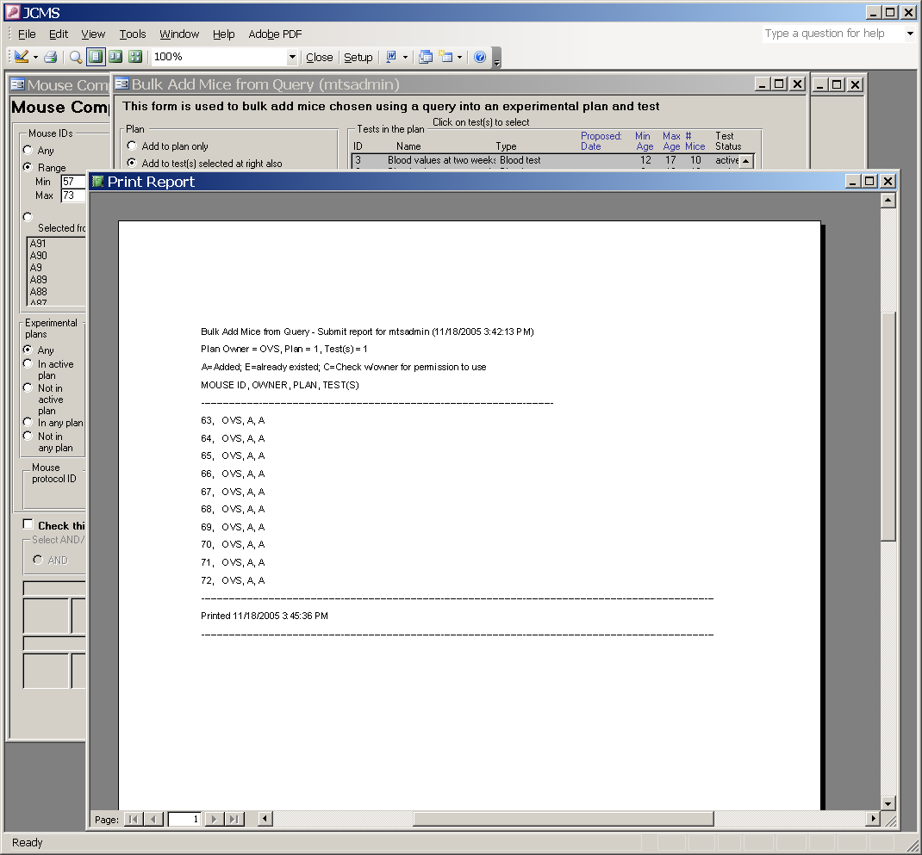

Figure ‑ Report: Add Mice to Plan

### Error message: “XX mice were selected by the query, more than can be held in the Query Results box.”

**“The list has been shortened to show only xx mice**. Use these or close the form and re-do the query.” It is possible to select a very large number of mice with the Mouse complex query form. The Bulk Add Mice from Query form arbitrarily selects only about 50 of these mice for use with the form. Otherwise, the dataset can become awkward to deal with. If the mice displayed are not those desired, close the form and change the query criteria.

## Managing an Experimental Plan

Click the **Manage/Edit Exp Plan** **button** to open the form. It is used to move mice in and out of tests and for deletion of mice from tests and plans. This form is also used for editing the experimental plan fields and deletion of tests from a plan. **Mice are considered** **“in” a test and/or plan** if they have been pre-selected for it or if they have an experimental data record containing the results for the test. Mice do not have to be pre-selected; they will be automatically added to the plan/test when the data results are entered.

### Choosing Mice for Experimental Tests

The Manage/edit Experiment Plan form is used for moving mice pre-selected for a plan into and out of experimental tests associated with that plan.

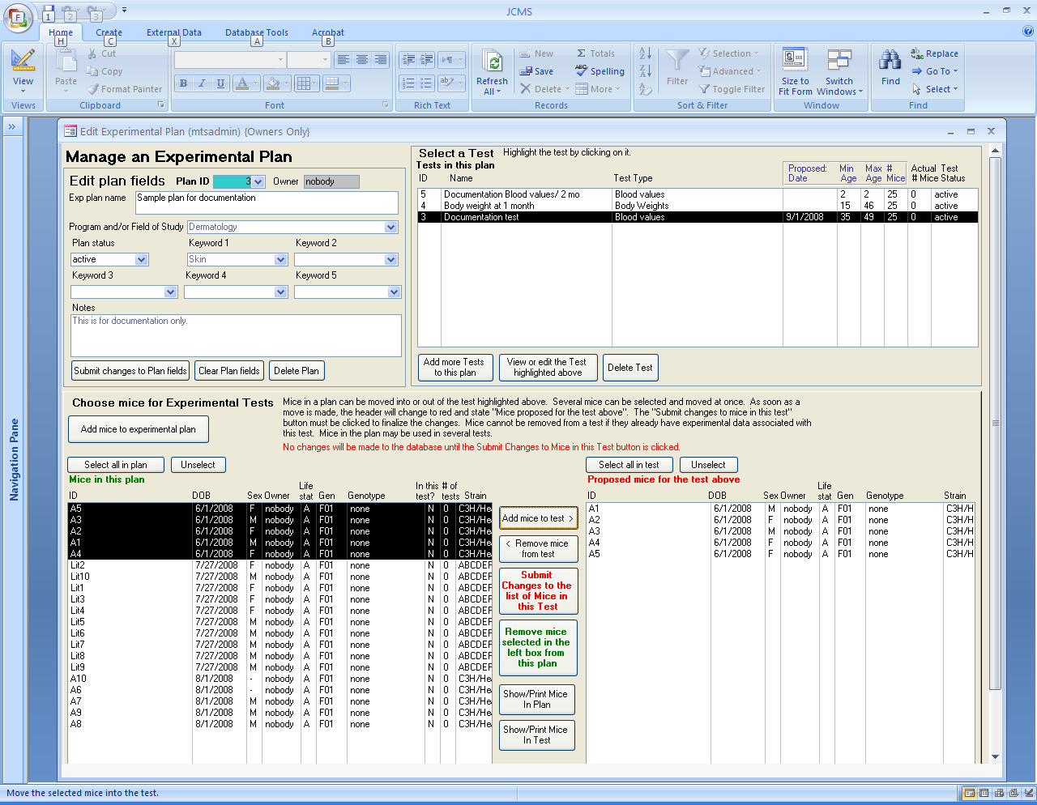

Figure ‑ Form: Manage Experimental Plan

First **choose the plan ID**. Then **select one experimental test** by clicking on it in the “Tests in this plan” list box (upper right of the form). All mice in the plan will be listed in the bottom left box and all mice currently in this test will be listed in the bottom right box. Select mice and move them back and forth between the boxes with the **“Add mice to test >”** and **“< Remove mice from test”** buttons. Multiple mice may be chosen by holding down the Control (Ctrl) key while clicking on each mouse. The “Select all” and “Unselect” buttons may be used to pick all the mice at once or to remove the selection from all the mice.

No changes will be made to the database until the **“Submit changes to the list of mice in this test”** button is clicked. A report is displayed on the screen showing the changes that were made to the database. If no mice are listed, then all mice in the “Proposed mice for the test above” list box (right side) were already in the test. Otherwise, one of the following actions will be listed for each mouse: **D** (mouse was removed from those pre-selected for the test); **A** (mouse was added to those pre-selected for the test); or **X** (mouse was not removed because it already has an experimental data record for this test).

The **“Show/print mice in test”** button will display a report listing all mice in the test and the current action that has been specified for each mouse. This action may be: **A** for add this mouse, **R** for remove this mouse, or **N** for no action.

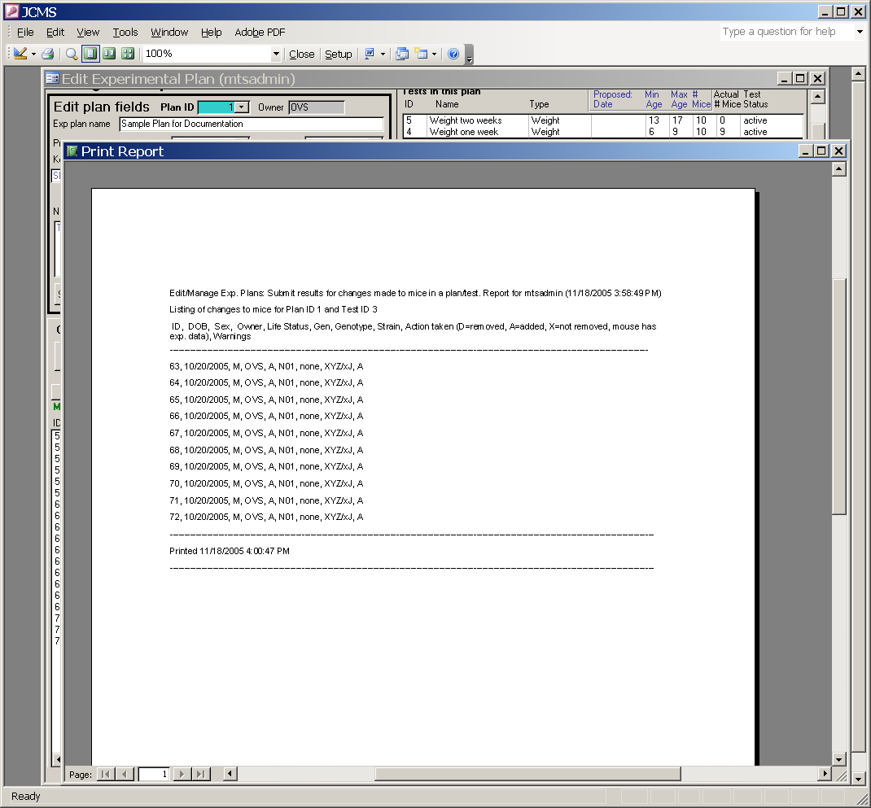

Figure ‑ Report: Edit/Mange Experimental Plan

### Removing Mice from an Experimental Plan

The Manage/edit Experiment Plan form is used to remove mice from the list of those pre-selected for an experimental plan.

First **choose the plan ID**. Select the mice to be removed from the plan in the **“Mice in this plan”** list box (left side). Multiple mice may be chosen by holding down the Control (Ctrl) key while clicking on each mouse. The “Select all” and “Unselect” buttons may be used to pick all the mice at once or to remove the selection from all the mice. Click the **“Remove mice selected in the left box”** button. A report is generated showing the changes that were made for each mouse selected. “Y” indicates the mouse was removed from those pre-selected for the plan. “**Unable to delete from plan**” indicates that the mouse is also pre-selected for an experimental test or has experimental data records for one or more tests. Mice that have data may not be removed from the plan. Mice that are only pre-selected for an experimental test must be removed first from the test. Then the mouse may be removed from the plan.

The **“Show/print mice in plan”** button will display a report listing all mice in the plan with a Y/N indicating if each mouse may be deleted or not. This report also indicates if the mouse is in the currently selected test and how many tests in this plan that each mouse is in.

### Editing Experimental Plan Fields

The Manage/edit Experiment Plan form is used for changing the fields describing the experimental plan. These are the fields shown in the upper left section of the form. Select the Plan ID. The “**Clear Plan fields**” button will blank all fields including the required ones. The “**Submit changes to Plan fields**” button must be clicked to make the changes permanent in the database. The owner and plan ID may not be changed. The plan name and status are required.

### Deleting an Experimental Plan

The Manage/edit Experiment Plan form is used for deleting experimental plans. Select the plan ID. Click the “**Delete Plan**” button. A plan cannot be deleted if it has any experimental tests, any pre-selected mice, or any experimental data records associated with it.

### Deleting an Experimental Test

The Manage/edit Experiment Plan form is used for deleting experimental tests. Select the test from the list box at the upper right side of the form. The delete test button will only function if there is no experimental data for this test and no mice have been pre-selected for the test.

## Adding or Editing Experimental Data for a Mouse

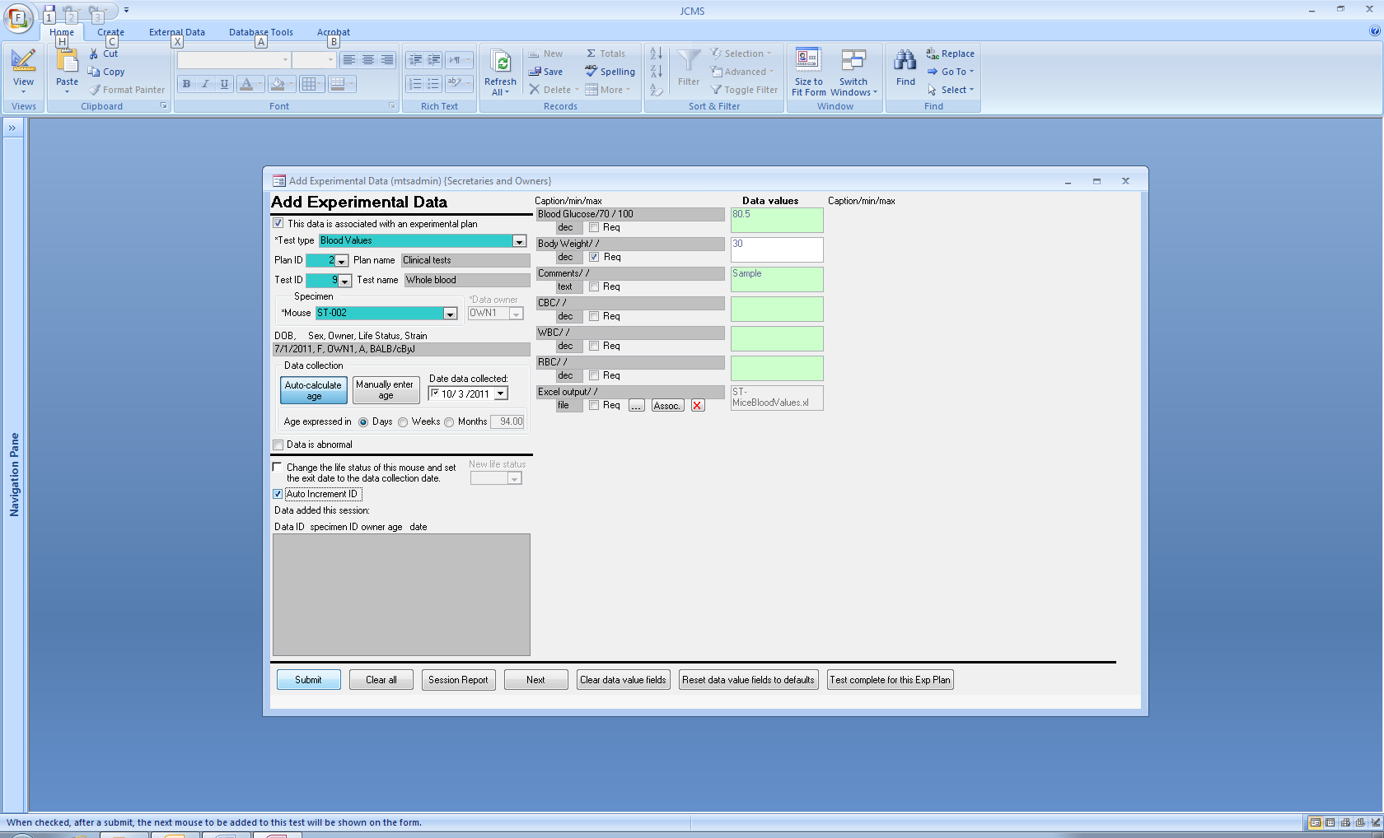

Figure ‑ Form: Add Experimental Data

Click the **Add Exp Data** button from the experiments tab to open the form. Experimental data does not have to be associated with an experimental plan and test. To add data for mice not in a plan, remove the check mark next to “**This data is associated with an experimental plan**”. The unnecessary fields will now be grayed out and all mice will be listed in the mouse drop down box.

Begin adding experimental data by choosing the **test type**. The captions for the data values will then appear on the form. Any minimum or maximum values will be displayed and the required box will be checked if the field must have data entered. Choosing the test type will narrow down the choices of experimental plans and tests to only those for this test type.

Choose the **Plan ID** to narrow down the choices of experimental tests. Then choose the **Test ID**. The test ID may be chosen without first picking the plan ID. Once the test is chosen, any default data values that have been set up for it will be displayed. These are to aid in data entry and should be changed to the actual value for each specimen.

Once the test ID is chosen, only mice that need to have a data record added will be listed in the **mouse** drop down box. These are mice that are pre-selected for this test. See the section on managing an experimental plan to learn how to pre-select mice.

To enter data for a mouse that is not pre-selected for a test, type the mouse ID into the mouse drop down box. A confirmation box will appear to verify that the mouse should be added to the list of pre-selected mice for this test. If YES is selected, the mouse will be added to the list of those pre-selected **even if the data record is not later successfully submitted**. The mouse is added to the pre-selection list first, before the experimental data submit occurs. See the section on managing an experimental plan to learn how to remove mice from those pre-selected for a test.

JCMS always sets the owner of the data to be the same as the owner of the plan. If no experimental plan and test is used, then the owner of the data may be set to any valid owner.

The age field indicates the **age of the specimen at the time of data collection**. JCMS will calculate this from the data collection date and birth date of the mouse if the **Auto-calculate age** button is selected. A warning message will appear if the mouse’s life status is not “alive” and the experiment date is after the mouse’s exit date. JCMS will store the age field value as number of days old. Age may be entered in weeks or months by selecting the appropriate radio button.

If one or more data values in the test results for this specimen are abnormal, then check the Data is abnormal box. Later, this value may be used to easily locate all experimental data records with unusual results.

If the “**Change the life status of this mouse and set the exit date to the data collection date**” box is checked, then the mouse record will be updated at the same time as the experimental data record is submitted. The mouse will not be updated unless the submit is successful for the experimental data record.

If “**Auto Increment ID**” is checked, then the next pre-selected mouse ID (alphabetically) will be displayed in the mouse drop down box.

The “file” data format is used to add an association between this data record and a document. Documents are computer files (such as an image, spreadsheet, word document, etc.) It is not possible to directly enter the file name into the data result box. Use the ...(upload), assoc., or X(delete) buttons to select the file. See Section 17 on documents for more information on the forms used for uploading and associating documents. More than one data result field may be defined with the file format; however, a specific file may only be associated once with a specific experimental data record.

The **Data ID** for this experimental data record is assigned by JCMS and will be displayed in the “Data added this session” box.

The **Test complete for this Exp Plan** button will change the test status in the experimental test record for the test currently indicated in the Test ID box to “done”.

## Editing Experimental Data

Click the **Edit Exp Data** button to open the form. Select either **Data ID** or **Mouse** as the method to use for selecting the experimental data record to edit.

Selecting a **Plan ID** or **Test ID** will limit the choices in the other drop down boxes. If the desired drop down boxes are grayed out (not available to choose from), then click the Data ID or Mouse buttons again. This will start the selection process over. When no test ID is selected, a particular mouse may be listed multiple times in the mouse drop down box, once for each experimental test the mouse has data results for.

The Data ID and Mouse drop down boxes will show all experimental data records that exist for the selected test ID. These boxes will not show pre-selected mice that have no experimental data record yet. Use the Add experimental data form to add the data for the pre-selected mice.

The rest of the fields on the form work the same as on the Add experimental data form described above.

## Adding Experimental Data to Several Mice at Once

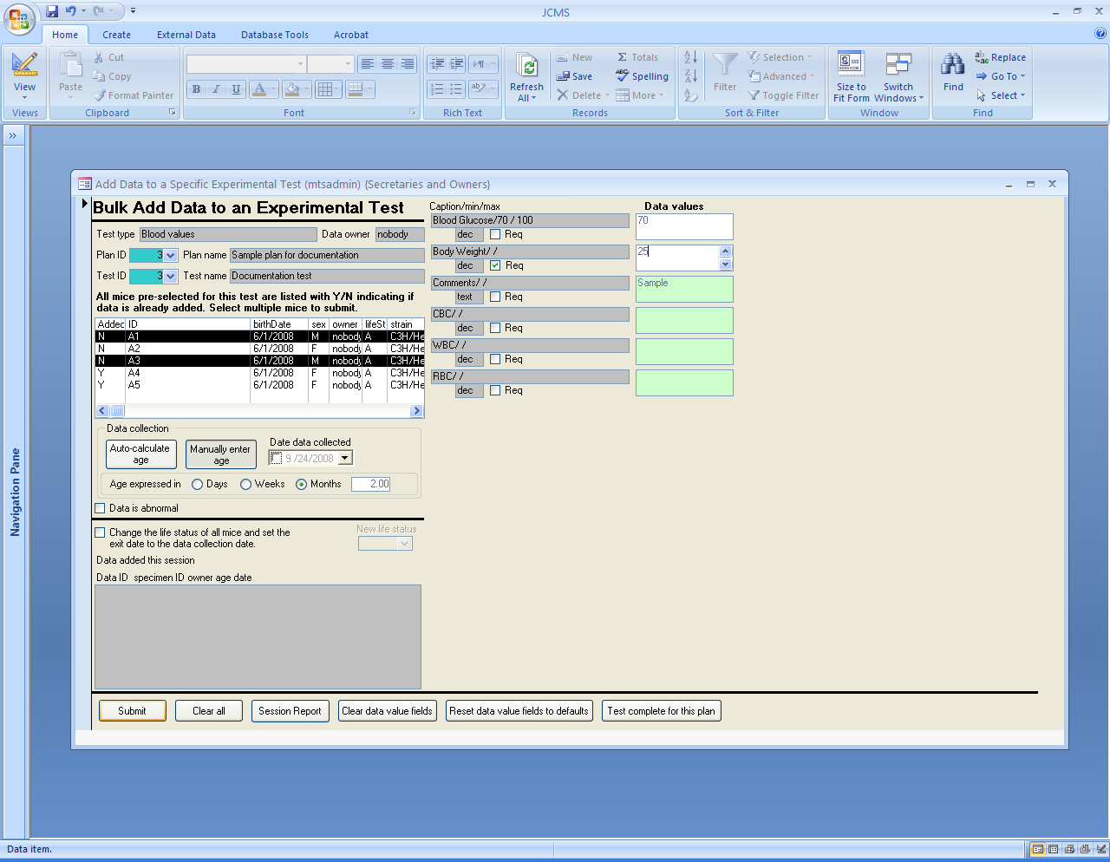

Figure ‑ Form: Bulk Add Experimental Data

Click the **Bulk Add Data to Specific Test** button to open the form. This form is used to enter new data values for mice that have already been selected as part of a particular plan and test. If several mice should have all the same data values, this form may be used to speed up data entry. Or, it could be used to create data records for a group of mice where many of the data values are the same, then use the Edit Experimental Data form to change or add specific values for each individual mouse.

Select the experimental **plan ID** to limit the choices in the test ID box to only those for the specific plan.

Once a **test ID** is chosen, the list box will show all mice that have been pre-selected for the test. The first column indicates if a data record has already been added (Y) or not (N) for that mouse ID.

**Select one or more mice in the list box**. WARNING: The whole batch will be rejected if any of the selected mice already have a data record (Added = Y).

The rest of the form works similarly to the Add Experimental Data form described above.

Note: This form does not allow adding information in a data value field using the “file” format. If a “file” format field is required the form may not be used for that experimental test.

## Experiment Work Report for Scheduling Procedures

Click the **Experiment Work Report** button on the Reports tab to open the form for requesting the report. This report is designed to provide lists of mice for a work “to-do” schedule. There are many criteria available for limiting the mice shown on the report, such as a date range, experimental plan owner, mouse life status, experimental test status, test type, or specific experimental tests. Entering selections for experimental plan owner, experimental test status, and/or test types will cause the list of experimental tests to change to show only those that satisfy the criteria. There are two forms of output, a formatted report or a datasheet for exporting to Microsoft Excel or other spreadsheet.

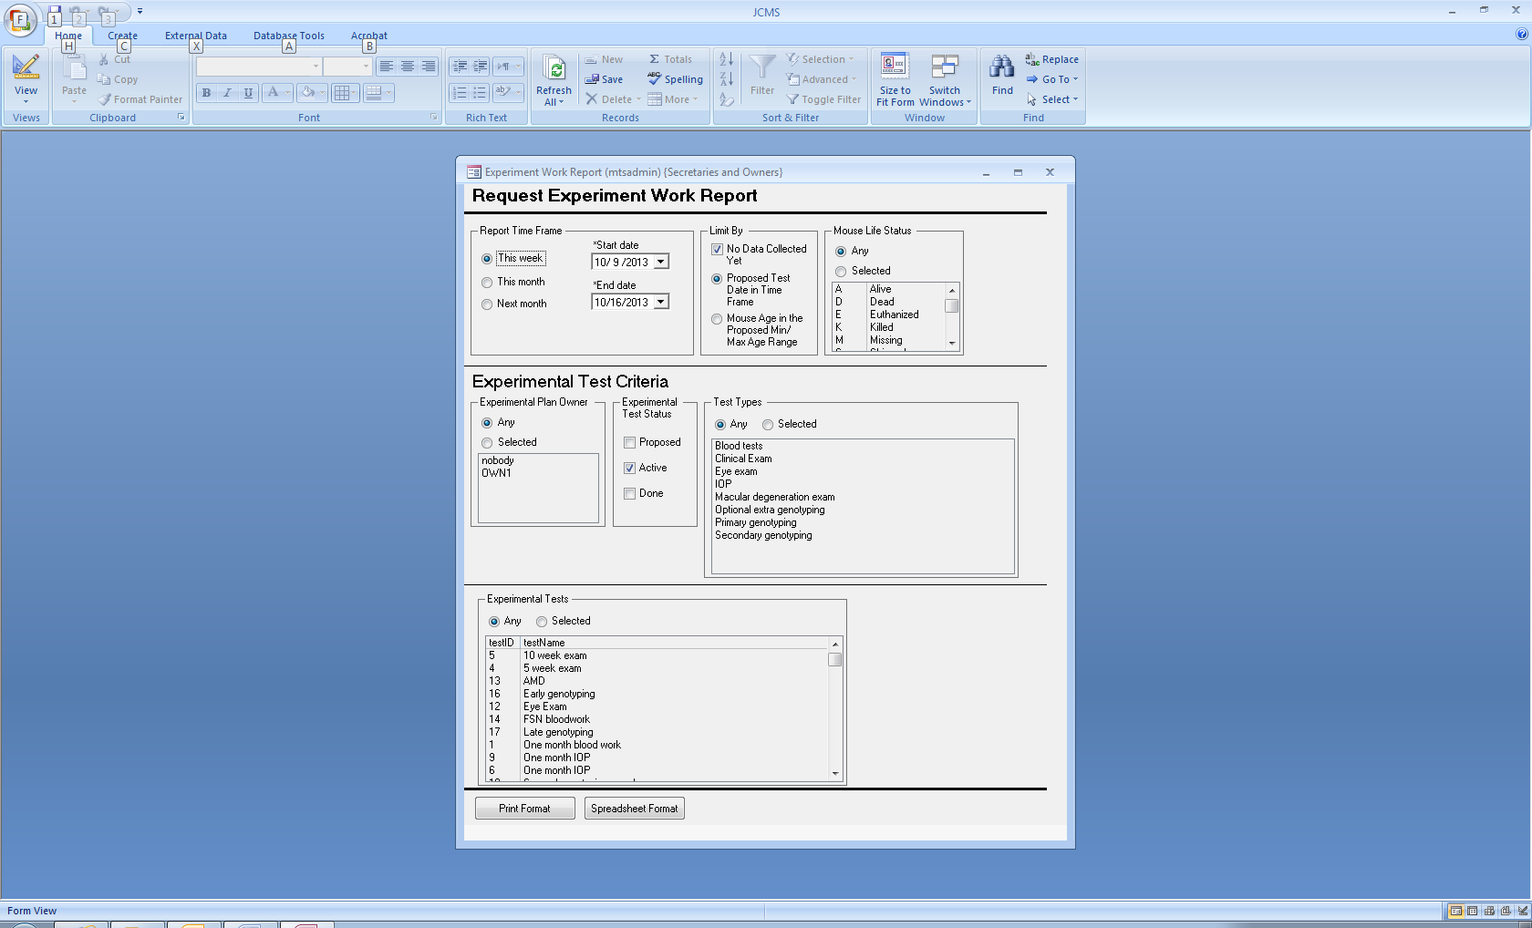

Figure ‑ Request Experiment Work Report

The formatted report gives a listing sorted by experimental plan owner, experimental plan, experimental test, and mouse ID. Basic information about the mice will be shown (ID, pen, strain, generation, date of birth, age today, sex, and life status). In addition it shows the plan ID, test ID, and the test’s proposed values for minimum age, maximum age, and to-do date. When a minimum and/or maximum age is available, an age window is shown for each mouse (date the mouse reaches the minimum age and date the mouse reaches the maximum age). When there is a proposed date for the test, the mouse’s age on the proposed date is shown.

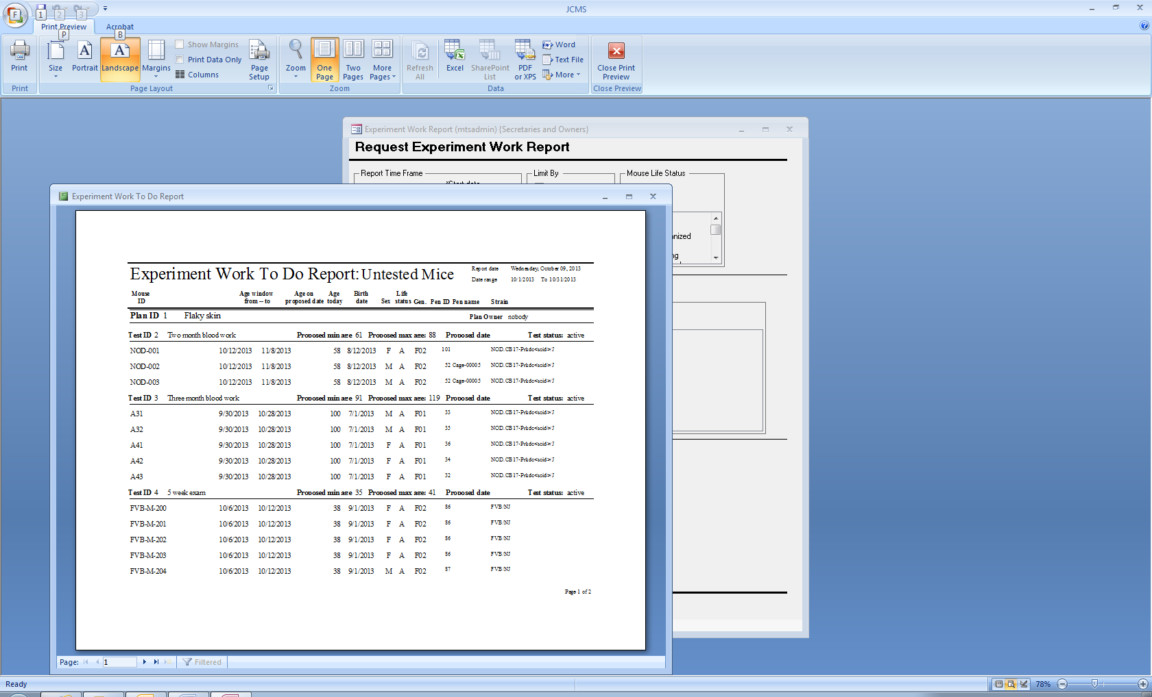

Figure ‑ Experiment Work To Do Report Based on the Mouse Age Range

The spreadsheet version of the report contains all the same information and includes an extra column for data collected (Y/N). If the check box “No data collected yet” is not checked, then all mice selected for the test will be listed.

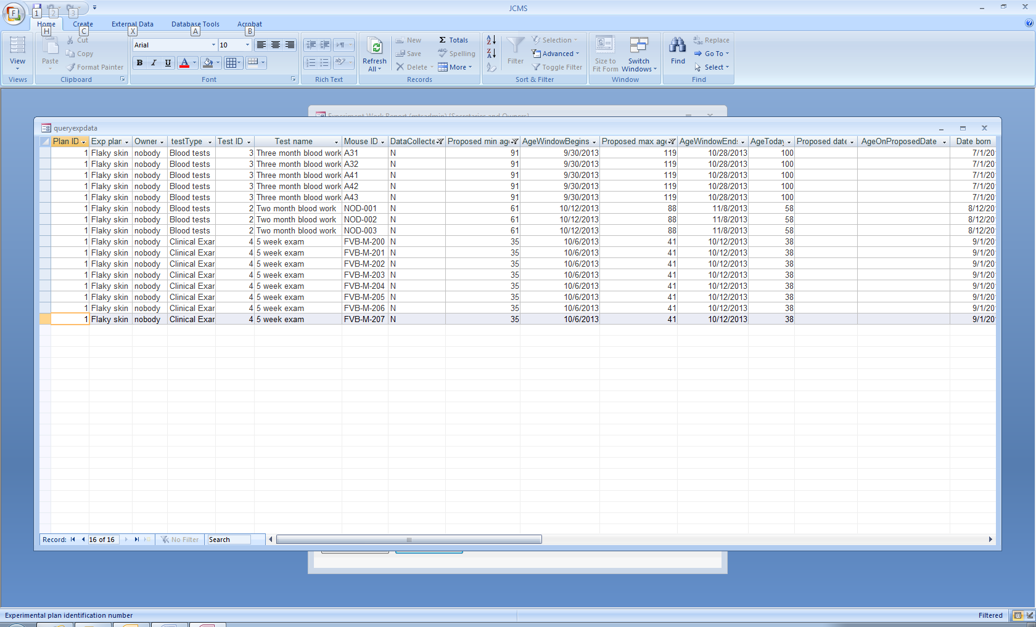

Figure ‑ Experiment Work Report Spreadsheet

### Connector/ODBC Window Pops-up When Using the Experiment Work Report

This window will appear if some of the parameters for the MYSQL database have changed.

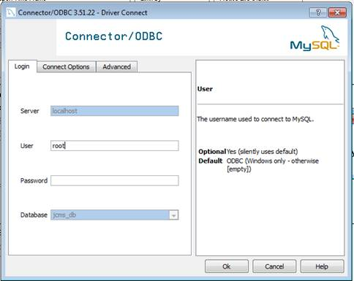

Figure ‑ Connector/ODBC window

To eliminate the problem update the MySQL setup variables shown below.

### Setup Variables Used by the Experiment Work Report

Table ‑ MySQL setup variables

|  |  |  |  |
| --- | --- | --- | --- |
| JCMS_MySQL_DATABASE_NAME | | jcms_db | The name of your MySQL database. |
| JCMS_MYSQL_DRIVER | {MySQL ODBC 3.51 Driver} | | The name of your MySQL driver. |
| JCMS_MYSQL_SERVER | | localhost | The name of your MySQL server. |
| JCMS_MYSQL_USER_ID | | root | The name of your MySQL user ID. |

These four setup variables are necessary for the query used by the report to work efficiently. The defaults are shown. The upgrader/installer will initialize these; however, if later on changes are made to one or more of these values, it may be necessary to also manually change them in the setup variable table.

## Experimental Plan Query

This query is described in the Queries section under Experimental Plan Query.

## Importing Experimental Data

The Import Experimental Data function of JCMS loads data from files and automatically populates the *experimental data* records for the mice identified in the file. The data may be associated with *experimental tests* that are part of an *experimental plan* or just be associated with mice.

Many research programs use machines to generate data, such as blood work. It is impractical to try to support individual file formats for the many different machines that already exist and new ones being built each year. Therefore, imported data must be in a specific file format known as CSV (comma separated values). Many applications, such as MS Excel, are capable of creating a file using this standard format. Some user-manipulation of the file may be required prior to importing it.

The data format must match a user-created and defined JCMS *experimental data definition (test type)*. This test type may be set up to closely match the output file from a machine or application. The JCMS identifier (*mouse ID*) is used to match the data to the mice.

**Process Diagram**

Figure ‑ Process for importing experimental data from a user file

User data

User converts to CSV

JCMS import program

Error reports

Post-import reports

JCMS Experimental Data

### Input File Format

A file using the CSV (comma separated values) format consists of multiple lines or rows with the data values separated with commas. If the file is created using MS Excel, then each line is the same as a row in a spreadsheet. Each data value consists of the contents of one cell in a column. MS Excel will insert the comma used to separate the data values when the file is saved. These commas are not visible in the cells. CAUTION NOTE: data values, such as comments, cannot contain comma characters because commas are used as data value separators.

**JCMS format requirements**

Token row: The input file may contain rows that are ignored at the beginning. It must start with a row containing “JCMS_DATA”. This is a token used by the import program to determine where to start processing the file.

Header row: The header row must be the next row following the JCMS_DATA token. The header row contains the captions indicating what data value is in each column.

* There are three special captions: Mouse ID, Abnormal Data Flag, and Data Collection Date. The first two are required and the Data Collection Date is optional.
* All data values that are imported must be in a column with a caption that matches one defined in the JCMS *Test Type*.
* Columns that do not match a *Test Type* caption or the three special captions are ignored.
* If the *Test Type* has required data, a column for that data must be present.
* The columns may be in any order.
* Duplicate captions are not allowed and will generate an error message.

**Example of an input file**

Blood, body weight test

Tested on 1/2/08

Chuck Donnelly

**JCMS_DATA**  
**Mouse ID, Abnormal Data Flag, Data Collection Date, Blood Glucose, Body Weight, Comments**

CJD-002, T, , 0, 45.0, found dead

CJD-003, F, 1/2/08, 89.2, 34

CJD-010, F, 1/3/08, 76.95, 30

CJD-005, T, 1/2/08, , 36.4, malfunction

Data rows: All rows after the header are assumed to contain data.

* Data collection date is an optional field and may be left blank. If all the data has the same collection date, then the date may be entered once on the import form instead of being present in the input file.
* Blank rows within the file and at the end are ignored.

### Create a Test Type

This is an example of the Add test type form showing creation of a test type that matches the input file header above. 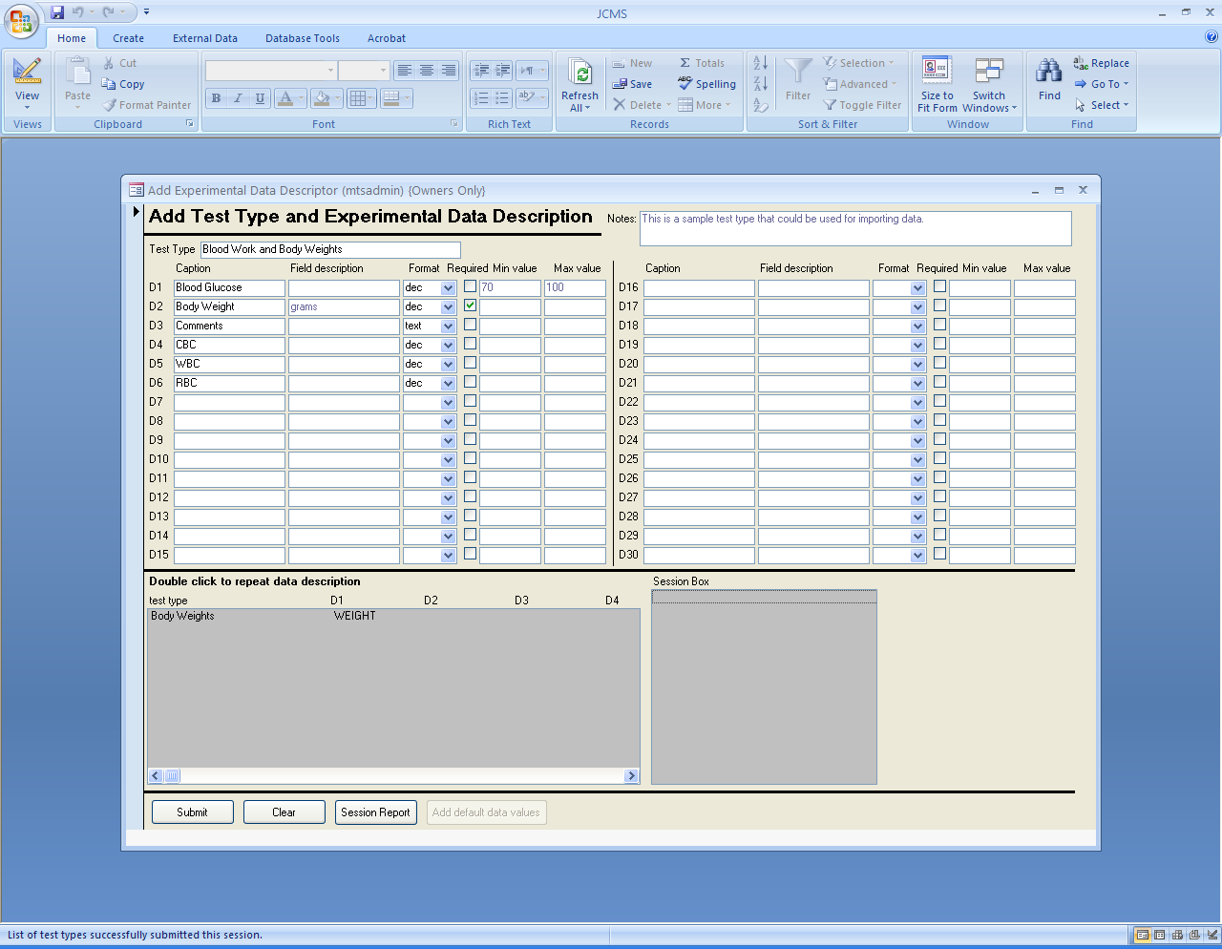

Figure ‑ Create a test type to match the input fields

Note there can be captions in the test type that are not used in the importation process.

### User Interface

The *Import Exp Data* button on the experiments tab is used to initiate the import process.

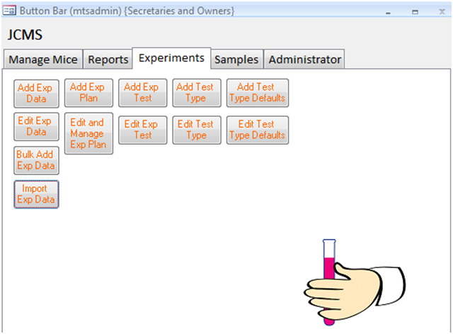

Figure ‑ Import Exp Data button

**Filling in the Import Experimental Data form**.

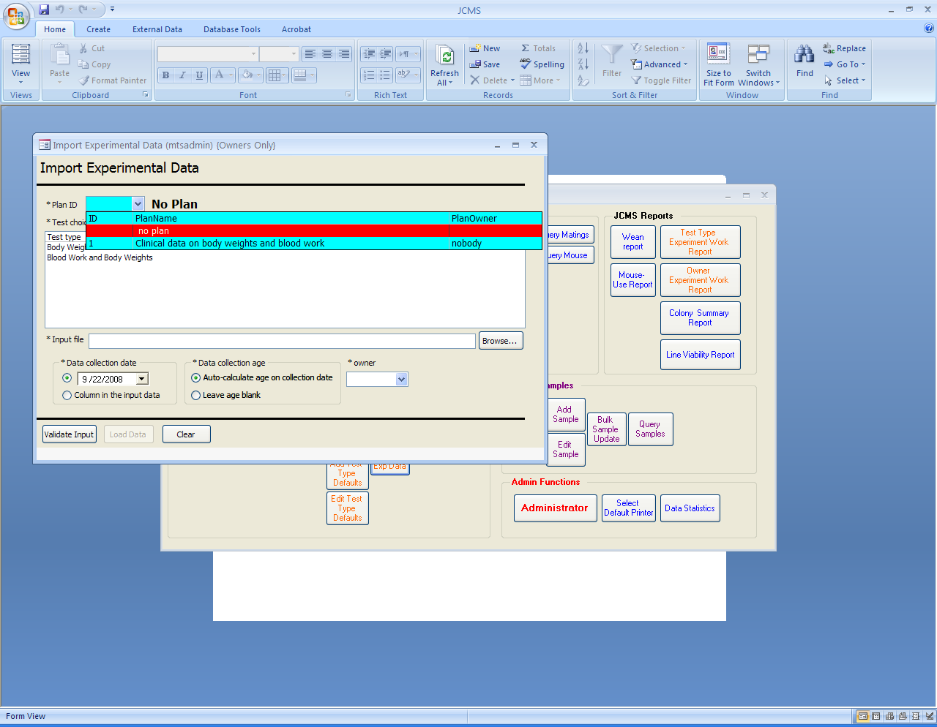

Figure ‑ Import Experimental Data with no experimental plan

To add experimental data to mice without using an experimental plan, select “no plan” from the choices in the Plan ID combo box.

Select the test type from the list of choices. Browse to find and select the input file. The data collection date may be entered with the same value for all the data records by selecting it using the calendar. Otherwise, use the radio button to indicate it is present in a column in the input data file. The data collection age is an optional field. It may be auto-calculated (by using the mouse’s birth date and the data collection date) or left blank. When an experimental plan is not used, the owner of the data must be specified. This may be different from the owner of the mice.

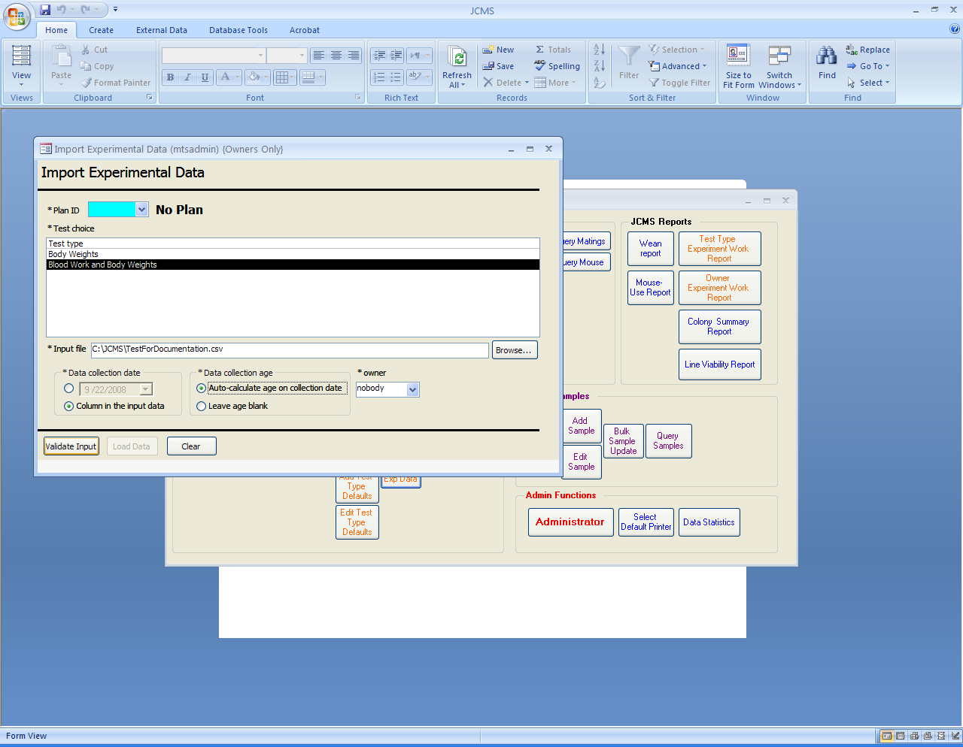

Figure ‑ Validate input

Use the Validate Input button to initiate the validation process. The data file will be checked to determine if there are any problems and a report will be displayed indicating if the data may be imported.

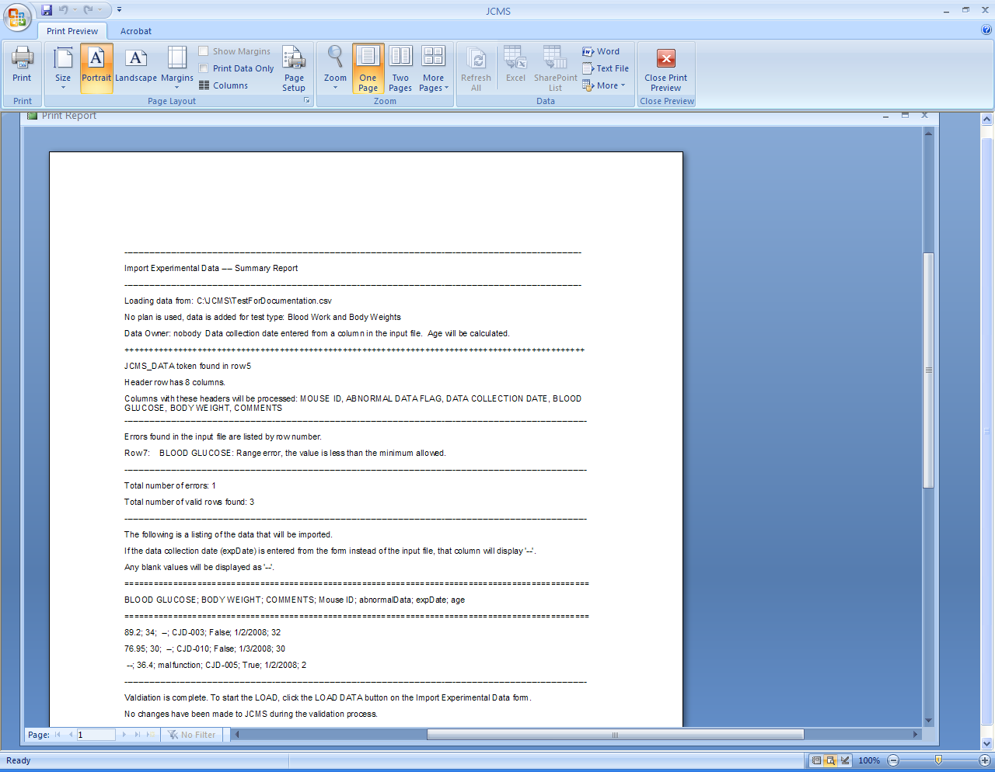

How to proceed

Input file data rows that may be imported

Errors found

Information about the input file

Information about the request.

Figure ‑ Sample validation report

In the case above, one input file row has been rejected with an error. The rest of the input file may be imported or the input file can be corrected and the validation run again.

The number of errors that are acceptable is determined from a setup variable called JCMS_MAX_IMPORT_EXP_DATA_ERRORS. Once the error limit is reached validation will stop and errors must be corrected in the input file. The default is 10 errors.

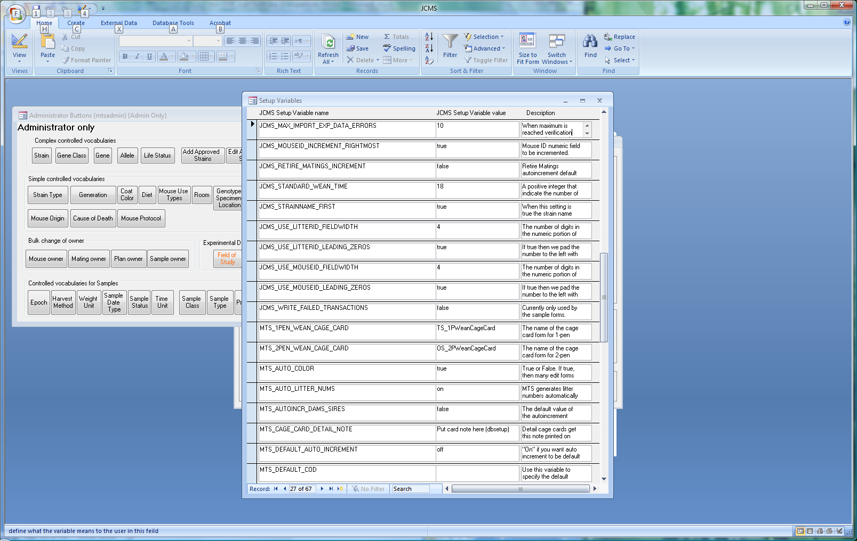

Figure ‑ Maximum number of validation errors

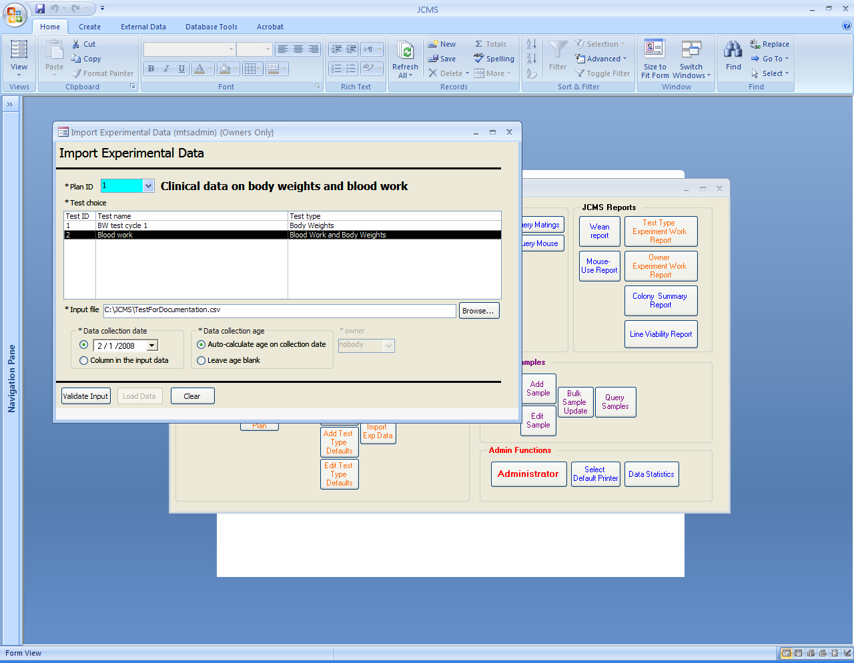

Figure ‑ Import Experimental Data using an Experimental Test

To record experimental data that is associated with a particular experimental test, first choose the experimental plan ID. The list of choices will change to show all active tests for that experimental plan. The owner is automatically set to be the experimental plan owner. Browse to select the input file. Select the experimental test and data collection date and age settings. Click the Validate Input button.

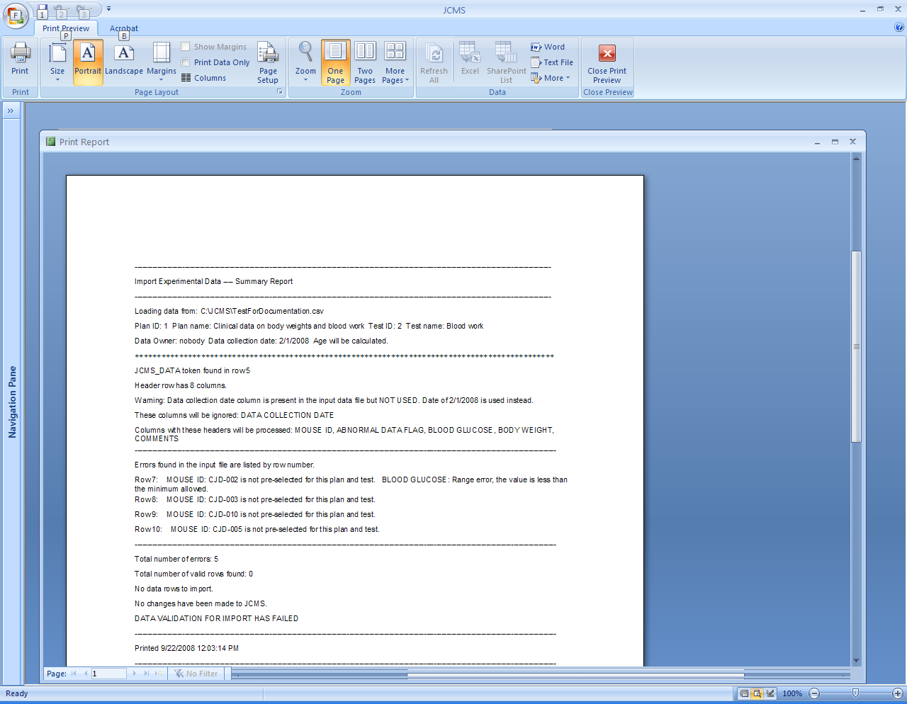

Information about the input file

Validation failure

Errors found

Information about the request.

Figure ‑ Data validation failure

In the case above, no rows have passed the validation step and the input file or other parameters must be changed. The mouse IDs need to be added to this test using the Manage Exp Plan form or the setup variable shown below must be changed to “false”, allowing the mice to be added to the experimental test at the same time as the data is imported.

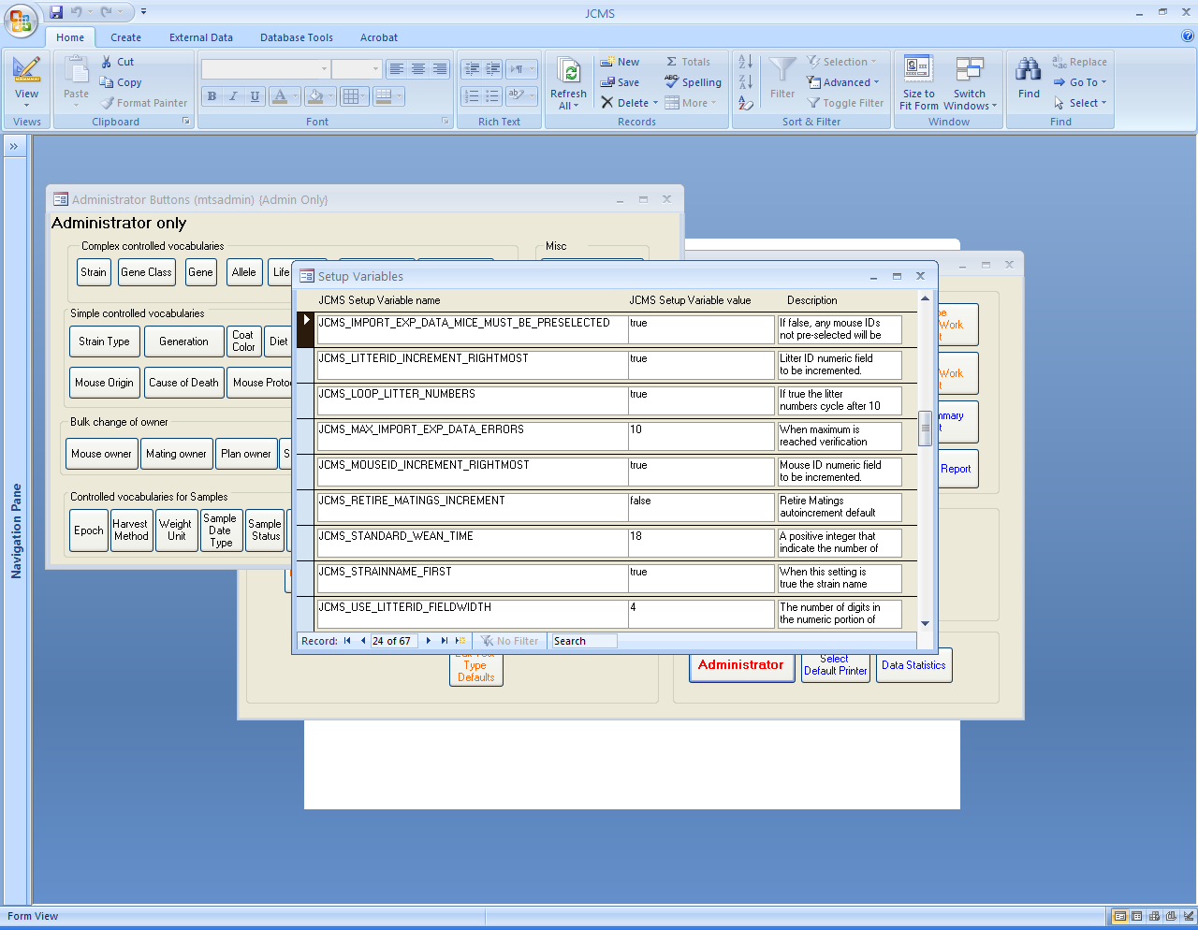

Figure ‑ Allow experimental data to be imported to an experimental test without preselecting the mice

Set the setup variable JCMS_IMPORT_EXP_DATA_ALLOW_MULTIPLE to true if importing with NO experimental plan and you want to allow more than one record for a test type/mouse combination.

When some of or the entire input file has passed the validation step, the Load Data button will be enabled. Click it to proceed. The load report will be displayed listing the rows added and those rejected with errors.

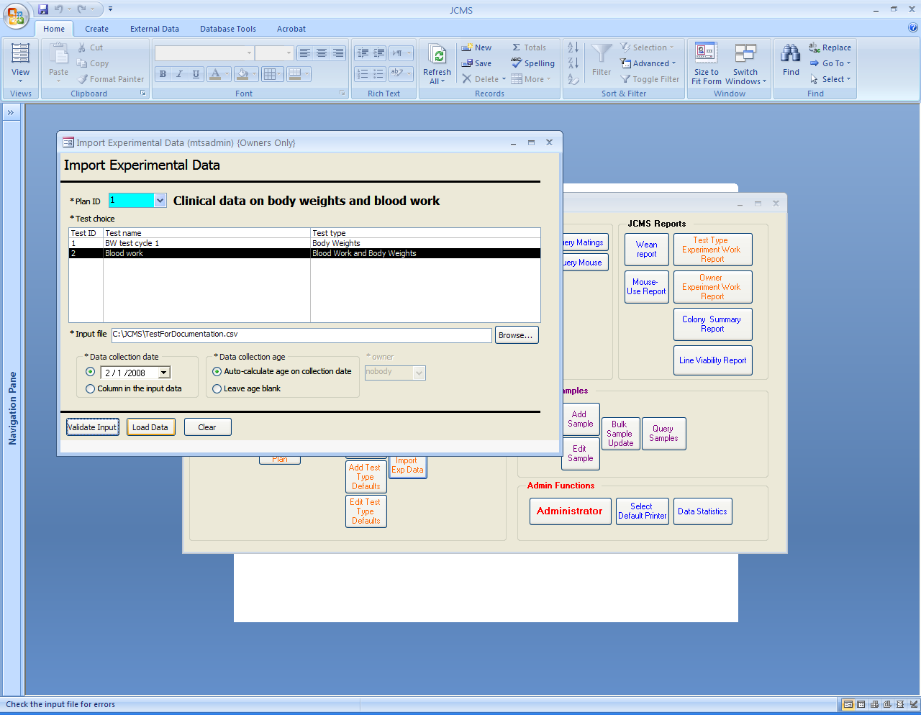

Figure ‑ Enabled load data button

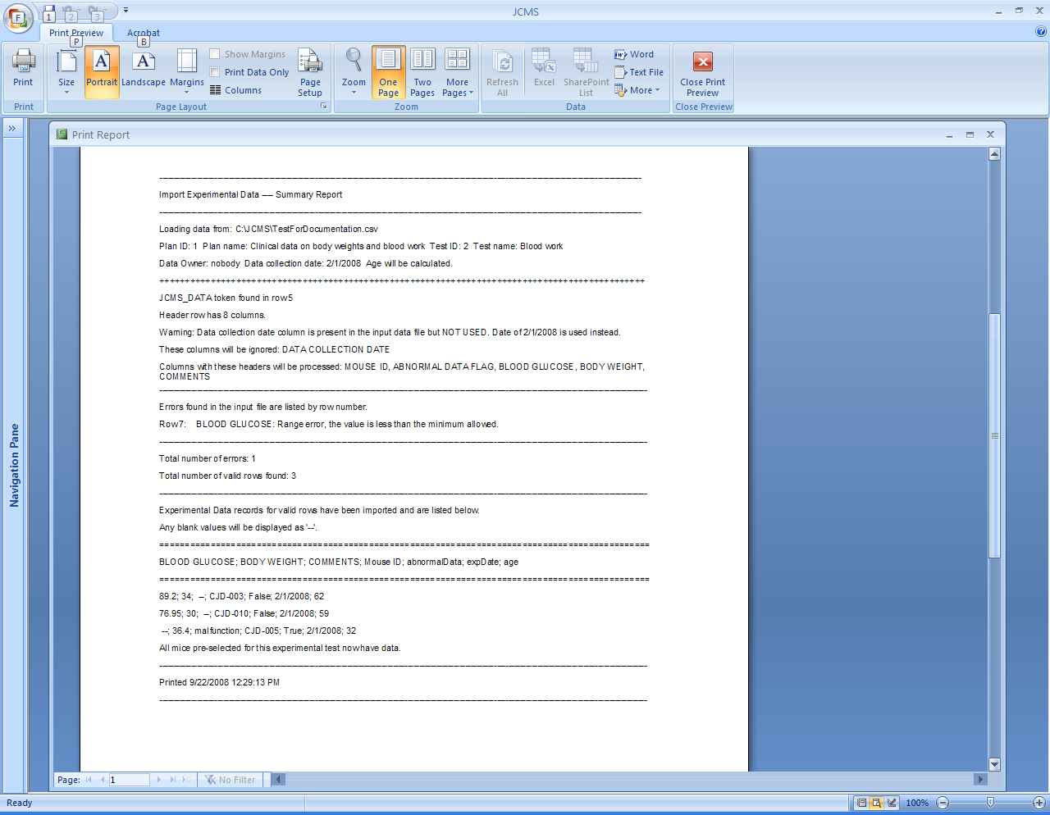

Input file data rows that have been imported

Errors found

Information about the input file

Information about the request.

Figure ‑ Final load report

When a load to an experimental test is completed, if all the preselected mice have a data record, the option to change the experimental test status from “active” to “done” is offered.

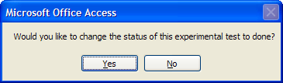

Figure ‑ Changing the experimental test status

### Troubleshooting Notes

* Data values, such as comments, cannot contain comma characters because commas are used as data value separators.
* The *test type* selected directly (no plan) or associated with the experimental test when using an experimental plan may not contain data value fields with the captions: Mouse ID, Data Collection Date, or Abnormal Data Flag. These are special captions used by the importation process.
* Do not insert spaces between the commas used to separate missing values. These can be accidentally interpreted as a value. A line of data containing A,B,,,C is not interpreted the same as A, B, , , C. There is no need to follow a comma with a space.
* Some applications insert characters at the beginning of a file that provide information to the application. If the file has the JCMS_DATA token on the first line these special characters may cause it to not find the token. The solution is to insert a blank line at the beginning of the file.

# Samples

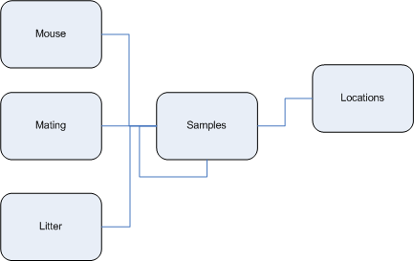

## Set up Controlled Vocabulary for Sample Tracking

The first step in using the sample tracking features is to set up the controlled vocabulary for your lab. Sample tracking has both simple controlled vocabulary (see section 3.3.1) and several more complex controlled vocabularies.

The simple controlled vocabularies for sample tracking are as follows:

* 1. Epoch: Used to qualify the sample’s age
  2. Harvest Method: Indicates how the sample was harvested
  3. Weight Unit: Units the weight is measured in
  4. Sample Date Type: Used to qualify the sample date
  5. Sample Status: All potential statuses a sample may be identified with
  6. Time Unit: Used for indicating sample age
  7. Sample Class: Top level category for a sample

Some values have already been added to these tables. Examine each one and add or remove values as necessary. These values are accessed by clicking on the corresponding button on the Administrative button bar:

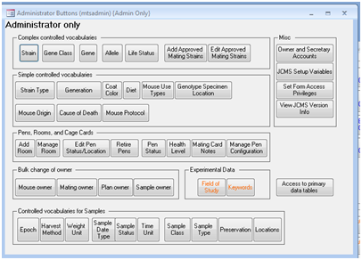

Figure ‑ Simple controlled vocabulary buttons for sample tracking

After clicking the button, the values are displayed in table format:

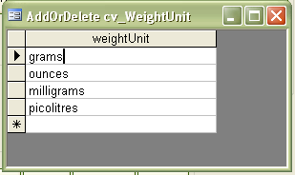

Figure ‑ Example of editing simple controlled vocabulary

**To add a new value**, place the cursor in the bottom blank row and type in the new value. Move the cursor out of that row for the new value to save.

**To remove a value** from the table, click on the box at the left side of the row in the table. The whole row will be highlighted. Press the delete key. A dialog box will ask for confirmation that the record should be deleted.

See section 3.1.1 for more details regarding simple controlled vocabularies.

In addition, there are three complex controlled vocabularies for sample tracking. They are:

1. Sample Type: Within class, identifies the sample type
2. Preservation (Type, Method, Detail): Values for indicating how the sample is preserved
3. Location: Where the sample resides

As with simple controlled vocabularies, add and remove values as necessary. Do this by clicking the corresponding buttons on the Administrator button bar:

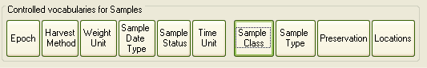

Figure ‑ Complex controlled vocabulary buttons for sample tracking

To administer sample types, click the Sample Type button. The following screen is displayed:

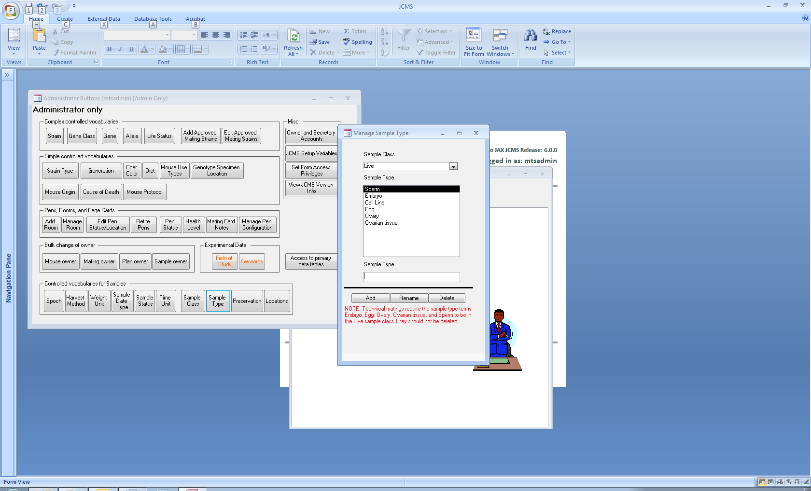To add a sample type, first select the sample class it should belong to from the drop down at the top of the screen. Then enter the value in the Sample Type text box and click Add. To rename one, double click it, update the name, then click Rename. To remove one, highlight it and click Delete. A sample type may not be removed after it has been used for samples.

Note that technical matings require the “Live” sample class to contain the following Sample Type terms: Egg, Embryo, Ovary, Ovarian tissue, and Sperm. These are initially added by either the installation or upgrade of JCMS. Deleting any of them will cause there to be no sample choices for technical matings

Figure ‑ Manage sample types screen

To administer preservation vocabularies, click the Preservation button on the Administrator button bar. This window is displayed:

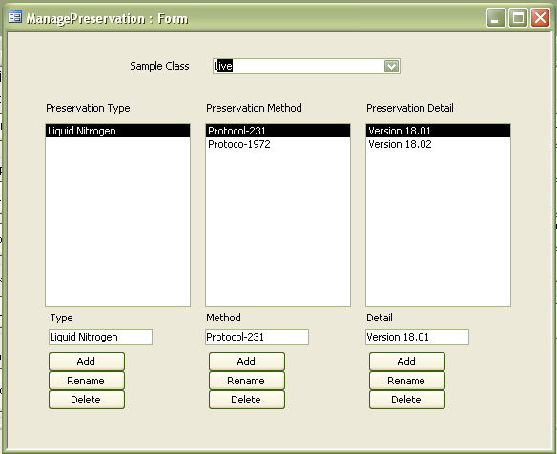

Figure ‑ Manage preservation vocabularies screen

It is important to remember that, on this screen, the values in a list are relevant only to the selection made in the list to its left, and all values pertain to the selected sample class at the top of the screen. The preservation methods listed pertain to the selected preservation type, and the preservation details pertain to the selected method. To add any value, type the value in the text box below the list and click the Add button. To rename a value, double click it, update the value in the text box and click Rename. To remove a value, highlight it and click Delete. As with other vocabularies, an item may not be removed if it has already been used in a sample record.

Finally, to administer locations in your facility, click the Locations button on the Administrator button bar. Following is the location administration screen:

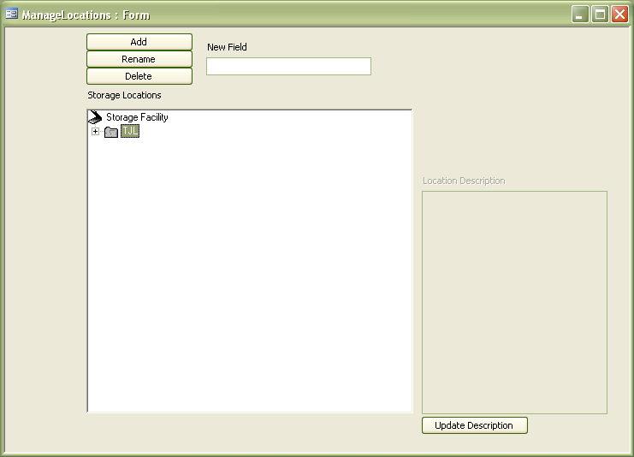

Figure ‑ Manage sample locations screen

This screen is organized as a “tree view” with “nodes” representing locations. You may expand and collapse the nodes in the tree, and add and remove nodes at any level. For example, you may have a building node under the root level, and beneath that node are room nodes, beneath that may be shelf nodes. This allows you to be as general or specific about locations as necessary. To add a new value, highlight the parent value, type the name in the New Field text box, and click Add. Following the previous example, to add a new room to a building, highlight the building, enter the name of the room, and click Add. To rename a value, highlight it, enter the new name in the New Field text box, and click Rename. To remove a value, highlight it and click Delete. Enter text descriptions for any node by typing in the Location description box on the right hand side of the screen and click Update Description.

## Pooled Samples

A *pooled sample* is one from multiple sources. These sources may all have the same strain or have differing strains (*Relax Single Strain Constraint*). When pooling samples from sources from multiple strains, it is suggested to set up a mechanism to help readily identify and search for such pooled samples. Set up a dummy Strain. The dummy Strain is not associated with any actual mice or matings; it is used only as the Sample’s assigned Strain. This enables easily identifying all multi-strain pooled samples using the Sample Query form.

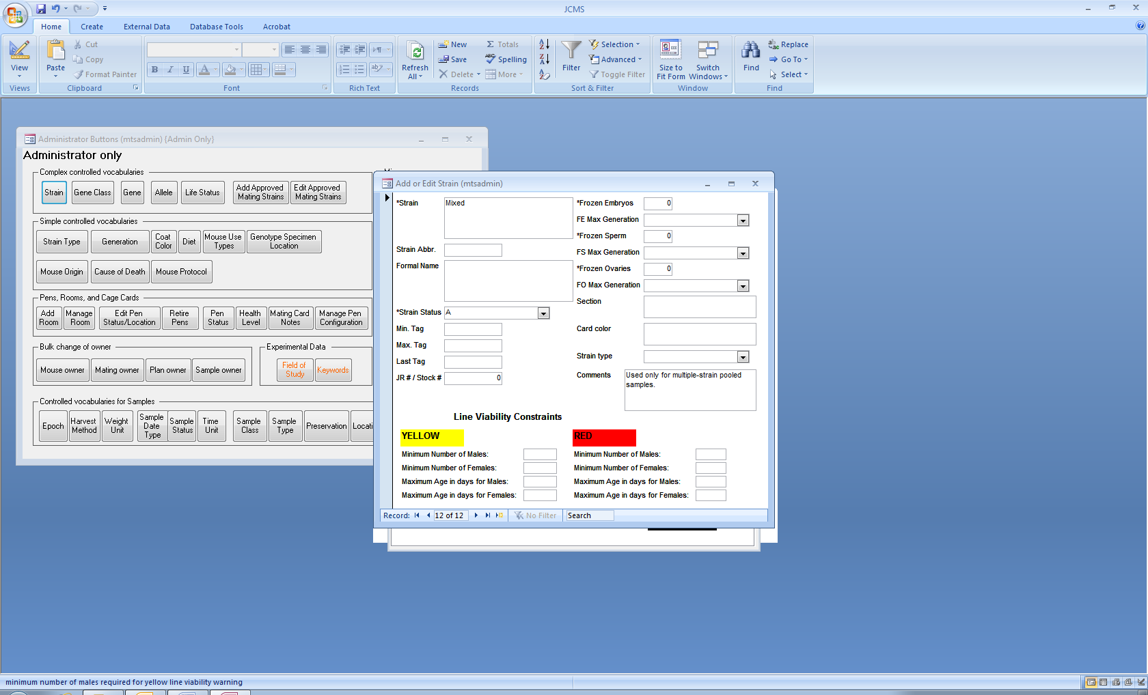

Figure ‑ Dummy strain for a pooled sample

## Add Samples

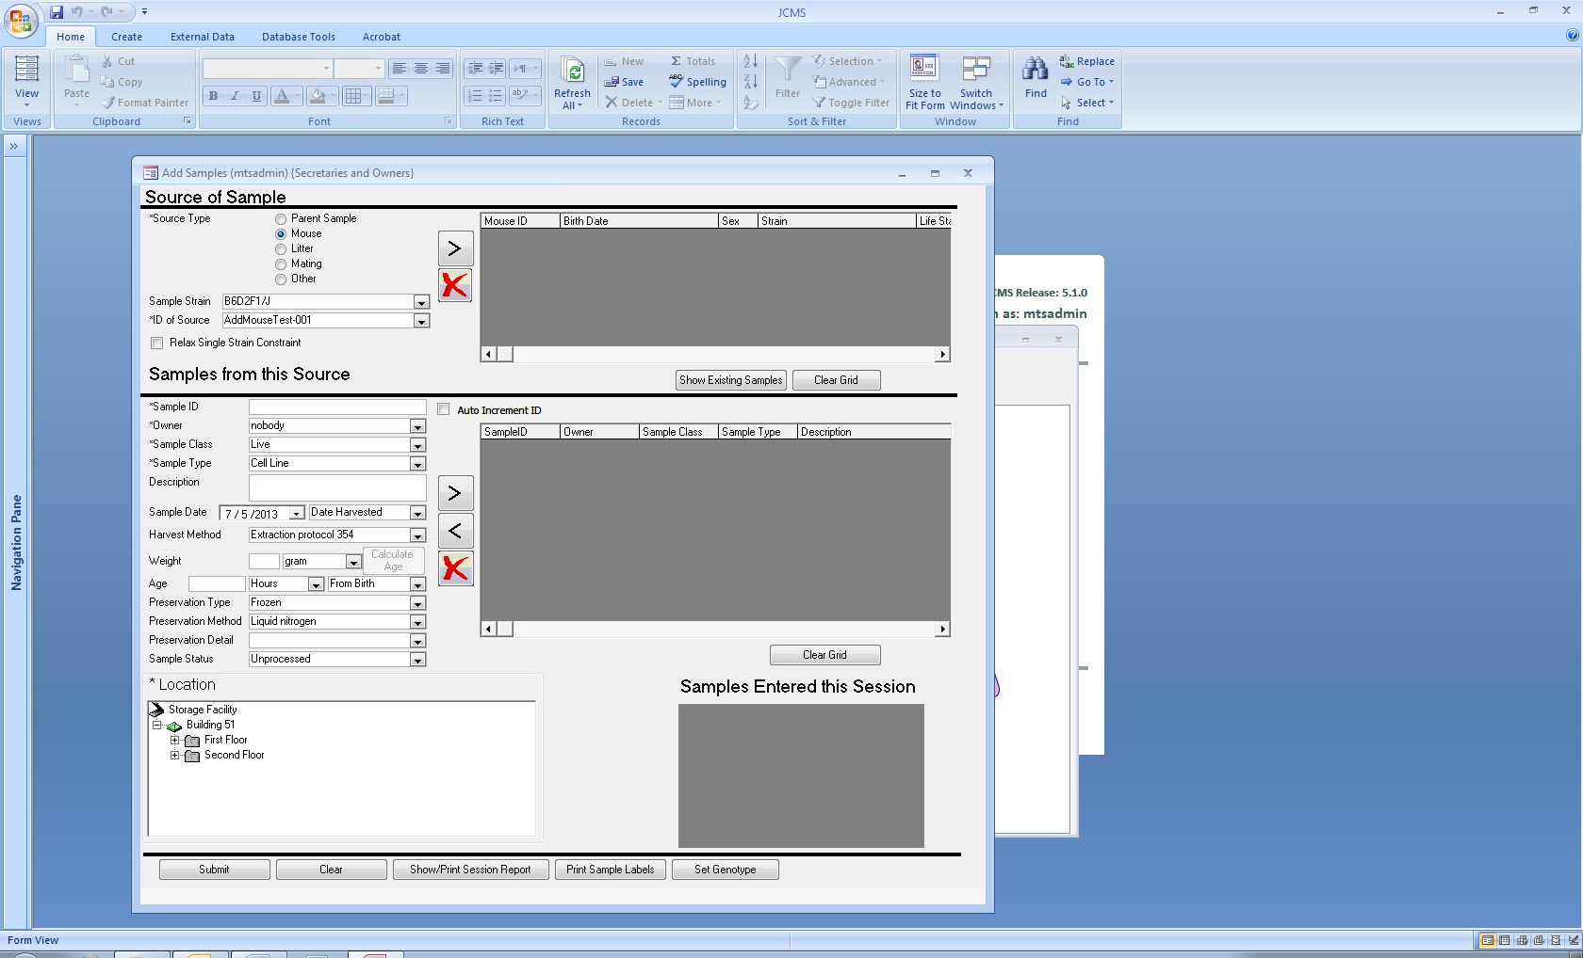

Figure ‑ Add Sample form

The Add Sample form is accessed by clicking the Add Sample button from the Samples tab. Use the Add Sample form to add as many samples during a session as necessary. No sample information is saved to the database until you click the Submit button at the bottom left of the screen.

This screen is divided into two sections, the top part is for identifying the source of the sample and the bottom part is for the sample data. Each section contains a grid that can hold one or more items. It is important to understand that a sample or samples may have one or more sources, and a source or sources may have one or more samples associated with it. You may view samples previously entered for the source(s) by clicking the Show Existing Samples button.

The source(s) of a sample may be another sample, a mouse, mating, or litter. There is also an *Other* option; if this is selected, only the strain is saved as the source of the sample. Except for the *Other* option, when you make a selection for the source type, the ID of Source drop down list is populated with ID’s relevant to the source type. For example, if you select a source type of Mouse, the ID’s of Source drop down list will contain mouse ID’s.

By default, the *Sample Strains* list is populated with strains relevant to the *Source Type.* Selecting a strain from the *Sample Strain* list in turn filters the list of *Source IDs* for those associated with the specified *Sample Strain*.

A check box is provided (below the *ID of Source* selection list) that relaxes this constraint, allowing Users to create samples that reference multiple sources from different strains. When checked, the *Sample Strain* list shows all defined strains and the selection of one does not restrict the IDs in the *ID of Source* list. The *Sample Strain* value becomes the Strain value for the Sample. The *Source* record’s Strain value may differ from the Sample’s Strain value. See section 20.2 Pooled Samples for more information about pooled samples.

To select an item from the list as a source, select it in the ID’s of Source drop down list and click the “>” button to move it into the source grid. The source grid indicates the source(s) that have been selected for this sample. If multiple sources are indicated, they must be of the same type. For example, both a mouse and a litter may not be indicated as the sources for a sample. In addition, the sources selected must be of the same strain when the *Relax Single Strain Constraint* is not checked (the default). To remove a source from the selected sources grid, highlight it and click the red “X” button.

After identifying the source(s), enter the sample information. Each sample is identified by a Sample ID and these must be unique. Enable the system to generate these by checking Auto-generate ID. When using this, indicate the format to use with the first sample entered, and the system will then use that format for subsequent samples. For example, to enter five samples in the format S_01, S_02, S_03, S_04, and S_05, enter the first one (S_01) and the system will increment the numeric digits for the remaining samples. Required data entry fields are identified with asterisks. Indicate the sample’s class and type (i.e. Live, Embryo) and the values for the sample type will be based on the selected sample class. Values in the drop down lists for Preservation Type, Method, and Detail are dependent on the selection for Sample Type.

Note that the sample date, weight, and age have both a data entry box and one or more drop down lists to qualify the value. For example, enter a value for age, and then use the drop down lists to indicate the time units and how the age is measured. The Calculate Age button may be used to automatically generate the age based on the relevant date of the source. Relevant dates are birth date for mouse, mating date for mating, and litter born date for litter. If more than one source is indicated, and the relevant dates are different (i.e. two mice with different born dates,) the Calculate Age button will be disabled.

The sample’s location is specified by using the location “Tree” at the bottom left side of the screen. Expand the tree by clicking on the “+” to the left of any branch of the tree, allowing you to drill down to whatever level of detail is necessary. Select any branch of the tree at any level, which allows saving the location from something as general as a building, to something as specific as a box on a shelf in a room in a building.

After entering the sample information, use the “>” button next to the sample grid to move the sample into the grid. Then repeat the process to add additional samples to the grid. All samples added to the grid will be associated with the source(s) identified in the first step. To remove a sample from the grid, highlight it and click the red “X” button. Note that both the source and samples grids have a Clear Grid button that will remove all entries from that grid. Edit a sample in the grid by highlighting it and clicking the “<” button, updating the data on the left, and then clicking the “>” button.

When the samples grid is complete and you are ready to save, click the Submit button. This enters the samples into the database and the rows in the grid will turn green to indicate that they were saved successfully. Then either close the form or continue entering additional samples. The Clear button at the bottom of the screen will clear all values so that you can start entering a new set of samples. Everything entered will appear in the Samples Entered this Session list.

## Edit Samples

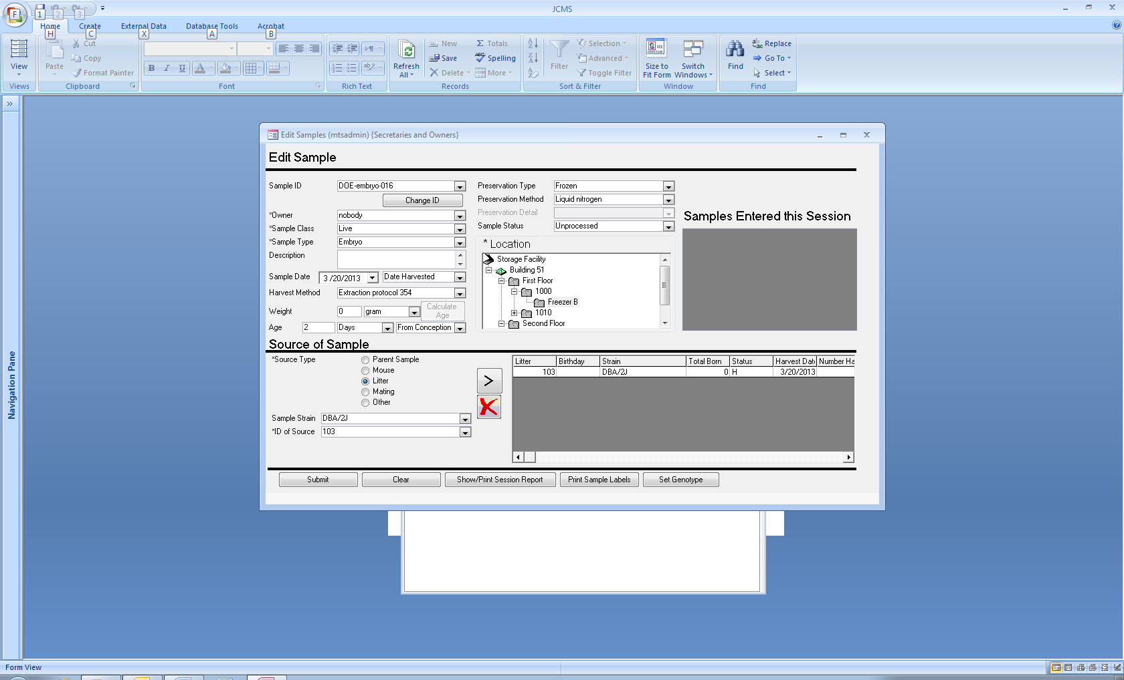

Figure ‑ Edit Sample Form

The Edit Sample form is accessed by clicking the Edit Sample button on the Samples tab. All data about a sample, including its source(s), may be updated on the edit sample screen. This screen is used to update one sample at a time. The first step is to select the Sample ID of the sample to be updated from the Sample ID drop down list at the top of the screen. After selecting a sample, make whatever updates are necessary. The data entry fields on this screen function the same way as their corresponding data entry fields on the Add Sample screen. After the information has been updated, click the Submit button to save the changes.

## Bulk Change Samples

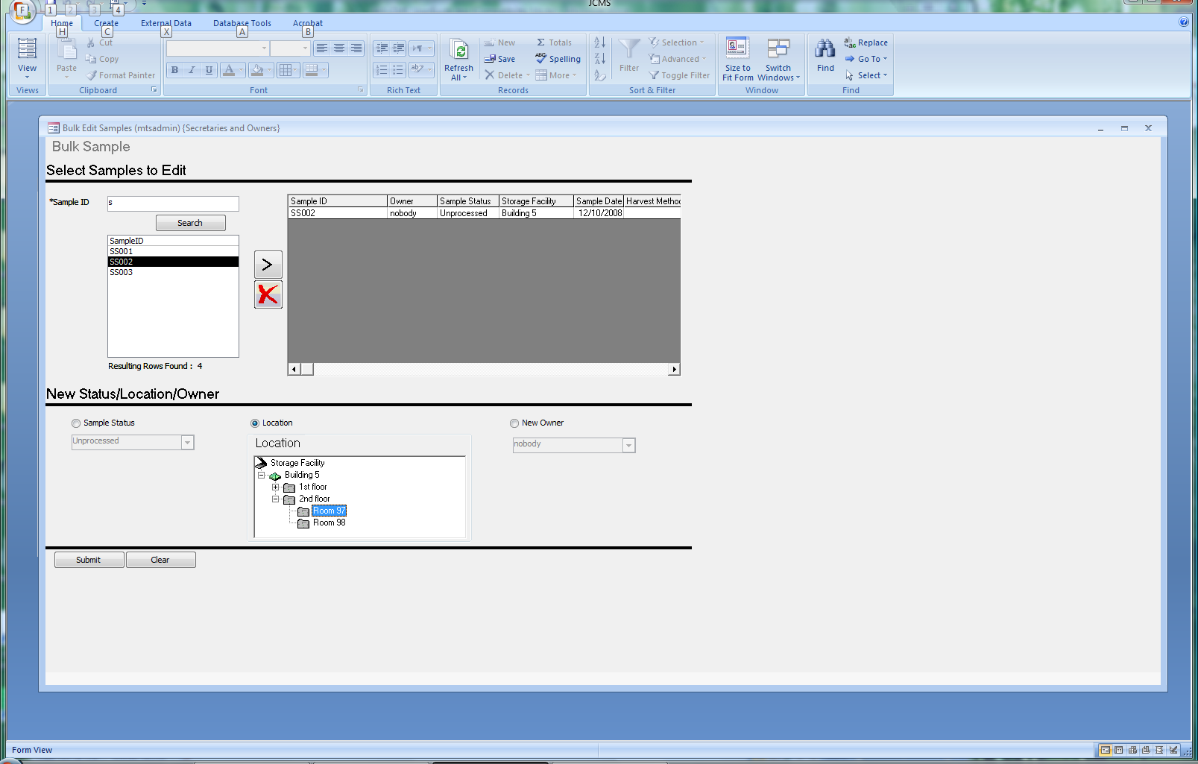

Figure ‑ Bulk Sample Update Form

JCMS Sample Tracking provides a specialized screen for bulk updates to a group of samples to change their status, location, and/or owner. To get to this screen, click the Bulk Sample Update button on the Samples tab.

The top half of this screen is used for indicating the group of samples to be updated. This is done by searching for samples by Sample ID, selecting one or more samples from the search results, and moving them into the selected samples grid. You may enter a full or partial sample ID in the Sample ID box and then click the Search button. Samples matching the search criteria will appear in the search results list. Select one or more samples by highlighting them and click the “>” button to move the samples into the selected samples grid. You may perform as many searches as necessary to fill the selected samples grid. As on the Add Sample screen, you may remove a sample by highlighting it and clicking the red “X” button.

On the bottom half of the screen, select one of the update options, and then select the new value to be applied. When the submit button is clicked, the updated value will be applied to all samples in the grid. You may make additional updates if necessary. For example, to change a status and location for a group of samples, you would first select Sample Status and pick the new status and click Submit. Then you would select Sample Location and pick the new location value and click Submit.

Only samples belonging to the logged on user may be transferred to a new owner using this form. If ownership transfers by an administrator from one owner to another are desired, the Bulk Change of Ownership form, under Admin Functions, is used.

## Query Samples

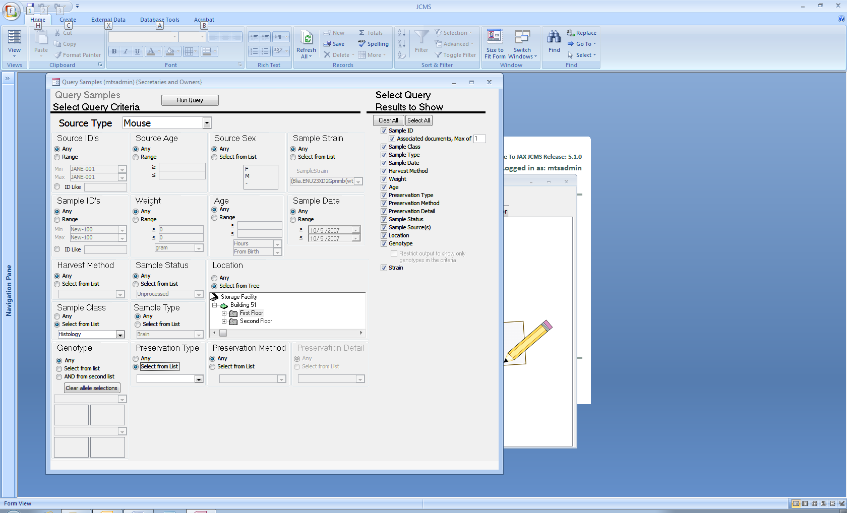

Figure ‑ Query Samples Form

This screen is accessed by clicking the Query Samples button on the Reports tab. It is used for producing a query and obtaining results for samples. It allows maximum flexibility, as any combination of sample information may be selected to filter the results, and there is control over which output values are viewed. To see all results for a specific search criterion, leave the selection at the default “Any.” To narrow results, select a value either by typing it in or selecting it from the drop down list where applicable. Where possible, a range of values may also be entered. Use the check box list along the right hand side of the screen to select which values to include in the results.

Search criteria on this screen may be enabled or disabled based on a selection made in another area. This happens if the two search criteria are dependent on each other. For example, sample type and preservation information are dependent on the sample class. When “Histology” is selected for sample class, the sample status, sample type, and preservation type areas became enabled. When a specific preservation type is selected, rather than “Any,” the preservation method area becomes enabled, and so forth. This allows “drilling down” into the dependent information.

When the query selections have been made, click the Run Query button to see the results in tabular format.

Note: the Strain criterion for Sample searches is matched **only** to the Sample’s Strain, not to the strain associated with individual sample sources. When pooled sources span multiple strains, the search does not include the source’s strains, i.e., it does not answer the question “show me samples where any constituent source is from strain X.” See section 20.2 Pooled Samples for more information about pooled samples.

### Searching for sample genotypes

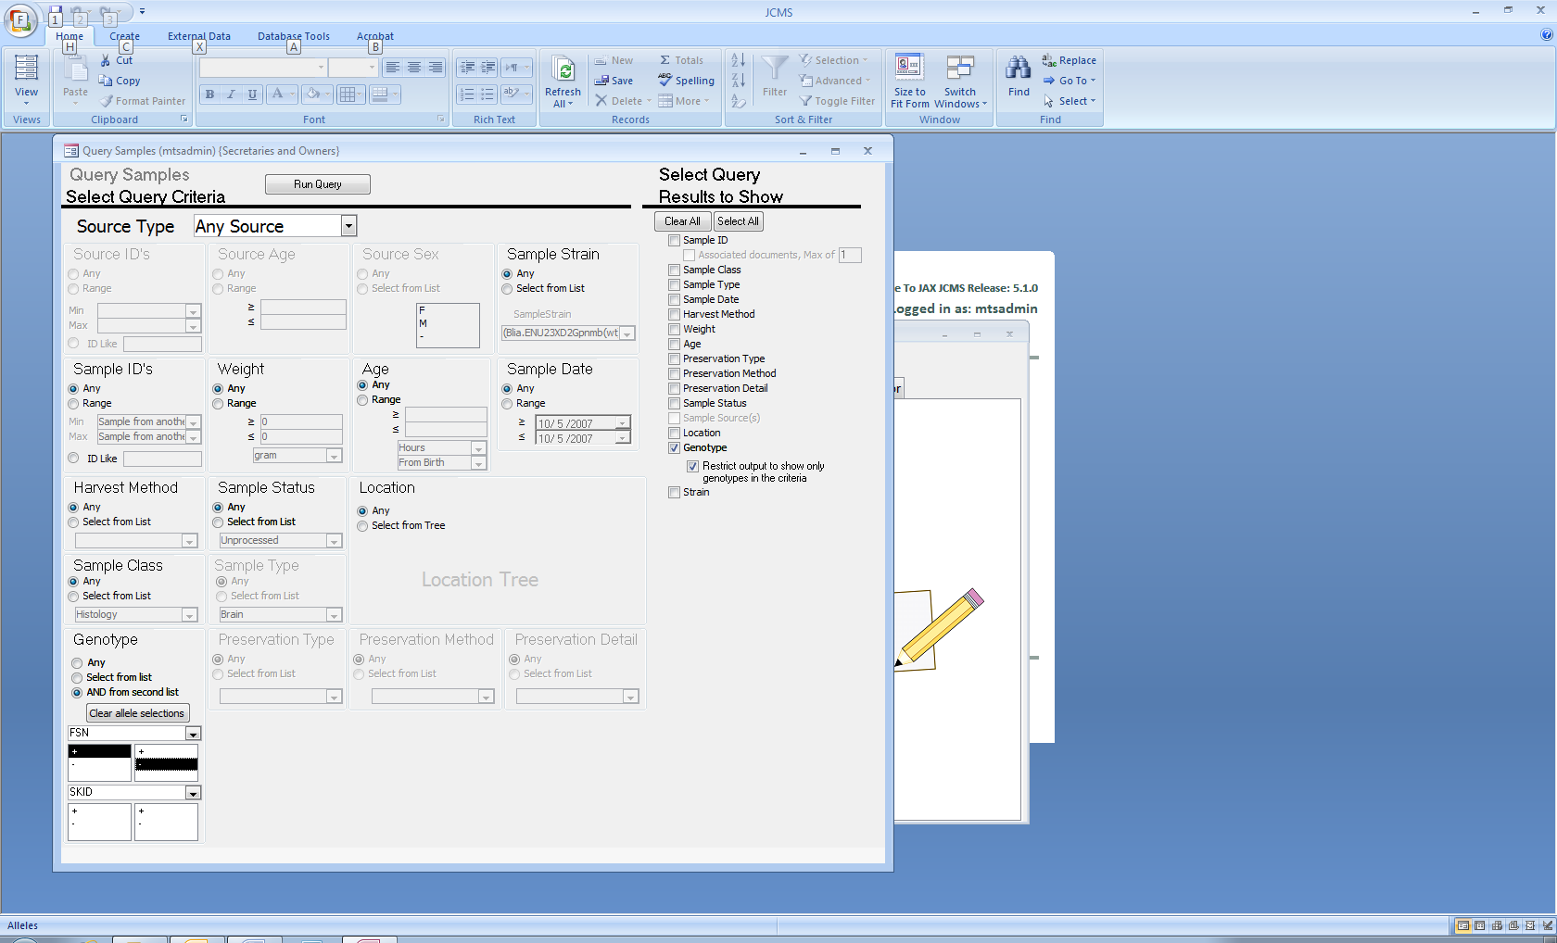Up to two genes with allele combinations may be selected as criteria. When two genes are selected, results are returned only if the sample is typed for both genes. When no alleles are highlighted, the results will contain any allele combination for the gene. Use the *Clear allele selections* button to remove the allele criteria. In this example, samples are returned that have the genotype FSN +/- AND any SKID genotype.

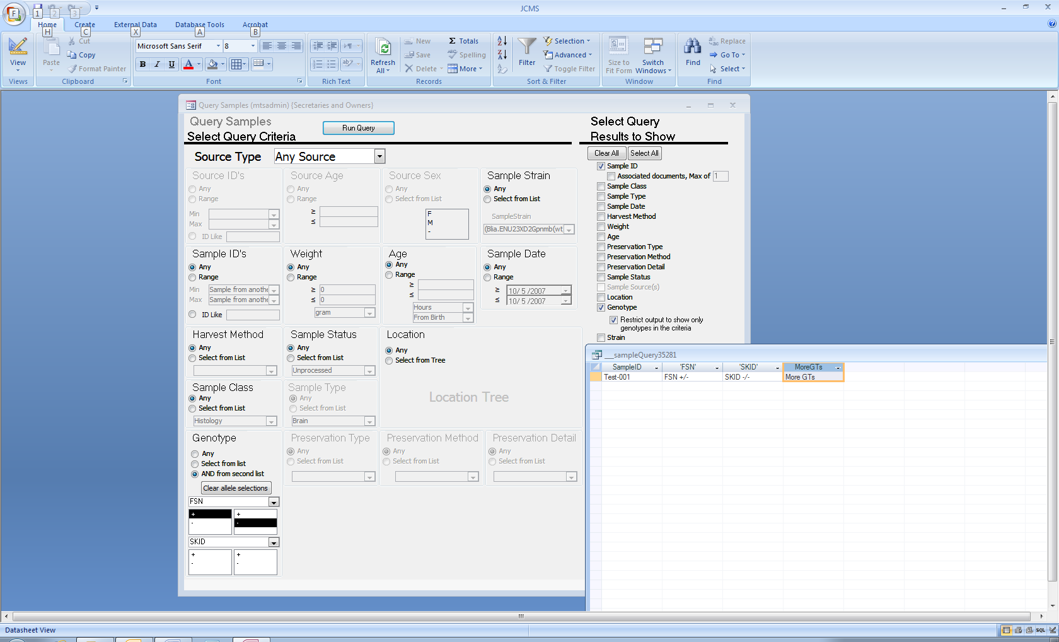Figure ‑ Sample genotype criteria

The genotype does not have to be included in the results. When it is, there are two options. Checking “Restrict output to show only genotypes in the criteria” will create a separate output column for each gene, plus a third column called “MoreGTs” that indicates if the sample has been typed for other genes.

Figure ‑ Sample genotype results in multiple columns

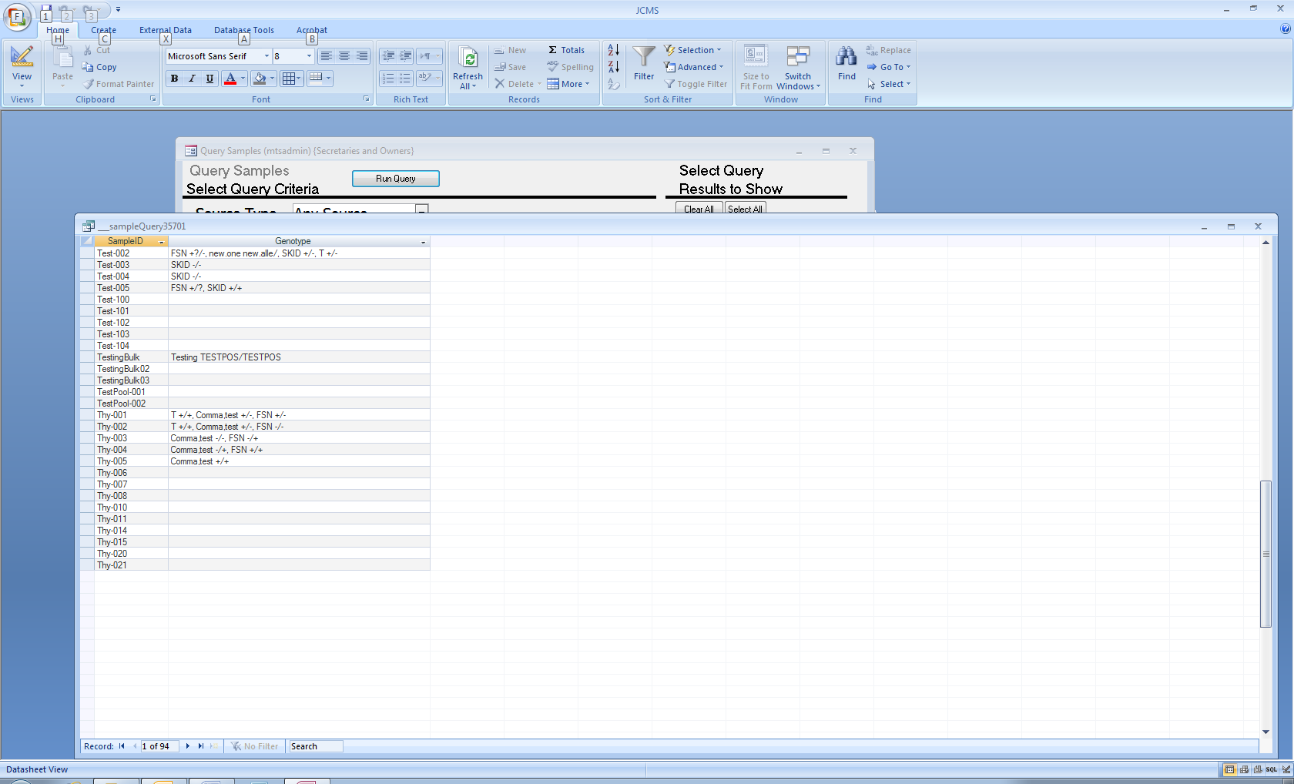When “Restrict output to show only genotypes in the criteria” is not checked, all genotypes are displayed in one column separated with commas. Genotype results are always returned this way if there are no genotype criteria.

Figure ‑ Genotype results when no gene criteria

## Browse Sample Storage Locations

Use this form to display a listing of all samples in a particular location.

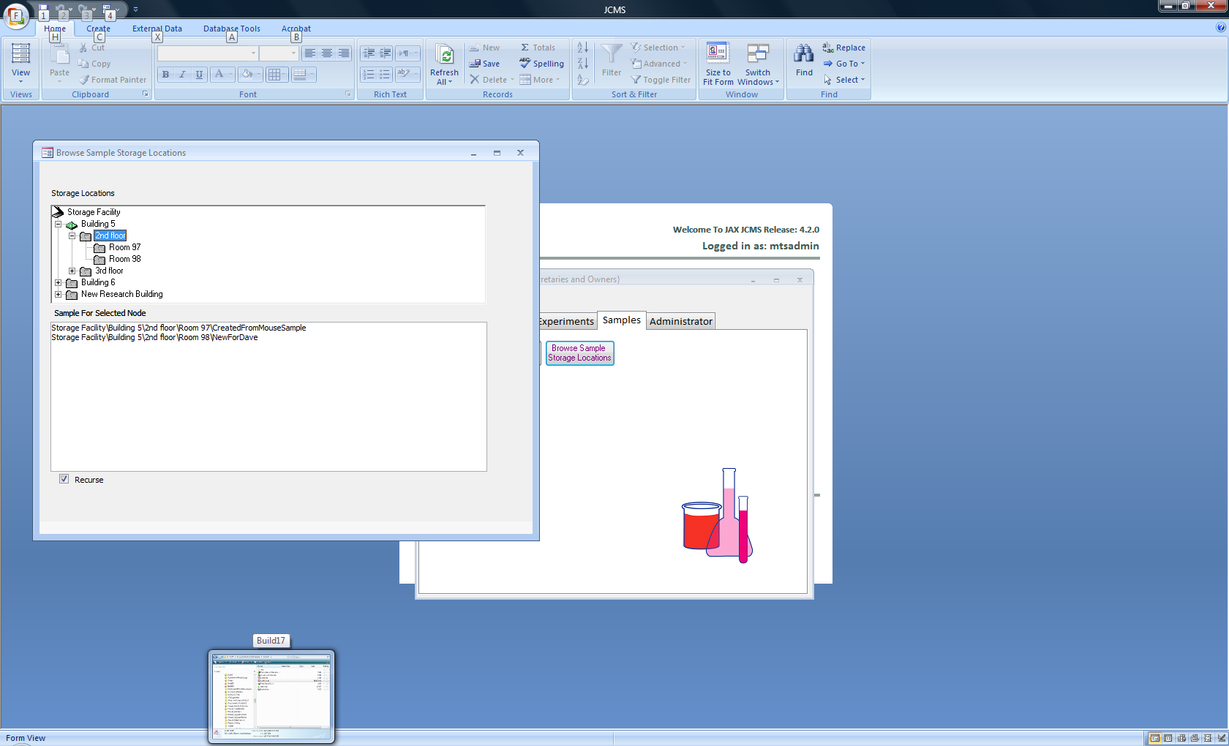

Figure ‑ Browse Sample Storage Locations Form

Check “Recurse” to see all samples in nodes below the selected one.

## Print Sample Labels

A “Print Sample Labels” button found on the Main Menu reports tab, Add Sample, Add Embryo Litter, and Edit Sample forms will open the Print Sample Labels form, shown below in Figure 20‑16. Use this form to print samples selected by searching on the Sample ID value. First configure the label parameters by indicating the height of the label, font size, and whether you want text or bar coded labels. After that, select the samples to print. Similar to the mechanism for selecting samples to edit, enter a full or partial sample ID value, click “Search,” and then select samples for printing based on the search results. To select a sample for printing, highlight it in the search results list and click the right arrow (“>”) button. Multiple values may be selected by using the shift (consecutive select) and control (non-consecutive select) keys. Samples may be removed from the samples to print list by highlighting them and clicking the remove (“X”) button, or clear the entire list by clicking the “Clear List” button. After setting the label parameters and selecting samples to print, click the “Preview” button. This will bring up the print preview window, and if everything looks correct, print the labels on the printer from there.

See Section 2.3.11 for instructions on obtaining a bar code font in order to use bar code labels.

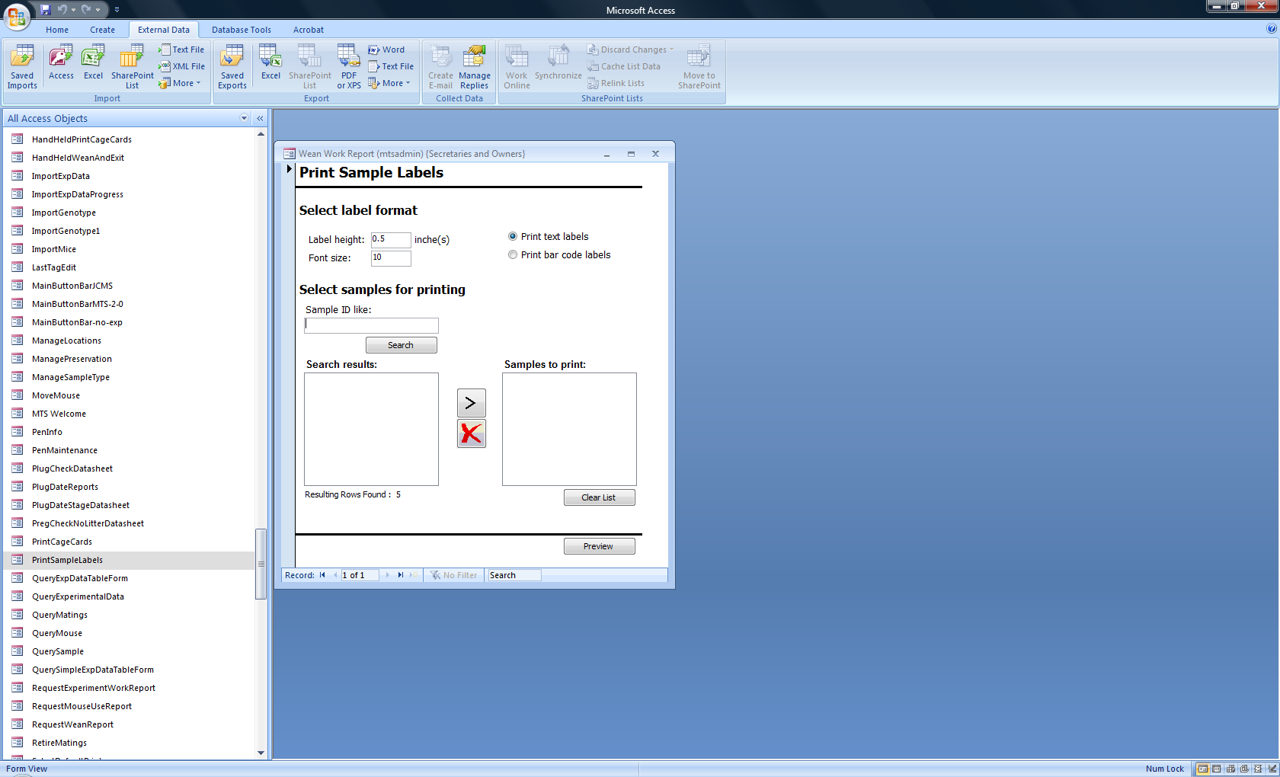

Figure ‑ Print Sample Labels

# FAQ’s (Frequently Asked Questions)

### JCMS starts up and shows the database, but no welcome window appears.

Find the answer to this question in the Configuration Issues section 2.3.13.7.

### Every time I add, edit, or delete a record in JCMS I’m prompted with a dialog box.

MS Access has an option that allows this feature to be turned on or off. Section 2.3.5 describes how to configure these database options.

### What to do about an “end/debug” error message

Occasionally an error dialog box will be displayed with two buttons, *end* and *debug*. This dialog box is displayed only when the program encounters a serious bug. If you see this dialog box you should write down a description about what you were doing at the time and the exact text of the error message. Then contact your Administrator as soon as possible. If your Administrator is not available, select the “end” button and close any program code windows that are left open. You can check your data entry via the various JCMS query forms. If the data looks okay, then continue to work, but be sure to report the bug so it can be fixed in the next release.

Oftentimes, the bug is a minor thing that can be worked around until the next release. If you detect a data problem, stop all data entry and report the problem immediately.

### Error messages when editing date fields

Why are date fields giving error messages when edited?

Problem: If the format the dates are in is MM/DD/YYYY (a 4 digit year), when this is edited, JCMS expects the date to be in the format MM/DD/YY (a 2 digit year) and gives an error. Most of the dates have now been changed to use a pick control, eliminating this problem.

Solution: Remember to highlight the whole field when editing and enter the date with a two digit year. A second, more permanent solution is to change the computer to use two digit dates. From the Windows Start button, choose Settings – Control Panel. Double click on the Regional Settings Icon. Click on the date tab. Change the “Short date style” to mm/dd/yy. This will change how all dates on this computer are displayed.

### Error message: “user Admin does not have permission to use this form”

JCMS does not recognize user *Admin* as a JCMS Administrator. In fact, JCMS prevents user *Admin* from working in JCMS at all. In order to use JCMS you need to be logged on as *mtsadmin*, an owner, or a secretary of an owner. NOTE: Microsoft Access will not prompt for a logon unless user Admin has a password. So assign a password to the Admin user before using JCMS. See the Installation section 2.2.3 on initializing passwords for more information about user accounts.

### Error message about “could not find file”

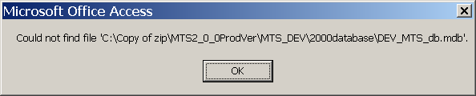

Figure ‑ Could Not Find File Error

The most common reason for this error message is that the file server is not available over the network. JCMS is looking for the linked data tables located on the file server. This message also occurs if the data tables have been moved and the JCMS access interface has not been updated to re-link the tables.

### A note about session boxes

Session boxes provide a history list for the data entry person. MS Access limits the size of this list to 2048 characters long (including some format characters that do not display in the box). If the session box string grows to long, JCMS will warn that the string will be reset soon. You can keep working and the session box will reset before the MS Access limit is reached. The only loss to the user is the history list starts over again. NO DATA IS LOST when you see the warning message or when the session box is reset.

### List boxes of mice information are scrambled!

On several forms, there are list boxes with rows of mouse information or session boxes. The rows of data in these list boxes sometimes get messed up if there are semicolons or commas in the data. The easy fix: remove any commas or semicolons from the terms in the controlled vocabulary tables. If this doesn’t solve the problem, report the bug to the Jackson Laboratory.

Figure ‑ Error: You can't save this record at this time

### Warning message about not saving a record.

This message appears when there was an error on the form that was not corrected. This type of error may be something such as an invalid date or entering something that is not in a pick list. Answer yes if the information on the form was not supposed to be submitted / entered into the database and the form should just be closed. Answer no if the information needs to be entered and correct the information on the form, then resubmit it.

### The database keeps telling me it is “Read only”

Logged in with administrator permissions, navigate to the folder containing your JCMS files. For example c:\Program Files\The Jackson Laboratory\JAX-CMS\. Right click on the folder containing the files (For example: JAX-CMS). Select ‘properties’. Open the ‘Securities’ tab. Give ‘Users’ Read/Write privileges.

### The Connector/ODBC Window is Popping Up

If this occurs when using the Experiment Work Report, edit the MySQL setup variables to reflect the current status. See Section 19.16.1 for more details.

### Other FAQs

Also check the Configuration issues in section 2.3.13, the online [JCMS Discussion Forum](http://community.jax.org/forums/default.aspx?GroupID=7), and the online colony management website [FAQs](http://colonymanagement.jax.org/support-2/faqs/jcms-colony-management-system/).

# Technical Guide

## Security

The JCMS security implementation is based on the premise that people who have access to JCMS are not malicious. JCMS security is therefore limited to trying to prevent accidental changes to the database.

JCMS has two components, an interface component and a database component. The interface component is installed on all workstations that require access to the database. Each installation of the interface component has its own set of user accounts.

Data security is implemented as a hierarchy with two parameters: access level (horizontal) and ownership (vertical). Higher access levels inherit all access permissions from lower access levels plus additional permissions associated with the higher level.

The vertical access parameter (ownership) comes into play only when a user attempts to submit a record-update or a record-addition to an ownership-protected table in the database.

We define three security access levels: Administrator, Owner, and Secretary. In the diagram below, groups are illustrated in solid outlined boxes. An individual logon account can belong to only one access level. In practice this means that secretaries can belong to more than one secretary group (secretary level is the only level that has more than one group associated with it). Also note there is exactly one mtsadmin.

Figure ‑ Administrator - Owner - Secretary Security Relationship

mtsadmin

Owner 1

Owner 2

Owner n

…

Owner 1 secretary group

Owner 2 secretary group

Owner n secretary group

Administrator

Owner

Secretary

Individual secretaries can belong to many secretary groups. Thus, it is possible to for an owner to share the services of a single secretary; however, you need to be careful. Any secretary that belongs to more than one owner-secretary group will have the ability to edit records owned by all owners associated with the secretary in the same edit session. It may be a better administrative policy to give one person more than one access account (log on name) if needed.

Several tables in the database have an owner field: Mouse, Mating, ExpPlan, ExpData, and Sample. Litters inherit ownership from their mating. When editing involves Mouse, Mating, Litter, Experimental Plan, Experimental Data, or Sample, access to the records is restricted by owner.

## Changing Security Access to Forms

Access to the database is restricted by the form interface. That is, each form is assigned an access security level. Users *cannot* use forms that have a higher security level than their assigned level. The opposite is also true; users can use all forms with security level less than or equal to their assigned security level. The mtsadmin has the highest access level and therefore has complete access to the database.

The DbFormPrivileges table controls the access security level (or privilege level) for certain forms. The administrator may change the level between secretary, owner, and administrator for these forms by using the Set Form Access Privileges button on the Administrator button bar. The forms not listed in this table are required to stay at a certain security level. Any changes will take effect the next time JCMS is started by a particular user.

## Data Integrity

Data integrity is only loosely enforced. If all data are entered through the user interface forms, then data integrity will not be a problem. There is one important exception. It is possible for users to conflict in their usage of the database. If multiple users access the database simultaneously and change records there is the possibility of conflicting edits.

## Back up the Database

Having a backup strategy that is followed regularly is very important. Routinely make full copies of the JCMS installation folder and all of its contents. Be sure when backing up to copy the interface (JCMS.mdb) file from wherever you have installed it.

MySQL backups should be conducted by your MySQL system administrator according to published industry recommendations.

## The dbInfo Table

The dbInfo table has release information in it as well as counters for maximum pen ID and maximum auto mouse ID number and maximum auto litter ID number.

## Access to the Primary Data Tables

JCMS allows access to the primary tables through a set of data-sheet forms. Use this level of access to the data only sparingly to correct mistakes in data entry. Entering or changing data this way can cause the data to have multiple problems because the normal forms interface enforces business rules which will not be enforced here.

From the Administrator button bar (click the Administrator button on the Administrator tab), click the button labeled *Access to primary data tables*.

Each table can be opened in “datasheet view,” which appears similar to a spreadsheet. Use the scroll bars to navigate. Click on the column headers and drag to resize them if some of the information in the field is not visible.

Note: the Pen Group table is maintained for historical purposes for those users who upgraded from releases prior to 4.0.0. Changes to this table will have no effect on current pens and rooms.

### Editing Records in Datasheet View

Any field that is typed in will be changed by the database as soon as the cursor moves into another field. Some changes will not be allowed and will generate an error message.

Add records by scrolling to the bottom of the list and entering the new record into the bottom row. It is not allowed to add the record unless values are entered into all of the required fields. Adding will occur when the mouse is clicked on a different row. A **key** must be enteredinto any field with a name that begins _xxx_key. The key should be a number one larger than in the previous row. This is an internal number that normally is not visible. The database is using this key field to keep track of the records. When the forms are used, the database is generating this number automatically. When the tables are used in datasheet view, this number must be added manually.

To delete records from the table, click on the box at the left side of the row in the table. The whole row will be highlighted. Press the delete key. A dialog box will ask confirmation that a record should be deleted.

## Temporary Tables

JCMS creates temporary tables for storing query results that are generated by the user query forms (e.g. query matings) and some of the experimental data forms. Temporary tables are bound to the query output form (i.e., the results of the query) or other screen forms. When the query results form is deleted or other forms are closed, the temporary tables can be removed.

When JCMS starts up it attempts to delete all temporary tables. If a table is still bound to a form then it may not get deleted. An Administrator can delete temporary tables, but be aware that if one of the client installations currently has a query results form bound to the table, the temporary table could be locked (undeletable).

MTSTemp – These temporary tables are named MTSTemp*X*. *X* in the name MTSTemp*X* is an integer that makes the current temporary table name unique in the tables collection. Temporary tables that are not bound to any form are deleted on startup.

## Temporary Queries

The cage use summary report creates temporary queries named ___BillingReportQuery*xxxxx* and the Query Samples form creates temporary queries named ___sampleQuery*xxxxx*. These are deleted when JCMS starts up.

## Screen Resolution

The forms used by this system are rather large and take up quite a bit of screen space. Every effort has been made to make them fit on a normal screen. Many just fit with a screen resolution of 800x600 on a 17” screen. For a smaller screen, try using a higher resolution such as 1024x768. Otherwise, some forms will have to be scrolled to see the entire contents.

## Printer Notes

The cage card reports use the default printer and default paper location. Many modern printers will use the sheet feeder as the default whenever there is paper in the sheet feeder. To print cage cards, open the sheet feeder and load the cards into the envelope feeder part of it. Also set the printer to use as straight a paper path as possible. Many printers have an option for sending sheets out the back if it is open or have a toggle switch to change the path.

The cage cards are designed to print on either the upper left side or center of the paper depending on the card format used. If the envelope feeder places the cards in another location, a programmer will have to change the margin settings to match the location of the envelope feeder.

It is possible to have a programmer customize what printer and paper location is used by changing the File-Page Settings information in the Design View for an individual report.

# Appendix 1: Automated TGS Genotype Loader Submissions

JCMS has an automated interface into The Jackson Laboratory’s Transgenic Genotyping Service (TGS). This interface is only visible to users whose setup variable JCMS_JAXLAB_INSTALLATION is set to true.

## Adding a TGS Genotype Request

Click on the “Add Genotype Request” button from the ‘Manage Mice’ tab.



Figure ‑ The Add Genotyping Request button

Add samples (mice) by

* Selecting the mouse ID
* Selecting a pattern of mouse IDs
* Select a pen
* Filtering by strains
* Filtering by life status

Below is an example of select all mice that begin with the letters “A1”.

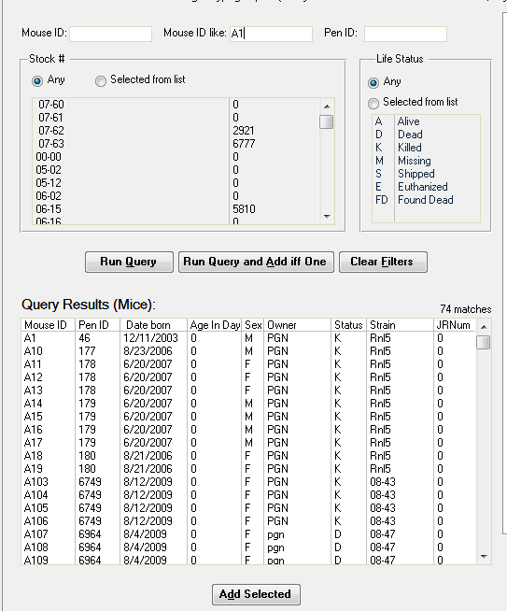

Figure ‑ Select mice whose IDs begin with “A1”

To place mice on the well plate, select them by single clicking on them. Then click “Add Selected”. If this is the first time a dialog will appear that will ask for an ID for the plate.

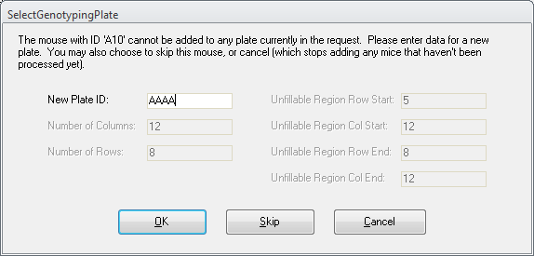

Figure ‑ Setting the plate ID

Any number of plates can be contained within a request.

Samples are added to the well plate grouped by Stock number (JRNum). A column cannot contain samples from more than a single Stock number. The example below has mice from Stock # 000000 and Stock # 008003.

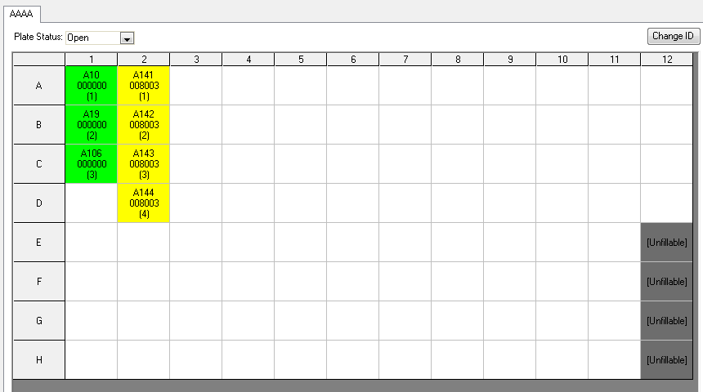

Figure ‑ A well plate with samples from seven mice of two strains

To remove samples (mice) select the cells to be deleted by holding down the shift key and clicking on the cells. (If you are only removing one cell then you do not need to hold down the shift key.) Then click “Remove Selected”.

Before saving a Genotyping Request ID must be entered.

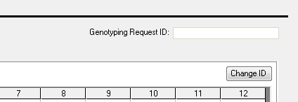

Figure ‑ The genotyping request ID field

Save your work at any time by clicking on the “Save” button. To exit this form, click on the “Cancel” button.

To submit a request, first seal the plate. After a plate is sealed no more mice may be added.

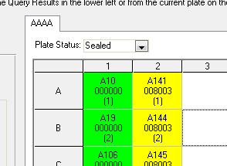

Figure ‑ To seal the plate select “Sealed”

The plate is now ready for submission.

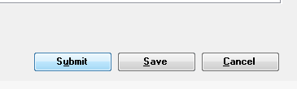

Figure ‑ The Submit button

Upon submission a file name komp2typ.txt is written into the folder identified by the JCMS setup variable JCMS_TGS_REQUEST_PATH. **Only one submission file at a time is allowed**. The TGS application will move the file when it is processed. If successful you will see some variation of the dialog box below.

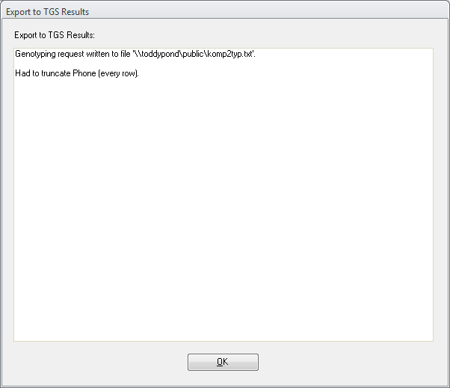

Figure ‑ Notification of a successful submission.

## Editing a TGS Genotype Submission Request

To edit a submitted or un-submitted genotype request click on the “Edit Genotyping Request” button on the ‘Manage Mice’ tab.

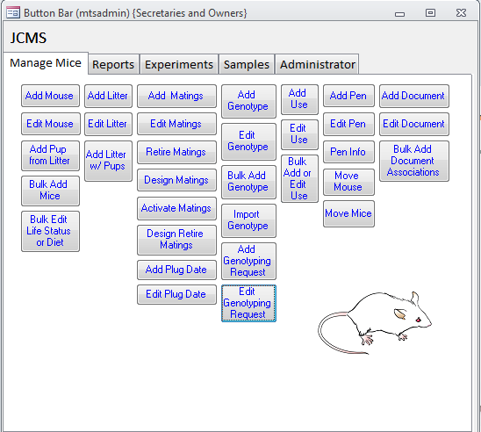

Figure ‑ To edit an existing genotyping request

A selection dialog appears.

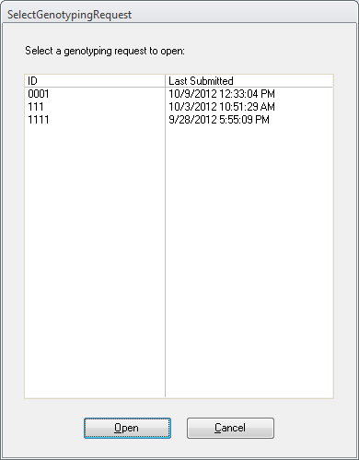

Figure ‑ Select a request to be edited.

Select a request ID and click “Open”. The ‘Edit Genotype Request’ form will open. It operates exactly like the ‘Add Genotype Request’ form.

 When the results are ready the person identified by the setup variable MTS_PI_NAME will receive an email.

## Importing TGS Genotyping Results

Click on the “Import Genotype” button.

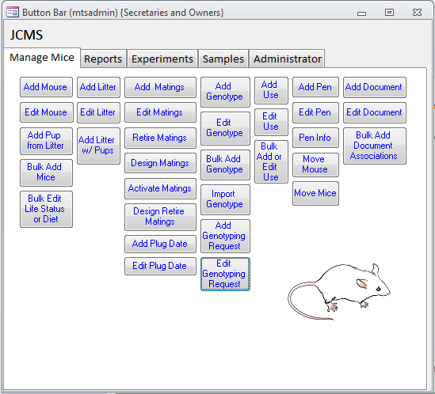

Figure ‑ Import Genotype data

Select “Import TGS format file”. Click OK.

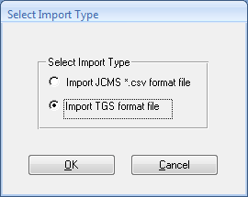

Figure ‑ Select the format

It will take you to the folder identified by the setup variable JCMS_TGS_RESPONSE_PATH. Select the file typ2komp.txt. When ready click the “Import” button.

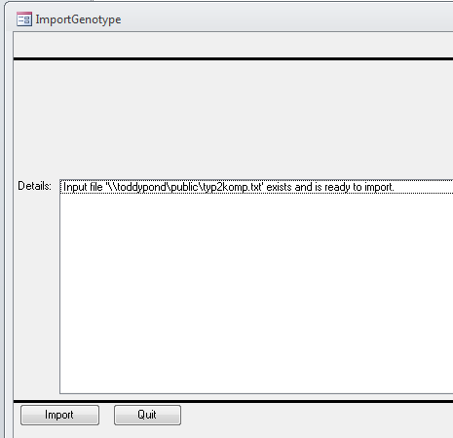

Figure ‑ To import the results from the selected file.

The results will appear in the ‘Details’ dialog box.

 **It is up to the JCMS user to rename or delete the input file after a successful import. TGS will not overwrite the file.**